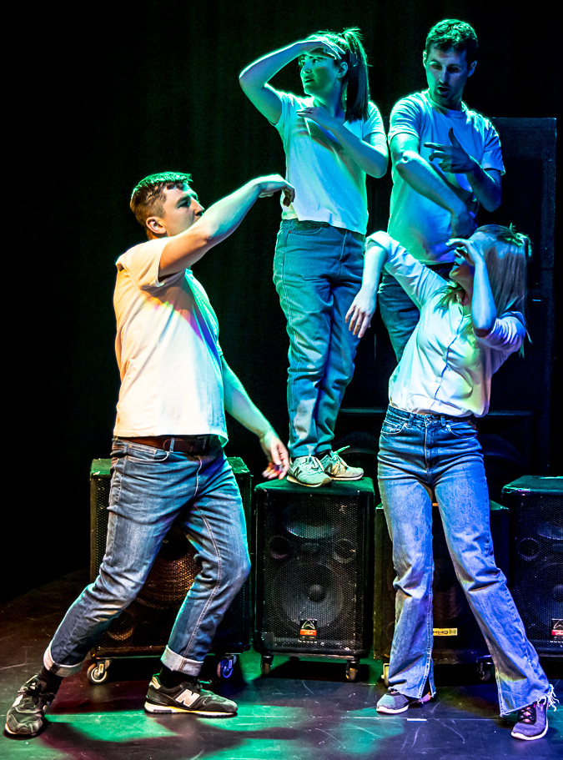 | I Love You, Mum – I Promise I Won’t Die  by Mark Wheeller  Performance and workshops available to book now

TiE It Up Theatre is touring its acclaimed production of Mark Wheeller’s I Love You, Mum – I Promise I Won’t Die for a strictly limited period in Spring Term 2026. This verbatim play, a set text on the Eduqas GCSE Drama curriculum, tells the true story of Dan, a popular 16-year-old South London schoolboy who attends an illegal rave, takes ecstasy and tragically dies as a result of taking a lethal dose.

Watch the trailer of our as-live recording…  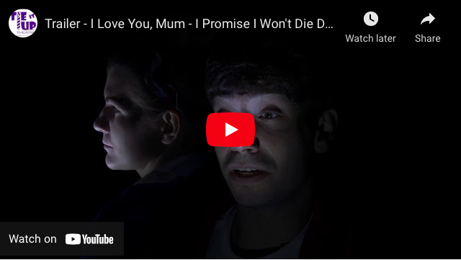 | Reviews  ****½ “powerful and poignant”  Reviews Hub   “moving performances”  Theatre & Art Reviews   “beautiful and deeply touching”  A Broadway World   “a touching tribute to a life  needlessly lost”  A Younger Theatre

Tour dates 23 Feb-21 March 2026
(possible w/c 23 March depending on demand)
See offers and deals
Book by completing the form below and return to david@tiu-theatre.co.uk
We are touring across all England and Wales, ask us about when we are in your area

‘I Love You, Mum – I Promise I Won’t Die’ will be performed by four experienced professional actors and workshop facilitators
With every booking, teachers receive:
- A Drama Teachers’ Resource Pack to assist in teaching ‘I Love You, Mum…’ from a theoretical and practical perspective
- Drug Education Teachers’ Resource pack, developed with the Daniel Spargo-Mabbs Foundation charity
- Post-delivery access to our filmed as-live performance for the rest of this school year
ORDER FORM
Please complete this order form and email to: david@tiu-theatre.co.uk
Choose
I Love You, Mum – I Promise I Won’t Die live performance
+ 1hr drama or 30-min drug education workshop £799*
I Love You, Mum – I Promise I Won’t Die
live performance only £729*
Full Day Delivery includes:
I Love You, Mum – I Promise I Won’t Die 2 x live performances
+ up to 2 x 1hr drama workshops (max 40 students/workshop)
+ up to 2 x 30-min drug education workshops £1,429*
MULTI-SCHOOL DEAL OFFER
(See info below)
*All prices subject to VAT @ 20%
Your name: | Position at school/organisation:

School/organisation name:

Contact Tel. No.
Invoice address:

Signed: [ type here ] | Date:
Authorising Name: [ type here ]  Authorising e-signature: [ type here ] | Date:

For more details on TiE It Up Theatre visit our website
Facebook Twitter Tel: 07747 014895 30 June 2025

MULTI-SCHOOL DEAL OFFER

This is a popular deal for schools in a multi-academy trust or group and offers a significant saving on our single-performance prices. It works like this:

1. One school in the MAT acts as a host, inviting students from the other schools to watch the performance (and this can be x 2 performances in the day) the cost to each school is cut considerably on a sliding scale from the standard £729 (performance-only) or £799 (performance + workshop) prices:

1 x performance for 2 schools = £579 paid by each school
1-2 x performance for 3 schools = £529 "
1-2 x performance for 4 schools = £479 "
1-2 x performance for 5 schools = £429 "
1-2 x performance for 6 schools = £379 "

A tailored drama workshop can be offered depending on the numbers of students involved. Normally, we ask that there are no more than 50 students per drama workshop. If the numbers are more than this, we can run a version of the workshop including a Q&A.

2. For schools in an MAT who cannot attend one venue, we can offer the full package (performance + drama and/or drug ed workshop + resources) at the single delivery price of £729. This is only possible if the schools in the MAT can be scheduled on the same day.

In both scenarios, all schools receive the Drama and Drug Education Teacher Resources + access to our filmed resource for the remainder of the academic year.

LIVE PERFORMANCE DETAILS…

Running time
- Performance: c.55-mins
- Drama workshop: 60 mins (or tailored to suit your requirements)
- Drug education workshop: 30 mins

Performance space
- Min. performance space of 6m wide x 6m deep (there may be some flexibility around this floor area)
- We require access to at least 1 x 230v power socket.

Staging
- Tie It Up Theatre will bring all equipment to stage the performance
- If we are performing in a space with theatre lighting, we would ask that there is a ‘cool wash’ generated on the performance area.

Audience set-up
- The performance is adaptable to any audience set-up with the exception of in-the-round. School halls, if possible are best set up in traditional (face on) theatre style, or thrust, with seating placed face on and to both sides.
- The performance ideally should take place on the same floor level as the seating, but can easily be performed on a school hall stage.
- The production is equally suited to a school theatre/studio.

Audience & workshop numbers
- A max. of 200 students for any one performance
- A max. of 200 students per drug education workshop
- A max. of 40 students per drama workshop

Pre-delivery
- A checklist will be sent at least two weeks prior to delivery with all the details you need about TiE It Up Theatre’s visit to your school.

Terms & conditions, cancellation and refund policy
- Please refer to our terms on our website

If you have any questions prior to your delivery day, please get in touch

David Chafer – Producer/Actor david@tiu-theatre.co.uk
Elliot Montgomery – Artistic/Education Director elliot@tiu-theatre.co.uk

www.tiu-theatre.co.uk Facebook Twitter @TiUTheatre

Tie It Up Theatre Ltd: registered in England no. 10454219

