ORDER LIVE RECORDINGS OF OUR SHOWS!
Available now and can be used until 31 July 2026
Hard to Swallow  By Mark Wheeller    Watch the trailer  TiE It Up Theatre has recorded a high-quality, live performance of its acclaimed version of Mark Wheeller’s Hard to Swallow.  Our Hard to Swallow professional production completed three national school tours – to acclaimed teacher and student feedback. It is unlikely we will tour the show again for some time, so this live recording will be a perfect teaching and learning tool. To make this recording we received an Arts Council England grant and support from the late Maureen Dunbar’s estate.  Drama Teacher Resource Pack with every purchase:  - Powerpoint slide deck packed with ideas and support for teachers and students  - Interviews with cast members  - Rehearsal and workshop exercises  - Exam questions and how to tackle them  Just $199* | I Love You, Mum  – I Promise I Won’t Die  By Mark Wheeller  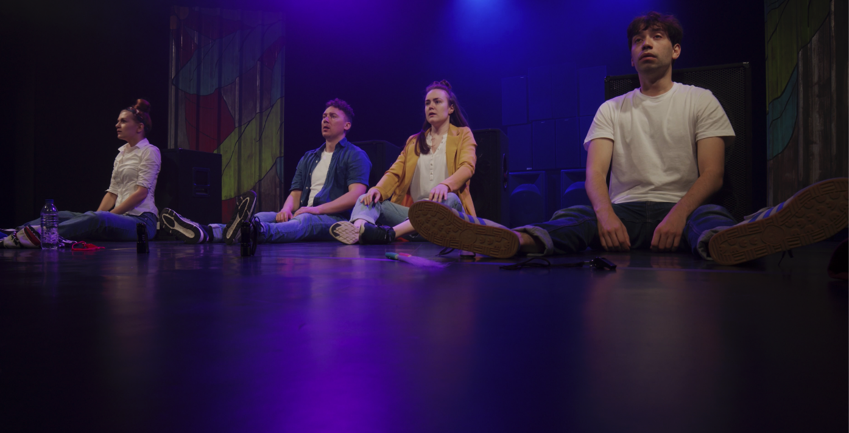  Available to stream now is the live recording of this moving and powerful play.  Our new stage version and live film recording of I Love You, Mum – I Promise I Won’t Die, was originally commissioned by the Daniel Spargo-Mabbs Foundation, the drug education charity. The play tells the true story of Dan, a popular 16-year-old South London schoolboy, who attended an illegal rave in January 2014, took MDMA (ecstasy) and tragically died as a result of taking a lethal dose. The play recounts what happened to Dan, his family and friends, in their own words.  Drama Teacher Resource Pack & Drug Education Resource Pack with every purchase  Watch the trailer    Just US$199*

ORDER BOTH FILMS NOW FOR JUST $299*

ORDER FORM

ORDER FORM
Please complete this order form and email to: david@tiu-theatre.co.uk
(*All prices in US dollar) Choose
I Love You, Mum – I Promise I Won’t Die recording $199 + vat
Password protected link to the film (running time 57mins)
– available to use until 31 Jul 2026 + Drug Education & Drama Teacher Resource Packs
Hard to Swallow recording $199 + vat
Password protected link to the film (running time 1hr 10mins)
– available to use until 31 Jul 2026 + Drama Teacher Resource Pack
Order both resources for $299 + vat

Your name: | Position at school/organisation:

School/organisation name:

Invoice address:

Tel. No.

Signed: [ type here ] | Date:
Authorising Name: [ type here ]  Authorising e-signature: [ type here ] | Date:

For more details on TiE It Up Theatre visit our website
Facebook Twitter Tel: +44 7747 014895 26 June 2025

David Chafer – Producer/Actor david@tiu-theatre.co.uk
Elliot Montgomery – Artistic/Education Director elliot@tiu-theatre.co.uk

Tie It Up Theatre Ltd: registered in England no. 10454219

PLEASE READ: Terms & Conditions, Refund Policy…

Terms & Conditions, Refund Policy…

Streamed content
- To confirm the purchase of a streamed content product, a fully completed booking form must be received by the Company.
- Upon receipt of a booking form, an invoice will be generated and sent to the customer within 2 days, the invoice acts as the Company’s confirmation of your order.
- Invoices must be paid by internet bank transfer or by card payment within 14 calendar days of date of invoice. Customers will be advised how to complete a card payment.

Cancellation Terms & Refunds for a streamed content product
- Customers have 14 calendar days from date of invoice to cancel their purchase. If payment has been made within this period, the customer is entitled to a 100% refund.
- After 14 calendar days of date of invoice, customers are liable for the full amount to be paid immediately.
- There are no refunds after 14 calendar days from date of invoice.
- In certain circumstances, at the discretion of Tie It Up Theatre, a credit note for use towards other products/deliveries may be issued.

www.tiu-theatre.co.uk Tie It Up Theatre Ltd: registered in England no. 10454219

Registered Address: 9 Lea Brook Lane, Wentworth, Rotherham, S62 7SH

