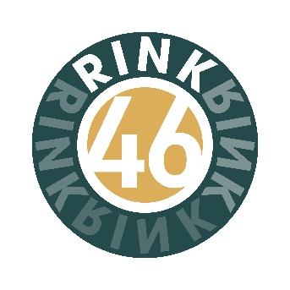
DRAYTON BOWLS CLUB INC.
46 Gipps Street, Drayton, Qld. 4350.
PO Box 41, Drayton North, 4350.
drayton.bowls@gmail.com
Phone: 07 4630 1223/ 07 46369069
APPLICATION FOR ORDINARY MEMBERSHIP
Please print your details and sign where indicated

Section A.
FULL NAME:-……………………………………………………………………………………………………………..

STREET:-…………………………………………………………………TOWN:-……………………………………..
STATE:-……………………Postcode:-…………………………… Date of Birth:-…………/……………/……………………

Home Phone:-…………………………………………………Mobile:-……………………………………………………..…

Email address [important]………………………………………………………………………………………………………………

Have you ever been a member of a Bowls Club?....Yes / No .
If ‘Yes’, go to Section B. If ‘No’, go to Section C.

Section B.
- Are you now a member of a Bowls Club? Yes / No . If yes, which Club…………………………………
- Are you a winner of a Championship?...Singles....Yes / No ... Pairs....Yes / No 
Triples....Yes / No ...Fours....Yes / No ...Mixed Pairs....Yes / No .
- Are you an accredited Coach?.......Yes / No .
- Are you an accredited Umpire? …....Yes / No …...or Measurer? ....Yes / No .
- Have you ever been refused membership, been suspended or expelled from a Bowls Club for any reason? ....Yes / No .
Have you ever held an administrative position in a Bowls Club? ....Yes / No .
If yes, indicate position/s………………………………………………………………………………………………
- Have you included a Clearance Form with this Application? ....Yes / No .
[To comply with Bowls Qld. and Bowls Australia rules, an Inter-Club Clearance Form from a previous or
current Club is required BEFORE an application can be processed].
Proceed to Section C, [over].

Section C
If accepted as a member of this club, do you intend playing bowls? .... Yes / No ]
FEES: - A nomination fee of $15.00 must be lodged with this application.
A Bowls Qld. registration fee of $55.15 is payable upon notification of acceptance for new members.
2025/2026 - Full membership $ 180.00 (1 July – 30 June). Membership fees will be based on pro rata basis for members who join during the year. On acceptance of the application, an invoice will be sent outlining the breakdown of fees due.

Declaration by Member:

When elected to membership, I agree to comply with and be bound by the Constitution
and By-Laws of the Drayton Bowls Club Inc.

Drayton Bowls Club needs to collect information about you for the primary purpose of providing a quality service to you
I agree to the collection of my sensitive information for contact purposes in relation to games, events, Club and District matters. My information will be shared with City Golf Club, Bowls Queensland and will be covered under their Privacy Policy.

Signature:______________________________________Date:_____/_____/______.

Section D

Nominated by …………………………………………………… Signature ……………………………………………

Seconded by ……………………………………………………… Signature …………………………………………..

