Crime Statistics
Overall crime decreased 6% (-27) compared to September of 2025. Part 1 violent crime decreased by 5% (-1) while Part 1 property crimes decreased by 4% (-5). Part 2 violent crime increased by 23% (+18). Part 2 property crime decreased by 30% (-15). Areas along W. Third Street saw the most activity during this period.

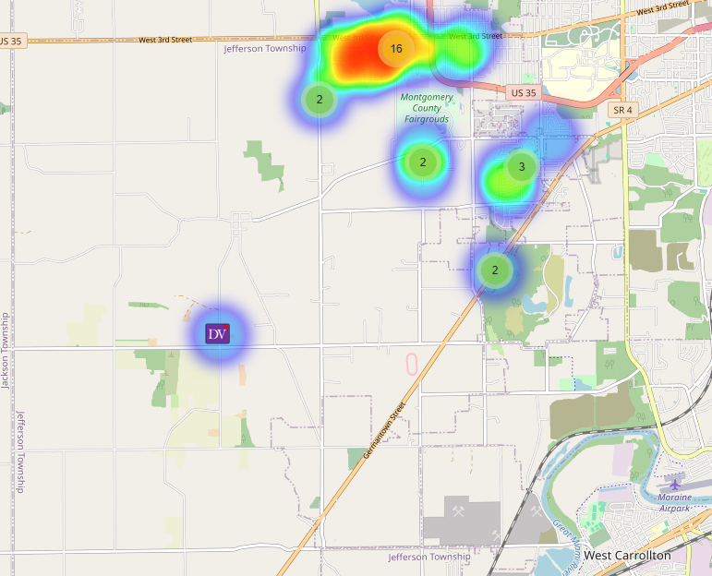

Community Concerns
Community Concern reference to construction barrels and vehicles being too close to the roadway at the Shell construction site on State Route 4. Captain Steele contacted owner, and they advised they would take care of it.

Case report/Jefferson Twp

85 reports were generated in Jefferson Twp. 24 of those reports needed additional follow-up by Detective Phelps.

Incident Narrative
On September 3rd, 2025 (Sun) at approximately 0005 hours, Deputies were patrolling the area of Frazer St. and observed three individuals riding their bicycles in the middle of the dark roadway without any lights. Two of the subjects were found to be in possession of methamphetamine, heroin, pills, marijuana and a BB gun. Both were taken to jail, and the other was released at the scene.

On September 8th, 2025 (Mon) at approximately 0850 hours, Deputies were dispatched to the 6300 block of W. Third St. reference to a stabbing. Upon arrival a male told Deputies he was just stabbed in his right arm. Upon being interviewed by Detectives at the hospital he claimed he fell on a piece of metal on the ground. The Detectives are working the case to obtain any additional information.

On September 12th, 2025 (Fri) at approximately 1216 hours, Deputies were dispatched to the 4700 block of Weaver Rd reference to a missing critical elderly 82-year-old female. We had a very large and fast response from first responders who all volunteered to check the area. Unfortunately, when the female was found she was unable to be brought home safely. We wanted to extend a special thank you to the Jefferson Twp Fire Department, Farmersville Fire Department, Eye in the sky Drone recovery, EquuSearch, Ohio LandSar, The SAR Sheps Search and Rescue, Box 21, and numerous area Police Departments. It shows how the community can come together and show concern and attempt to help other citizens when needed.

On September 17th, 2025 (Wed) at approximately 1323 hours, we were notified that a suspect shot up a stop sign approximately 2 weeks ago at Lansdown and Vinal Ave. Det. Phelps is actively working the case and has presented charges to the Prosecutor’s Office reference to felony discharging a firearm over the roadway.

Forensic Services

During the Month of September, the Forensic Services Unit handled 226 calls for evidence. 142 were handled in Harrison Township, 31 were handled in Jefferson Township, 19 were handled in Washington Township, and 34 were handled in other jurisdictions.

56 were handled by First Watch, 58 were handled by Second Watch, and 112 were handled by Third Watch evidence technicians.

Traffic Services/Jefferson Township
During the month of September deputies from Jefferson Township investigated nine traffic crashes. This reflects a decrease in two crash investigations (-18.18%) when compared to September 2024. Of these crashes, there were five property damage crashes, and four minor injury crashes. There were five people with minor injuries. There was one crash investigated as hit and run, none of the crashes involved a pedestrian, and one of the crashes involved an impaired driver.

Tuesdays, Wednesdays, and Fridays were the busiest days of the month accounting for two crashes each. Failure to maintain reasonable control and other causes were the most common causative factors accounting for two crashes each. US Route 35 was the most prevalent roadway, accounting for four crashes. The other crashes occurred at various locations within Jefferson Township.

There was one hit and run crash reported during the month of September. The other crash remains under investigation.

The crash involving the impaired driver is a felony OVI case and will be presented to the grand jury.

TRAFFIC ENFORCEMENT
 | JEFFERSON TOWNSHIP | MONTGOMERY COUNTY
Traffic stops conducted | 142 | 51
Traffic related warnings | 119 | 41
Driving under suspension | 1 | 0
Speed | 1 | 3
Adult seat belt violations | 0 | 0
Juvenile seat belt violations | 0 | 0
Other moving violations | 15 | 4
Non-Moving violations | 25 | 2
OVI (over 21) | 0 | 0
OVI (under 21) | 0 | 0
Commercial overweight violations | 0 | 0
TOTAL CITATIONS ISSUED | 42 | 9
K-9 deployments
13 deployments with reports.

Environmental Crimes
During September, Deputy Amlin, working the MCSWD contract, worked in the areas of Butler Township, Harrison Township, Miami Township, Washington Township, Jefferson Township, Dayton, Trotwood, Vandalia, Moraine, Miamisburg, and Clayton. Deputy Amlin’s crew worked a total of 128 hours and collected a total of 362 bags.

During September, Deputy Jackson had 2 new cases in Harrison Township, 1 new case in Jefferson Township, no new cases in Washington Township, 5 new cases in Dayton, and no new cases in Moraine.

During September, Deputy Jackson has had 28 new dispatches, 2 new assists, 1 new Large-Scale Clean-Up, and 13 follow-ups.

******************************************************************
Captain Steele is having an Impact meeting at District 7 Headquarters located at 555 Infirmary Rd on December 4th, 2025 (Wed) at 1700 hours. All are encouraged to attend to learn about all that the Sheriff’s Office provides at District 7/Jefferson Township and to speak about current events and any concerns from the community.
******************************************************************

Monthly Stats
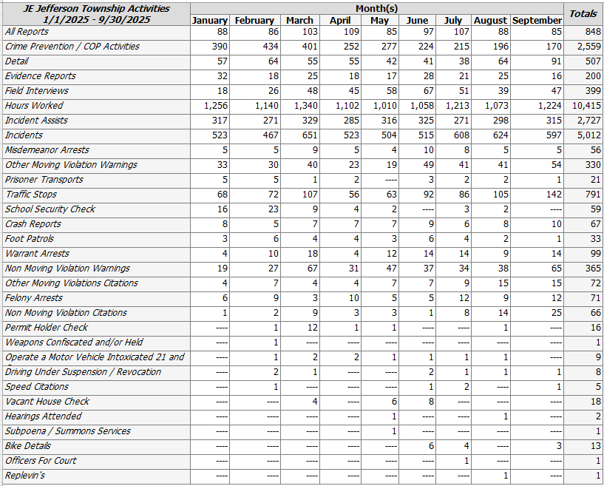

Prepared By:
Captain Walt Steele #88
Montgomery County Sheriff’s Office
District 7 Road Patrol Headquarters/Jefferson Township Substation
555 Infirmary Road Dayton, OH 45417
937-496-6887
Steelew@mcohiosheriff.org

