Crime Statistics
Overall crime decreased 5% (-21) compared to October of 2025. Part 1 violent crime decreased by 4% (-1) while Part 1 property crimes decreased by 9% (-12). Part 2 violent crime increased by 29% (+25). Part 2 property crime decreased by 30% (-16). Areas along W. Third Street saw the most activity during this period.

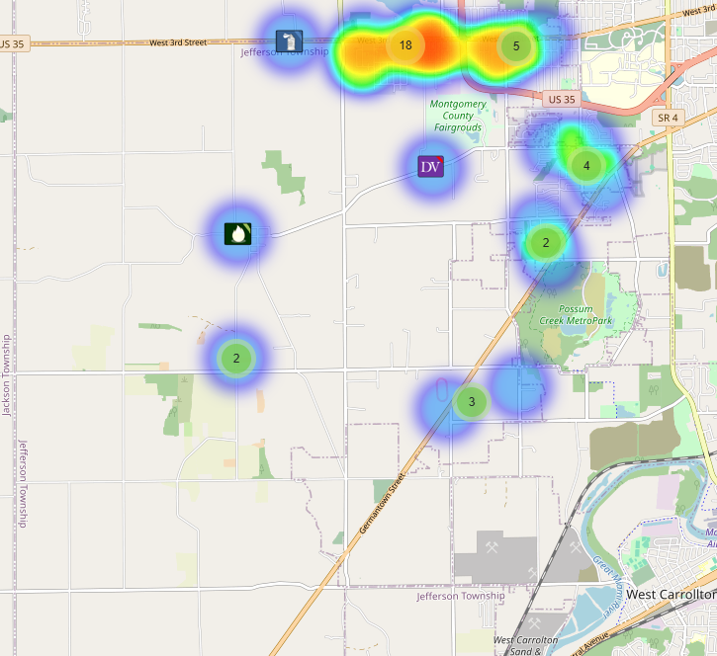
Community Concerns
No new Community Concerns this month.

Case report/Jefferson Twp

90 reports were generated in Jefferson Twp. 25 of those reports needed additional follow-up by Detective Phelps.

Incident Narrative

On October 1st, 2025 (Wed) at approximately 0300 hours, Deputies were patrolling the area of W. Third St and stopped a subject on a bicycle riding through the dark plat. The subject was found to be in possession of suspected crack cocaine and methamphetamine and was taken to jail without incident.

Later that same day on October 1st, 2025 (Wed) at approximately 1015 hours, Deputies were dispatched to the 100 block of Infirmary Rd. reference to a shooting. The victim initially lied and claimed he was shot in the hand in Trotwood behind a business. The investigation led to Infirmary Rd and the suspect was found and scene located and the weapon was recovered. The victim refused to file charges and claimed he was accidentally shot by the homeowner. Det. Phelps is handling the investigation.

On October 10th, 2025 (Mon) at approximately 1345 hours, Deputies were dispatched to the 7000 block of Dayton Liberty reference to a suspicious fire. Det. Phelps is working with Jefferson Twp fire and an arson investigator as it is suspected that a known suspect was angry and purposely set the house on fire.

On October 6th, 2025 (Mon) at approximately 1600 hours, Deputies were dispatched to the 1600 block of S. Snyder Road reference to a motor vehicle crash. Upon arrival, Deputies found the motorcyclist to have serious injuries. Our traffic services unit is handling the investigation.

On October 12th, 2025 (Sun) at approximately 2330 hours, Deputies were dispatched to the 4000 block of Tenshaw reference to smoke inside a residence from subjects inside cooking. One of our Deputies was taken to the hospital reference to smoke inhalation and later made a full recovery.

We are beginning to get Flock camera’s put up in the Township and are expected to have 8 operational by the end of the year. As soon as we obtained the first camera, we were alerted to a stolen vehicle that rammed Deputies in Clark County. We were able to stop the vehicle and recover it as the suspect fled the area.

Forensic Services

During the month of October, the Forensic Services Unit handled 265 calls for evidence. 145 were handled in Harrison Township, 29 were handled in Jefferson Township, 25 were handled in Washington Township, 3 were handled in Perry Township, and 22 were handled in other jurisdictions.

96 were handled by First Watch, 61 were handled by Second Watch, and 108 were handled by Third Watch evidence technicians.

Traffic Services/Jefferson Township
During the month of October, deputies from Jefferson Township investigated thirteen traffic crashes. This reflects an increase of one crash investigation (8.33%) when compared to October 2024. Of these crashes, there were five property damage crashes and seven minor injury crashes. There were ten people with minor injuries, and one with a serious injury. There was one crash investigated as hit and run, none of the crashes involved a pedestrian, and one of the crashes involved an impaired driver.

Saturday was the busiest day of the month, accounting for four crashes. Failure to yield right of way was the most common causative factor, accounting for four crashes, followed by speed/ACD, and failure to control. State Route 4 was the most prevalent roadway, accounting for seven crashes. The other crashes occurred at various locations within Jefferson Township.
There was one hit-and-run crash reported during October.

TRAFFIC ENFORCEMENT
 | JEFFERSON TOWNSHIP | MONTGOMERY COUNTY
Traffic stops conducted | 97 | 51
Traffic related warnings | 90 | 34
Driving under suspension | 1 | 3
Speed | 2 | 3
Adult seat belt violations | 0 | 0
Juvenile seat belt violations | 2 | 0
Other moving violations | 16 | 12
Non-Moving violations | 6 | 10
OVI (over 21) | 0 | 2
OVI (under 21) | 0 | 0
Commercial overweight violations | 0 | 0
TOTAL CITATIONS ISSUED | 27 | 30

K-9 deployments
9 deployments with reports.

Environmental Crimes
During October, Deputy Amlin, working the MCSWD contract, worked in the areas of Butler Township, Harrison Township, Miami Township, Washington Township, Jefferson Township, Dayton, Trotwood, Vandalia, Moraine, Miamisburg, and Clayton. Deputy Amlin’s crew worked a total of 136 hours and collected a total of 295 bags.

Monthly Stats

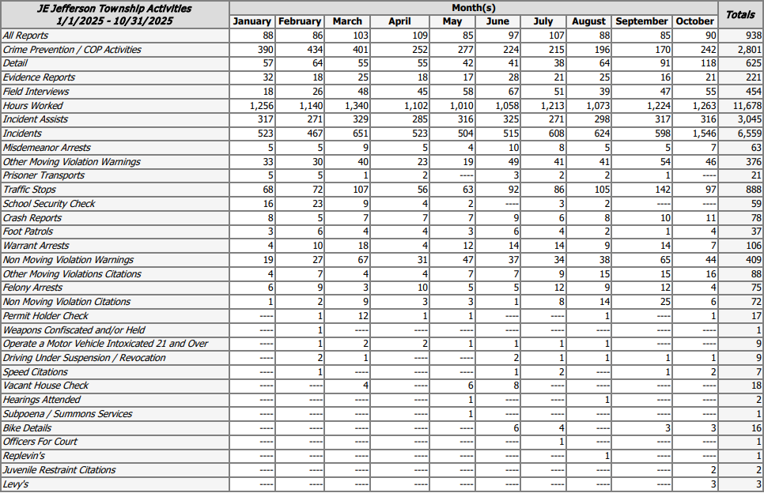

******************************************************************
Captain Steele is having an Impact meeting at District 7 Headquarters located at 555 Infirmary Rd on December 4th, 2025 (Wed) at 1700 hours. All are encouraged to attend to learn about all that the Sheriff’s Office provides at District 7/Jefferson Township and to speak about current events and any concerns from the community.
******************************************************************

Prepared By:
Captain Walt Steele #88
Montgomery County Sheriff’s Office
District 7 Road Patrol Headquarters/Jefferson Township Substation
555 Infirmary Road Dayton, OH 45417
937-496-6887
Steelew@mcohiosheriff.org

