Crime Statistics
Overall crime decreased 6% (-30) compared to November of 2024. Part 1 violent crime decreased by 15% (-4) while Part 1 property crimes decreased by 6% (-10). Part 2 violent crime increased by 35% (+32). Part 2 property crime decreased by 37% (-23). Areas along W. Third Street saw the most activity during this period.

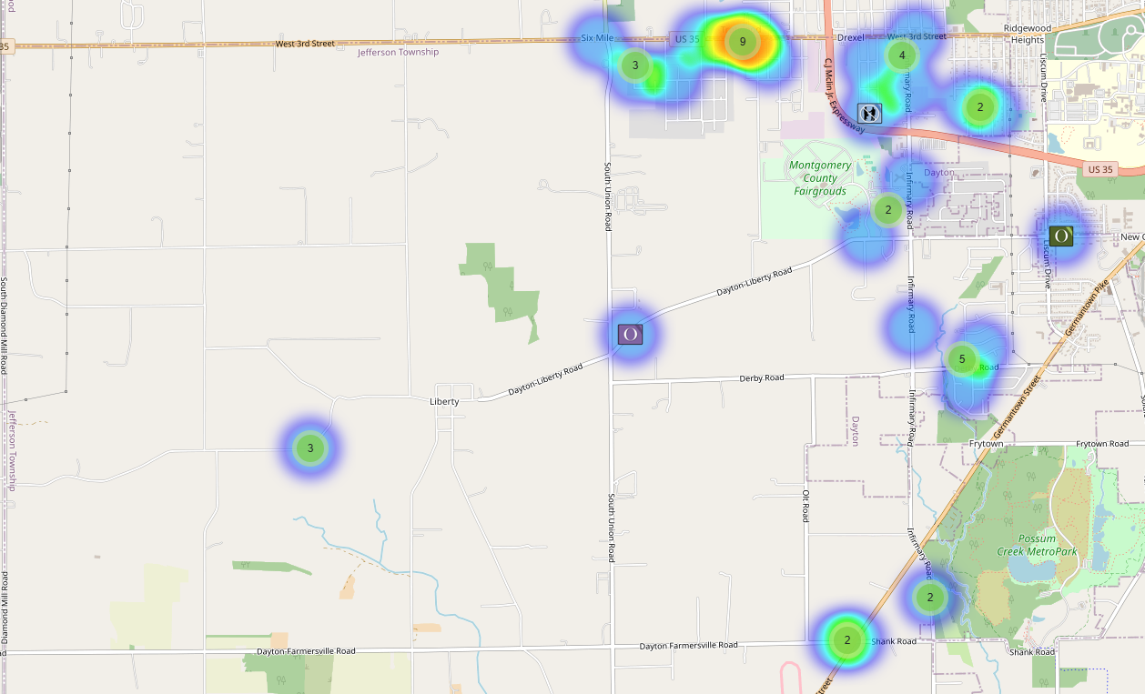

Community Concerns
No new Community Concerns this month.

Case report/Jefferson Twp

88 reports were generated in Jefferson Twp. 28 of those reports needed additional follow-up by Detective Phelps.

Incident Narrative
On November 2nd, 2025 (Sun) Deputies were dispatched to the Olive Hill apartments on Pawtucket St. reference to a robbery. 2 juveniles took their father’s vehicle without permission. While driving around the area, the juveniles claimed that unknown males robbed them at gun point. The vehicle was processed and returned to the father and Detective Phelps is investigating the incident.

On November 3rd, 2025 (Mon) Deputies were dispatched to the 6000 Blk of Derby Rd reference to a two-car head on crash. A 22-year-old female driver that had no driver’s license and was not wearing a seat belt was pronounced deceased at the scene. 2 occupants of the other vehicle sustained minor injuries. Our traffic services unit is handling the investigation.

On November 17th, 2025 (Mon), I along with numerous other Deputies, the US Marshal’s Service and members of our RANGE Task force located wanted subject John Dean in the city of Kettering. As we were taking him into custody he attempted to flee and struck other police vehicles with his vehicle. He attempted to run on foot, but he was able to be arrested after he assaulted one of our Deputies. Dean had prior charges in Jefferson Twp. where he injured a Deputy in 2024 after resisting arrest while having a firearm in his possession. He also fired shots at numerous subjects on W. Third St and fled from Deputies earlier this year.

On November 21st, 2025 (Fri) Deputies were dispatched to a tire shop located at the 5000 Blk of W. Third St. reference to a medic call. A male stated he was not feeling well and recently suffered from a broken rib from a fight. Medics responded as the male went unresponsive and was transported to the hospital where he shortly later died. Incident is being investigated by our Special Investigations Unit.

Forensic Services

During the month of November, the Forensic Services Unit responded to a total of 217 calls for evidence processing. Harrison Township generated the largest volume of activity, accounting for 125 calls. Additional calls were handled in Jefferson Township (26), Washington Township (18), and Perry Township (7), with the remaining (41) calls occurring in other jurisdictions throughout the county.
First Watch technicians handled 62 calls, while Second Watch completed 64 calls. Third Watch managed the highest volume, responding to 91 calls during the month.

Traffic Services/Jefferson Township
During the month of November, Jefferson Township deputies investigated a total of (14) traffic crashes. This represents no change from the number of crashes investigated in November 2024. Of the (14) incidents, (10) resulted in property damage, (3) involved minor injuries, and (1) crash was fatal. In total, (5) individuals sustained minor injuries, and (1) fatality was reported. No crashes this month involved a hit-and-run, pedestrian, or impaired driver.
Sunday was the most active day for crash investigations, accounting for (5) of the (14) incidents. The leading contributing factor was failure to control, cited in (6) crashes, followed by improper lane usage. The roadways with the highest number of incidents were Dayton Farmersville Road and West Third Street, which together accounted for (4) crashes. The remaining incidents occurred at various other locations throughout the township.
TRAFFIC ENFORCEMENT

 | JEFFERSON TOWNSHIP | MONTGOMERY COUNTY
Traffic stops conducted | 52 | 48
Traffic related warnings | 42 | 33
Driving under suspension | 0 | 3
Speed | 0 | 0
Adult seat belt violations | 0 | 0
Juvenile seat belt violations | 0 | 0
Other moving violations | 9 | 7
Non-Moving violations | 11 | 9
OVI (over 21) | 0 | 0
OVI (under 21) | 0 | 0
Commercial overweight violations | 0 | 0
TOTAL CITATIONS ISSUED | 20 | 19

K-9 deployments
11 deployments with reports.

Environmental Crimes
During November, Deputy Amlin, assigned to the MCSWD contract, provided service in Huber Heights, Harrison Township, Jefferson Township, Trotwood, Vandalia, Moraine, and the City of Dayton. Deputy Amlin’s crew worked a total of (80) hours and collected (170) bags of debris.
Deputy Jackson reported the following case activity during November: no new cases in Harrison Township, (1) new case in Jefferson Township, no new cases in Washington Township, (5) new cases in Dayton, and (1) new case in Moraine.
Throughout the month, Deputy Jackson handled (24) new dispatches, (1) new assist, (1) new large-scale clean-up, and conducted (8) follow-up investigations.

Monthly Stats

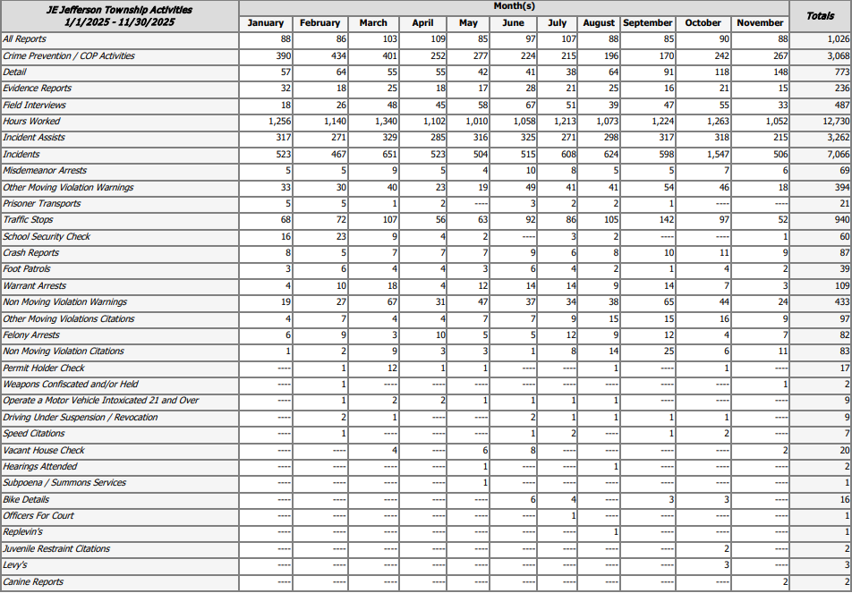

Prepared By:
Captain Walt Steele #88
Montgomery County Sheriff’s Office
District 7 Road Patrol Headquarters/Jefferson Township Substation
555 Infirmary Road Dayton, OH 45417
937-496-6887
Steelew@mcohiosheriff.org

