Crime Statistics
Overall crime decreased by 23% (-57) compared to May of 2024. Part 1 violent crime decreased by 42% (-5) while Part 1 property crimes decreased by 14% (-10). Part 2 violent crime increased by 22% (+10). Part 2 property crime decreased by 54% (-15). Areas along W. Third Street and SR 4 plat areas saw the most activity during this period.

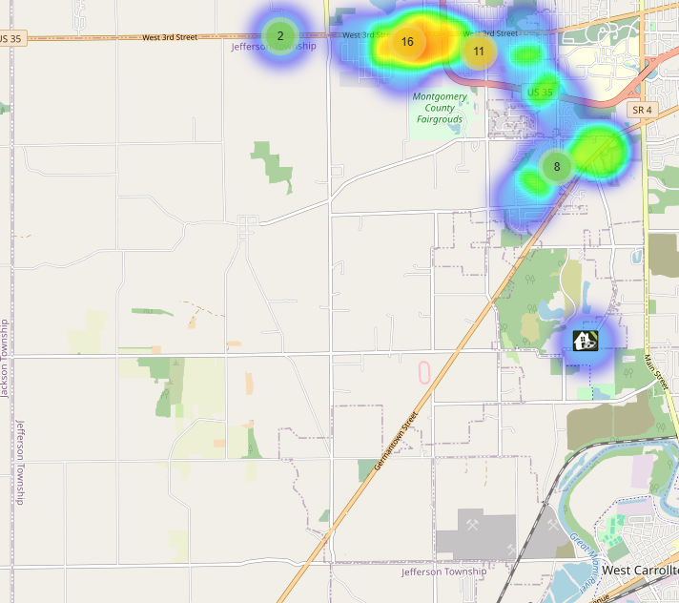

Community Concerns
No new Community concerns for May 2025.

Case report/Jefferson Twp

85 reports were generated. 30 of those reports needed additional follow-up by Detective Phelps.

Incident Narrative
On May 1, 2025, Deputy Richards conducted a traffic stop of a vehicle reference to traffic violations in the area of W. Third St and Calumet Ln. The driver was found to be under multiple suspensions. A K-9 was requested and suspected crack cocaine inside the vehicle was located. The driver was taken to jail reference to the violations and possession of drugs without incident.

On May 6, 2025, Deputy Potter conducted a traffic stop of a vehicle that was driving recklessly, squealing tires and fish tailing at a high rate of speed in the area of W. Third St and US 35. Upon a search of the vehicle, a loaded firearm was located. Our Special Investigations section is investigating the incident.

On May 13, 2025, we had a Deputy injured responding to an animal complaint. The Deputy sustained a broken ankle and is expected to return to work sometime in June.

On May 17, 2025, Deputies responded to the area of W. Third St and Davenport reference to a robbery. They learned that a victim had his dirt bike taken from him at gunpoint earlier in the city of Trotwood. The Deputies located the stolen dirt bike along with the suspect of the armed robbery that was attempting to sell the stolen property. The dirt bike was able to be returned to the owner, and the armed robbery suspect was taken to jail.

Forensic Services

During the Month of May, the Forensic Services Unit handled 211 calls for evidence. 32 of those calls were provided to Jefferson Township.

Traffic Services/Jefferson Township
During the month of May deputies from Jefferson Township investigated nine traffic crashes. This reflects a decrease of seven crash investigations (-43.75%) when compared to May 2024. Of these crashes, there were four property damage crashes, and five minor injury crashes. There were 11 people with minor injuries. There were no crashes investigated as a hit and run, none of the crashes involved a pedestrian, and none of the crashes involved an impaired driver.

Thursdays were the busiest day of the month accounting for four crashes. Failure to maintain reasonable control was the most common causative factor accounting for four crashes. U.S. Route 35 was the most prevalent roadway accounting for five crashes. The other crashes occurred at various locations within Jefferson Township.
TRAFFIC ENFORCEMENT
 | JEFFERSON TOWNSHIP | MONTGOMERY COUNTY
Traffic stops conducted | 63 | 33
Traffic related warnings | 52 | 29
Driving under suspension | 0 | 0
Speed | 0 | 1
Adult seat belt violations | 0 | 0
Juvenile seat belt violations | 0 | 0
Other moving violations | 7 | 3
Non-Moving violations | 3 | 0
OVI (over 21) | 1 | 0
OVI (under 21) | 0 | 0
Commercial overweight violations | 0 | 0
TOTAL CITATIONS ISSUED | 11 | 4

K-9 deployments
14 deployments with reports.

Environmental Crimes
During May, Deputy Amlin, working the MCSWD contract, worked in the areas of Trotwood, Dayton, Moraine, Harrison Township, Miamisburg, Vandalia, and Jefferson Township. Deputy Amlin’s crew worked a total of 222 hours and collected a total of 373 bags.

During May, Deputy Kidwell, working the ODOT contract, worked the areas of Miami Township, Harrison Township, Jefferson Township, Butler Township, Clay Township, Washington Township, and German Township. Deputy Kidwell’s crew worked a total of 160.25 hours and collected a total of 190 bags.

During May, Deputy Jackson had two new cases in Harrison Township, one new case in Jefferson Township, no new cases in Washington Township, five new cases in Dayton, and two new cases in Moraine.
During May, Deputy Jackson had 32 new dispatches, 6 new Assists, two new Large-Scale clean-ups, and 19 Follow-ups.

Monthly Stats

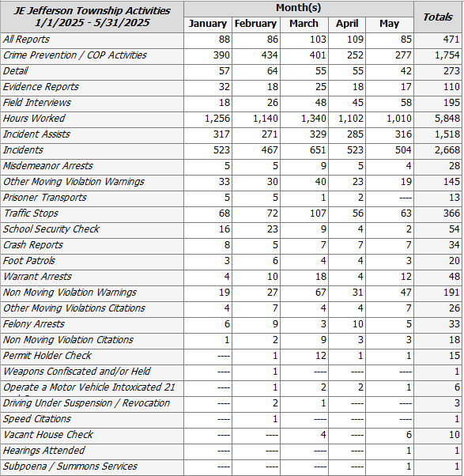

Prepared By:
Captain Walt Steele #88
Montgomery County Sheriff’s Office
District 7 Road Patrol Headquarters/Jefferson Township Substation
555 Infirmary Road Dayton, OH 45417
937-496-6887
Steelew@mcohiosheriff.org

