Crime Statistics
Overall crime is down by 26% (-37) compared to March of 2024. Part 1 violent crime decreased by 33% (-3). Part 1 property crimes decreased by 3% (-1). Part 2 violent crime also decreased by 3% (-1). Part 2 property crime decreased by 46% (-6). Areas along Third Street, US 35 and the neighboring plat areas saw the most activity during this period.

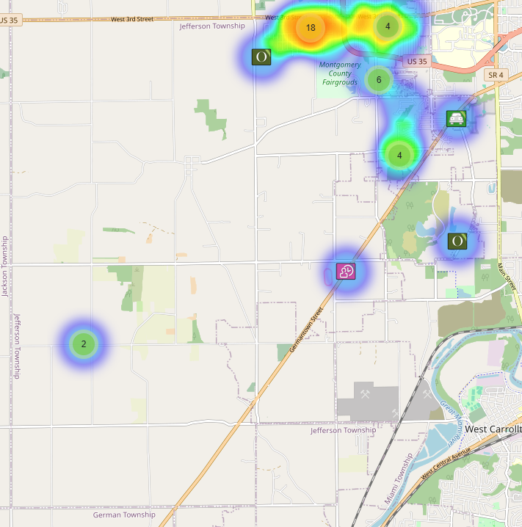
Community Concerns
There were 3 Community concerns for March:

Dumping complaint at 1490 S. Union. Our environmental services Deputy Robbie Jackson is following up on it. Apparently, the owner passed away and the property is in probate court. I also had one of our Deputies follow up with the Probate Judge to provide information on what is going on. Zoning and the State is also assisting.

Large Trucks driving on Frytown Rd. and the Colgate plat areas. I requested that Deputy’s do extra checks in the area.

Inoperable vehicles on the roadways/expired registrations will be stickered and towed if not fixed.

Case report/Jefferson Twp

103 reports Generated. 15 of those reports needed additional follow-up by Detective Phelps.

Incident Narrative
On March 5, 2025 Deputies responded to 10 Maeder Ave. reference to a fire. Fire Chief believed the fire was suspicious and State Fire Marshall investigating as an arson.

On March 7, 2025 a crash occurred on Fiske at Liscum. Three subjects fled from the vehicle that caused the crash. The vehicle that was struck had 2 occupants that were seriously injured. One of our cruisers was struck by another vehicle during the incident with minor damage. Traffic services handling the investigation.

On March 9, 2025 Deputies responded to the 300 block of Bricker Ave reference to a dog bite. A bull terrier bit a 17-year-old female causing injuries to her ear and both arms and legs. The dog was able to be secured in a cage and animal control was called for a follow-up.

On March 17, 2025 Deputies responded to the 300 block of Cherokee reference to a weapons complaint. A worker was getting off work at Valicor and as he was driving through the area an unknown suspect shot his vehicle. He was not injured but evidence of the shooting was left at the scene. Detective Section following up on the incident.

Traffic Services/Jefferson Township
During the month of March deputies from Jefferson Township investigated 10 traffic crashes. This reflects a decrease in one crash investigation (-9.09%) when compared to March 2024. Of these crashes, there were four property damage crashes, four minor injury crashes, and two serious injury crashes. There were five people claiming minor injuries, and two people sustained serious injuries. There was one crash investigated as a hit and run, none of the crashes involved a pedestrian, and two of the crashes involved an impaired driver.

Fridays were the busiest day of the month, accounting for three crashes. Failure to maintain reasonable control was the most common causative factor accounting for six crashes. State Route 4 was the most prevalent roadway, accounting for three crashes. The remaining crashes occurred at various locations within Jefferson Township.

There was one hit and run crash reported during the month of March. The crash remains under investigation.

TRAFFIC ENFORCEMENT
 | JEFFERSON TOWNSHIP | MONTGOMERY COUNTY
Traffic stops conducted | 107 | 48
Traffic related warnings | 107 | 36
Driving under suspension | 1 | 0
Speed | 0 | 1
Adult seat belt violations | 0 | 0
Juvenile seat belt violations | 0 | 0
Other moving violations | 4 | 6
Non-Moving violations | 9 | 4
OVI (over 21) | 2 | 1
OVI (under 21) | 0 | 0
Commercial overweight violations | 0 | 0
TOTAL CITATIONS ISSUED | 16 | 12

K-9 deployments
9 deployments with reports.
Environmental Crimes
During March, Deputy Amlin, working the MCSWD contract, worked in the areas of Trotwood, Dayton, Moraine, Harrison Township, Miamisburg, Vandalia, and Jefferson Township. Deputy Amlin’s crew worked a total of 352.6 hours and collected a total of 702 bags.

During March, Deputy Kidwell, working the ODOT contract, worked the areas of Miami Township, Miamisburg, and Butler Township. Deputy Kidwell’s crew worked a total of 237 hours and collected a total of 378 bags.

During March, Deputy Jackson had two new cases in Harrison Township, two new cases in Jefferson Township, no new cases in Washington Township, three new cases in Dayton, and no new cases in Moraine.

During March, Deputy Jackson had 34 new dispatches, 2 new Assists, one new Large-Scale Clean-Up, and 16 Follow-ups.

Monthly Stats

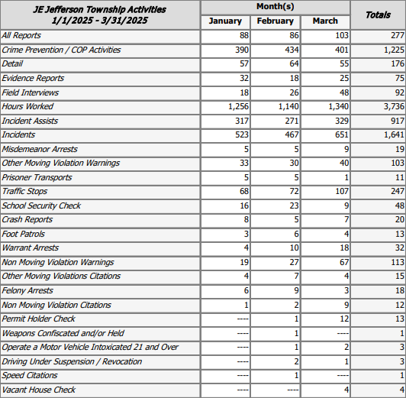

Prepared By:
Captain Walt Steele #88
Montgomery County Sheriff’s Office
District 7 Road Patrol Headquarters/Jefferson Township Substation
555 Infirmary Road Dayton, OH 45417
937-496-6887
Steelew@mcohiosheriff.org

