Crime Statistics
Overall crime decreased by 16% (-46) compared to June of 2024. Part 1 violent crime decreased by 15% (-2) while Part 1 property crimes decreased by 7% (-6). Part 2 violent crime increased by 40% (+20). Part 2 property crime decreased by 50% (-18). Areas along W. Third Street and SR 4 plat areas saw the most activity during this period.
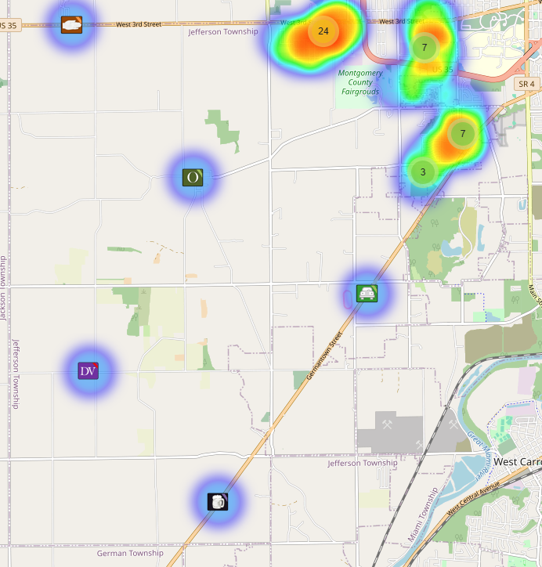
Community Concerns
No new Community concerns for June 2025.

Case report/Jefferson Twp

97 reports were generated in Jefferson Twp. 31 of those reports needed additional follow-up by Detective Phelps.

Incident Narrative
On 6/14/25 (Sat) at approximately 0045 hours, Deputies were dispatched to 330 Lawncrest reference to a shooting. The caller indicated a suspect named Corey had shot the victim and fled the scene. Upon arrival, Deputies found a male victim with gunshot wounds to both legs. Deputies applied tourniquets to both legs and Jefferson medics transported the victim to the hospital. The victim was uncooperative with the investigation and claimed he shot himself.

On 6/17/25 (Tue) at approximately 1837 hours, Deputies along with Jefferson fire were dispatched to 25 S. Iona reference to a suspicious fire. Our Evidence processed the scene as if it were an arson. The incident is under investigation.

On 6/27/25 (Fri) at approximately 1118 hours, wanted suspect John Dean fired shots over the roadway in the area of 5410 W. Third St. Upon Deputies arrival, he fled the scene at a high rate of speed. With the assistance of our drug unit and Special Investigation Detectives we tracked him to a gas station in the area of 70/127. We found him fleeing across the roadway after he dumped his vehicle at the gas station. He was taken into custody and ultimately indicted reference to discharging over the roadway, having weapons under disability and failure to comply. It should be noted that this suspect was involved in an earlier incident several months back where he fought and injured a Deputy and had a gun on him also in Jefferson Twp.

Forensic Services

During the Month of June, the Forensic Services Unit handled 40 calls in Jefferson Township.

Traffic Services/Jefferson Township
During the month of June deputies from Jefferson Township investigated 10 traffic crashes. This reflects an increase of four crash investigations 66.67% when compared to June 2024. Of these crashes, there were five property damage crashes, four minor injury crashes, and one serious injury crash. There were seven people with minor injuries, and one person who sustained serious injuries. There were two crashes investigated as hit and runs, none of the crashes involved a pedestrian, and none of the crashes involved an impaired driver. Tuesdays and Wednesdays were the busiest days of the month accounting for three crashes on each day. Assured clear distance ahead to stop, failure to control, failure to yield the right of way, and other were the most common causative factors accounting for two crashes each. State Route 4 and South Union Road were the most prevalent roadway accounting for three crashes each. The other crashes occurred at various locations within Jefferson Township.

There were two hit and run crashes reported during the month of June. One crash remains under investigation, and the other crash involved the victim leaving the scene and not providing information prior to deputies arriving on scene.

TRAFFIC ENFORCEMENT

 | JEFFERSON TOWNSHIP | MONTGOMERY COUNTY
Traffic stops conducted | 92 | 33
Traffic related warnings | 80 | 31
Driving under suspension | 2 | 0
Speed | 1 | 0
Adult seat belt violations | 0 | 0
Juvenile seat belt violations | 0 | 0
Other moving violations | 7 | 2
Non-Moving violations | 1 | 1
OVI (over 21) | 1 | 0
OVI (under 21) | 0 | 0
Commercial overweight violations | 0 | 0
TOTAL CITATIONS ISSUED | 12 | 3

K-9 deployments
6 deployments with reports.

Environmental Crimes
During June, Deputy Amlin, working the MCSWD contract, worked in the areas of New Lebanon, Dayton, Moraine, Harrison Township, West Carrollton, Vandalia, and Jefferson Township. Deputy Amlin’s crew worked a total of 214.58 hours and collected a total of 271 bags.

During June, Deputy Kidwell, working the ODOT contract, worked the areas of Miami Township, Harrison Township, Jefferson Township, Butler Township, Clay Township, Washington Township, and German Township. Deputy Kidwell’s crew worked a total of 245.75 hours and collected a total of 262 bags.

During June, Deputy Jackson had one new case in Jefferson Township. She had 29 new dispatches, 4 new Assists, two new Large-Scale clean-ups, and 16 Follow-ups. Junk Yard inspections were completed.

Monthly Stats

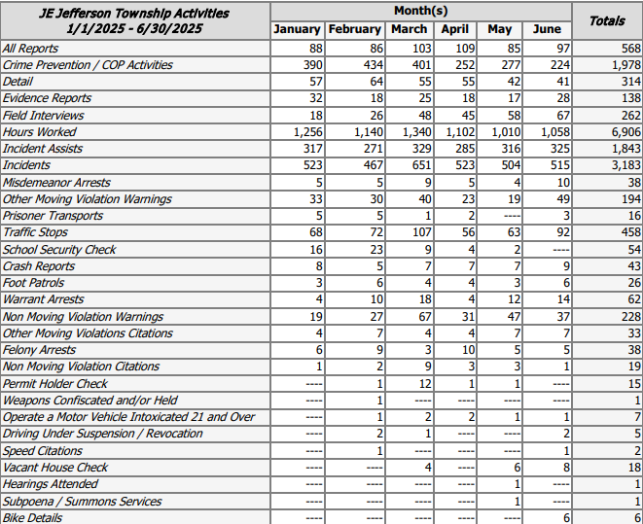

Prepared By:
Captain Walt Steele #88
Montgomery County Sheriff’s Office
District 7 Road Patrol Headquarters/Jefferson Township Substation
555 Infirmary Road Dayton, OH 45417
937-496-6887
Steelew@mcohiosheriff.org

