Crime Statistics
Overall crime decreased by 13% (-45) compared to July of 2025. Part 1 violent crime increased by 14% (+2) while Part 1 property crimes decreased by 11% (-10). Part 2 violent crime increased by 27% (+17). Part 2 property crime decreased by 38% (-16). Areas along W. Third Street and SR 4 saw the most activity during this period followed by areas along State Route 4.
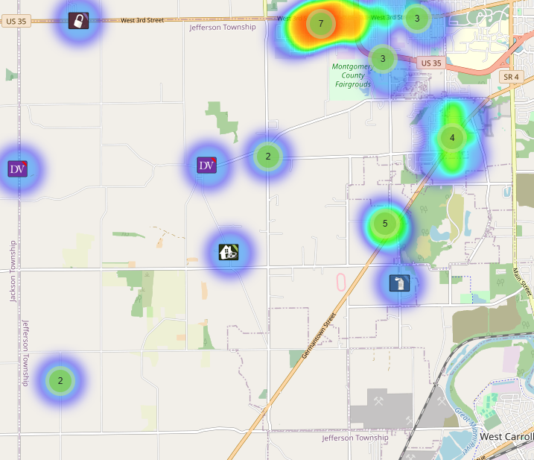

Community Concerns
No new Community concerns for July 2025.

Case report/Jefferson Twp

107 reports were generated in Jefferson Twp. 32 of those reports needed additional follow-up by Detective Phelps.

Incident Narrative
On 7/18/25 (Thursday) at approximately 1735 hours, Deputies were dispatched to the area of 5996 Germantown Pk. reference to an injury crash with an entrapment. There were found to be multiple injuries and Care Flight was on standby during the accident.

During this time the fire Chief’s vehicle was struck by another vehicle while in the intersection with its emergency equipment activated.

On 7/21/2025 (Monday) Deputy Richards stopped a female on W. Third and Calumet Ln. She was found to have a warrant reference to probation violation and found to be in possession of fentanyl. She was taken to jail reference to the violations.

On 7/27/2025 (Sunday) at approximately 1048 hours, Deputies were dispatched to the Olive Hill apartments reference to a shooting. Upon arrival, they found a male had been shot in the legs and stomach. He was transported to the hospital with non-life-threatening injuries. The suspect was quickly apprehended as he attempted to flee the scene in a vehicle. He was taken to jail reference to felonious assault without further incident.

Forensic Services

During the Month of July, the Forensic Services Unit handled 40 calls in Jefferson Township.

Traffic Services/Jefferson Township
During the month of July, deputies from Jefferson Township investigated eight traffic crashes. This reflects a decrease of three crash investigations (27.27%) when compared to July 2024. Of these crashes, there were six property damage crashes, and two minor injury crashes. There were eight people who suffered minor injuries. There were no crashes investigated as hit and runs, none of the crashes involved a pedestrian, and none of the crashes involved an impaired driver.

Thursdays were the busiest day of the month accounting for three crashes. Failure to yield the right of way and assured clear distance ahead to stop were the most common causative factors accounting for three crashes each. State Route 4 was the most prevalent roadway accounting for four crashes. The other crashes occurred at various locations within Jefferson Township.

There were no hit and run crashes reported during the month of July.

TRAFFIC ENFORCEMENT
 | JEFFERSON TOWNSHIP | MONTGOMERY COUNTY
Traffic stops conducted | 86 | 16
Traffic related warnings | 75 | 15
Driving under suspension | 1 | 0
Speed | 2 | 0
Adult seat belt violations | 0 | 0
Juvenile seat belt violations | 0 | 0
Other moving violations | 9 | 2
Non-Moving violations | 8 | 0
OVI (over 21) | 1 | 0
OVI (under 21) | 0 | 0
Commercial overweight violations | 0 | 0
TOTAL CITATIONS ISSUED | 21 | 2

K-9 deployments
5 deployments with reports.

Environmental Crimes
During July, Deputy Amlin, working the MCSWD contract, worked in the areas of New Lebanon, Dayton, Moraine, Harrison Township, Trotwood, Vandalia, and Jefferson Township. Deputy Amlin’s crew worked a total of 201.52 hours and collected a total of 239 bags.

During July, Deputy Jackson had no new cases in Jefferson Township.

During July, Deputy Jackson had 34 new dispatches, 3 new Assists, one new Large-Scale clean-up, and 13 Follow-ups. Tire shop inspections have picked up due to Tire Buy Back in September.

Monthly Stats

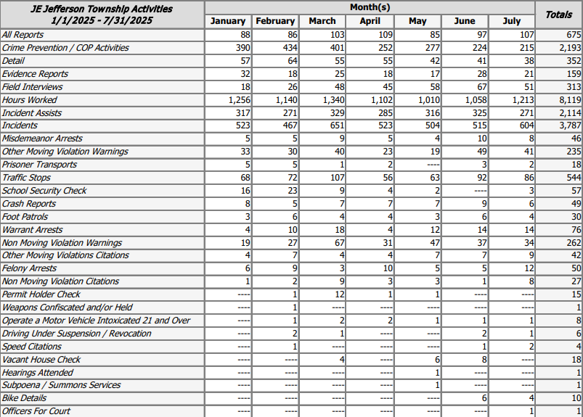

Prepared By:
Captain Walt Steele #88
Montgomery County Sheriff’s Office
District 7 Road Patrol Headquarters/Jefferson Township Substation
555 Infirmary Road Dayton, OH 45417
937-496-6887
Steelew@mcohiosheriff.org

