Crime Statistics
Overall crime decreased by 12% (-7) compared to January 2023. Part 1 violent crime increased by 67% (+2) while Part 1 property crimes decreased 29% (-6). Part 2 violent crime decreased by 10% (-1). Part 2 property crime saw no change over 2023. Areas along Third Street and US 35 saw the most activity during this period followed by areas along State Route 4.
Areas with the most activity are depicted in the below map:
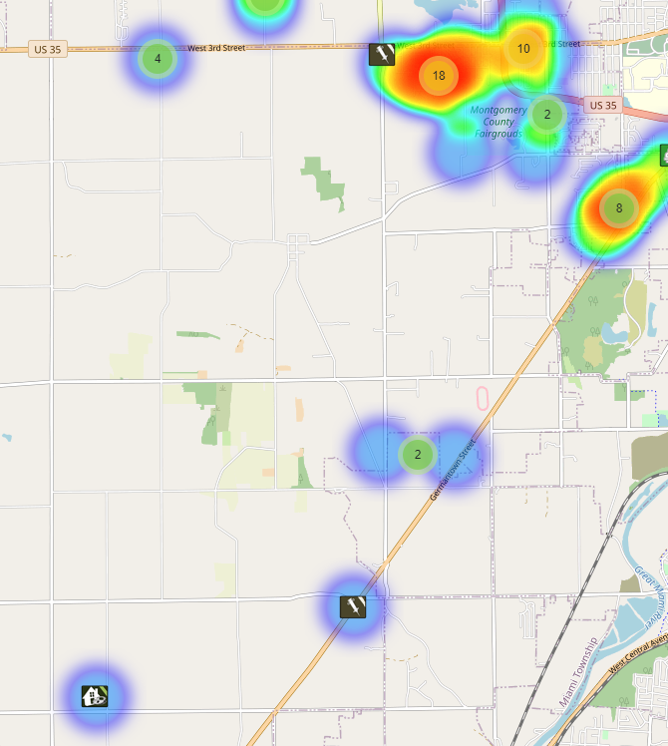
Community Concerns
There were no new community concerns for January.

Incident Narrative
On Monday, January 29, 2024, Jefferson Township and County crews responded to 4150 Germantown Pike, Napoleon’s, on a homicide that occurred in the parking lot. Special Investigations responded for the investigation and FSU responded to handle the scene. An arrest was made in the case and an indictment was handed down.

Traffic Services/Jefferson Township
During the month of January deputies from Jefferson Township investigated nine traffic crashes. This reflects a decrease in crash investigations of (-43.75%) when compared to January 2023. Of these crashes, there were five property damage crashes, four minor injury crashes. There were five people who claimed minor injuries. There was one crash investigated as hit and run crash. One crash involved a pedestrian, and one crash involved an impaired driver.

Tuesday and Wednesday were the busiest days of the month, accounting for three crashes each. Failure to maintain reasonable control was the most common causative factors accounting for three crashes. There was not a prevalent roadway each crash occurred on different roadways within Jefferson Township.

There was one hit and run crash reported during the month of January. The crash remains under investigation.

TRAFFIC ENFORCEMENT
 | JEFFERSON TOWNSHIP | MONTGOMERY COUNTY
Traffic stops conducted | 49 | 31
Traffic related warnings | 34 | 22
Driving under suspension | 1 | 4
Speed | 0 | 0
Adult seat belt violations | 0 | 2
Juvenile seat belt violations | 0 | 1
Other moving violations | 10 | 2
Non-Moving violations | 2 | 8
OVI (over 21) | 1 | 0
OVI (under 21) | 0 | 0

Environmental Crimes
During January, Deputy Amlin working the MCSWD contract worked the areas of Moraine, Harrison Township, Butler Township, Jefferson Township, Vandalia, German Township, and Trotwood. Deputy Amlin’s crew worked a total of 183.75 hours and collected a total of 568 bags.

During January, Deputy Jones, working the ODOT contract worked the areas of Huber Height, Dayton, Harrison Township, Vandalia, Clayton, Germantown, and Jefferson Township. Deputy Jones crew worked a total of 157 hours and collected a total of 355 bags.

During January, Deputy Jackson had no new cases in Harrison Township, one new case in Jefferson Township, no new case in Washington Township, 4 new cases in Dayton, 1 new case in Moraine.

During January Deputy Jackson has had 30 new dispatches, 2 new Assists, 6 new Reports, 1 new Large-Scale Clean-Ups, and 22 Follow ups.

Jefferson Totals
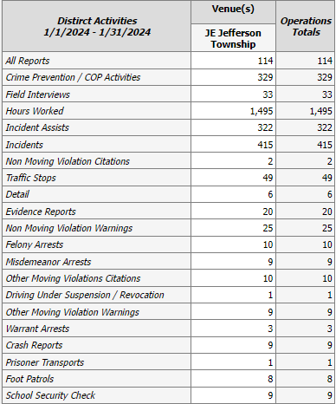

Prepared By:
Captain A. Flagg #77
mcohiosheriff.org Montgomery County Sheriff’s Office
District 7 Road Patrol Headquarters/Jefferson Township Substation
555 Infirmary Road Dayton, OH 45417
937-496-6887
Flagga@mcohiosheriff.org

