Crime Statistics
Overall crime decreased by 56% (-28) compared to January of 2024. Part 1 violent crime decreased by 25% (-1) while Part 1 property crimes decreased by 56% (-9). Part 2 violent crime decreased by 67% (-6). Part 2 property crime decreased by 57% (-4). Areas along Third Street and US 35 saw the most activity during this period followed by associated plat areas.
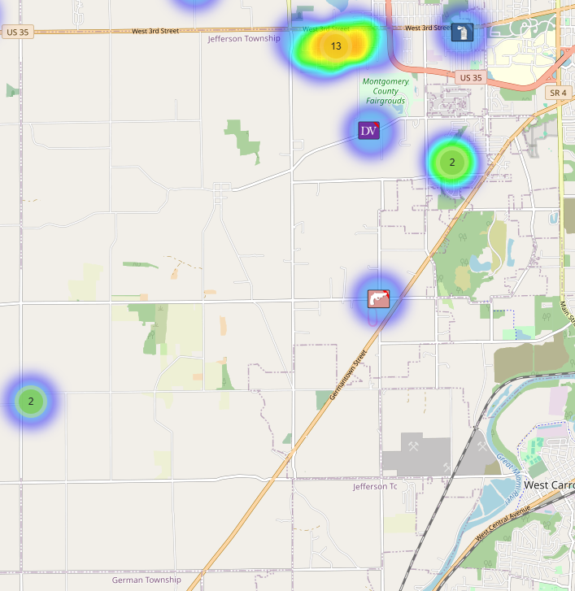
Community Concerns
There were no new community concerns for the month of January.

On December 17, 2024, D7 held an IMPACT meeting for Jefferson Township residents. The main topic of discussion centered around recreational shooting in townships with discussion on current ORC, prosecutor’s opinions, and future trends being discussed by the Ohio Township Association.

Incident Narrative
On January 6, 2025, Deputies responded to the 6000 block of Dayton Farmersville Rd. and met with a male victim that advised a known subject arrived in a silver Jeep and robbed him at gunpoint. The suspect along with other subjects fled the scene after they obtained cash from the victim. The suspect was later located and arrested and found to be in possession of a handgun.

On January 7, 2025 Deputies were dispatched to the 9000 block of Hemple Rd. reference to a B&E in progress. Deputies located a green S10 pick-up truck, occupied by a male and female. Both occupants were secured. Items from inside the building were located in the bed of the pick-up truck and identified by the owner. The male was transported to the hospital after he claimed to swallow narcotics. The female was booked into the jail. The male will be booked after being medically cleared. The truck was towed to D7 to be processing.

On January 23, 2025 a Deputy was conducting a traffic stop near S. Iona. The Deputy identified the two occupants of the vehicle. The driver fled on foot and within just a few feet into the foot chase, the Deputy slipped on ice and had to go to the Miami Valley Hospital to be treated for minor injuries. The suspect was not apprehended but complaints for obstructing were sent to court for a warrant.

Traffic Services/Jefferson Township
During the month of January deputies from Jefferson Township investigated five traffic crashes. This reflects a decrease of three crash investigations (-37.50%) when compared to January 2024. Of these crashes, there were three property damage crashes, and two minor injury crashes. There were two people claiming minor injuries. There was one crash investigated as a hit and run, none of the crashes involved a pedestrian, and none of the crashes involved an impaired driver.

Tuesdays and Sundays were the busiest days of the month, accounting for two crashes each. Assured clear distance ahead to stop was the most common causative factor accounting for two crashes. There was not a most prevalent roadway. Each crash occurred on different roadways within Jefferson Township.

There was one hit and run crash reported during the month of January. The crash remains under investigation.

One of the crashes involved a Montgomery County Sheriff’s Office cruiser with minor damage to the vehicles.

TRAFFIC ENFORCEMENT
 | JEFFERSON TOWNSHIP | MONTGOMERY COUNTY
Traffic stops conducted | 69 | 19
Traffic related warnings | 53 | 15
Driving under suspension | 0 | 3
Speed | 0 | 1
Adult seat belt violations | 0 | 3
Juvenile seat belt violations | 0 | 0
Other moving violations | 4 | 1
Non-Moving violations | 1 | 5
OVI (over 21) | 0 | 2
OVI (under 21) | 0 | 0
Commercial overweight violations | 0 | 0
TOTAL CITATIONS ISSUED | 14 | 17

Environmental Crimes
During January, Deputy Amlin working the MCSWD contract worked the areas of Moraine, and Jefferson Township. Deputy Amlin’s crew only worked a total of 29.27 hours and collected a total of 107 bags due to weather and illness.

During January, Deputy Jones, working the ODOT contract worked the areas of Miami Township, Miamisburg, and Butler Township. Deputy Jones crew only worked a total of 52 hours and collected a total of 125 bags due to weather.

During January, Deputy Jackson had no new cases in Harrison Township, one new case in Jefferson Township, one new case in Washington Township, four new cases in Dayton, and no new cases in Moraine.

During January, Deputy Jackson had 34 new dispatches, 1 new Assists, 3 new Reports, no new Large-Scale Clean-Ups, and 21 Follow-ups.

Monthly Stats

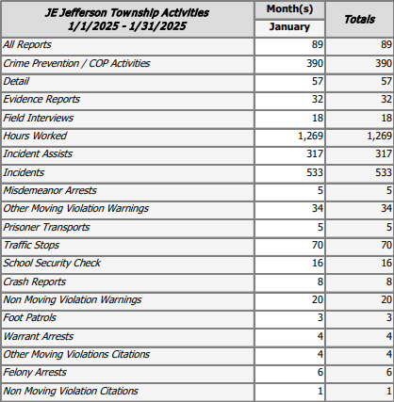

Prepared By:
Captain Walt Steele #88
Montgomery County Sheriff’s Office
District 7 Road Patrol Headquarters/Jefferson Township Substation
555 Infirmary Road Dayton, OH 45417
937-496-6887
Steelew@mcohiosheriff.org

