Crime Statistics
Overall crime decreased by 23% (-19) compared to February of 2024. Part 1 violent crime was the same 0% (0) while Part 1 property crimes decreased by 17% (-4). Part 2 violent crime increased by 5% (+1). Part 2 property crime decreased by 60% (-6). Areas along Third Street and US 35 saw the most activity during this period followed by areas along State Route 4.

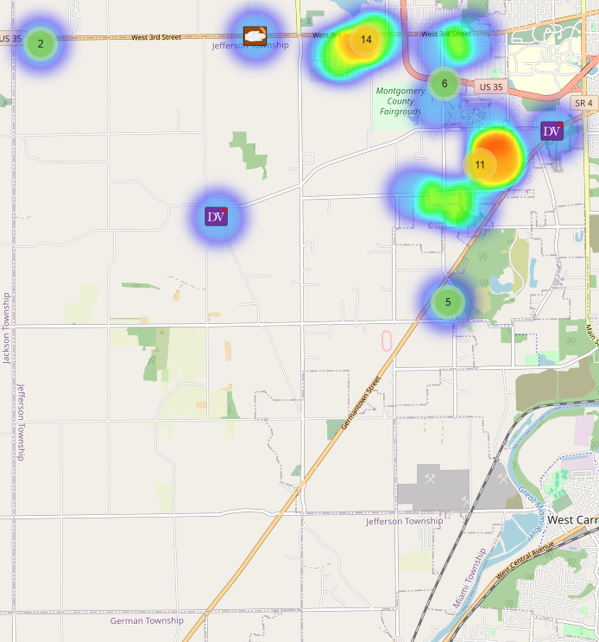
Community Concerns
There were no new community concerns for the month of February.

Incident Narrative
On February 7, 2025 Deputies responded to the Fairgrounds reference to a male attempting to steal property. The male was located and the stolen property was recovered. Suspected drugs were found on the male and he was taken to jail without incident.

On February 26, 2025 Deputies were dispatched to the 4000 block of Tenshaw Dr. reference to a felonious assault call. Upon arrival, they learned 2 subjects were arguing outside of the residence. At some point one of the males had a sword and the other male fired a shot in the air outside. The shooter fled the scene but was later located. The incident is being reviewed by the Prosecutors Office.

On February 28, 2025, Deputies responded to the 100 block of Maeder Ave. reference to an overdose call. They found a male unresponsive reference to possibly taking fentanyl. Deputies and medics quick response working together administered Narcan and revived the male that was taken to the hospital for further evaluation.

Traffic Services/Jefferson Township
During the month of February deputies from Jefferson Township investigated five traffic crashes. This reflects a decrease of five crash investigations (-50.00%%) when compared to February 2024. Of these crashes, there were one property damage crash, three minor injury crashes and one serious injury crash. There were six people with minor injuries and one person who sustained serious injuries. There was one crash investigated as hit and run, none of the crashes involved a pedestrian, and none of the crashes involved an impaired driver.

Sundays was the busiest day of the month accounting for two crashes. Failure to yield the right of way was the most common causative factor accounting for three crashes. State Route 4 was the most prevalent roadway, accounting for three crashes. The other crashes occurred at various locations within Jefferson Township.

There was one hit-and-run crash reported during the month of February. The crash involved serious injuries and is being investigated by the Traffic Services Unit.

TRAFFIC ENFORCEMENT
 | JEFFERSON TOWNSHIP | MONTGOMERY COUNTY
Traffic stops conducted | 72 | 7
Traffic related warnings | 57 | 6
Driving under suspension | 2 | 0
Speed | 1 | 0
Adult seat belt violations | 0 | 0
Juvenile seat belt violations | 0 | 0
Other moving violations | 7 | 0
Non-Moving violations | 2 | 0
OVI (over 21) | 1 | 0
OVI (under 21) | 0 | 0
Commercial overweight violations | 0 | 0
TOTAL CITATIONS ISSUED | 13 | 0

Environmental Crimes

During February, Deputy Amlin working the MCSWD contract worked in the areas of Trotwood, Dayton, Moraine, and Jefferson Township. Deputy Amlin’s crew only worked a total of 93.41 hours and collected a total of 237 bags due to weather and illness.

During February, Deputy Jones, working the ODOT contract worked the areas of Miami Township, Miamisburg, and Butler Township. Deputy Jones crew only worked a total of 96.5 hours and collected a total of 167 bags due to weather.

During February, Deputy Jackson had one new case in Harrison Township, no new cases in Jefferson Township, no new cases in Washington Township, four new cases in Dayton, and one new case in Moraine.

During February, Deputy Jackson had 31 new dispatches, 3 new Assists, one new Large-Scale Clean-Up, and 7 Follow-ups.

Monthly Stats

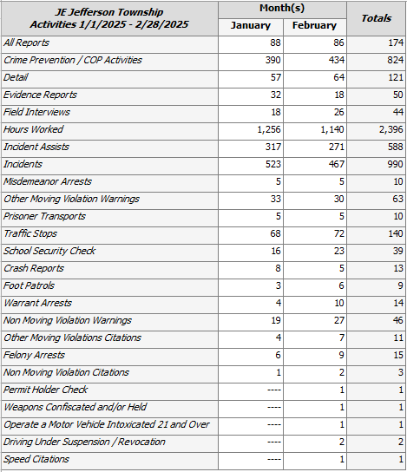

Prepared By:
Captain Walt Steele #88
Montgomery County Sheriff’s Office
District 7 Road Patrol Headquarters/Jefferson Township Substation
555 Infirmary Road Dayton, OH 45417
937-496-6887
Steelew@mcohiosheriff.org

