Crime Statistics
Overall crime increased by 9% (+31) compared to December 2023. Part 1 violent crime increased by 23% (+7) while Part 1 property crimes saw no increase. Part 2 violent crime increased by 23% (+21). Part 2 property crime increased by 42% (+21). Areas along Third Street and US 35 saw the most activity during this period followed by areas along State Route 4.
Areas with the most activity are depicted in the below map:
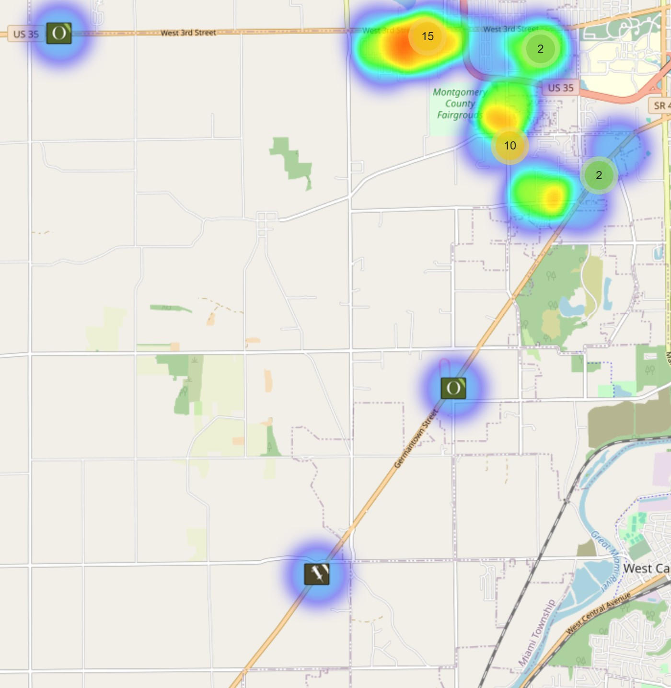

Community Concerns
There was a concern of individuals living on a property on Maeder Avenue. People living in a camper, tents, and an abandoned house.

Incident Narrative
On December, 9, 2023 First Watch Jefferson Township crews responded to a strong arm- robbery in the 5100 block of Retford Avenue. Special Investigations handled the investigation and the victim ultimately declined to pursue charges.

Traffic Services/Jefferson Township
During the month of December deputies from Jefferson Township investigated nine traffic crashes. This reflects a decrease in crash investigations of (50.00%) when compared to December 2022. Of these crashes, there were six property damage crashes, two minor injury crashes and one serious injury crash. There were five people who claimed minor injuries and one person claimed serious injuries. There were two crashes investigated as hit and run crashes, none of the crashes involved a pedestrian, and neither of the crashes involved an impaired driver.

Thursdays and Saturdays were the busiest days of the month, accounting for three crashes each. Failure to obey traffic control device, Speed, and Improper Lane usage were the most common causative factors accounting for two crashes each. State Route 4 and US 35 were the most prevalent roadways accounting for two crashes each. The other crashes occurred at various locations within Jefferson Township.

There were two hit and run crashes reported during the month of December.

Traffic Enforcement

 | JEFFERSON TOWNSHIP | MONTGOMERY COUNTY
Traffic stops conducted | 79 | 25
Traffic related warnings | 57 | 18
Driving under suspension | 1 | 3
Speed | 2 | 2
Adult seat belt violations | 0 | 2
Juvenile seat belt violations | 0 | 0
Other moving violations | 7 | 1
Non-Moving violations | 5 | 8
OVI (over 21) | 0 | 0
OVI (under 21) | 0 | 0
Commercial overweight violations | 0 | 0
TOTAL CITATIONS ISSUED | 15 | 18
 | JEFFERSON TOWNSHIP | MONTGOMERY COUNTY
Traffic stops conducted | 79 | 25

Environmental Crimes
During December, Deputy Amlin working the MCSWD contract worked the areas of Moraine, Harrison Township, Butler Township, Jefferson Township, Vandalia, German Township, and Trotwood. Deputy Amlin’s crew worked a total of 198.75 hours and collected a total of 438 bags.

Prepared By:
Captain A. Flagg #77
Montgomery County Sheriff’s Office
District 7 Road Patrol Headquarters/Jefferson Township Substation
555 Infirmary Road Dayton, OH 45417
937-496-6887
Flagga@mcohiosheriff.org

