Crime Statistics
Overall crime increased by 18% (+53) compared to August of 2025. Part 1 violent crime decreased by 7% (-2) while Part 1 property crimes stayed the same. Part 2 violent crime increased by 35% (+27). Part 2 property crime decreased by 28% (-9). Areas along W. Third Street saw the most activity during this period.

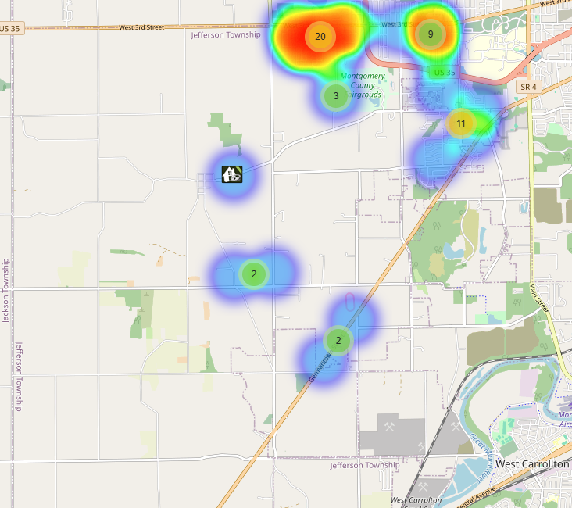
Community Concerns
No new Community concerns for August 2025.

Case report/Jefferson Twp

88 reports were generated in Jefferson Twp. 40 of those reports needed additional follow-up by Detective Phelps.

Incident Narrative
On August 10th, 2025 (Sun) at approximately 1657 hours, Deputies were dispatched to 6122 W. Third St. (Drexel Food Town) reference to a strong-armed robbery. Deputies were able to locate and arrest the suspect who initially provided fictitious information.

On August 14th, 2025 (Thu) at approximately 1930 hours, Deputies were dispatched to the first block of Hanover Ave. reference to a double stabbing. Investigation revealed 2 brothers got into a domestic dispute and stabbed each other. Both were transported to the hospital. One brother was found to be the primary aggressor and was later charged with felonious assault and domestic violence.

On August 20th, 2025 (Wed) at approximately 1830 hours, Deputies were dispatched to the 6000 block of W. Third St. reference to a suspicious fire. Deputies assisted with the State Fire Investigators and Jefferson Twp. Fire Department where the building was found to be vacant.

On August 26th, 2025 (Tue) at approximately 1130 hours, Deputies were dispatched to the 300 block of Lawncrest reference to vicious dogs. Upon arrival it was learned that several Cane Corso’s attacked 2 neighbors in the area that sustained serious injuries, where one of the dogs had been shot. ARC immediately responded and with the assistance of Deputies a search warrant was completed to obtain the dogs and collect evidence of the scene. The owner of the dog was cited with further follow-up to be conducted by ARC and our Detective Phelps. Jefferson Twp Zoning was also contacted and has done a great job assisting in the incident.

Forensic Services

During the Month of August, the Forensic Services Unit handled 45 calls in Jefferson Township.

Traffic Services/Jefferson Township
During the month of August, deputies from Jefferson Township investigated 10 traffic crashes. This reflects a decrease of three crash investigations (-23.08%) when compared to August 2024. Of these crashes, there were seven property damage crashes, two minor injury crashes, and one serious injury crash. There were four people claiming minor injuries, and one person sustained serious injuries. There was one crash investigated as a hit and run, none of the crashes involved a pedestrian, and none of the crashes involved an impaired driver. Thursdays were the busiest day of the month, accounting for three crashes. Failure to yield the right of way and failure to maintain reasonable control were the most common causative factors accounting for three crashes each. State Route 4 was the most prevalent roadway accounting for four crashes. The other crashes occurred at various locations within Jefferson Township. There was one hit and run crash reported during the month of August. The crash remains under investigation.

TRAFFIC ENFORCEMENT
 | JEFFERSON TOWNSHIP | MONTGOMERY COUNTY
Traffic stops conducted | 105 | 30
Traffic related warnings | 79 | 24
Driving under suspension | 1 | 0
Speed | 0 | 0
Adult seat belt violations | 0 | 0
Juvenile seat belt violations | 0 | 0
Other moving violations | 15 | 5
Non-Moving violations | 14 | 3
OVI (over 21) | 1 | 0
OVI (under 21) | 0 | 0
Commercial overweight violations | 0 | 0
TOTAL CITATIONS ISSUED | 31 | 8

K-9 deployments
10 deployments with reports.

Environmental Crimes
During August, Deputy Amlin, working the MCSWD contract, worked in the areas of New Lebanon, Dayton, Moraine, Harrison Township, Trotwood, Vandalia, and Jefferson Township. Deputy Amlin’s crew worked a total of 319.22 hours and collected a total of 561 bags.

During August, Deputy Jackson had no new cases in Jefferson Township.

During August, Deputy Jackson had 33 new dispatches, 4 new Assists, two new Large-Scale clean-ups, and 16 Follow-ups. Tire shop inspections have picked up due to Tire Buy Back in September.

Monthly Stats

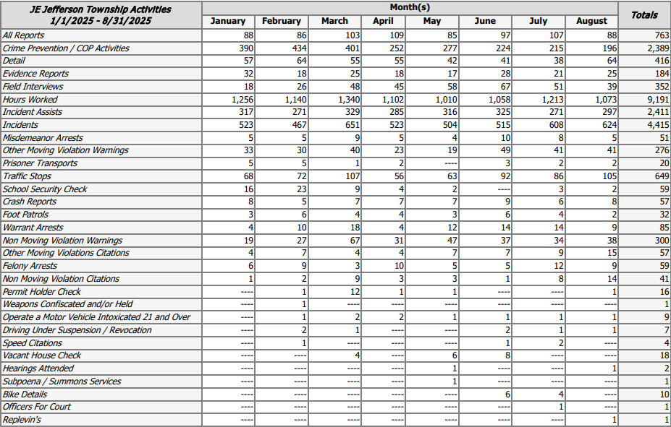

Prepared By:
Captain Walt Steele #88
Montgomery County Sheriff’s Office
District 7 Road Patrol Headquarters/Jefferson Township Substation
555 Infirmary Road Dayton, OH 45417
937-496-6887
Steelew@mcohiosheriff.org

