Crime Statistics
Overall crime is down by 21% (-39) compared to April of 2024. Part 1 violent crime decreased by 30% (-3). Part 1 property crimes increased by 2% (+1). Part 2 violent crime also increased by 20% (+6). Part 2 property crime decreased by 50% (-10). Areas along Third Street, US 35 and the neighboring plat areas saw the most activity during this period.

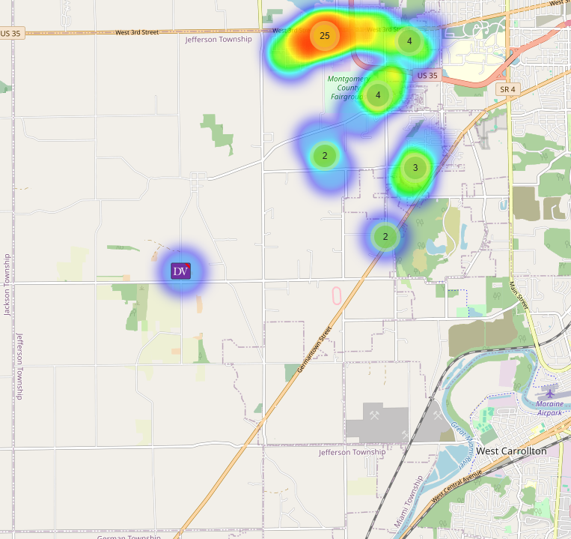
Community Concerns
There was 1 Community concern for April:

Large Trucks driving on Frytown Rd. and the Colgate plat areas. I requested that Deputy’s do extra checks in the area.

Case report/Jefferson Twp

109 reports Generated. 27 of those reports needed additional follow-up by Detective Phelps.

Incident Narrative
On April 20, 2025, Deputy Flora was dispatched to the 7000 block of Bronson on the report of a 5-yr old child falling from a 2nd story window. The child was bleeding from the nose and face and transported to Children's Hospital. It was alleged that a non- verbal 6 yr pushed the 5-yr old out of the window. CSB contacted and Det. Phelps is following up.

On April 21, 2025, at approximately 2139 hours, Deputies received information that a suspect fired shots at another victim on S. Lansdowne. A house was hit but no one was injured during the incident. Both subjects were gone upon Deputies’ arrival.

On April 29, 2025, at approximately 2211 hours, Deputies were dispatched to the 7400 block of Bronson Street reference to a “shots fired” call. They located the suspect that fled the area on foot when confronted by Deputies and was apprehended in a nearby parking lot.

A male victim was also located in the area with what is believed to possibly be a bullet graze wound to his head. The victim was uncooperative in the investigation and refused medical treatment for his minor injuries at the scene. A K-9 was requested to search the area for a weapon. A live round was located in the area. The suspect was taken to jail reference to obstructing official business at this time.

Traffic Services/Jefferson Township
During the month of April deputies from Jefferson Township investigated six traffic crashes. This reflects no change in crash investigations (0.00%%) when compared to April 2024. Of these crashes, there were five property damage crashes, and one minor injury crash. There were three people with minor injuries. There were no crashes investigated as hit and run, none of the crashes involved a pedestrian, and two of the crashes involved an impaired driver.

Saturday was the busiest day of the month, accounting for two crashes. Assured clear distance ahead to stop was the most common causative factor accounting for two crashes. U. S. Route 35 was the most prevalent roadway, accounting for two crashes. The other crashes occurred at various locations within Jefferson Township.
There were no hit-and-run crashes reported during the month of April.

Montgomery County

During the month of April, deputies investigated two traffic crashes in Montgomery County outside the contracted townships. This reflects an increase of two crash investigations (200.00%) when compared to April 2024. Of these crashes, there were two property damage crashes. There were no crashes investigated as hit and runs, none of the crashes involved a pedestrian, and none of the crashes involved an impaired driver. There was not a busiest day of the month as one crash occurred on a Monday, and the other occurred on a Wednesday. Failure to yield the right of way was the most common causative factor accounting for both crashes. One crash occurred on Amity Road in Perry Township, and the other crash occurred on State Route 49 in the Village of Phillipsburg. There were no hit and run crashes reported during the Month of April.

TRAFFIC ENFORCEMENT
 | JEFFERSON TOWNSHIP | MONTGOMERY COUNTY
Traffic stops conducted | 56 | 102
Traffic related warnings | 54 | 59
Driving under suspension | 0 | 4
Speed | 0 | 20
Adult seat belt violations | 0 | 4
Juvenile seat belt violations | 0 | 0
Other moving violations | 4 | 5
Non-Moving violations | 3 | 10
OVI (over 21) | 1 | 0
OVI (under 21) | 0 | 0
Commercial overweight violations | 0 | 0
TOTAL CITATIONS ISSUED | 8 | 43

K-9 deployments
19 deployments with reports.

Environmental Crimes
During April, Deputy Amlin, working for the MCSWD contract, worked in the areas of Trotwood, Dayton, Moraine, Harrison Township, Miamisburg, Vandalia, and Jefferson Township. Deputy Amlin’s crew worked a total of 309.97 hours and collected a total of 601 bags.

During April, Deputy Kidwell, working the ODOT contract, worked the areas of Miami Township, Harrison Township, Jefferson Township, Clay Township, Washington Township, and German Township. Deputy Kidwell’s crew worked a total of 269.5 hours and collected a total of 317 bags.

During April, Deputy Jackson had three new cases in Harrison Township, one new case in Jefferson Township, no new cases in Washington Township, three new cases in Dayton, and one new case in Moraine.

During April, Deputy Jackson had 31 new dispatches, 4 new Assists, two new Large-Scale clean-ups, and 20 Follow-ups.

Monthly Stats

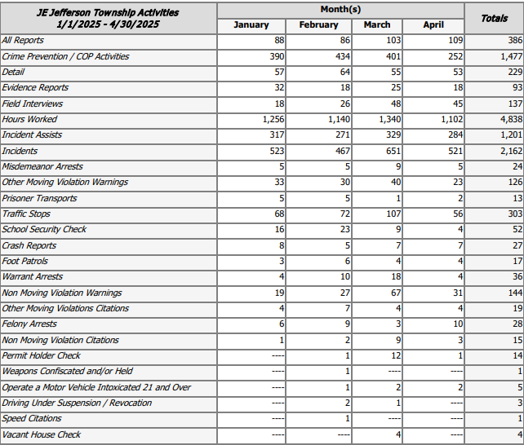

Prepared By:
Captain Walt Steele #88
Montgomery County Sheriff’s Office
District 7 Road Patrol Headquarters/Jefferson Township Substation
555 Infirmary Road Dayton, OH 45417
937-496-6887
Steelew@mcohiosheriff.org

