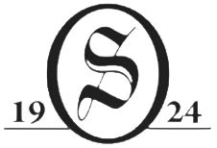
2026 Reserve Cup Results
Overall Champions
Betlem, J. / Cahoon, J. (63) $100 each
Men’s Division
T-1st Darrow / Swan 65 $70 each
T-1st Mitchell / Mitchell 65 $70 each
T-3rd Vandemortel / Motkowski 66 $50 each
T-3rd Scarcelli / Fagner 66 $50 each
T-3rd DeBiase / Ashnault 66 $50 each
Mixed Division
1st Hamm / Shadduck 67 $45 each
T-2nd Deichmiller / Deichmiller 68 $30 each
T-2nd Ortiz / Pragel 68 $30 each
Women’s Division
1st Burlee, P. / Johnson, M. 65 $35 each
2nd Cuvelier, A. / Cuvelier, N. 66 $20 each

CTP #7 Barry Deane 3’2’’ CTP #15 Danielle Steadman 9’5’’
LD #1 Amy Mason LD #13 Spencer Johnson

Shootout Payouts:
1st – Hamm / Shadduck $300
2nd – DeBiase / Ashnault $220
3rd – Betlem, J. / Cahoon, J. $140
4th – Burlee, P. / Johnson, M. $80

