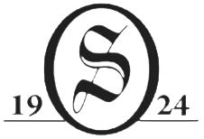
2026 Naylor Cup
Tournament Results

1st Place Kathy Cantaben & Elaine Tarana 130 $60.00 ea.

2nd Place Susan Fulton & Sharon Lilla 135 $30.00 ea.

