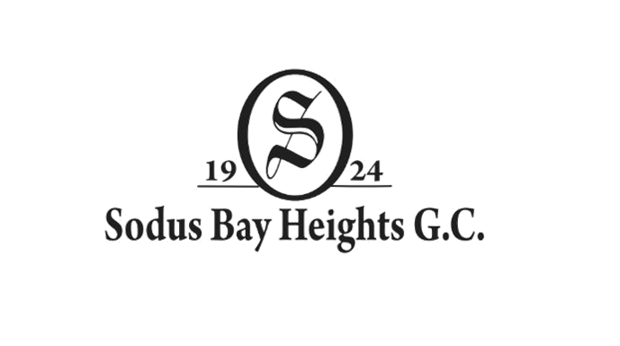
2026 Men’s Guest Day Results
2 of 4 Best Ball

1st Place – Betlem / Nikolevski / Dalton / Mooney 124 $60 ea.
T-2nd Place – Eskander / Pavone / Livecchi / Pavone 127 $45 ea.
T-2nd Place – Little / Ennis / Mayberry / Lambert 127 $45 ea.
4th Place – Cuvelier, M. / Kelly / Cahoon, C. / Miers 131 $30 ea.
T-5th Place – Coyle / Waldron / Deane / Jezsu 132 $10 ea.
T-5th Place – Carlin / Corsi / Petrus / Rowe 132 $10 ea.

CTP:
#3 (Members) - Livecchi 10’
#3 (Guests) – Clancy 5’4’’
#15 (Members) – Lair 5’1’’
#15 (Guests) – Kulzer 17’1’’

