ADDING ADDITIONAL BROKERS TO A PURCHASE AGREEMENT
- SF Purchase Agreement provides for 2 Brokerages representing the Seller (or Buyer) in Para 1 using the CAR Additional Broker Acknowledgement (CAR ABA)

- CAR RPA provides for 2 Brokerages representing the Seller ( or the Buyer) in para 2. C. by attaching the Additional Broker Acknowledgement (CAR form ABA)
- The CAR RPA further confirms on page 16 in the REAL ESTATE BROKERS SECTION:
CAUTION

- The PRDS contract is silent on 2 Brokerages representing either the Seller or the Buyer. The CAR ABA should be added in para 6 as an ADDITIONAL CONTRACT DOCUMENT. This this ties the Acjknowledgemetn to the contract.
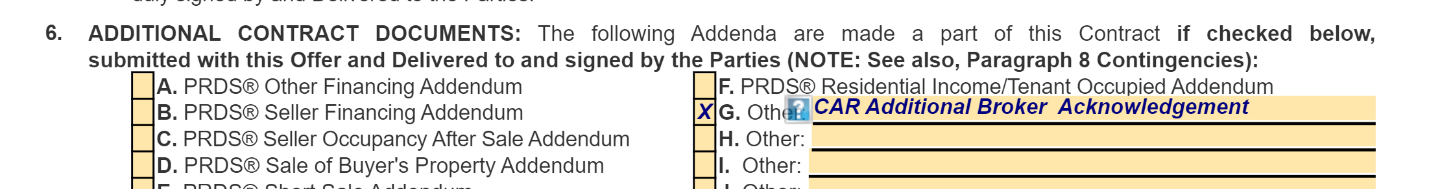
CAUTION: Adding Additional Agents to a purchase contract can cause confusion and the potential for documents to be sent to the wrong email/ agent.If needed, after contract is ratified. Use AAA form on Listing Agreement to add team members and or other agents. Have commission sharing agreement in writing.

