Online Age Managers Course
The SLSA Age Managers course has been developed to assist you with your role as an Age Manager. It will allow you to develop a greater knowledge about how SLS operates and provide you with the skills and knowledge to assist you in the successful coordination and delivery of the Nippers program.
Please note: Life Saving Victoria have developed the Nipper Education Resource in replacement of the Junior Development Resource (JDR) which is referenced in Topic 6 of this course. Click here to access Life Saving Victoria’s Nipper Education Resource.

Course outcomes
By the end of the course and successful completion of the practical requirements, you will be able to: • understand the roles and responsibilities of the Age Manager, and Age Manager Mentor
• develop strategies to work with children, parents and guardians, coaches, officials and club administrators
• manage risks in the beach environment
• cater for the physical, emotional and social development of Nippers in your care
• safely deliver lesson plans
• emphasise fun and participation through educational games and engaging activities
• utilise a range of communication, teaching and behaviour management strategies to help Nippers learn basic skills.

SLSA award entry requirements
To become a qualified SLS age manager, you must:
- be a minimum of 18 years old (Vic Requirement)
- have completed the relevant state/territory legislation check(s) for working with children
- be a financial member of a club.
- Members to have Working with Children Check details recorded in SurfGuard Profile
- Complete the online Child Safe Awareness course, Via LSV Member Training Portal
- Complete an Age Manager Course Via LSV Member Training Portal
- Watch the Age Manager Proficiency video on the Via LSV Member Training Portal
- Once the above three components are complete you will be automatically awarded a 12-month accreditation
- Undertake 2 on-beach mentoring and technical sessions.

Please contact the Membership and Leadership Development Department on 03 9676 6945 or membershipandleaderhsip@lsv.com.au if you need any assistance.

Online course access
To access the online option for this course, simply follow the steps below:
1. To start the course, you will need to log into the LSV Member Training Portal

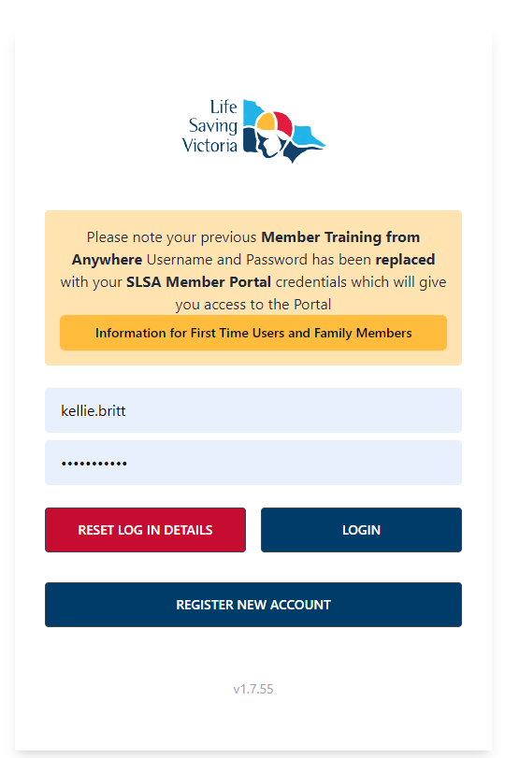

2. Once logged in, click on Leadership & Development
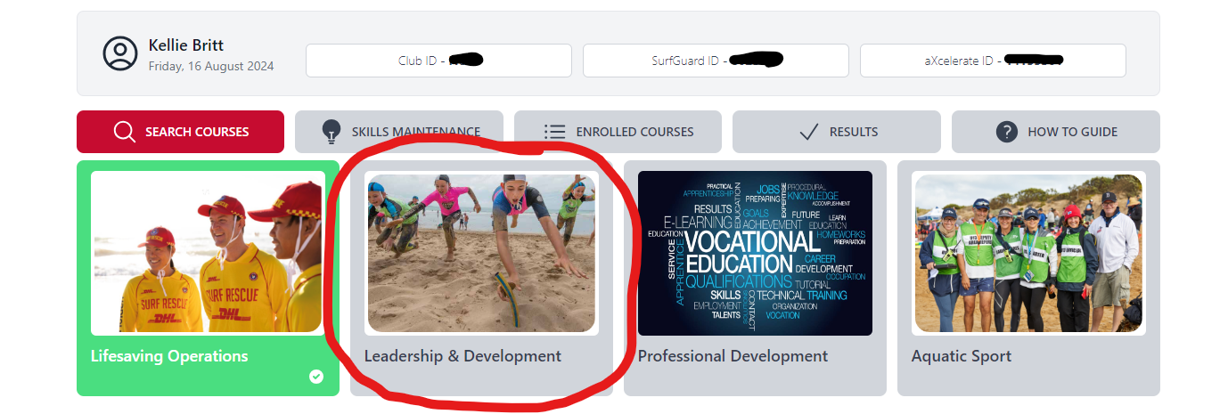
3. This will open all the available courses – Child Safe Awareness Course & SLSA Age Manager Course Video
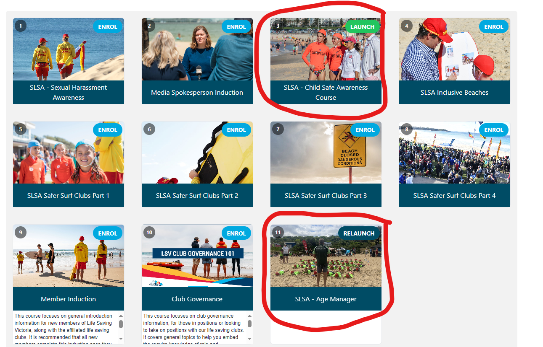

11. All Age Managers must watch the NEW Age Manager Proficiency video which can also be found in the Age Manager online Course section of the LSV member training portal, you will not receive proficiency unless this is also completed.
