2024-2025
ANNUAL
REPORT

EXPLORE
THE
POSSIBLITIES

Celebrating
57 years of
quality service

660 Sixth St. (530)-662-8616
Woodland, CA 95695 FAX (530) 662-8959
Website: www.yoloes.org

Celebrating Achievement
Celebrating 57 years of quality services

A message from Yolo Employment Services Executive Director, Beth Conn-Ossenfort.
We thanked Alice Tapley at a retirement party last December for her 39 years of service at Yolo Employment Services, Inc. Her leadership has guided the company through many storms and has provided even more accomplishments. We are happy to have her as a consultant during this transition in leadership. We will continue the strong programming developed by Alice and the staff, the positive history of the program and our Board Members remain strong in their support of Yolo Employment Services. Yolo Employment Services once again could not be prouder of the accomplishments made by individuals with intellectual, developmental, mental, and other disabilities and the staff that has made all of this possible.

Some of the highlights are listed below:
*We continue to be an E-Waste drop off center and will pick up on a limited basis.
*We are providing integrated paid internships to more clients
*We continue to support individuals in a variety of employment settings based on their needs.
*We continue to work with Ability One and State of California to provide federal and state job
opportunities for individuals.
*We continue to support individuals in a variety of employment settings based on their needs.
*We adjusted the ratio from 1:8 to 1:6 for our ATP program this year.
*Our Fee for Service rates went up which helped to offset the recent Minimum Wage increase.
*We added another SE group at the Dunnigan rest stop in collaboration with PRIDE Industries.

Celebrating 57 years of quality services
2024-2025 ANNUAL REPORT

We offer a variety of programs that individuals can participate in to maximize their potential.

ADULT TRAINING PROGRAM (ATP)
The Adult Training Program is a site based, personal goal-oriented program of developmental and therapeutic services designed to develop, maintain and or increase an individual's independent functioning in self-care, physical and emotional growth, socialization, communication, education, prevocational skills, and community integration. We transitioned from 1:8 to 1:6 ratio in this program as of January 2025.
SUPPORTED EMPLOYMENT/WORK CREWS
Supported Employment (Work Groups) provides paid work experiences and introduces, develops, and improves work skills and behaviors. The goal of this program is to prepare clients for their own jobs in the community. With supervision, clients are evaluated on their work skills and behaviors, physical endurance, and desire to participate in work training. To work in this program client must be able to work 5 days a week. This program can be either short or long-term depending on the progress, needs and interest of clients. We added one crew to this program in 2025.
COMMUNITY/INDIVIDUAL PLACEMENT
The Community Employment Services program opens the door of opportunity for individuals with disabilities by discovering strengths and career goals, linking them to a job that will help them gain greater financial independence. We also provide job developing and coaching in which we help the individual secure and maintain a job. The program also provides External Situational Assessment which is a way for individuals with disabilities to discover their skills and abilities through real work opportunities. We also provide PVSA (Personal Vocational Social Adjustment).
YES! TO EMPLOYMENT
The goal is to offer a community-based program for clients to increase their potential for community-integrated employment through developing resumes, accessing the local One Stop, mobility training, job exploration, volunteer opportunities and paid internships. The goal of this program is placing clients in jobs of their choice. The program is a full-time program option.
Celebrating 57 years of quality services

2024-2025 ANNUAL REPORT

ADULT TRAINING PROGRAM
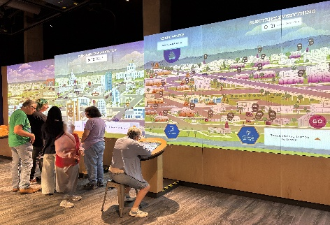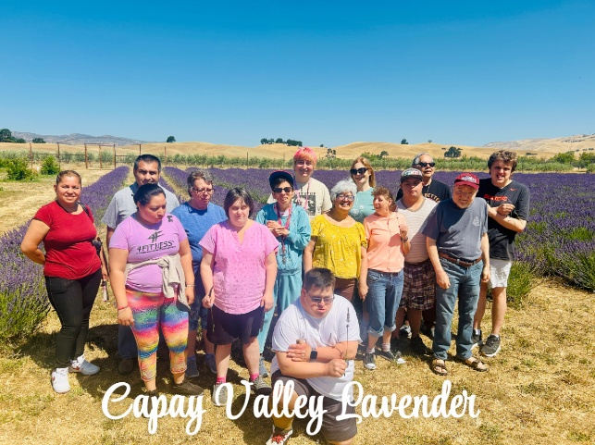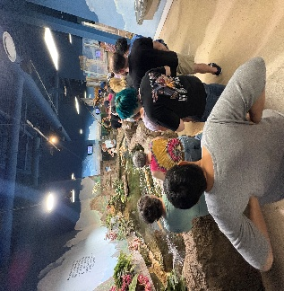
MoSAC Museum Capay Valley Lavender Reptile Museum
ATP clients keeping busy this year. They had community trips and volunteer jobs.
FISCAL YEAR 24-25
OUTCOMES
*We have provided services for 31 clients this past year.
*Did community outings to the Sacramento Zoo, Capay Valley Lavender, NorCal Aquarium & Wildlife, MOSAC Science Museum, Gorman Museum of Native American Art, UCD, Cache Creek Preserve, Yolo County Fair, Pumpkin Patch, Full Belly Farms and many more throughout the year
*Volunteered at Yolo County Food Bank, The Grove, (Formally known as Alderson Convalescent Hospital),Meals on Wheels and the Woodland Food Closet.

Celebrating 57 years of quality services

2024-2025 ANNUAL REPORT
SUPPORTED EMPLOYMENT
The Supported Employment Program continues to work at Walgreens Distribution Center where we began our 24th year. Clients are doing various jobs at the warehouse and continue to provide valuable service. We continue to operate our recycling center and collect e-Waste. In January 2025, we re-established ourselves as the sole contractor for another three-year term with Caltrans where a YES! Crew maintains the restrooms and grounds at Elkhorn Rest Area. In the Spring of 2025, we added new business as a sub0contractor for PRIDE Industries in their Caltrans contract for Dunnigan Rest Area. This janitorial and grounds maintenance agreement resulted in the formation of an entirely new YES! Crew.
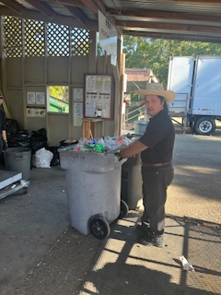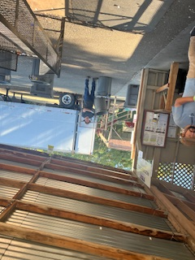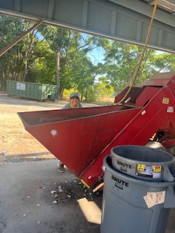
Clients working at our recycling site.
FISCAL YEAR 24-25
OUTCOMES
*Supported 16 clients in supported employment work groups
*Provided over 16,309 hours of labor to local businesses for the year
*Paid $268,089 in client wages

Celebrating 57 years of quality services

2024-2025 ANNUAL REPORT
COMMUNITY/INDIVIDUAL PLACEMENT
We supported sixteen clients in their community-based jobs. These individuals are provided long term support through funding from Alta Regional Center. Over the past year, we provided job development services for twenty-eight, which led to fouteen successful employment opportunities. Of the twenty-two individuals we provided job development services for; twelve received their own jobs in the community. We had thirteen External Situation Assessments this year.
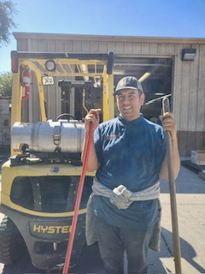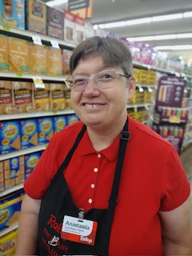
Clients working at Raleys and Grow West
Dreams do come true
FISCAL YEAR 24-24
OUTCOMES
*Placed 16 individuals in community base jobs to help them achieve their employment and
financial goal
*Supported 28 individuals in job development
*Supported 24 individuals with job coaching
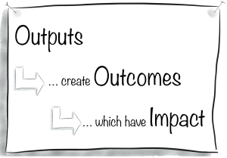
*Supported 10 individuals for ESA (External Situation Assessment)

Celebrating 57 years of quality services

2024-2025 ANNUAL REPORT

YES! TO EMPLOYMENT
YES! To Employment program provided services for 19 individuals during the past fiscal year. They continued to assist clients with developing work skills, developing their resumes, how to do a successful interview, etc. We continue to offer integrated paid internships to clients in this program and have now embarked on assisting clients set up their own business through Microenterprises.

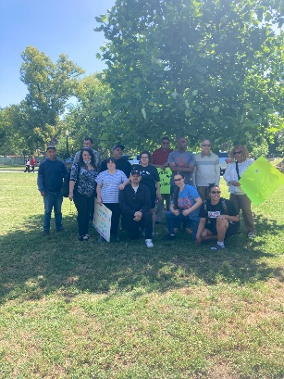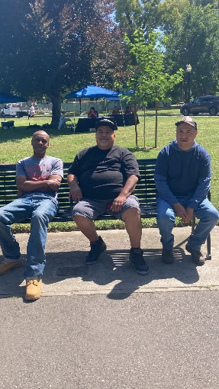
The clients spending a day at the State Capital advocating for their rights.
FISCAL YEAR 24-25
OUTCOMES
*Supported 19 individuals in the program this year
*Placed 4 clients in community-based jobs to help them achieve their employment goal
*Provided 18community based paid internships
Celebrating 57 years of quality services

2024-2025 ANNUAL REPORT

Client Outcomes
Due to lower referrals, we served fewer individuals for ESA and PVSA assessments. We are looking forward to these numbers increasing in the coming year. The number of clients we served in the majority of our programs remained steady. Below is a chart of individuals served in the various programs.

Program Clients Served/2024-2025
Adult Training Program 31
YES To Employment 19
Supported Employment Work Groups 16
Job Coaching 18
External Situation Assessments/PVSA 3
Job Development 36
Placements 15
Totals 138
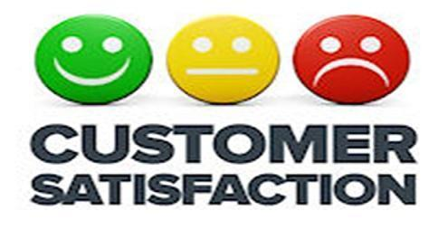

CUSTOMER SATIFICATION
We continue to get feedback from our stakeholders. We use this information to improve service

Celebrating 57 years of quality services

2024-2025 ANNUAL REPORT____________________________



Charitable Contributions:
Changing lives is a way of life here at YES!. Things happen here at YES! with the help of our community supporters and friends in the community.
Annual Giving:
These donations can be made at any time of the year for any occasion. Charitable gifts can be made in monetary donations, gifts of stock, or other ways of giving

Bequests:
This gift will allow you to fulfill your charitable wishes. Allow your money to shine through generations of hope.

Nugget/Food 4 Less Scripps:
Shopping at your favorite store can help YES. Sign up for the Scripps program and designate Yolo Employment Services to receive a percentage of what you purchase.

e-Waste Recycling:
YES! is a California State Certified Collector of e-Waste. We accept all TVs, computer monitors, laptops, and computer towers and printers. Our e-Waste Drop-Off is at YES! Recycling Center, 660 6th Street in Woodland. You can also call the office at 530-662-8616 for more information.

Celebrating 57 years of quality services

2024-2025 ANNUAL REPORT
Our Board of Directors has been a key component in this achievement. Their unwavering support, valued input and steadfast vision continue to strengthen and energize our agency. The staunch backing of Friends of the Workshop, Kiwanis, individuals and businesses throughout Yolo County coupled with strategic partnerships with other organizations has made Yolo Employment Services the success it is today.
Where do we go from here? We want to do MORE!
* Offer MORE services
*Reach out to MORE people
*Inspire MORE smiles
*Celebrate MORE successes

We look forward to you joining us on this exciting adventure!
LEADERSHIP
Jorge Ayala Yolo County Superintendent of Schools (Retired)
Steve Barzo Military, UCD (Retired)
Sarah Gould Teacher (Retired)
Steve Harris Cross Court Gym/Fitness (Retired)
Richard Harrison-Treasurer Electrician/Business Owner (Retired)
Tom Loewen Probation Officer (Retired)
Steve Price- President Senior Insurance Investigator
Dan Richards Woodland Library/Consumer
Pete Rominger Farmer (Retired)
Bob Schoech Engineer (Retired)
Roz Stone-Secretary Nurse (Retired)
Beth Conn-Ossenfort Executive Director

660 Sixth St. (530) 662-8616
Woodland, CA FAX (530) 662-8959
Website: www.yoloes.org
