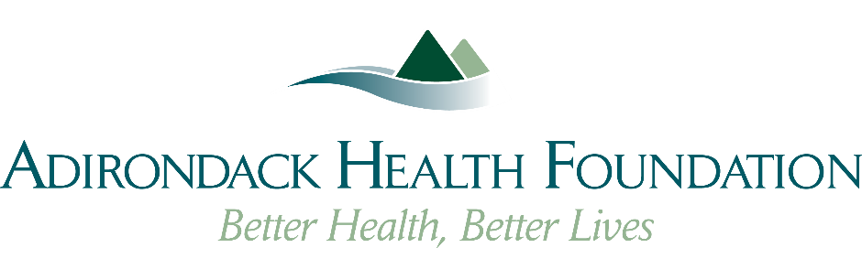
2026 Mini-Grant Process Timeline
Pre-Application Training
📅 December 2025
Educational sessions to review application guidelines, eligibility, and evaluation criteria.
Application Launch
📅 January 5, 2026
The 2026 Mini-Grant application will be made available online.
Application Deadline
📅 February 13, 2026
All applications and required documentation must be submitted by 5:00 PM.
Mini-Grant Advisor Review Meeting (February 23rd @ 2:00 PM)
📅 Week of February 23, 2026
A cross-functional Advisor Review Committee will be established to evaluate all mini-grant submissions prior to presentations. This committee will include representatives from the Executive Group, Supply Chain, Biomed, and IT, along with other key stakeholders as needed. Their role is to ensure proposals are complete, cost-justified, and aligned with institutional priorities—streamlining the review process and supporting strategic decision-making.
Shark Tank Presentations (March 16 from 8 am – 2:30 pm)
📅 Week of March 15, 2026
Finalists will present their proposals in a dynamic pitch-style format to the review panel.
Mini-Grant Awards Reception (March 25 @ 8 am – 10 am)
📅 Week of March 23, 2026
All applicants will be invited to celebrate the announcement of 2026 mini-grant recipients.

