St. Leonard Christian Formation Handbook
W173 S7777 Westwood Drive
Muskego, WI 53150
262-679-0880

2025 to 2026

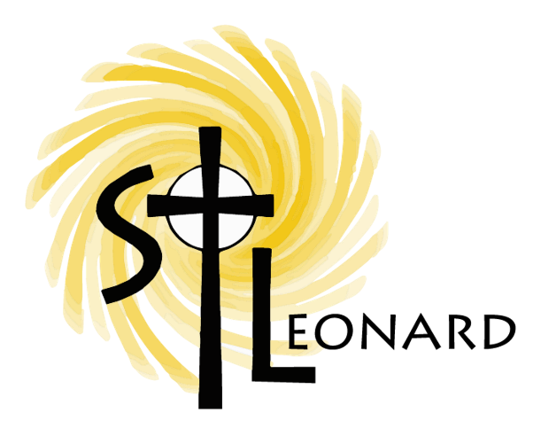

OUR MISSION
Growing as Catholics in the image of Jesus Christ through Worship,
Formation and Community.

Table of Contents

Staff Contact Information | 2
Inclement Weather Policy | 2
Sunday Mass / Mass Reflections | 3
General Information | 4 – 8
Calendar of Classes | 9
Elementary (Gr. 1 - 6) | 10 – 11
Youth Ministry (Gr. 7 - 9) | 12
Confirmation (Gr. 10 & 11) | 13
Completion of Requirements / Athletic Eligibility | 14
Holy Hour | 15
Home Study | 16
Service Hours | 17
Enrichment Events | 18
Jr. Leo’s (K3 / K4 / K5) | 19
Little Leos Nursery Program | 19
Related Groups / Fund Raisers | 20
Sacramental Life | 21 – 23
Vine and Branches Special Needs Program | 24

Contacts

Director of Child Ministry: Lisa Jachimiec

Nursery through Grade 6: lisa.jachimiec@stleonards.org

Director of Youth Ministry: Bethanne Maus-Schaefer
Grades 7 – 11: bethanne.maus-schaefer@stleonards.org

Administrative Assistant: Suzanne Kasper
suzanne.kasper@stleonards.org

Vine & Branches-Christian Formation for Student with Disabilities
Ages 6 through age 22: bridget.klawitter@stleonards.org
Cay Landowski, Coordinator
Bridget Klawitter, Staff Liaison
262-679-1773 ext. 13

Mass Reflections and Service Hour Forms:
STLCFO@stleonards.org

Phone: 262-679-0880
Website: www.stleonards.org (click on Christian Formation tab)

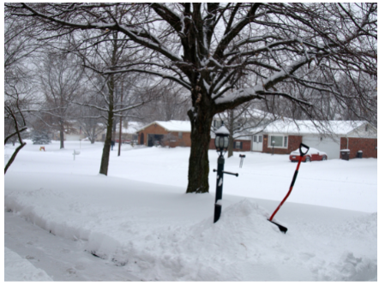

Inclement Weather Policy

If there are weather conditions (snow, ice, etc.) or an emergency that necessitates the cancellation of the Christian Formation Program or events, the appropriate information will be posted to the Christian Formation website at: www.stleonards.org and our voicemail will be updated.

Local news channels WTMJ and WISN should also be notified.

Sunday Mass

The Catholic Church tells us that we have an obligation to go to Mass every Sunday. It is an obligation that most of us fulfill willingly, but many people don’t understand why the Church requires this of us.
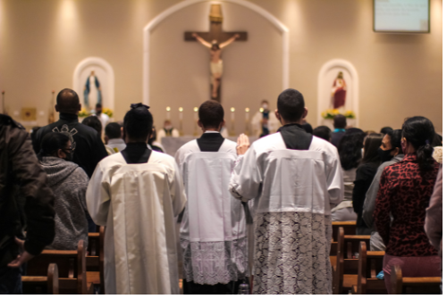
In the Third Commandment, God tells us to “Remember to keep holy the Sabbath day.” For the Jews, the Sabbath was Saturday; Christians, however, transferred the Sabbath to Sunday, the day of Jesus Christ’s resurrection from the dead. The Church tells us that we have an obligation to fulfill this commandment by refraining from unnecessary work on Sunday and by participating in the Mass, our chief form of worship as Catholics.
From the earliest days of the Church, Christians have understood that being a Christian isn’t a private matter. We are called to be Christians together; while we can and should engage in the private worship of God throughout the week, our primary form of worship is public and communal, which is why Sunday Mass is so important.

Mass Reflections
Mass attendance is an integral part of our faith journey and formation. Classroom instruction and activities rely on students regularly attending Mass. When students are not familiar with the structure of the Mass, prayers, etc., it reduces the quality of our classroom experiences. Each student in grades two through eleven are required to complete eight Mass Reflections throughout the year. Forms for Grades 2/3, 4/5/6, and 7-11 can be found on our website (https://www.stleonards.org/Mass-Reflection-Sheets). Paper copies will no longer be available.

Please have your child use the appropriate grade level form. Email completed forms to: STLCFO@stleonards.org

Forms will only be counted if you have completed a reflection from a Catholic Mass. Non-Catholic services are not a Mass. Only Mass reflections submitted on the appropriate forms can be accepted for credit.

GENERAL INFORMATION

Parking Lot Safety
To ensure the safety of all children, please observe the following procedures. When dropping off children, make sure that children have safely entered the building before leaving the parking lot.

Note: No pick up or drop off is allowed at the South Entrance to the school building for the protection of all of our children. Enter the parking lot at the north driveway (Church side) and exit by the south (School / Youth Center) driveway. Please drive slowly and be aware of pedestrians, especially in the evenings.

Attendance
Regular attendance at classes is essential for any measure of success in a Christian Formation Program. Weekly attendance enables children to grow in the knowledge of the Faith, to develop a sense of belonging to the parish community, and, through regular prayer to build a relationship with God. 100% attendance is preferred – but the required attendance is as follows:

Grades 1 – 6*: 15 of 20 classes (up to five absences *makeup work available upon request for illness or family emergency related absences)
Grades 4 - 9: Enrichment Event (with a parent - see page 18)
Grades 7 - 9: 13 of 16 classes (up to three absences)
Confirmation 10-11: 14 of 16 classes (up to two absences)

- Ushering or Altar Serving at Mass is NOT a substitute for attending class and are not to be scheduled during class time.
- Students with more than allowed absences have not “Completed Requirements” which will affect eligibility for Athletics.
- If your child(ren) will be absent, please call before class begins. Calling in your missing student does not negate the absence.
- Due to space considerations and attendance tracking, students are not able to attend class on another day.
- Missing class for a St. Leonard Athletic event is not permitted.

Grades 4 – 9 Attendance Specifics
All students in Grades 4 – 9 are required to attend one Enrichment Event with their family. (A Enrichment Event schedule will be emailed to parents in October and the most current schedule can be found online at www.stleonards.org. Click on the ‘Enrichment Events’ tab.)

Late Arrival / Early Release of Students
For the safety of students and volunteers, the building is locked after the bell rings. This also includes the indoor access door between the Church and Formation Office.

Those arriving after the bell - or - leaving prior to the ending bell:
- Parent(s) and student(s) come to the Christian Formation Office (ring bell outside entrance) ~ parent signs child in as a late arrival
- Parent(s) comes to the Christian Formation Office (ring bell outside entrance) and signs out child as an early departure

As always, students are not allowed to leave early for any
St. Leonard Athletic event (games, tournaments,
practices or team Masses).

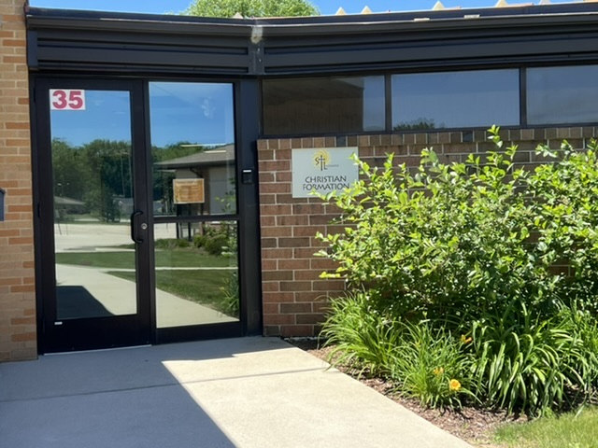
St. Leonard Christian Formation Office Entrance

Code of Conduct

Students in Christian Formation are expected, at all times, to be respectful, courteous, and honest to the faculty, staff, and fellow students.
In class, students are expected to...
• Arrive on time and report directly to classroom (please be aware of the time if you are attending Hospitality Sunday)
• Be prepared for class with their homework and supplies
• Respect the property of the school and other students
• Listen to the catechist (teacher) and follow directions
• Show respect, through words and actions, to the catechist and to other students
• Not call out in class or leave their seats unless asked to do otherwise
• Not be a distraction to or disrespectful toward other students

If a student does not follow the above guidelines...
• 1st Incident – child is sent to the Christian Formation Office

• 2nd Incident – child is sent to the Christian Formation Office – and – contact is made with the parents
• 3rd Incident – a parent of the child is required to sit in class with the student until the teacher feels the child is ready to be on his or her own again.

Dual Household Reporting

In cases where parents and / or legal guardians do not reside in the same household, the names and addresses of both parents should be listed on the registration form. The Christian Formation Office should have custodial information indicating to which parent the child should be released after class. Unless otherwise instructed, information commonly made available to parents of any student in attendance will be provided to both parents whenever possible.

Emergency Contact Information

At registration, parents/guardians are asked to provide an email address, home and work phone numbers, as well as any other phone number which would be used in case of an accident or emergency. Should any of this information change during the year, please notify the Christian Formation Office. Email addresses are required at the time of registration for direct communication for non-emergency issues throughout the year.

Emergency Response
At the beginning of each Christian Formation semester, we will be explaining our emergency procedures. The response for the emergency procedures will be as follows:

Fire – All students will take their coats and proceed in an orderly fashion with their teachers to the nearest exit to the front parking lot. They will remain there until it is safe to return to the building.

Tornado or Weather emergency – All students and their teachers will go to the cafeteria. They will sit on the floor until the danger has passed.

Lockdown – Students will remain in their classrooms with the teacher unless instructed otherwise.



Sacramental Preparation

To fully participate in the Sacramental life of the Church, all students should complete the Christian Formation programs for grades 1-9 or attend a Catholic school for grades 1-9 and be fully prepared for the reception of First Reconciliation, First Eucharist and Confirmation.

Baptism: All students must receive the Sacrament of Baptism prior to receiving the Sacrament of Reconciliation, First Eucharist and/or Confirmation.

If a child is seven or older and is not baptized – or – is delayed in the reception of Eucharist, please contact Bridget Klawitter at the Parish Office: 262-679-1773. If you need assistance in this area, we are happy to help you and your child.

In the Archdiocese of Milwaukee, preparation for the sacraments of Reconciliation and Eucharist normally occurs during a child’s second grade year with one full year of faith formation as a foundation prior to this year.

St. Leonard policy requires children be enrolled in Christian Formation either here or at another Catholic church or school for one full year before they can begin their preparation for these two sacraments. This ensures each child begins to develop a foundation in faith formation and the understanding that the celebration of the sacraments is a lifelong process.

First Reconciliation: Preparation for First Reconciliation is completed in the fall semester of a child’s second year of formation (please see above statement on preparation). This study culminates in all second-year students attending a reconciliation prayer service in December. Attendance at this service is a required part of the program. You and your child determine if he or she is ready to receive the sacrament at the end of the service. A required informational parent meeting will be held. (See page 9 for meeting date.)

First Eucharist: Preparation for First Eucharist occurs in the spring semester of second grade. An informational parent meeting is held in mid-January and one parent is required to attend this important meeting.

Confirmation: Preparation for Confirmation. Details can be found under the Confirmation Preparation section of this handbook.
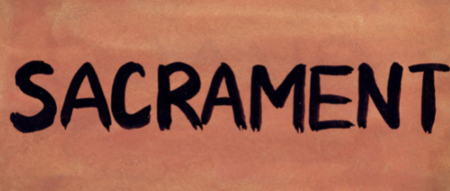
2025-2026 CALENDAR OF CLASSES
Grades 1 - 11
Students MUST attend both Fall and Spring Sessions
Elementary and Youth Ministry Class times
Sunday 10:15 - 11:30 am / Monday 6:15 - 7:30 pm

Elementary
*Required Parent Meeting to be held in person
FALL SESSION SPRING SESSION

September 14/15 *Large grp/Parent Night
September 21/22
September 28/29
October 5/6
October 12/13 No classes (Nursery only)
October 19/20
October 26/27
November 2/3
November 9/10
November 16/17
November 23/24
January 11/12
January 18/19
January 25/26
February 1/2
February 8/9
February 15/16
February 22/23
March 1/2 No classes
March 8/9
March 15/16
March 22/23

Youth Ministry Gr. 7- 9
FALL SESSION SPRING SESSION

September 28/29
October 5/6
October 12/13 No Classes
October 19/20
October 26/27
November 2/3
November 9/10
November 16/17
November 23/24

January 25/26
February 1/2
February 8/9
February 15/16
February 22/23
March 1/2 No Classes
March 8/9
March 15/16
March 22/23

Confirmation Grades 10 - 11
Class times: Sunday 6:30 - 8:00 pm
*Mandatory Parent Meeting first day of class – one parent is required to attend
FALL SESSION SPRING SESSION

September 28**Large grp/Parent Night January 25
October 5 Large Group February 1
October 12 No Classes February 8 Meal Pack Class Time 1-2:30 PM
October 19 February 15
October 26 February 22
November 2 March 1 No Classes
November 9 March 8
November 16 March 15
November 23 March 22

Elementary Grades 1 – 6

Requirements for students in Grades 1 – 6 are as follows:

- All Grades: required Attendance in class (15 of 20 classes)
- Grades 2 – 6: Complete eight Mass Reflections (see Mass Reflections section)
- Grade 2 – Attend a Reconciliation Prayer service
• Grades 3 – 6: Attend a Youth Holy Hour (see Youth Holy Hour section)
- Grades 4, 5, 6: complete one Enrichment Event (see Enrichment Event section)

The Christian Formation Office can be called or emailed at any time to verify the status of student requirements.

Our Elementary Program is open to children in grades one through six. It includes teachings on the Tradition, Scriptures, Prayer and Social Teachings of the Catholic Church.

Enrichment Events
In order to increase our contact time with students in grades 4 – 6, these students are required to complete one of the Family Faith in Action / Enrichment Events scheduled throughout the year. An adult needs to accompany students. (A Family Faith in Action/Enrichments Event schedule will be emailed to parents in October and the most current schedule can be found online at www.stleonards.org. Click on the ‘Enrichment Event’ tab.)

HOME STUDY See Home Study section with details on Home Study options




Elementary continued

Watch for information, sent via email, on the following:
- Class Assignments about ten days prior to the start of the program
- Spring Session information
- First Reconciliation Parent Meeting
- First Communion Parent Meeting
- Parent newsletters - will be emailed when published and be available on the website: www.stleonards.org

FIRST RECONCILIATION

FIRST RECONCILIATION PARENT MEETING: (parents only please)
Wednesday, October 8, 2025 @ 6:30 pm in Church

FIRST RECONCILIATION PRAYER SERVICE: (Attendance required)
Saturday, December 6, 2025 @ 10:00 – 11:15 am in Church

*FIRST COMMUNION

FIRST COMMUNION PARENT MEETING
Wednesday, January 28, 2026, 6:30 pm Church
*Sign up for your First Communion date will happen after this required meeting. You and your child are required to attend the rehearsal for the date of First Communion reception.

FIRST COMMUNION RETREAT (Required parent / child attendance.)

Saturday, February 14, 2026 8:45 – 11:30 am OR
Saturday, February 21, 2026 8:45 – 11:30 am

Separate Scheduled First Communion Mass
Sunday, April 26, 2026, 1:30 pm
Required Rehearsal Date: Wednesday, April 22, 2026, 6:30–7:45 pm
Sunday, May 3, 2026, 1:30 pm
Required Rehearsal Date: Wednesday, April 29, 2026, 6:30 – 7:45 pm

Regularly Scheduled Parish Mass
Saturday, May 9, 2025, 5:00 pm Mass
Required Rehearsal Date: Friday, May 8, 2026 @ 6:00 pm

.
Youth Ministry ~ Grades 7 - 9

Requirements for students in grades 7 – 9 are as follows:

- Attend at least 13 of 16 classes
• Attend one Enrichment Events with a parent*
• Grades 7 – 9 ten service hours - (see page 16)
• Attend a Youth Holy Hour - (see page 14)
• Complete eight Mass Reflections - (see page 3)

The goal for attendance is 100% for classes and one Family Faith in Action Event with a parent. All families have obligations they must attend. It is our hope that families make Christian Formation a priority. In order to work collaboratively with the needs of busy families, we allow three absences for the year.

*Enrichment Events are meant to enhance spiritual formation in a non-classroom setting. These opportunities are meant for parents to spend time with their children in an environment that can enrich their faith journeys. (An Enrichment Event schedule will be emailed to parents in October and the most current schedule can be found online at www.stleonards.org. Click on the ‘Enrichment Events’ tab.)

Service hour requirements:
Grade 7: Two hours
Grade 8: Five Hours
Grade 9: Ten Hours

See Service Hour section for more details.


The Christian Formation Office can be called or emailed at any time to verify the status of student requirements.

Curriculum for Youth Ministry is meant to be a more in-depth study of the Catholic faith. Students review what they have already learned in elementary Christian Formation and become more involved in their faith. Below is the focus for each year.

Seventh & Eighth Grades – Alpha

Ninth Grade – Morality

Make-up work is not available.
Due to space considerations and attendance tracking, students are not able to attend class on another day.

Confirmation Program ~ Grades 10 & 11

Requirements to receive the sacrament of Confirmation are as follows:
• Complete the Christian Formation program in grades 1-9 – OR – attend a Catholic school in grades 1-9
• Complete a two-year Confirmation Program with required attendance (Catholic High School students, Junior year only)
• Complete eight Mass Reflections each year (see Mass Reflections section)
• Attend a Youth Holy Hour each year (see Youth Holy Hour section)
• Complete 15 service hours Junior year / 10 service hours Sophomore year (see Service Hours section)
• Attend a one day retreat Sophomore year (see below)
• Attend a one day Confirmation retreat Junior year (see below)
• Write a letter to the Archbishop – OR – fill out Confirmation Candidate Questionnaire for the Bishop presiding at the Confirmation Mass (Junior year)
• Complete a Confirmation interview (Junior year)

One parent MUST attend with your student on the first night of class!

More information about the Confirmation and Sophomore Retreats will be provided when available. Please mark your calendars with these dates.

Confirmation Retreat dates
One day long retreat (9:00 am – 6:00 pm) held at St. Leonard
Saturday, January 31, 2026 – OR – Saturday, February 7, 2026

Sophomore Retreat dates

One day long retreat (9:00 am – 6:00 pm) held at St. Leonard.

Saturday, November 1, 2025

Confirmation Interview dates

Sunday, February 15, 2026 (scheduled times, 1-3 pm) – OR –

Sunday, February 22, 2026 (scheduled times, 1-3 pm)

CONFIRMATION DATE

The Archdiocese has posted our assigned Confirmation date:

Friday, April 17, 2026, 6:30 pm with Most Reverend Archbishop Jeffrey Grob

REHEARSAL DATE: Wednesday, April 15, 2026, 6:30 pm in Church
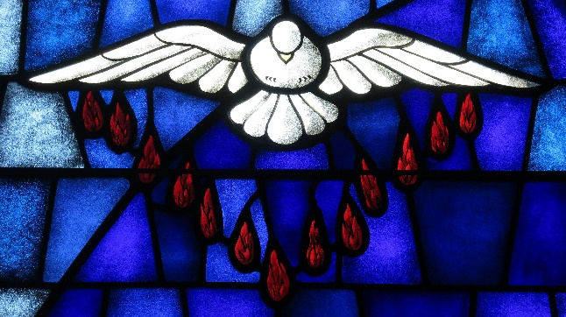

Completion of Requirements / Participation in Athletics Programs


Annual Expectations

- Required attendance in class
(students may not attend class on another day)
  - K4/K5 participants must be enrolled in the in-person Jr. Leo's program for Athletic eligibility
- Complete the Grade Level Prayer Experience (Grades 1 – 6)
- Youth Holy Hour attendance (Grades 3 - 11)
- First Reconciliation Prayer Service attendance (Grade 2)
- Complete and submit Eight Mass Reflections (Grades 2 -11)
- Required Hours of Service (Grades 7 - 11)
- Enrichment Event attendance (Grades 4 - 9)
- Acceptable Behavior - If a student reaches a third incident, participation in Athletics will be suspended.

Athletics Participation *
In order to be eligible to participate in St. Leonard Athletics Programs, students in K4 - 11th grade must fulfill all requirements for the year of participation by the deadline. Per Christian Formation Eligibility Standards, students must complete the requirements for the current year in order to maintain their eligibility for the following year. All students have a completion date of April 15, 2026 to maintain Athletic Eligibility for the 2026 to 2027 year.

Students may not leave class early or miss class due to a St. Leonard Athletics event or activity. Participation in the St. Leonard Athletics program is a privilege for students who continue to complete all requirements in Christian Formation.

Sacramental Reception
An important part of your child’s formation experience includes preparation to receive Sacraments. When a child is not fully prepared through attendance / participation in class and completion of the requirements, his or her readiness to receive the Sacraments will be reviewed and potentially delayed. Discussion with Director(s), Pastor, and parents along with your child, will determine what additional instruction and formation needs to be completed.

*Students with missing Sacramental preparation are expected to complete the appropriate program / materials and be caught up within the first two years of enrollment in Christian Formation to maintain Athletic Eligibility.

Holy Hour
Reconciliation Services for students in grades *3 – 10 have been replaced by the Youth Holy Hour. This hour-long service consists of prayer, Eucharistic Adoration and the opportunity to receive the Sacrament of Reconciliation

*Grade 2 students attend a special First Reconciliation Prayer Service in December. Grade 11 Students attend a Holy Hour during their Retreat.

Annual celebration of Reconciliation (forgiveness, mercy, repentance, confession) encourages children and youth to understand and experience that reconciling with God, with others, and with oneself is central to the message of Jesus in the Gospels.

Grades 3 -10: Youth Holy Hour – Students will be REQUIRED to attend ONE of the
services listed below with the opportunity to receive the Sacrament.

Grade 11: Confirmation Candidates will attend a Holy Hour during their daylong Retreat

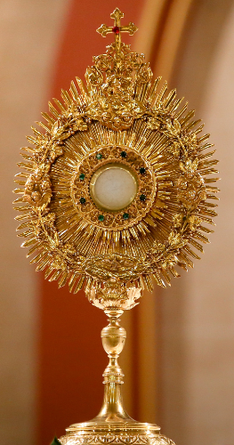

Youth Holy Hour / Parish Reconciliation Services

Tuesday, September 30, 2025 – 6:30 pm (Holy Hour)

Wednesday, October 29, 2025 – 6:30 pm (Holy Hour)

**CANCELLED**Tuesday, November 25, 2025 – 6 – 7 PM in Honor of our Patron St. Leonard of Port Maurice (feast day Nov. 26th) Parish oriented

Thursday, January 8, 2026 – 6:30 pm (Holy Hour)

Wednesday, February 11, 2026 – 6:30 pm (Holy Hour)

Wednesday, March 4, 2026 – 6:30 pm in Church (Parish oriented)

Home Study

Students benefit greatly from the classroom experience which cannot be duplicated at home. Families are encouraged to make the necessary accommodation for this. For the families who cannot attend classes due to a legitimate conflict, St. Leonard Christian Formation offers a Home Study alternative on an exception basis only.

Home Study participants are required to meet with the coordinator/Director. All completed materials are due according to the provided schedule. The completion of eight Mass Reflections by the final due date is required for students in Grades 3-9. Students have access to the audio-visual aides and / or craft projects by contacting the Christian Formation Office.


Elementary (Grades 1, 3, 4, 5, & 6)
Families will be given a student textbook, online access to parent over-reviews, and a schedule of due dates for the chapter reviews. All Home Study students are required to attend the appropriate Prayer Experience, so please review the schedule when it is completed and plan accordingly. Students in grades 3 - 6 are also required to attend one Youth Holy Hour (see page 13 for the schedule). Students in grades 4 - 6 are required to attend one Family Faith in Action /Enrichment Event with a parent.

Due to the extensive Sacramental Preparation, Home Study is not available for second grade.

If you have questions or would like additional information on our Home Study program for Grades 1, 3, 4, 5, 6, please contact Lisa Jachimiec at 262-679-0880.

Youth Ministry (Grades 7, 8, & 9)

All Home Study participants are required to complete coursework and attend one Family Faith in Action/Enrichment Event with a parent. Each student is also required to attend a Youth Holy Hour (see page 13). Students are asked to participate in community service (see page 15). These requirements become part of the student record and are a component of “Eligibility” status.

Confirmation (Grades 10 & 11)
Home Study is not available for the Confirmation program.

If you have questions or would like additional information on our Home Study program for Grades 7, 8, and 9, please contact Bethanne Maus-Schaefer at: 262-679-0880.

Service Hours

“As each one has received a gift, use it to serve one another as good stewards of God’s varied grace.”
1 Peter 4:10

As Catholics, we are required to perform service to others. As a child grows, we firmly believe having students complete service hours helps bring them closer to God.

Youth ministry students in grades 7- 11 must complete service hours.
Grade 7 – Two Hrs. Grades 8 – Five Hrs. Grade 9 – Ten Hrs. Grade 10 – Ten Hrs.
Grade 11 – Fifteen Hrs.
Only Service Hours that are submitted on the Service Hour form will be accepted for credit.

If you are a member of the organization that benefits from, or are under obligation to perform the activity, the work does not count toward this Christian Formation requirement.

Community service hours performed to satisfy a court order may not be used toward Christian Formation requirement.

Service hour sheets are available on our website (under Christian Formation tab on Right hand side “All Forms” ). Completed Service Hour sheets should be emailed to: STLCFO@stleonards.org

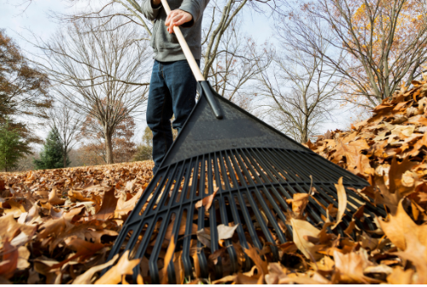
Service opportunities that are available through St. Leonard:
- Labor of Love (LOL) – ongoing
- World Series to Strike Out Hunger
- Souper Bowl of Caring – February
- Mission Trip – Summer
- VBS – Summer
- Veggie Tales - multiple times
- Church Decorating - multiple times
- Knights of Columbus activities - multiple times
- Little Leo’s and Jr. Leo’s during 9:00 am Mass
- Additional opportunities are presented weekly during class time and will be listed on our website

“Small acts, when multiplied by millions of people, can transform the world”
- Howard Zinn

Enrichment Events

Learning about our faith is the way we create a foundation. However, putting our faith to work is how we come to ‘know’ Jesus on a personal level. These events are designed to inform the participants about different non-profit organizations and complete a service project to benefit the speaker’s ministry. Pick one of the events to attend with your child(ren) throughout the year. A schedule of opportunities will be emailed in October.

RSVP’s are required by five days prior to the event.

Events may include in-person, interactive speakers, or activities. More events will be added throughout the year. For the most up-to-date schedule of Enrichment events, watch your Parent newsletters or check the Christian Formation website at: www.stleonards.org.


15

LITTLE LEO’S NURSERY PROGRAM
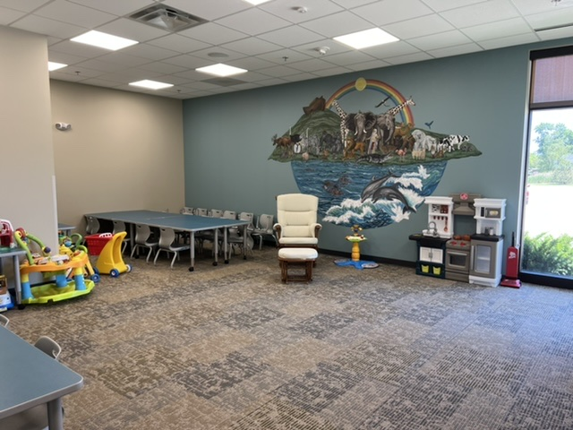
Do you have young children you bring to Mass each week? Our Little Leos Nursery program is for you!! Held during 9:00 am Mass, we offered a unique opportunity for children, ages six months through four years, to experience God at their level. Staffed by two adults and two youth, there are toys, games, videos and coloring with a connection to the Sunday readings. Little Leos is currently held most weekends of the year. Our new facility is near the restrooms in the Gathering Space and is totally free!!
For more information, or if you would be interested in volunteering in Little Leos, please contact Lisa Jachimiec in the Christian Formation Office.

Jr. Leo’s – K3, K4 and K5

Our Junior Leo’s program is designed for children who will be in K3, K4 or K5 this fall (three years old by September 1, 2025) and are reasonably on the way to being potty trained. We would LOVE to have you be a part of Jr. Leo's this year.

The cost is only $75 per year, per child to cover materials. We meet during the 9:00 am Mass times beginning in October. Pre-registration is mandatory so we can ensure we have the volunteer staff required. Don't miss out on this very fun and exciting way to be a part of Jr. Leo's this year!!

CALENDAR OF CLASSES-SUNDAY DURING 9AM MASS

FALL SESSION SPRING SESSION
October 5, 19, 25 No classes Oct. 12 January 11, 18, 25 No Classes Jan. 4
November 2, 9, 16, 23 February 1, 8, 15, 22
December 7, 14 No Classes Dec. 21 & 28 March 8, 15, 22, 29 No Classes Mar. 1st

Groups Related to Christian Formation
LABOR OF LOVE - a youth/family service organization that provides service to residents in the Muskego area.

MISSION TRIP - An annual summer trip to another state for teens and adults to give an immersion experience with worship, prayer and a focus on community service. We work with Catholic Heart Workcamp.

VACATION BIBLE SCHOOL (VBS) – Due to the construction projects scheduled in the school for Summer of 2025, we did not have VBS. Traditional VBS Scheduling will return for Summer 2026! (Dates TBA)

CLAS - Christian Learning And Spirituality is an advisory committee to the Christian Formation Department.
The purpose of catechesis (Christian formation) is to make a person’s faith become living, conscious, and active through the light of instruction...” Catechesis is a lifelong process for the individual and a constant and concerted activity of the Christian Community”. The Christian Learning and Spirituality committee seeks to carry out its above stated purpose through program design and instruction, support of the work of the directors, and fundraising.


Fund Raisers

SCRIP is just like cash – it’s money you would spend anyway without costing anything extra. Check our website for a SCRIP order form with a complete listing of retailers. Pay face value and the parish gets a percentage of the sale!

MISSION TRIP FUNDRAISERS
- Stock Sale - $10.00 per share. Profits to go to the group as a whole.

Sacramental Life

As Roman Catholics, sacraments are a key part of both our formational and worship experiences. Receiving a sacrament (and its accompanying grace) is one way we draw closer to God throughout our lives.

Understanding the reception of a sacrament is an integral part of your child’s development through our Christian Formation programs. Because the Church feels so strongly about our Sacramental life, we are outlining the preparation process for First Reconciliation, First Eucharist, and Confirmation. These processes are begun with the understanding that your child has been baptized in a Catholic (or other Christian) religion. If your child is NOT baptized or is delayed in their reception of a sacrament (other than what is listed) please see the Sacraments at a Later Age section for more information on how we can work with your individual family needs.

Children who have completed the first year of formation (typically while in First Grade) enter their second year beginning preparation for the reception of two sacraments.

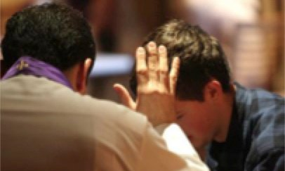
First Reconciliation
Our fall semester prepares your child to receive Reconciliation (Confession) in his or her second year of formation.



First Eucharist

Our spring semester of second year formation focuses on preparing your child to receive Jesus through the Eucharist. Preparation focuses on learning about the Real Presence of Christ as well as the actions and prayers we share during this special time.

Confirmation
The Sacrament of Confirmation is held in the spring of the candidate’s Junior year of high school. Preparation for Confirmation is a two-year program. Candidates must complete both years of Christian Formation classes and the requirements for both years to be adequately prepared for Confirmation.
Requirements to receive the sacrament of Confirmation are as follows:
• Complete the Christian Formation program in Grades 1-9 ~ OR ~ attend a Catholic school in Grades 1-9
- Complete a two-year Confirmation Program with required attendance - for Catholic High School students, Junior year only
- Complete Eight Mass Reflections each year
- Attend a Youth Holy Hour each year
- Complete 15 service hours Junior year / 10 service hours Sophomore year (see Service Hours section)
- Attend a day long retreat Sophomore year
- Attend a day long Confirmation retreat Junior year
- Write a letter to the Archbishop – or – complete Questionnaire for the Bishop presiding at the Confirmation Mass (Junior year)
• Complete a Confirmation interview (Junior year)
* For Sophomores, all requirements must be completed by April 15, 2026.
* For Juniors, all requirements must be completed by December 1, 2025 - except for the Retreat and Reconciliation which must be completed by March 1, 2026.


Junior year of high school tends to be an extremely busy year for most youth. Please encourage your child to start working on their service hours and Mass reflections for their Junior year during the summer months. Both service hours and Mass reflections may be turned in starting July 1 for the upcoming year.

Sacraments at a Later Age (SALA)

There are as many reasons as there are children as to why someone is not prepared to receive a Sacrament at the “usual age.” Each situation is unique — and we have experienced an increase in our students receiving Sacraments at a later age in recent years. We want to work with you to prepare your child to receive missing Sacraments. If your child is in third grade or above (and Baptized) or over the age of seven (and not Baptized), we have a program to assist in preparation.


Baptized—Grade Three and Higher
Students entering Third Grade or higher (and Baptized) will be placed in their appropriate level formation year and spend that year learning along with their peers. During the second year of formation, students will continue the classroom instruction and additionally, meet with our Pastoral Associate outside of classroom time for small group study focused on the sacramental preparation needed.

Not Baptized—Age Seven or Older OCIA
Students who have reached the Age of Reason (age seven) and are not Baptized will follow a similar two-year process. During the first year of your child’s formation, he or she will attend classroom instruction with peers. During the second year of formation, in addition to grade level classroom instruction, preparation for full initiation into the Church will be completed. Full initiation (reception of Baptism, Eucharist and Confirmation) will take place at the Easter Vigil—held Holy Saturday evening. Please plan accordingly.

Students with missing Sacramental preparation are expected to complete the appropriate program within the first two years of enrollment in our Christian Formation programs in order to meet Athletic Eligibility Requirements.

Vine and Branches
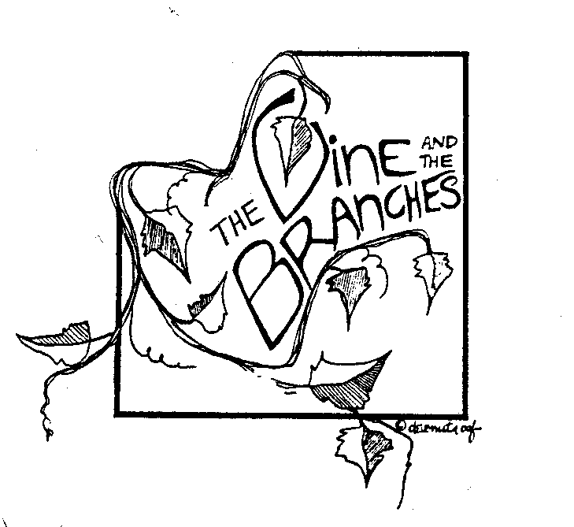Christian Formation for Students with Disabilities

I AM THE VINE,
YOU ARE THE BRANCHES
ALL WHO LIVE IN ME AND I IN
THEM WILL PRODUCE ABUNDANTLY
FOR APART FROM ME
YOU CAN DO NOTHING
(John 15:5)

Jesus calls us all to live in Him, to realize our full potential as members of the Christian Community.

Vine and Branches is a program which answers that call by providing a program of faith development and religious education to persons with intellectual disabilities for whom standard Christian Formation programs are a challenge.

Children/Teens from the area parishes (ages 6-18) and adults (up to age 22) who have any type of cognitive developmental disability are invited to join us.

Vine and Branches meets 17 times a year at St. Leonard Catholic Church, Muskego in the Youth Center Building at the south end of the campus.

Participating parishes will be asked to pay a stipend therefore no individual tuition is charged. Students from other parishes are always welcome.

This program is sponsored by the Knights of Columbus.

For more information contact: Bridget Klawitter, Pastoral Associate
www.bridget.klawitter@stleonards.org

2025-2026 Vine & Branches Schedule

Fall Session Spring Session
September 29 January 19
October 5 January 26
October 13 No Class February 2
October 20 February 9
October 27 February 16
November 3 February 23
November 10 March 2 No Class
November 17 March 9
November 24 March 16
March 23

