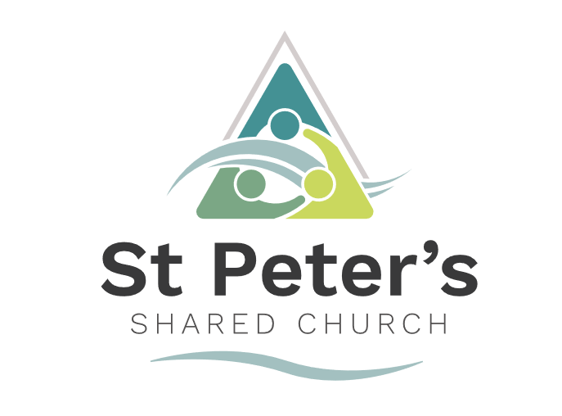

Youth, Children and Families Intergenerational
Ministry Worker

Join us on an exciting next step for St Peter's Shared Church as we step out in faith deeper into our community.
This new role incorporates development of intergenerational worship, work with schools, families, young people and whole households. This is a mission-focused role: shaping, forming and resourcing growth in faith in Jesus across generations - especially seeking to engage families, youth and households.
This role is subject to an enhanced DBS disclosure. There is a ‘Genuine Occupational Requirement’ for the person applying for this post to be a practising Christian. Selection will be made through application, interview and presentation.

Our context:
St Peters Shared Church is a church that has a deep love and care for all in our community and a passion to see lives transformed by Jesus Christ. Our mission is to “Share Christ’s love in this Community through Mission, Worship and Community”.
We are an ecumenical partnership between the Church of England and the United Reformed Church, serving the parish of Bellfields, Slyfields and Jacobs Well; covering one of the most deprived areas in Surrey.
One of our Key Mission objectives is that: “Every child and young person has the opportunity to hear the Gospel and respond” - this is where you come in…...
We are looking for a confident, fun and committed Youth, Children and Families Intergenerational Ministry Worker who is passionate about making Jesus known to children and young people of all ages and enabling their parents/carers to explore faith for themselves. Building on committed teams of volunteers, we want to grow our existing ministry to youth and see current toddlers and their parents’ journey on a pathway that engages (them and) their children through to their teenage years and early 20’s. We are seeking to grow this church across every generation.
We are looking to appoint someone to this role for 3 years (with potential to extend if funding is available).
Salary and benefits:
- Salary: £30,750 - £33,947 (FTE) depending on experience; pro rata 0.5 time
- There is an employee pension contribution scheme and funded training provided.
- Holidays: 100 hours plus Bank Holiday allowance with dates by negotiation (to be available for some school holiday activities and key festivals) – this includes taking 5 Sundays off per year.

Hours:
- Part-time 20 hours p/w spread flexibly across the week to include Sunday and the potential need for late afternoons/evenings each week.
- You will be required to work in the Sunday afternoon 4pm slot that you will be developing.
- Two ‘days off’ to be agreed to suit the post holder.
- The expectation is that you would worship with us on Sunday mornings.
Location:
- There is a shared workspace/office at St Peters Shared Church and you will have a dedicated laptop and phone for your work use. Some work will be out-and-about and some preparation work can be at home (with negotiation).
The role:
St Peters Shared Church is looking to recruit a part-time worker who can head up our intergenerational ministry. Whilst the role will strengthen existing church ministries, its primary focus will be outward-facing: building relationships within the community, creating opportunities for people to encounter Jesus, and developing clear pathways into discipleship and belonging within the church. This role offers you opportunities to bring your creativity, experience and fresh ideas to mission and outreach to our local families.
Our vision for this role is to:
1. Grow an intergenerational church
- Develop a church culture in which children, young people, parents, grandparents and older adults worship, learn, serve and build relationships together.
- Enable every generation to recognise that they have a part to play in nurturing faith across the church family. This feeds into one of our priorities that we would be a church where all are welcome and valued.
2. Reach more children, young people and families
- Strengthen existing ministries and develop new opportunities that enable those with little or no church background to encounter Jesus through welcoming, accessible and relevant activities.
- Create clear pathways from community engagement into worship, discipleship and belonging. This feeds into another one of our priorities which is that every child in the community has the opportunity to hear and respond to the Gospel.
3. Strengthen families in faith
- Support parents and carers as they explore faith and help them become confident in nurturing faith at home.
- Be enthusiastic about deepening spiritual growth across families.
- Develop opportunities for adults to investigate Christianity through Alpha, nurture courses and pastoral relationships. This stems from our priority that we would be a church that feeds its community spiritually and physically.
- Lead on evangelism and discipleship amongst families / households and faith development across the church community.
4. Build stronger partnerships within the community
- Deepen relationships with our local Primary and Secondary schools (with whom we already have excellent links), Youth Catalyst Project, local churches and community organisations so that the church becomes increasingly present within the everyday life of the parish.
- Develop new initiatives that particularly engage with those experiencing deprivation, loneliness or complex need.
- Raise the profile of St Peters shared church across the community, particularly children, families, youth in intergenerational worship.
5. Develop sustainable ministry
- Work in partnership with the wider church family to develop and grow ministry to children and young people, helping them to develop a sticky faith.
- Recruit, train and encourage volunteers so that ministry becomes increasingly shared across the whole, growing congregation.
- Develop future leaders and ensure ministries are well organised, safe and sustainable.

Key priorities for the post holder:
Work with the Vicar to re-imagine and implement:
- Sunday afternoons (currently Messy Church once a month) exploring ways to develop new intergenerational worship for afternoons in a more regular pattern.
- Enabling integration of youth into worship and ministry.
- Work with primary school years 4 + 5 in outreach to encourage participation and engage them in faith activities leading to connection with youth ministry here.
- How best we can engage older teens and school leavers (who start work) in our community – who are post youth group.
- Instilling a sense of church identity and commitment amongst the young people and children so they might fully participate in the ongoing life of the church.
- Regular engagement with our toddler group families as part of building intergenerational worship.
- Encouragement of all generations to be role models towards the younger children.
- Encouragement of all generations to be ministered to by children and young people.
Other responsibilities
You will be expected to:
- Maintain a strong, personal relationship with Jesus through prayer and Bible reading and the gathered life of the church; pursuing growth into Christ-likeness.
- Commit to ongoing training.
- Promote all aspects of safeguarding, welfare, health & safety and ensure the highest standards of care and Safeguarding for children and families are maintained in all ministry areas, prioritised through record-keeping, training and close work with the Parish Safeguarding Officer, including in the recruitment of volunteers.
- Work alongside the SCC (Shared Church Council) and wider activity teams in our strategy for our outreach to children and families.
- Work alongside the existing ministry team, build up a network of volunteers to support activities and develop young and adult leaders, sourcing training where necessary.
- Work within the church ministry team to serve and support all aspects of church life and ministry to include any other task reasonably requested of the post-holder by the Vicar.
Admin
- Plan and budget for all approved activities.
- To produce risk assessments for activities and abide by safeguarding policies.
- Attend SCC meetings to report on progress as required usually annually or biannually.
- Promote events and activities to the church and wider parish.
Seasonal responsibilities
- In collaboration with the vicar and key children’s leaders to deliver schools’ work: helping with planning and admin for Prayer Space in schools; assemblies; and experiential events such as ‘Easter Encounter’ and ‘Advent Adventure’ in collaboration with other local churches.
- Plan and run a holiday club or activity programme to engage children in Primary school with a team of volunteers (dates in August TBC).
- Join in WAY Camp (3-4 churches together) youth camp (currently booked for 23rd – 27th July 2027).

Person specification and competencies  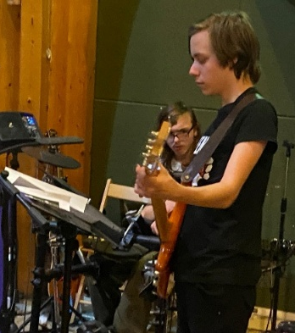  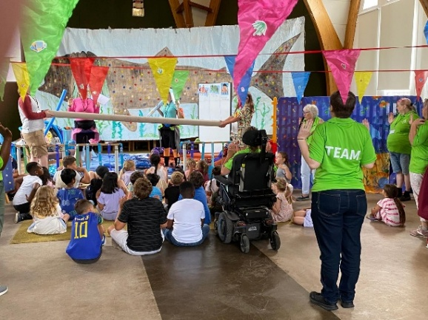  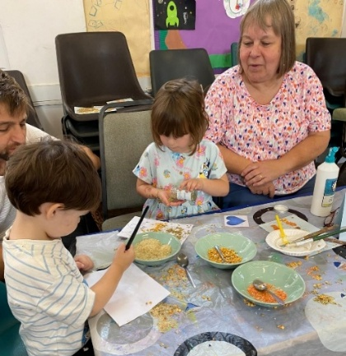 | - Able to connect and communicate positively with all generations: children, families, households and young people.  - A committed Christian: enthusiastic with an active faith (there is a Genuine Occupational Requirement that the person be a practising Christian).  - Able to use scripture/Bible to communicate faith in a way appropriate to context.  - Able to lead/organise intergenerational worship in collaboration with vicar and ministry team.  - Able to manage their own time well, planning and arranging events and communicating well with others who are involved  - Comfortable presenting to children and adults alike.  - Experience of working with or leading in children’s and families work (could be as a volunteer or in another professional capacity, e.g. teaching, social work).  - Experience of working in a children or families ministry within a Christian or church setting (paid or voluntary).  - Experience of families with complex needs could be helpful.  - Team player: able to inspire and motivate others.  - Flexible and innovative, adapting to change as needed.  - Satisfactory DBS check and at an enhanced plus level.  - Possess an understanding and awareness of safeguarding practice within a church context and willingness to undergo specific training in this.  - Competent in IT skills such as Microsoft Office.  - Familiar with social media and able to use it in a ministry context as appropriate.  - We are a Local Ecumenical Partnership URC/Anglican, we describe ourselves as open evangelical (charismatic) and expect the candidate to live a lifestyle in line with our values and ethos.  - A baptised member of a church (of any denomination) willing to work within a majority Anglican context.
Supervision and management | - The Youth, Children and Families Intergenerational Ministry Worker will be responsible to the Incumbent and to the Church Council (SCC).  - There will be a weekly staff meeting/supervision with the Incumbent.  - We expect to nominate another person for you to relate to, who will be available to offer additional, pastoral support to you.

