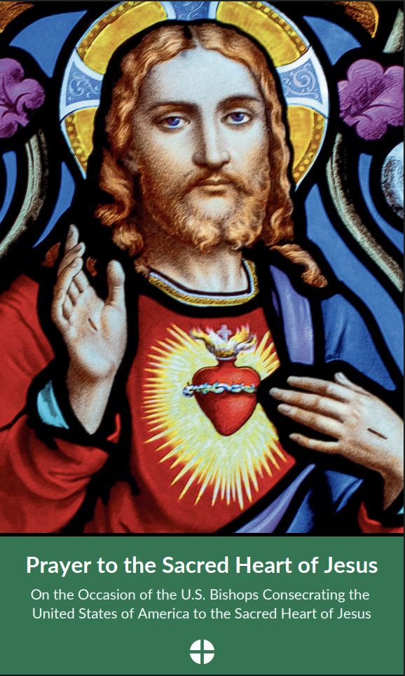
Prayer to the Sacred Heart of Jesus

O Most Sacred Heart of Jesus:
You know the longings of our hearts, and you desire that we enjoy friendship with you.
From your pierced side, you have poured out the wellspring of life, for which we thirst.
Your heart burns with a love for all people to return to a right relationship with you.
We celebrate the abundant gifts you have given this nation, founded on the self-evident truths that our Creator has endowed all people with the right to life, liberty, and the pursuit of happiness.
We make reparation for the offenses against you and against human dignity that have taken place in this nation.
May our hearts be united to yours, so that our families and communities enjoy peace and happiness; may broken relationships be reconciled, injustices repaired, and the wounds of our land be healed.
May your holy Catholic Church serve as a sign, pointing all people to your infinite love.
O Desire of Nations and Center of History, we ask you to bless these United States of America.
Who live and reign with God the Father in the unity of the Holy Spirit,
God, for ever and ever.
Amen.
Most Sacred Heart of Jesus, have mercy on us!
Immaculate Heart of Mary, pray for us!

