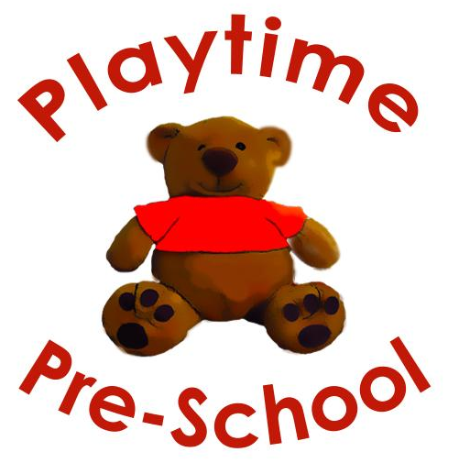
Regular Booking Form

Name of child:................................................ D.O.B;....................... Age;........................ Start Date:...................................

Please tick boxes below for the sessions you require.

Tuesday |  | Thursday |  | Friday
3 hr  8.30 – 11.30 |  | 3 hr  8.30 – 11.30 |  | 3 hr  8.30 – 11.30
3hr  11.30 – 2.30 |  | 3hr  11.30 – 2.30 |  | 3hr  11.30 – 2.30
6 hr  8.30 – 2.30 |  | 6 hr  8.30 – 2.30 |  | 6 hr  8.30 – 2.30

I am eligible for a benefits based 2 year old funded place | NCC reference
I will be using 15 hours Universal 3&4 year funding | Yes/No | No code required
I am eligible for 30 hours Working Family Funding 9 months to 4 years | Working Family HMRC Code:
I will be paying for my child’s sessions | Yes/No | No code required
The fees are currently: 0-2 years £10 , 2-3 years £8, 3&4 year olds £, all per hour.
Preschool should be notified by email or text if your child will not be attending a booked session.

Refunds/Credits cannot be given for cancelled invoiced sessions, unless 1 months notice is given.

Please ensure you collect your child on time.

If WE have to close in an emergency parents will receive a text message and email as soon as possible and either a refund or credit on Quick books will be given for invoiced sessions.

If your booking changes in the future a new form will be issued for completion.

This contract covers any period there is a valid booking form in operation.

Places cannot be held if a valid booking form is not received, and fees not paid up to date.

Signed: .......................................................................... Date:...............................................
Full Name:.............................................................................. (Mother/Father/Carer)

