MODULE 1 TOOLKIT: LEAD WITH VISION

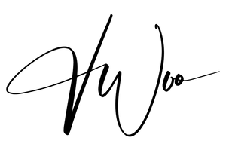

# VISION WORKSHEET

Step 1: Big Picture Prompt

The future I want to build is because .

Step 2: Look Ahead

When I imagine myself 5 years from now, I want . The impact I want to make is

.

Step 3: Motivation Prompt

What’s something I would do even if I wasn’t paid for it?

What frustrates me int he world that I feel called to fix?

Step 4: Draft Your Why Statement

Combine your answers into 1-2 sentences.

Example: “I want to create opportunities for students to succeed without burning out, because I know what it feels like to be overwhelmed and unsupported.”

# GOLDEN CIRCLE TEMPLATE

WHY?

HOW?

WHAT?

WHY - What’s your purpose, cause, or belief? Why do you do what you do?

HOW - What principles, values, or strengths guide you? How do you bring your Why to life?

WHAT - What do you actually do?

# VISION REFLECTION GUIDE

Prompts to revisit weekly or monthly:

What do I value most right now?

What future excites me most?

What’s one small step I can take this week that aligns with my vision?

# VISION TRACKER

Weekly Check-In (circle one):

 Did I make one choice that aligned with my vision this week? Yes or No  Did I say “no” to something that didn’t fit my vision? Yes or No

 Did I share or act on my Why with someone else? Yes or No

Optional Reflection:

What’s one thing I did this week that felt aligned with my vision?

What’s one adjustment I’ll make for next week?

# VISION RECAP

MY WHY STATEMENT:

MY GOLDEN CIRCLE:

WHY: HOW: WHAT:

MY 3 CORE VALUES:

1. 2. 3.

MY VISION ACTION STEP FOR THIS WEEK:

BRAIN DUMP: