**Behind-The-Wheel Contract**

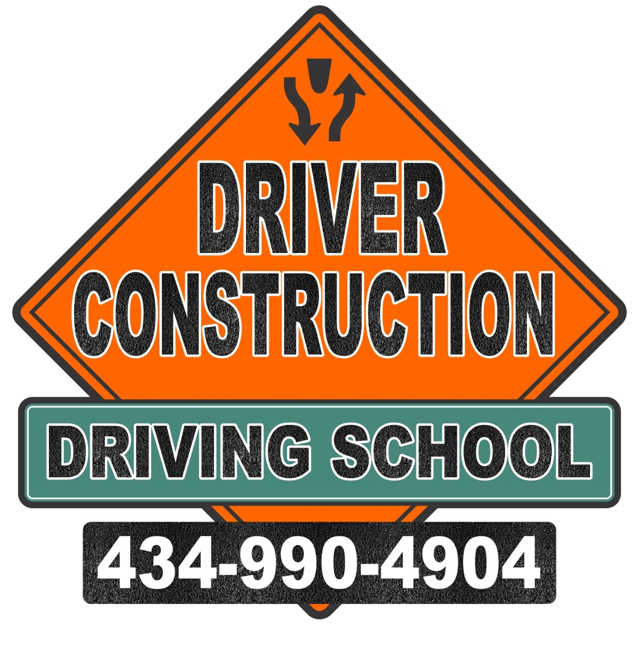

**(In-Car)**

Agreement/Authorization Between:

Customer Number: _______________

Full Student Name: _______________________

Owner: Larry Morris _______________________________________

8315 Spotswood Trail Address: _______________________________

Stanardsville, VA 22973 _______________________________________

Phone (434) 990-4904 Phone #: _______________________________

info@driverconstruction.org Cell #: _________________________________

Birth Date: ________ / ________ / __________

**In-Car Training Specifics: $350.00**

• Students under 18 years of age must have completed Drivers Education at a private driving school or have a DEC-1 (proof of classroom driver education) from another school showing the completion of a Driver’s Education class. Student must also provide a certificate of completion for the required

90-minute Parent/Teen Course.

• Students 18 years of age and older may hold the learner’s permit for 60 days in lieu of completing a

drivers training course.

• Must have their learner’s permit

• 14 periods, 50 minutes each, of In-Car Instruction with another student

7 Periods of Driving, 7 Periods of observing

• Arrangements for pick up and drop off are pre-arranged before the day of driving with parents, students and instructors. $65 fee for distances further than 30 minutes away from Driver Construction’s office

No show fee of $50 cancellations must be made 4 Hours prior to the appointment time.

• Students must have their learners permit with them during training and wear appropriate foot wear for driving (no flip-flops).

**Upon Completion of BTW**

• The DEC-1 (proof of classroom driver education) is used to fill out their license (DTS-B form).

• During the 14th period, a Road Skills Test will be administered by one of Driver Construction’s instructors. Upon completion and passing the test the student will be given their license. The instructor will explain this license to the student and their parents.

• Training MUST BE paid in full before any certificates of completion or license can be released.

• Payment plans are optional: Pay in full, or make payments as specified by this agreement.

We accept Cash, Credit Cards, and Local Checks (made payable to Driver Construction) **($50 returned check fee).** This training will be taught by an instructor that is certified by the Commonwealth of Virginia and licensed by the Department of Motor Vehicles. Driver Construction will provide a car that has been enhanced to meet the requirements of the State of Virginia and approved by the DMV. Driver Construction is fully insured for student instruction.

Driver Construction reserves the right to dismiss from any or all training due to inappropriate behavior, disrespect of others and/or property, or illegal activity. The use of tobacco products is not allowed on school property.

Students under 18 years of age who are either married or emancipated shall be allowed to sign contracts on their own behalf if they present proper evidence of the solemnization of their marriage or a certified copy of a court order indicating that they are emancipated.

The instruction provided by Driver Construction, does not guarantee that any student will pass the state driver’s license examination, that the student can secure a driver’s license, or that a student will be guaranteed employment upon completion of the course.

*“I have read the “Behind-The-Wheel Contract,” I understand the Payment Schedule, and agree with the terms and conditions.”*

Signature of Student: _________________________________________ Date: ____ / ____ / __________

Signature of Parent/Guardian__________________________________ Date: ____ / ____ / __________

Signature of Driver Construction Instructor________________________ Date: ____ / ____ / __________

**Training Dates:** Beginning Date of Instruction ____ / ____ / __________

Ending Date of Instruction: ____ / ____ / __________

Payment Schedule Total In-Car fee - $350 (Payment options: Pay in full prior to training, or pay the required $150.00 deposit, then make two payments, $100.00 prior to training, and $100.00 prior to the fourth training session.)

**Date of payment: Amount Paid: Payment Method:**

____ / ____ / __________ $_______ . ______ __ Cash __ Check# _______ __ Credit

____ / ____ / __________ $_______ . ______ __ Cash __ Check# _______ __ Credit

____ / ____ / __________ $_______ . ______ __ Cash __ Check# _______ __ Credit

*where applicable, a refund of any fees or tuition or any part thereof, may be provided upon written request and review unless Driver Construction, is capable or willing to perform its part of the contract within a reasonable time.

Driver Construction is committed to complete Behind-The-Wheel in a timely manner.

DMV is committed to promoting transportation through safety through certification of quality driver training programs. If you have comments or concerns about this course, Call DMV at 1-877-855-5790 or email dmvclu@dmv.virginia.gov