SAFETY DATA SHEET
SECTION 1 - IDENTIFICATION OF THE MATERIAL AND SUPPLIER
- Product name: OXY SANITISER
- Product Code: None allocated
- Other names: None allocated
- Recommended use: CLEANER AND STAIN SOAK REMOVER
- Supplier name: Blandeen Pty Ltd
- Supplier address: Po Box 274 Kilcoy QLD 4515
- Supplier telephone number: 0411 884 942
- Emergency number: poisons Information Centre 131126 or Distributor 0755314890
- Distributor name: DUNCKERS
- Distributor address: 3A Whalley Creek Close Nambour QLD 4560
- Distributor telephone number: 07 54413390
- Distributor fax number: 07 54412630
SECTION 2 - HAZARD IDENTIFICATION

Hazard Classification: Hazardous according to the criteria of the Globally Harmonised System of Classification and
Labelling of Chemicals (GHS).
Not Classified as Dangerous goods according to the criteria of the Australian Code for the
Transport of Dangerous Goods by Road and Rail.

Hazard Categories: Acute Toxicity (Oral) – Category 4
Eye Damage Irritation – Category 1
Oxidising Solids - Category 2

Signal Word: Danger

Pictograms:
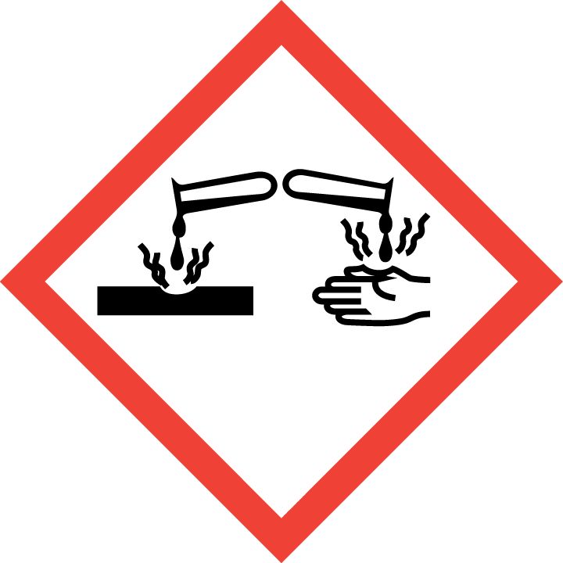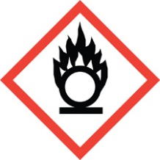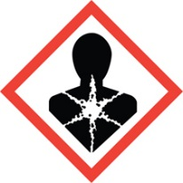

Hazard Statements: H302 Harmful if swallowed.
H318 Causes serious eye damage.
H272 May intensify fire; oxidizer.

Precautionary Statements:

Prevention P210 Keep away from heat/sparks/open flames/hot surfaces. No smoking
P221 Take any precaution to avoid mixing with combustibles.
P280 Wear protective gloves/ protective clothing/eye protection/ face protection.

Response P310 Immediately call a POISON CENTRE or doctor/physician.
P305+P351+P338 If in EYES: Rinse cautiously with water for several minutes. Remove contact lenses, if present and easy to do. Continue rinsing.

Disposal P501 Dispose of contents/container to an approved waste disposal plant.

SECTION 3 - COMPOSITION / INFORMATION ON INGREDIENTS

Ingredients | CAS Number | Proportion
SODIUM PERCARBONATE | 15630-89-4 | >60%
Ingredients determined to be non-hazardous | Various | To 100%

SECTION 4 - FIRST AID MEASURES
If poisoning occurs contact a Doctor immediately or the Poisons Information Centre on 131126.
- First Aid Facilities: Normal washroom facilities / Eye wash station / Safety shower
- Eye Contact: Rinse eyes immediately (including under eye lids) for at least 20 minutes with
running water while holding eyelids open.. Seek medical advice immediately.
- Skin Contact: Remove all contaminated clothing and footwear. Wash the skin with plenty of
water and mild detergent for at least 20 minutes. Seek medical advice immediately. Fully launder clothes before re-use.
- Ingestion: DO NOT INDUCE VOMITING. Seek medical advice immediately. Do NOT
attempt to give anything by mouth to an unconscious person. Rinse mouth with water. Give water to drink. If vomiting occurs, give further water to dilute.
- Inhalation: Remove to fresh air. Seek medical advice immediately. If not breathing
provide artificial respiration.
- Advice to Doctor: Treat symptomatically. All treatments should be based on observation and
symptoms of distress.
SECTION 5 - FIRE FIGHTING MEASURES
- Extinguishing Media: Use water spray, alcohol-resistant foam, dry chemical or carbon dioxide.
- Hazards from Combustion
Products: Fire may produce irritating, corrosive and/or toxic gases. Decomposition releases
steam/heat.
- Fire Fighters: Fire fighters to wear full protective clothing and self-contained breathing apparatus. Move upwind of fire. Keep containers that are exposed to heat cool with water spray.
- Hazchem Code: 1Y
- Flashpoint: No data available.

SECTION 6 - ACCIDENTAL RELEASE MEASURES
- Emergency Procedures: Evacuate all unnecessary personnel.
- Methods and Materials for
Containment and Clean Up: Minor spills normally do not require any special clean up measures. In the event of a major spill prevent spillage from entering drains, water courses, sewers or any body of water. Wear protective equipment (as per section 8) to prevent skin and eye contamination. Contain and absorb any spillage with sand, earth or inert material. Scoop into a sealable container for disposal by an approved agent according to local conditions. Any residual deposits may be slippery. Wash down all areas with water. If contamination of sewers or waterways has occurred notify your local emergency services.

SECTION 7 HANDLING AND STORAGE
- Handling: Keep out of reach of children. When handling do not eat, drink or smoke.
Avoid contact with skin, eyes and do not inhale. Use in a well-ventilated area. Do not add water directly to the product. Add product slowly into water. Wash hands with water after handling.
- Storage: Store in a cool, well ventilated, dry place away from direct sunlight. Keep
container closed at all times.
- Container: Do not leave container open. Avoid formation of dust and aerosols. Container type
Packaging must comply with all applicable local legislation. Store in original
container
SECTION 8 EXPOSURE CONTROLS / PERSONAL PROTECTION
- Exposure standards: There are no exposure standards available for this product. Individual components
Exposure standards – Dust not otherwise specified is 3mg/m³ for respirable dust.
- Biological limit values: None established for this product.
- Engineering controls: Ensure ventilation is adequate and avoid generating mists of the product. Ensure
eyewash and/or a safety shower in working area. Keep container closed when not in use.
- Personal Protective Equipment:
Eye protection: Avoid contact with eyes. The use of safety goggles/ glasses with side protection is recommended.
Skin Protection: Wear chemical resistant gloves, overalls, apron and appropriate footwear.
Respiratory: If ventilation is inadequate wear a respirator to protect against exposure to high vapour concentrations. Respirators should comply with AS/NZS 1715 and AS/NZS 1716.
Other: Do not eat, drink or smoke whilst handling product. Wash hands after use.



SECTION 9 - PHYSICAL AND CHEMICAL PROPERTIES
- Appearance: White granular powder.
- Odour: No scent.
- pH: 10.
- Vapour Pressure: Not available.
- Vapour Density: Not available.
- Boiling Point: Not applicable.
- Freezing/Melting Point: Not available.
- Solubility: Soluble in water.
- Specific Gravity: Not available.
- Flash Point: Not flammable.
- Flammability limits: Not available.
SECTION 10 - STABILITY AND REACTIVITY

- Chemical stability: Stable at normal temperatures and pressure.
- Conditions to avoid: Avoid moisture. Avoid temperatures above 60 deg C, direct sunlight and contact with sources
Of heat.
- Incompatible materials: Acids, metal salts, Reducing agents. Organic materials. Flammable substances
- Hazardous decomposition
products: Can be released in case of fire. Carbon monoxide and carbon dioxide, sodium oxide.
- Hazardous reactions: Reacts vigorously with acids.
SECTION 11 - TOXICOLOGICAL INFORMATION

- Ingestion: Harmful if swallowed. Severe irritation of the mouth,throat esophagus and stomach.
Bloating of stomach, belching, nausea, vomiting and diarrhea.
- Skin Contact: May cause skin irritation when exposed for long periods of time. Slight irritation.
- Eye Contact: Severe eye irritation, watering and redness, can cause burns to the eye..
- Inhalation: Slight nose and throat irritation. At high concentrations, cough. In case of repeated or
Prolonged exposure risk of sore throat, nose bleeds, chronic bronchitis.
SECTION 12 - ECOLOGICAL INFORMATION

- Ecotoxicity: None available.
- Persistence and degradability: Sodium percarbonate dissociates in water into hydrogen peroxide and sodium
Carbonate. Hydrogen peroxide is rapidly degraded in a biological waster water
Treatment plant.
- Bioaccumulative potential: Both sodium carbonate and hydrogen peroxide are inorganic chemicals which
Do not bioaccumulate.
- Mobility: None available
This product is soluble in water. Do not discharge bulk quantities into drains, waterways, sewer or environment. Notify your local authority if this occurs.
SECTION 13 - DISPOSAL CONSIDERATIONS
- Disposal: To dispose of quantities of undiluted product refer to your State Land Waste
Management Authority. Do not discharge product into drains or waterways. Dispose of material through a licensed accredited waste disposal contractor.
SECTION 14 - TRANSPORT INFORMATION

- UN Number: 3378
- UN Proper Shipping Name: Sodium carbonate peroxyhydrate
- Class and Subsidiary Risk: 5.1 Oxidising Substance
- Packing Group: II
- Hazchem Code: 1Y
- Special precautions: None.

SECTION 15 - REGULATORY INFORMATION

- SUSMP Classification: 6 Poison
- Regulatory Information: Hazardous according to the criteria of the Globally Harmonised System of Classification and Labelling of Chemicals (GHS).

SECTION 16 - OTHER INFORMATION

- Issue Date: November 2016
- Version No. 1.0
- Revision Date: 7th April 2021

This SDS summarises at the date of issue our best knowledge of the health and safety hazard information of the product and how to safely handle and use the product in the workplace. Since the supplier and/or distributor cannot anticipate or control the conditions under which the product may be used, every user must prior to usage review this SDS in the context of how the user intends to handle and use the product in the workplace. If clarification or further information is required to ensure that an appropriate risk assessment can be made, the user should contact this company.
END OF SDS

