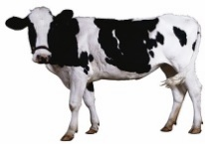
MIDLAND COUNTY LIVESTOCK YOUTH REGISTRATION DAIRY

CLUB__________________________________________________________________
LEADER/S___________________________________ PHONE #: ________________________ EMAIL______________________________
*(THIS FORM IS ONLY FOR DAIRY ANIMALS, DO NOT PUT ANOTHER SPECIES. MARKET OR BREEDING ON THIS FORM)
**(ONLY PUT ONE ANIMAL PER LINE)
Youth’s Name  Address, City, Zip | Parent or Guardian’s Name | Description of animal: breed, color, sex, age | Tag # | USDA # | Midland County Special  (Yes / No)

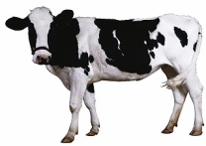
DAIRY
Youth’s Name  Address, City, Zip | Parent or Guardian’s Name | Description of animal: breed, color, sex, age | Tag # | USDA # | Midland County Special  (Yes / No)
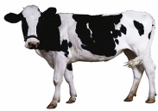 DAIRY
Youth’s Name  Address, City, Zip | Parent or Guardian’s Name | Description of animal: breed, color, sex, age | Tag # | USDA # | Midland County Special  (Yes / No)
DEADLINES (current fair year)
Market Beef – must be tagged by April 15 and paperwork emailed to Lori Anger, or the Midland Fair by April 22
Market Swine – must be tagged by June 15 and paperwork emailed to Lori Anger, or the Midland Fair by June 25
Market Lambs – must be tagged by June 15 and paperwork emailed to Lori Anger, or the Midland Fair by June 25
Breeding Beef, Prospect Beef, Breeding Sheep and Dairy - forms will need to be emailed to Lori Anger, or the Midland Fair by June 25
Completed forms should be emailed to the Youth Exhibit Office (PLEASE SEND TO BOTH EMAILS):
Lori Anger – dnganger@gmail.com you may reach Lori at (989) 600-2523
Midland Fair – Info@midlandfair.net
If email is not available mail the paper copy to the Youth Office Midland Fairgrounds 6905 Eastman Ave. Midland, MI 48642 by the required date.

Please use a separate form for each, beef, sheep, swine as well as breeding stock.
Leaders signature: _______________________________________________________ Date: ________________________
Date Received by official: ______________________ Received by: __________________________________________

