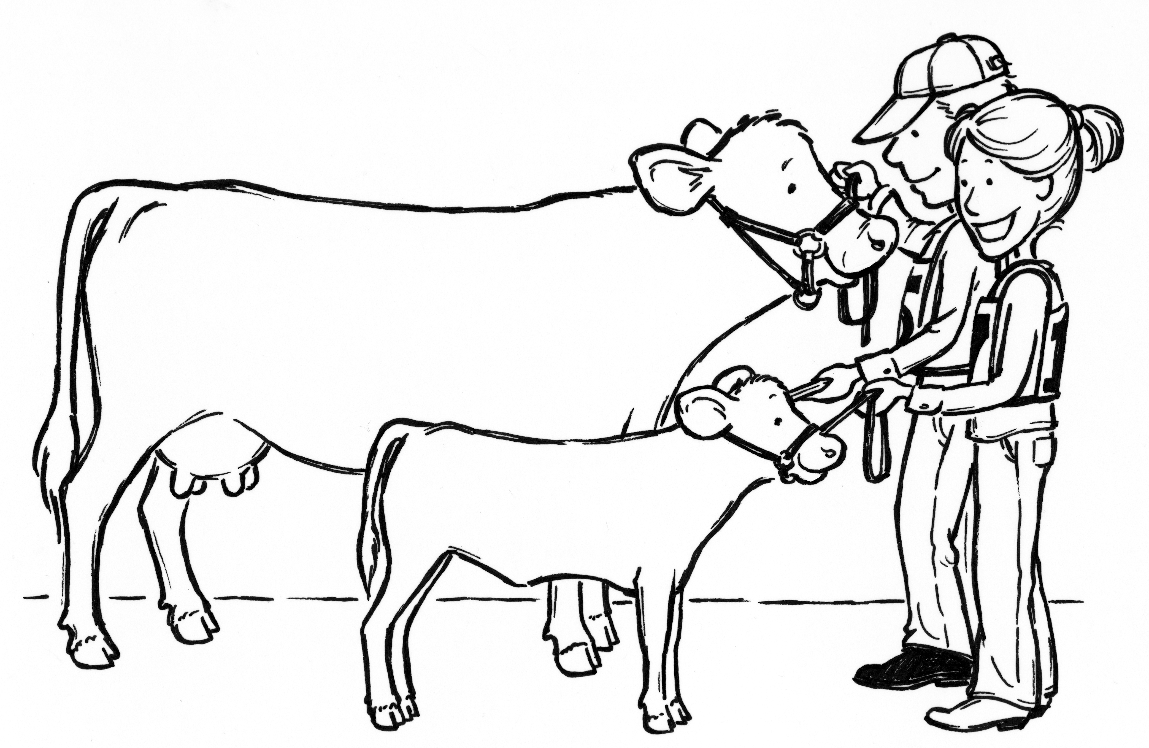
LIVESTOCK YOUTH REGISTRATION BREEDING BEEF

PARENT VOLUNTEER(S): __________________________________________
PHONE #: ____________________________________ EMAIL: ______________________________________ (if applicable)
*(THIS FORM IS ONLY FOR BREEDING BEEF, DO NOT PUT ANOTHER SPECIES OR BREEDING ON THIS FORM)
**(ONLY PUT ONE ANIMAL PER LINE)
Youth’s Name  Address, City, Zip | Parent or Guardian’s Name | Description of Animal (Color, Sex & Age) | Tag # | USDA # | Midland County Special  (Yes / No)

BREEDING BEEF
Youth’s Name  Address, City, Zip | Parent or Guardian’s Name | Description of Animal (Color, Sex & Age) | Tag # | USDA # | Midland County Special  (Yes / No)
BREEDING BEEF
Youth’s Name  Address, City, Zip | Parent or Guardian’s Name | Description of Animal (Color, Sex & Age) | Tag # | USDA # | Midland County Special  (Yes / No)
DEADLINES (current fair year)
Market Beef – must be tagged by April 15 and paperwork emailed to Lori Anger, or the Midland Fair by April 22
Market Swine – must be tagged by June 15 and paperwork emailed to Lori Anger, or the Midland Fair by June 25
Market Lambs – must be tagged by June 15 and paperwork emailed to Lori Anger, or the Midland Fair by June 25
Breeding Beef, Prospect Beef, Breeding Sheep and Dairy - forms will need to be emailed Lori Anger, or the Midland Fair by June 25
Completed forms should be emailed (SEND TO BOTH EMAILS) to the Youth Exhibit Office:
Lori Anger – dnganger@gmail.com you can reach Lori at (989) 600-2523
Midland Fair – Info@midlandfair.net
If email is not available mail the paper copy to the Youth Office: Midland Fairgrounds 6905 Eastman Ave. Midland, MI 48642 by the required date.

Please use a separate form for each, beef, prospect beef, sheep, swine as well as breeding stock.
Parent/Volunteer’s Signature: _______________________________________________________ Date: ________________________
Date Received by official: _____________________ Received by: __________________________________________

