Saint Mary Catholic Church
701 East Third Street, Wilton, IA 52778

23rd Sunday Ordinary Time – September 6, 2026
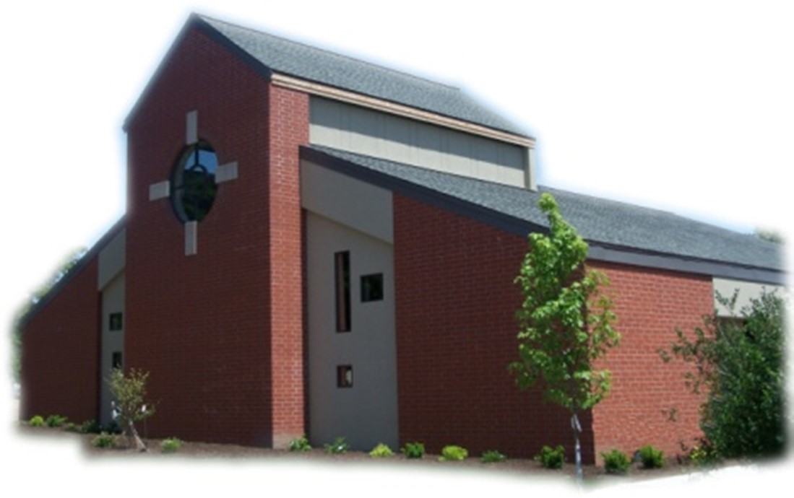

Sacramental Priest, Rev. Robert “Bud” Grant Email: grantrobert@sau.edu

Priest Moderator, Rev. Dale Mallory Email: malloryd@diodav.org

Parish Life Coordinator, Deacon Dan Freeman
Cell - 563-320-2462 Email: wiltonstmary@diodav.org

Office Manager - Rosemary Sullivan Director of Religious Education – Elizabeth Walker
C- 563-723-1050 /wiltonstmaryfin@diodav.org C- 563-260-3675/wiltonstmarydre@diodav.org

Mass Time: Sunday – 8:30 a.m.
Religious Education Classes start at 9:30 am during the school year.

Website: https://www.stmarywilton.org Facebook Page - https://www.facebook.com/stmarysofwilton
Today’s Readings – 9-6-26. On this Labor Day weekend we call to mind all those whose work makes our lives better and easier, from members of our family to people in our community, to people around the world. Even as we labor ourselves in service of one another, we are also called to labor in the vineyard to help build God’s kingdom. Today’s readings remind us that we are responsible for each other, that we cannot give up on others just because we disagree with them or they have hurt us. This weekend, as we appreciate and thank others for their labor, let us reconcile with those who have offended us, and so work to build up the entire kingdom of God. Question of the Week - When have I been reluctant to correct someone who has done something wrong? Have I considered doing so in an effort to put them on a path to forgiveness?

Welcome New Family – Jessica & Matt Coussens and daughters Kenzie and Kortney. Thank you for joining us!

St. Mary Parish Schedule:
- Sun Sep 6th Mass. Labor Day weekend.
- Sun Sep 13th Mass. Parish/Finance Councils meet after Mass. RE Classes start.
  - Parent meeting for all Religious Ed. Pre-K – Grade 6, 9:30 am in the Church. Parent meeting for Conformation Class to be held in the Annex Building, 1st floor.
- Sun Sep 20th Mass. RE Classes.
- Sun Sep 27th Mass. Priesthood Sunday. RE Classes. Catechetical Sunday – bless Students & Teachers. 2026-27 ADA Kick off. Altar Server training after RE Classes.
- Sun Oct 4th Mass of Creation. RE Classes - Vocations presentation?
- Wed Oct 7th Faith Formation Committee at 5:30 pm.

Donuts & Coffee every Sunday!!! Serve Donuts & Coffee and clean up after Mass. Parents of RE students sign up for the RE Sundays, Parishioners sign up for those Non-RE Sundays. Signup sheets in the Gathering Area. Donuts & Coffee begins on Sunday, September 13th. We also need volunteers to pick up the Donuts on the Saturday before – contact Jessica Williams.

Parish Breakfast Potluck & Cleanup Day – Sunday, October 25th after Mass we will have a Breakfast Potluck, the Parish will provide the meat, drinks, and table service. A Parish Cleanup Day will be held after the Potluck so bring/wear your work clothes. Details to follow.

Catholic Rural Life Mass of Thanksgiving will be held on Saturday, November 14, 2026, starting at 4:00 pm. Location is at the Seed barn of Terri and Jim Lilienthal, 2106 Yankee Avenue, Durant, IA 52747 – a big brown barn just north of I80 and on the right side of the road. Handicap Parking will be available. We will share a Potluck Supper after Mass, so bring your best dish! St. Mary will provide the table service. We will be in a partially heated building.

Holy Communion - Parishioners that are homebound or hospitalized may request that Holy Communion be brought to them after Mass on Sunday, or other days as necessary. Please contact Deacon Dan at 563-320-2462 or wiltonstmary@diodav.org with your request.

Aspire to be a Deacon. Inquiry Sessions are scheduled. For more information, please see the Class X webpage: https://www.davenportdiocese.org/class-x. Contact Deacon Dan with any questions.

Iowa Concern - When Life Gets Tough, Iowa Concern Can Help. Sometimes life gives you a lot to handle. Call 800-447-1985 or visit the Iowa Concern website.

OCIA stands for the Order of Christian Initiation of Adults. It’s a process through which non-baptized or baptized non-Catholic men and women enter the Catholic Church. It includes several stages marked by Study, Prayer, and Rites at Mass. Anyone interested in learning more about, or joining our Catholic Faith please contact Deacon Dan. Classes will start in August of 2026.

Impact the Church of tomorrow by naming St. Mary as a beneficiary of your retirement plan is an easy way to make a gift that costs you nothing now.
Christian Initiation Classes – Helping those Becoming Catholic or Joining the Catholic Church. Candidates, Sponsors, & Friends invited. All sessions are in the Parish Hall. Everyone is invited.
- Tue Sep 15th 5:30 pm Josh Smyser & Jet Riley – Ch 7 - People of God & Community
- Tue Sep 29th 5:30 pm Fr. Bud Ch 3 & 4 – Jesus, Lord, Messiah, Teacher & Savior.

Disability Advocate Minister – for our St. Mary Parish is someone who helps identify and remove obstacles for our Parishioners and visitors as they participate in the worship and praise activities of our Lord and Savior. If you are interested in this volunteer position please contact Deacon Dan.

Family Prayer for Vocations. Lord, help us to know more clearly the work you have called us to do in life. And grant us the graces we need to fulfill this call with courage, love, and a genuine dedication to your will. If it is your will to choose someone from our family to be a priest, sister, or brother, we thank you and we rejoice. Finally, we ask you to help us be a living example of your unselfish love. Amen.

New & Updated Iowa Catholic Radio App begins September 1st. New Features - built for the car - Full Car Play support puts the live streams and your shows on the dashboard display, so you can keep your hands on the wheel and your eyes on the road. Built for listening; • Audio keeps playing while you use other apps or lock your phone, with full controls on the lock screen, • Skip forward and back, adjust playback speed, and pick up where you left off, • Search every show and episode by name, • Share an episode with a friend in a couple of taps. The app is Iowa Catholic Radio. The website is; https://www.iowacatholicradio.com/.

We are updating our Facebook page and our St. Mary Website. Please check it out. The Parish Monthly Calendar on the Website is current and reflects the Parish activities and meetings.
https://www.stmarywilton.org/

Prayer Chain – to submit a name please contact Colleen Nichols at 563-260-2212.

Mass Intention for Sunday, September 13, 2026 – Martha Timmerman
Lay Mass Ministers for Sunday, September 13, 2026.
Announcer & 1st Reading – Madison Smyser 2nd Reading – Amanda Kitzmiller
EMHC – Darcy Wolf & Amanda Rockow Gift Bearers – Amanda & Dyllin Kitzmiller
Ushers – Dennis Sass & Joe Kaufman Servers – Ruth & Amelia Costello & Rosa Koopmann
Homebound Communion Minister – Deacon Dan Freeman

Mass Intentions for the deceased are $10.00 each. Please indicate who the Mass is for, who requested it, and how many Masses are requested. We will try to honor requested Mass dates.

To report child abuse, contact the Iowa Dept. of Human Services Child Abuse hotline: 800-362-2178. If clergy or church personnel are involved also notify Alicia Owens, Victim Assistance Coordinator, 563-349-5002; vac@diodav.org or 780 W. Central Park Ave., Davenport, IA 52804.

New Parishioners: Please complete the Registration form online at https://www.stmarywilton.org/ or request a form after Mass. The completed form may be placed in the Contribution Basket or given to Deacon Dan. See the contact information on the Bulletin to contact me with any questions.
Envelopes – If you are not receiving Parish Contribution Envelopes, please contact Deacon Dan.

Loss of Pregnancy or Infertility – you are not alone. Our Catholic faith offers hope, consolation, and support for those who have experienced infertility or loss of a pregnancy. Please feel free to contact Father Bud or me. Also a great resource is this website - https://springsinthedesert.org.

Questions about our Faith – here’s your chance to ask any question pertaining to the Catholic Church and our Catholic Faith that you are curious about. Simply email your question to wiltonstmary@diodav.org and it will be answered in the Bulletin anonymously.

Prayers are requested for Cameron Costello and all the Seminarians of the Davenport Diocese. We also pray for the 11 men in Diaconate Formation to be Ordained July 2027.

Our Lady of the Prairie – Retreat at 2664 145th Avenue, Wheatland, Iowa 52777. Details and register at www.theprairieretreat.org, or email – olpretreat@chmiowa.org, or call 563-374-1092.
- 4pm Friday - 11am Sunday, Sept. 25-27. Grace at the Edge of Life: Finding Hope and Meaning in Life’s Endings by Lori Erickson. Reflect on life’s endings in the light of grace; through storytelling, scripture, quiet reflection, and shared conversations, participants will be invited to release fear, deepen their trust in God’s presence. $200
- Wed., Sept. 23rd at 10-4. Rooted – Invitation of Science, Nature and Spirit by Kim Novak. Consider ways that science, nature and spirit invite us to listen, wander, relate, speak and grow in ways that keep us “co-creating” throughout our lives, even in times fraught with disease. $50

Project Rachel Ministry is a confidential, post-abortion healing ministry of the Catholic Church offering hope and healing to women and men hurting from past abortions. Project Rachel staff understand the emotional pain that follows an abortion. Helpline: 563-333-4107. E-Mail: projectrachel@diodav.org. Calls answered personally Monday, Wednesday and Friday, 9 am to 3 pm. Voice messaging available all other times. All calls returned promptly and discreetly.

Communion Rite videos - How to Receive the Body of Christ – (4.75 minutes – from Busted Halo.) www.stcroixcatholic.org/apps/video/watch.jsp?v=64276. How to receive the Blood of Christ (1 minute) https://www.youtube.com/shorts/xgCsaYzd0I4?feature=share. These videos offer great information regarding properly receiving the Holy Eucharist.

Fighting to break free from pornography? Get Help! https://integrityrestored.com/ or https://www.strive21.com/, or https://www.covenanteyes.com/. Call 563-334-4505 for a local group.

2026-27 Parish Leadership Team

Trustees: (2 year term – max 4 terms)
Denise Timmerman (24) 563-349-3880 denisetimmerman13@gmail.com
Henry Bentley (24) 563-340-3111 henrybentley1961@outlook.com
Parish Council: (2 year term – max 2 terms)
Jessica Williams (25) Chair/At Large 563-320-3699 jesss_99@yahoo.com
Andrew Koopmann (26)Vice Chair/Secretary 563-920-2993 ajkoop88@gmail.com
Taci Lilienthal (25) At Large 563-343-1144 taci.lilienthal@gmail.com
Damon Boorn (24) At Large 563-260-9816 damon.boorn@gmail.com
Jeremiah Costello (23) Faith Formation 563-370-2065 Jeremiahecostello@gmail.com
Scott Wolf Cemetery 563-370-3734 srwolf64@gmail.com
Jim Gavin Bldg. & Grounds 563-506-5112 gavinjames@netwtc.net
Dennis Sass Liturgy 319-430-2063 dwsass51@gmail.com
Finance Council: (4 year term – max 2 terms)
Andrea Shaffer (24) Chair 563-299-5632 shafferauto06@gmail.com
Eric Thornton (25) 563-299-4624 eric6982@hotmail.com
John Kuhl (26) 563-320-7433 johnkuhl@kentww.com

