Saint Mary Catholic Church
701 East Third Street, Wilton, IA 52778

24th Sunday Ordinary Time – September 13, 2026
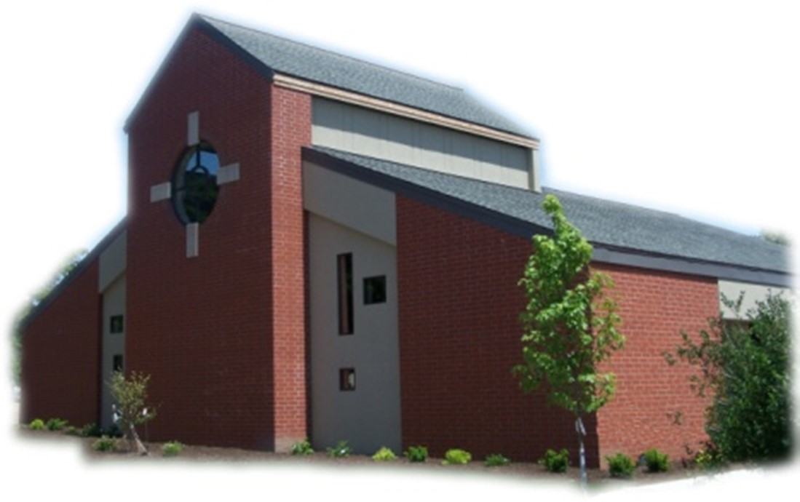

Sacramental Priest, Rev. Robert “Bud” Grant Email: grantrobert@sau.edu

Priest Moderator, Rev. Dale Mallory Email: malloryd@diodav.org

Parish Life Coordinator, Deacon Dan Freeman
Cell - 563-320-2462 Email: wiltonstmary@diodav.org

Office Manager - Rosemary Sullivan Director of Religious Education – Elizabeth Walker
C- 563-723-1050 /wiltonstmaryfin@diodav.org C- 563-260-3675/wiltonstmarydre@diodav.org

Mass Time: Sunday – 8:30 a.m.
Religious Education Classes start at 9:30 am during the school year.

Website: https://www.stmarywilton.org Facebook Page - https://www.facebook.com/stmarysofwilton
Today’s Readings – 9-13-26. We are reminded today of how important it is to forgive one another. When Peter asks Jesus how many times he needs to forgive someone, Jesus tells him not seven times, but seventy-seven times. He is essentially saying that there is no limit that should be put on forgiveness. After all, the Lord forgives us all constantly. And we need it! It’s the least we can do to forgive someone who has hurt us. Let us call to mind our own sins and our own need for forgiveness even as we consider those to whom we should offer that same gift. Question of the Week - Reconciliation means making a relationship whole again. Whom do I need to forgive to make our relationship whole once more?

On this 25th Anniversary of the 9/11 Terrorist Attack we remember those who have been lost and those who still suffer. May we all work and pray for peace throughout our world and in our minds and hearts. And may we forgive others as we ourselves ask for forgiveness.

St. Mary Parish Schedule:
- Sun Sep 13th Mass. Parish/Finance Councils meet after Mass. RE Classes start.
  - Parent meeting for all Religious Ed. Pre-K – Grade 6, 9:30 am in the Church. Parent meeting for Conformation Class to be held in the Annex Building, 1st floor.
- Sun Sep 20th Mass. RE Classes.
- Sun Sep 27th Mass. Priesthood Sunday. RE Classes. Catechetical Sunday – bless Students & Teachers. 2026-27 ADA Kick off. Altar Server training after RE Classes.
- Sun Oct 4th Mass of Creation. RE Classes - Vocations presentation.
- Wed Oct 7th Faith Formation Committee at 5:30 pm.

Christian Initiation Classes – Helping those Becoming Catholic or Joining the Catholic Church. Candidates, Sponsors, & Friends invited. All sessions are in the Parish Hall. Everyone is invited.
- Tue Sep 15th 5:30 pm Josh Smyser & Jet Riley – Ch 7 - People of God & Community
- Tue Sep 29th 5:30 pm Fr. Bud Ch 3 & 4 – Jesus, Lord, Messiah, Teacher & Savior.

Donuts & Coffee every Sunday!!! Serve Donuts & Coffee and clean up after Mass. Parents of RE students sign up for the RE Sundays, Parishioners sign up for those Non-RE Sundays. Signup sheets in the Gathering Area. Donuts & Coffee begins on Sunday, September 13th. We also need volunteers to pick up the Donuts on the Saturday before – contact Jessica Williams.

Parish Breakfast Potluck & Cleanup Day – Sunday, October 25th after Mass we will have a Breakfast Potluck. The Parish will provide the meat, drinks, and table service. A Parish Cleanup Day will be held after the Potluck so bring/wear your work clothes. Details to follow.

Catholic Rural Life Mass of Thanksgiving will be held on Saturday, November 14, 2026, starting at 4:00 pm. Location is at the Seed barn of Terri and Jim Lilienthal, 2106 Yankee Avenue, Durant, IA 52747 – a big brown barn just north of I80 and on the right side of the road. Handicap Parking will be available. We will share a Potluck Supper after Mass, so bring your best dish! St. Mary will provide the table service. We will be in a partially heated building.

2026-27 ADA Kickoff Sunday, September 27th our parish will join churches throughout the Diocese of Davenport in the Annual Diocesan Appeal. As Bishop Dennis Walsh reminds us, while each parish has its own unique ministries, we are united as one diocesan family. Through the ADA, we support ministries that form future priests and deacons, strengthen families, nurture faith at every age, care for those in need, and provide resources that benefit every parish. Thank you for prayerfully considering your participation in this year’s Appeal. Every gift, regardless of size, helps continue Christ’s mission throughout Southeast Iowa. St. Mary ADA goal for 2026-27 is $24,954.

Vocations Speaker – Sunday, October 4th after Mass, Sister Boby of the Benedictine St. Mary Monastery of Rock Island, IL will speak to us about vocations in general, her own experiences along with how and when she heard God calling her. Our own Terry Martz will speak about the Oblate Program also.

Aspire to be a Deacon. Inquiry Sessions are scheduled. For more information, please see the Class X webpage: https://www.davenportdiocese.org/class-x. Contact Deacon Dan with any questions.

Iowa Concern - When Life Gets Tough, Iowa Concern Can Help. Sometimes life gives you a lot to handle. Call 800-447-1985 or visit the Iowa Concern website.

Mass Ministry Schedule for October & November will be completed soon. Please email Denise Timmerman at Denisetimmerman13@gmail.com if you will NOT be able to serve. Thank you!

Disability Advocate Minister – for our St. Mary Parish is someone who helps identify and remove obstacles for our Parishioners and visitors as they participate in the worship and praise activities of our Lord and Savior. If you are interested in this volunteer position please contact Deacon Dan.

Impact the Church of tomorrow by naming St. Mary as a beneficiary of your retirement plan is an easy way to make a gift that costs you nothing now.

New & Updated Iowa Catholic Radio App begins September 1st. New Features - built for the car - Full Car Play support puts the live streams and your shows on the dashboard display, so you can keep your hands on the wheel and your eyes on the road. Built for listening; • Audio keeps playing while you use other apps or lock your phone, with full controls on the lock screen, • Skip forward and back, adjust playback speed, and pick up where you left off, • Search every show and episode by name, • Share an episode with a friend in a couple of taps. The app is Iowa Catholic Radio. The website is; https://www.iowacatholicradio.com/.

Holy Communion - Parishioners that are homebound or hospitalized may request that Holy Communion be brought to them after Mass on Sunday, or other days as necessary. Please contact Deacon Dan at 563-320-2462 or wiltonstmary@diodav.org with your request.

Mass Intention for Sunday, September 20, 2026 – Jim Koopmann
Lay Mass Ministers for Sunday, September 20, 2026.
Announcer & 1st Reading – Kinley Boorn 2nd Reading – Renee Cooley
EMHC – Rick Janney & Henry Bentley Gift Bearers – Jamey Meyer Family
Ushers – Andy Koopmann & Fred Grunder Servers – Colin & Connor Thornton & Zack Grotzky
Homebound Communion Minister – Colleen Nichols

Mass Intentions for the deceased are $10.00 each. Please indicate who the Mass is for, who requested it, and how many Masses are requested. We will try to honor requested Mass dates.

To report child abuse, contact the Iowa Dept. of Human Services Child Abuse hotline: 800-362-2178. If clergy or church personnel are involved also notify Alicia Owens, Victim Assistance Coordinator, 563-349-5002; vac@diodav.org or 780 W. Central Park Ave., Davenport, IA 52804.

New Parishioners: Please complete the Registration form online at https://www.stmarywilton.org/ or request a form after Mass. The completed form may be placed in the Contribution Basket or given to Deacon Dan. See the contact information on the Bulletin to contact me with any questions.
Envelopes – If you are not receiving Parish Contribution Envelopes, please contact Deacon Dan.

Sacraments - to schedule participation in any of these please contact Deacon Dan:
- Confession – email Father Bud at grantrobert@sau.edu for times prior/after Mass.
- Baptism – A prep class required for family’s first child. Contact Deacon Dan 1 month prior.
- Marriage – contact Deacon Dan a minimum of 7 months prior to the proposed event.
- Anointing – Anyone having surgery or experiencing illness may ask for the Rite of Anointing of the Sick. Father Bud will anoint immediately after Mass. Contact Deacon Dan.
- Funeral Preparation – please contact Deacon Dan. A great booklet is available to help.

Prayers are requested for Cameron Costello and all the Seminarians of the Davenport Diocese. We also pray for the 11 men in Diaconate Formation to be Ordained July 2027.

Prayer Chain – to submit a name please contact Colleen Nichols at 563-260-2212.

Our Lady of the Prairie – Retreat at 2664 145th Avenue, Wheatland, Iowa 52777. Details and register at www.theprairieretreat.org, or email – olpretreat@chmiowa.org, or call 563-374-1092.
- 4pm Friday - 11am Sunday, Sept. 25-27. Grace at the Edge of Life: Finding Hope and Meaning in Life’s Endings by Lori Erickson. Reflect on life’s endings in the light of grace; through storytelling, scripture, quiet reflection, and shared conversations, participants will be invited to release fear, deepen their trust in God’s presence. $200
- Wed., Sept. 23rd at 10-4. Rooted – Invitation of Science, Nature and Spirit by Kim Novak. Consider ways that science, nature and spirit invite us to listen, wander, relate, speak and grow in ways that keep us “co-creating” throughout our lives, even in times fraught with disease. $50

Family Prayer for Vocations. Lord, help us to know more clearly the work you have called us to do in life. And grant us the graces we need to fulfill this call with courage, love, and a genuine dedication to your will. If it is your will to choose someone from our family to be a priest, sister, or brother, we thank you and we rejoice. Finally, we ask you to help us be a living example of your unselfish love. Amen.

We are updating our Facebook page and our St. Mary Website. Please check it out. The Parish Monthly Calendar on the Website is current and reflects the Parish activities and meetings.

Project Rachel Ministry is a confidential, post-abortion healing ministry of the Catholic Church offering hope and healing to women and men hurting from past abortions. Project Rachel staff understand the emotional pain that follows an abortion. Helpline: 563-333-4107. E-Mail: projectrachel@diodav.org. Calls answered personally Monday, Wednesday and Friday, 9 am to 3 pm. Voice messaging available all other times. All calls returned promptly and discreetly.

Communion Rite videos - How to Receive the Body of Christ – (4.75 minutes – from Busted Halo.) www.stcroixcatholic.org/apps/video/watch.jsp?v=64276. How to receive the Blood of Christ (1 minute) https://www.youtube.com/shorts/xgCsaYzd0I4?feature=share. These videos offer great information regarding properly receiving the Holy Eucharist.

Fighting to break free from pornography? Get Help! https://integrityrestored.com/ or https://www.strive21.com/, or https://www.covenanteyes.com/. Call 563-334-4505 for a local group.

2026-27 Parish Leadership Team
Trustees: (2 year term – max 4 terms)
Denise Timmerman (24) 563-349-3880 denisetimmerman13@gmail.com
Henry Bentley (24) 563-340-3111 henrybentley1961@outlook.com
Parish Council: (2 year term – max 2 terms)
Jessica Williams (25) Chair/At Large 563-320-3699 jesss_99@yahoo.com
Andrew Koopmann (26)Vice Chair/Secretary 563-920-2993 ajkoop88@gmail.com
Taci Lilienthal (25) At Large 563-343-1144 taci.lilienthal@gmail.com
Damon Boorn (24) At Large 563-260-9816 damon.boorn@gmail.com
Jeremiah Costello (23) Faith Formation 563-370-2065 Jeremiahecostello@gmail.com
Scott Wolf Cemetery 563-370-3734 srwolf64@gmail.com
Jim Gavin Bldg. & Grounds 563-506-5112 gavinjames@netwtc.net
Dennis Sass Liturgy 319-430-2063 dwsass51@gmail.com
Finance Council: (4 year term – max 2 terms)
Andrea Shaffer (24) Chair 563-299-5632 shafferauto06@gmail.com
Eric Thornton (25) 563-299-4624 eric6982@hotmail.com
John Kuhl (26) 563-320-7433 johnkuhl@kentww.com

