Saint Mary Catholic Church
701 East Third Street, Wilton, IA 52778

22nd Sunday in Ordinary Time - August 30, 2026
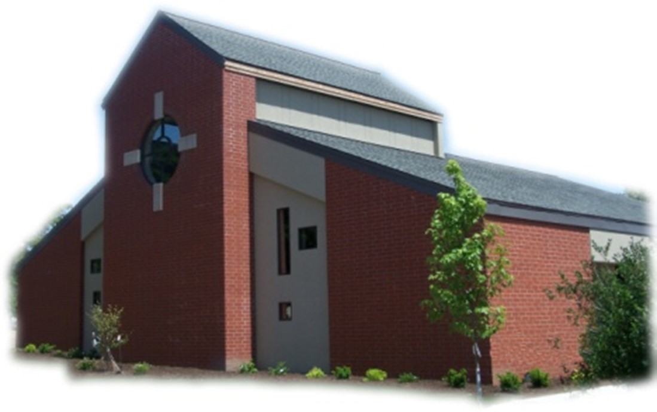

Sacramental Priest, Rev. Robert “Bud” Grant Email: grantrobert@sau.edu

Priest Moderator, Rev. Dale Mallory Email: malloryd@diodav.org

Parish Life Coordinator, Deacon Dan Freeman
Cell - 563-320-2462 Email: wiltonstmary@diodav.org

Office Manager - Rosemary Sullivan Director of Religious Education – Elizabeth Walker
C- 563-723-1050 /wiltonstmaryfin@diodav.org C- 563-260-3675/wiltonstmarydre@diodav.org

Mass Time: Sunday – 8:30 a.m.
Religious Education Classes start at 9:30 am during the school year.

Website: https://www.stmarywilton.org Facebook Page - https://www.facebook.com/stmarysofwilton
Today’s Readings – 8-30-26. In today’s Gospel, Jesus challenges us as his disciples to deny ourselves, take up our crosses, and follow him. None of these actions is easy. To put God’s will before our own, to willingly accept what will make us suffer, and to follow someone who was put to death on the cross, is very difficult. But we will not be alone, for Jesus is with us as we follow him. Also, as he tells us in the Beatitudes, our reward will be great in heaven. Let us realize his real presence as we celebrate and receive the Eucharist. Question of the Week - When have I been reluctant or unable to resist pressure to conform to society’s expectations?

New Families Welcome – Megan & Jared Varhasselt with June & Ellie of Durant and Joyce & Kimberly Freeland with Nesha, Kynlee & Kamari of Wilton. Thank you for joining us!

St. Mary Parish Schedule:
- Sun Aug 30th Mass. RE Registration. Teacher Inservice after Mass in the Parish Hall.
- Wed Sep 2nd Faith Formation Committee meeting at 5:30 pm.
- Sun Sep 6th Mass. Labor Day weekend.
- Sun Sep 13th Mass. Parish/Finance Councils meet after Mass. RE Classes start.
  - Parent meeting for all Religious Ed. Pre-K – Grade 6, 9:30 am in the Church. Parent meeting for Conformation Class to be held in the Annex Building, 1st floor.
- Sun Sep 20th Mass. RE Classes.
- Sun Sep 27th Mass. Priesthood Sunday. RE Classes. Catechetical Sunday – bless Students & Teachers. 2025-26 ADA Kick off. Altar Server training after RE Classes.

Parish Breakfast Potluck & Cleanup Day – Sunday, October 25th after Mass we will have a Breakfast Potluck, the Parish will provide the meat, drinks, and table service. A Parish Cleanup Day will be held after the Potluck so bring/wear your work clothes. Details to follow.

Catholic Rural Life Mass of Thanksgiving will be held on Saturday, November 14, 2027, starting at 4:00 pm. Location is at the Seed barn of Terri and Jim Lilienthal, 2106 Yankee Avenue, Durant, IA 52747 – a big brown barn just north of I80 and on the right side of the road. Handicap Parking will be available. We will share a Potluck Supper after Mass, so bring your best dish! St. Mary will provide the table service. We will be in a partially heated building.

Registration for Religious Education - You may also download a form from our website. Those who have previously registered only have to indicate if they will allow pictures of their children to be published on St. Mary’s Facebook or Website. Teachers’ children pay NO fees for Religious Education regardless of numbers.

Donuts & Coffee every Sunday!!! Parishioners sign up to serve Donuts & Coffee and clean up after Mass for those Sundays without Religious Education classes. Signup in the Gathering Area.

Iowa Concern - When Life Gets Tough, Iowa Concern Can Help. Sometimes life gives you a lot to handle. Call 800-447-1985 or visit the Iowa Concern website.

OCIA stands for the Order of Christian Initiation of Adults. It’s a process through which non-baptized or baptized non-Catholic men and women enter the Catholic Church. It includes several stages marked by Study, Prayer, and Rites at Mass. Anyone interested in learning more about, or joining our Catholic Faith please contact Deacon Dan. Classes will start in August of 2026.

Christian Initiation Classes – Helping those Becoming Catholic or Joining the Catholic Church. Candidates, Sponsors, & Friends invited. All sessions are in the Parish Hall. Everyone is invited.
- Sun Aug 30th 9:45 am Deacon Dan Ch 14 The Eucharist & the Mass.
- Tue Sep 15th 5:30 pm Josh Smyser & Jet Riley – Ch 7 - The People of God/Christian Community

Disability Advocate Minister – for our St. Mary Parish is someone who helps identify and remove obstacles for our Parishioners and visitors as they participate in the worship and praise activities of our Lord and Savior. If you are interested in this volunteer position please contact Deacon Dan.
Aspire to be a Deacon. Inquiry Sessions are scheduled. For more information, please see the Class X webpage: https://www.davenportdiocese.org/class-x. Contact Deacon Dan with any questions.

Small Faith Groups – are a great way to grow your faith in the company of our St. Mary community. The Parish will help by publicizing your group and purpose as well as providing books / supplies as needed. We are called to engage our faith and to grow. We can do this by studying and learning from our many resources as well as each other. Contact Deacon Dan to start a group.
St. Mary Ladies Faith Sharing. If interested in participating in St Mary Ladies Faith Sharing to begin this fall, please contact Jodie Dirksen, 641-430-5044. Monthly gatherings. All ages welcome.

Holy Communion - Parishioners that are homebound or hospitalized may request that Holy Communion be brought to them after Mass on Sunday, or other days as necessary. Please contact Deacon Dan at 563-320-2462 or wiltonstmary@diodav.org with your request.

Family Prayer for Vocations. Lord, help us to know more clearly the work you have called us to do in life. And grant us the graces we need to fulfill this call with courage, love, and a genuine dedication to your will. If it is your will to choose someone from our family to be a priest, sister, or brother, we thank you and we rejoice. Finally, we ask you to help us be a living example of your unselfish love. Amen.

Impact the Church of tomorrow by naming St. Mary as a beneficiary of your retirement plan is an easy way to make a gift that costs you nothing now.

Wilton Family & Fellowship Nights – The Wilton Public Library and the Wilton-Durant Ministerial Association are teaming up to bring everyone some family fun this summer! Saturday, August 29th is Music Night from 6-8 pm.

Prayer Chain – to submit a name please contact Colleen Nichols at 563-260-2212.

Mass Intention for Sunday, September 6, 2026 – Ellen Burton
Lay Mass Ministers for Sunday, September 6, 2026.
Announcer & 1st Reading – Nevin Williams 2nd Reading – Jesica Williams
EMHC – Linda Lund & Steve Grotzky Gift Bearers – Linda & Don Kraklio
Ushers – Gail & Bill Mc Crabb Servers – Carter, Cooper & Tucker Smyser
Homebound Communion Minister – Liz Walker

Mass Intentions for the deceased are $10.00 each. Please indicate who the Mass is for, who requested it, and how many Masses are requested. We will try to honor requested Mass dates.

To report child abuse, contact the Iowa Dept. of Human Services Child Abuse hotline: 800-362-2178. If clergy or church personnel are involved also notify Alicia Owens, Victim Assistance Coordinator, 563-349-5002; vac@diodav.org or 780 W. Central Park Ave., Davenport, IA 52804.

New Parishioners: Please complete the Registration form online at https://www.stmarywilton.org/ or request a form after Mass. The completed form may be placed in the Contribution Basket or given to Deacon Dan. See the contact information on the Bulletin to contact me with any questions.

Envelopes – If you are not receiving Parish Contribution Envelopes, please contact Deacon Dan.

Loss of Pregnancy or Infertility – you are not alone. Our Catholic faith offers hope, consolation, and support for those who have experienced infertility or loss of a pregnancy. Please feel free to contact Father Bud or me. Also a great resource is this website - https://springsinthedesert.org.

Questions about our Faith – here’s your chance to ask any question pertaining to the Catholic Church and our Catholic Faith that you are curious about. Simply email your question to wiltonstmary@diodav.org and it will be answered in the Bulletin anonymously.

Prayers are requested for Cameron Costello and all the Seminarians of the Davenport Diocese. We also pray for the 11 men in Diaconate Formation to be Ordained July 2027.

Our Lady of the Prairie – Retreat at 2664 145th Avenue, Wheatland, Iowa 52777. Details and register at www.theprairieretreat.org, or email – olpretreat@chmiowa.org, or call 563-374-1092.
- Fri., September 4th at 10 am - 4 pm. Awake to the Promise: Rediscovering the Old Testament, by Trevor Pullinger. Gain a renewed appreciation for the richness and enduring wisdom of the Old Testament. $50
- Wed., Sept. 23rd at 10-4. Rooted – Invitation of Science, Nature and Spirit by Kim Novak. Consider ways that science, nature and spirit invite us to listen, wander, relate, speak and grow in ways that keep us “co-creating” throughout our lives, even in times fraught with disease. $50

Project Rachel Ministry is a confidential, post-abortion healing ministry of the Catholic Church offering hope and healing to women and men hurting from past abortions. Project Rachel staff understand the emotional pain that follows an abortion. Helpline: 563-333-4107. E-Mail: projectrachel@diodav.org. Calls answered personally Monday, Wednesday and Friday, 9 am to 3 pm. Voice messaging available all other times. All calls returned promptly and discreetly.

Communion Rite videos - How to Receive the Body of Christ – (4.75 minutes – from Busted Halo.) www.stcroixcatholic.org/apps/video/watch.jsp?v=64276. How to receive the Blood of Christ (1 minute) https://www.youtube.com/shorts/xgCsaYzd0I4?feature=share. These videos offer great information regarding properly receiving the Holy Eucharist.

Fighting to break free from pornography? Get Help! https://integrityrestored.com/ or https://www.strive21.com/, or https://www.covenanteyes.com/. Call 563-334-4505 for a local group.

2026-27 Parish Leadership Team

Trustees: (2 year term – max 4 terms)
Denise Timmerman (24) 563-349-3880 denisetimmerman13@gmail.com
Henry Bentley (24) 563-340-3111 henrybentley1961@outlook.com
Parish Council: (2 year term – max 2 terms)
Jessica Williams (25) Chair/At Large 563-320-3699 jesss_99@yahoo.com
Andrew Koopmann (26)Vice Chair/Secretary 563-920-2993 ajkoop88@gmail.com
Taci Lilienthal (25) At Large 563-343-1144 taci.lilienthal@gmail.com
Damon Boorn (24) At Large 563-260-9816 damon.boorn@gmail.com
Jeremiah Costello (23) Faith Formation 563-370-2065 Jeremiahecostello@gmail.com
Scott Wolf Cemetery 563-370-3734 srwolf64@gmail.com
Jim Gavin Bldg. & Grounds 563-506-5112 gavinjames@netwtc.net
Dennis Sass Liturgy 319-430-2063 dwsass51@gmail.com
Finance Council: (4 year term – max 2 terms)
Andrea Shaffer (24) Chair 563-299-5632 shafferauto06@gmail.com
Eric Thornton (25) 563-299-4624 eric6982@hotmail.com
John Kuhl (26) 563-320-7433 johnkuhl@kentww.com

