Saint Mary Catholic Church
701 East Third Street, Wilton, IA 52778

18th Sunday in Ordinary Time - August 2, 2026
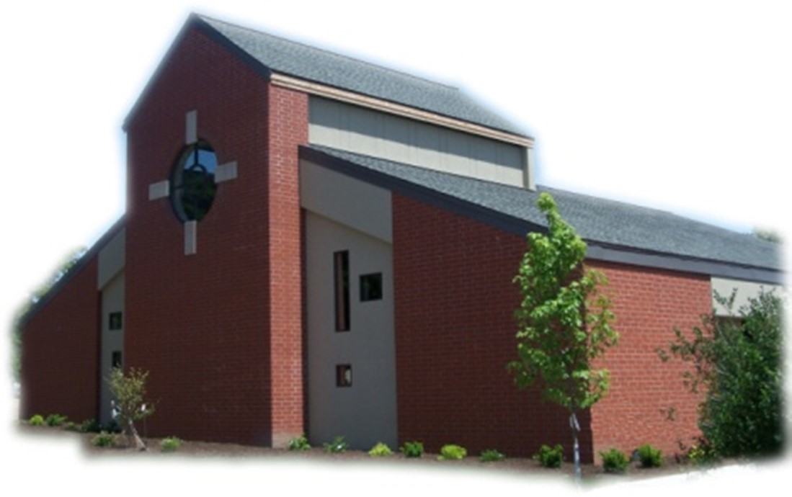

Sacramental Priest, Rev. Robert “Bud” Grant Email: grantrobert@sau.edu

Priest Moderator, Rev. Dale Mallory Email: malloryd@diodav.org

Parish Life Coordinator, Deacon Dan Freeman
Cell - 563-320-2462 Email: wiltonstmary@diodav.org

Office Manager - Rosemary Sullivan Director of Religious Education – Elizabeth Walker
C- 563-723-1050 /wiltonstmaryfin@diodav.org C- 563-260-3675/wiltonstmarydre@diodav.org

Mass Time: Sunday – 8:30 a.m.
Religious Education Classes start at 9:30 am during the school year.

Website: https://www.stmarywilton.org Facebook Page - https://www.facebook.com/stmarysofwilton
Today’s Readings – 8-2-26. Jesus takes us outside again today, to a deserted place where thousands of people followed him. Despite having only five loaves and two fish, Jesus is able to feed the entire crowd. We gather here every Sunday, a crowd perhaps only in the dozens or hundreds, but where we can all be fed, now with Jesus’ own body, offered and multiplied to satisfy us all. We can imagine that we are here with Jesus as he speaks to us and feeds us as he did on that wonderful day, for indeed this is what he does. Question of the Week - How can I feed others this week without discriminating, literally or figuratively?

St. Mary Parish Schedule:
- Sun. Aug 2nd Mass. Deacon Dan gone.
- Wed Aug 5th Faith Formation at 5:30 pm.
- Sun. Aug 9th Mass. RE Registration. Parish & Finance Councils meet after Mass.
- Wed Aug 12th Liturgy Committee meets at 5:30 pm.
- Sun Aug 16th Mass. RE Registration. Welcoming Committee meets after Mass.
- Sun Aug 23rd Mass. RE Registration.
- Sun Aug 30th Mass. RE Registration. Teacher Inservice after Mass.

Registration for Religious Education - You may also download a form from our website. Those who have previously registered only have to indicate if they will allow pictures of their children to be published on St. Mary’s Facebook or Website. Teachers’ children pay NO fees for Religious Education regardless of numbers.

OCIA stands for the Order of Christian Initiation of Adults. It’s a process through which non-baptized or baptized non-Catholic men and women enter the Catholic Church. It includes several stages marked by Study, Prayer, and Rites at Mass. Anyone interested in learning more about, or joining our Catholic Faith please contact Deacon Dan. Classes will start in August of 2026.

Christian Initiation Classes – Helping those Becoming Catholic or Joining the Catholic Church. Candidates, Sponsors, & Friends invited. All sessions are in the Parish Hall. Everyone is invited.
- Tue Aug 18th 5:30 pm Deacon Dan Introductory Session & Tour of the Church.
- Sun Aug 30th 9:45 am Deacon Dan The Mass Part I & II.

50th Wedding Anniversary Mass and Reception with Bishop Walsh at St. Patrick Catholic Church in Iowa City on Sunday, October 18, 2026, at 2 p.m. Please send me your name and address if you were married in 1976 or had not attended a Diocesan 50th Anniversary previously.

Wilton Family & Fellowship Nights – The Wilton Public Library and the Wilton-Durant Ministerial Association are teaming up to bring everyone some family fun this summer! Saturday, August 29th is Music Night from 6-8 pm.

Small Faith Groups – are a great way to grow your faith in the company of our St. Mary community. The Parish will help by publicizing your group and purpose as well as providing books / supplies as needed. We are called to engage our faith and to grow. We can do this by studying and learning from our many resources as well as each other. Contact Deacon Dan to start a group.
St. Mary Ladies Faith Sharing will resume again in September. We invite you to consider gathering with other ladies of the parish in friendship and the sharing of faith through Catholic based materials. We are hoping to also form a second group that will meet once a month on a weekday morning. Nine ladies participated last year and most of this initial group will continue meeting at church once a month after Sunday Mass. Please contact Jodie Dirksen if interested, 641-430-5044. Ladies of all ages are welcome!

Disability Minister Volunteer – the Davenport Diocese is providing training for ministry volunteers interested in supporting persons with disabilities and their families in parish life. You are invited to participate in this diocesan gathering focused on belonging, accessibility, and accompaniment in parish life. The date is August 5, 2026 at 10 am – 3 pm at St. Patrick Church – Iowa City. To register please go to https://www.davenportdiocese.org/belonging-disability-ministry.

Prayers are requested for Cameron Costello and all the Seminarians of the Davenport Diocese. We also pray for the 11 men in Diaconate Formation to be Ordained July 2027.

Part-time Program Coordinator position - Our Lady of the Prairie Retreat is a retreat center located in rural Wheatland, Iowa. A ministry of the Congregation of the Humility of Mary, it is the only Catholic retreat center in the Diocese of Davenport. We are currently seeking a part-time Program Coordinator to work approximately 20 hours per week. This is largely a hybrid/remote position that supports spiritual growth, ecological awareness, and community connection. Please contact 563-374-1092 or email tseifert@chmiowa.org to arrange a visit or for more information.

Wilton/Durant School Supply Drive – A message from our new DRE - my name is Liz Walker, and I am the new DRE for St. Mary's! My family and I moved to the area at the end of May. I look forward to meeting you as RE registration is approaching as well. Attached is a flyer for our school supply drive this year. Please take a look at the supplies needed for Wilton and Durant Community School Districts and participate as you're able. We're hoping to bless children in need with this drive. Please contact me if you have any questions. My email address is on the front of the Bulletin.

Aspire to be a Deacon. Bishop Walsh has approved the start of a 10th Class in our deacon formation program. An overview of the application process (including information about the required information sessions this fall) and brochures (in English and Spanish) are available at the website below. Please note that attendance at one of the information sessions is required for application. For more information, please see the Class X webpage: https://www.davenportdiocese.org/class-x. We are excited to be able to offer formation in both English and Spanish. Please contact Deacon Dan if you have any questions.

Donuts & Coffee every Sunday!!! Parishioners can sign up to serve Donuts & Coffee and clean up after Mass for those Sundays without Religious Education classes. Signup sheets will be in the Gathering Area. Please sign up soon as we would like to start soon.

Mass Intention for Sunday, August 9, 2026 – Christopher Gross
Lay Mass Ministers for Sunday, August 9, 2026.
Announcer & 1st Reading – Lucy Costello 2nd Reading – Jacqueline Grotzky
EMHC – Rick Janney & Judy Freeman Gift Bearers – Terry Martz & Colleen Nichols
Ushers – Terry Martz & Colleen Nichols Servers – Amelia & Ruth Costello & Scarlet Grotzky

Mass Intentions for the deceased are $10.00 each. Please indicate who the Mass is for, who requested it, and how many Masses are requested. We will try to honor requested Mass dates.

To report child abuse, contact the Iowa Dept. of Human Services Child Abuse hotline: 800-362-2178. If clergy or church personnel are involved also notify Alicia Owens, Victim Assistance Coordinator, 563-349-5002; vac@diodav.org or 780 W. Central Park Ave., Davenport, IA 52804.

New Parishioners: Please complete the Registration form online at https://www.stmarywilton.org/ or request a form after Mass. The completed form may be placed in the Contribution Basket or given to Deacon Dan. See the contact information on the Bulletin to contact me with any questions.
Envelopes – If you are not receiving Parish Contribution Envelopes, please contact Deacon Dan.

Fighting to break free from pornography? Get Help! https://integrityrestored.com/ or https://www.strive21.com/, or https://www.covenanteyes.com/. Call 563-334-4505 for a local group.

Holy Communion - Parishioners that are homebound or hospitalized may request that Holy Communion be brought to them after Mass on Sunday, or other days as necessary. Please contact Deacon Dan at 563-320-2462 or wiltonstmary@diodav.org with your request.

Our Lady of the Prairie – Retreat at 2664 145th Avenue, Wheatland, Iowa 52777. Details and register at www.theprairieretreat.org, or email – olpretreat@chmiowa.org, or call 563-374-1092.
- Thur., August 13th at 6-8 pm. ONLINE ONLY: Be Curious and Fascinated – Become a Dementia Friend. Mary Ann Grobstich, The Chris and Suzy DeWolf Family Innovation Center for Aging & Dementia. Learn more about the difference between dementia and typical aging. Free Will Offering
- Fri., September 4th at 10 am - 4 pm. Awake to the Promise: Rediscovering the Old Testament, by Trevor Pullinger. Gain a renewed appreciation for the richness and enduring wisdom of the Old Testament. $50
- Wed, September 23rd at 10 am - 4 pm. Rooted – the Invitation of Science, Nature and Spirit by Kim Novak. Consider the ways that science, nature and spirit invite us to listen, wander, shed, un-see, relate, speak and grow in ways that keep us “co-creating” throughout our lives, even in times fraught with disease. $50

St. Mary Cemetery – for information or to purchase plots please contact Scott Wolf at 563-370-3734 or srwolf64@gmail.com, or Deacon Dan.

Loss of Pregnancy or Infertility – you are not alone. Our Catholic faith offers hope, consolation, and support for those who have experienced infertility or loss of a pregnancy. Please feel free to contact Father Bud or me. Also a great resource is this website - https://springsinthedesert.org.

Loss of Pregnancy or Infertility – you are not alone. Our Catholic faith offers hope, consolation, and support for those who have experienced infertility or loss of a pregnancy. Please feel free to contact Father Bud or Deacon Dan. This website is a great resource - https://springsinthedesert.org.

Communion Rite videos - How to Receive the Body of Christ – (4.75 minutes – from Busted Halo.) www.stcroixcatholic.org/apps/video/watch.jsp?v=64276. How to receive the Blood of Christ (1 minute) https://www.youtube.com/shorts/xgCsaYzd0I4?feature=share.

Fighting to break free from pornography? Get Help! https://integrityrestored.com/ or https://www.strive21.com/, or https://www.covenanteyes.com/. Call 563-334-4505 for a local group.

2026-27 Parish Leadership Team

Trustees: (2 year term – max 4 terms)
Denise Timmerman (24) 563-349-3880 denisetimmerman13@gmail.com
Henry Bentley (24) 563-340-3111 henrybentley1961@outlook.com
Parish Council: (2 year term – max 2 terms)
Jessica Williams (25) Chair/At Large 563-320-3699 jesss_99@yahoo.com
Andrew Koopmann (26)Vice Chair/At Large 563-920-2993 ajkoop88@gmail.com
Taci Lilienthal (25) Secretary 563-343-1144 taci.lilienthal@gmail.com
Damon Boorn (24) At Large 563-260-9816 damon.boorn@gmail.com
Jeremiah Costello (23) Faith Formation 563-370-2065 Jeremiahecostello@gmail.com
Scott Wolf Cemetery 563-370-3734 srwolf64@gmail.com
Jim Gavin Bldg. & Grounds 563-506-5112 gavinjames@netwtc.net
Dennis Sass Liturgy 319-430-2063 dwsass51@gmail.com
Finance Council: (4 year term – max 2 terms)
Andrea Shaffer (24) Chair 563-299-5632 shafferauto06@gmail.com
Eric Thornton (25) 563-299-4624 eric6982@hotmail.com
John Kuhl (26) 563-320-7433 johnkuhl@kentww.com

