Saint Mary Catholic Church
701 East Third Street, Wilton, IA 52778

17th Sunday in Ordinary Time - July 26, 2026
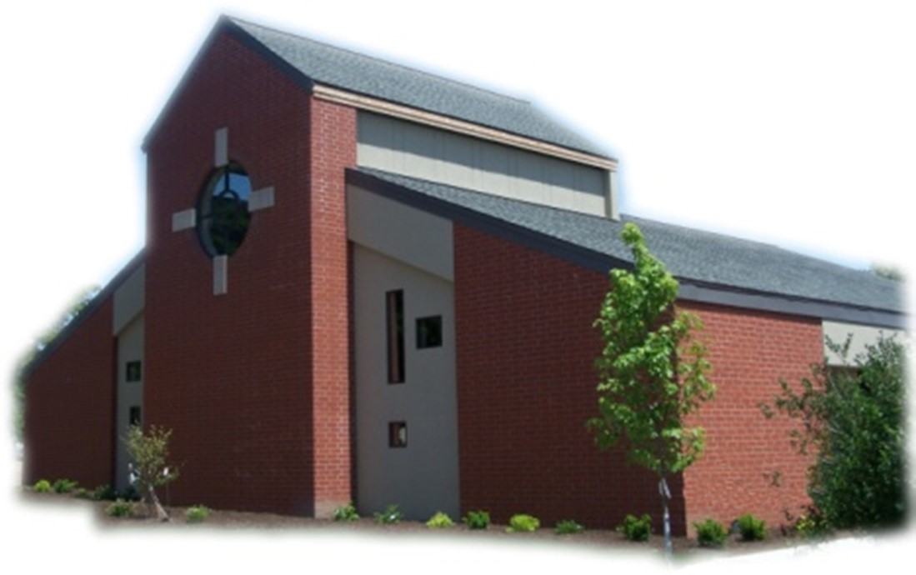

Sacramental Priest, Rev. Robert “Bud” Grant Email: grantrobert@sau.edu

Priest Moderator, Rev. Dale Mallory Email: malloryd@diodav.org

Parish Life Coordinator, Deacon Dan Freeman
Cell - 563-320-2462 Email: wiltonstmary@diodav.org

Office Manager - Rosemary Sullivan Director of Religious Education – Elizabeth Walker
C- 563-723-1050 /wiltonstmaryfin@diodav.org C- 563-260-3675/wiltonstmarydre@diodav.org

Mass Time: Sunday – 8:30 a.m.
Religious Education Classes start at 9:30 am during the school year.

Website: https://www.stmarywilton.org Facebook Page - https://www.facebook.com/stmarysofwilton
Today’s Readings – 7-26-26. Each Sunday when we come together to worship God, we are nourished first by God’s word in the readings, psalm, and Gospel and then by Christ’s own body in the Eucharist. We may take both for granted, because each is available to us every Sunday, but these are gifts that are meant to be treasured. In today’s Gospel, Jesus compares the kingdom of heaven to a great treasure buried in a field, bought by a person lucky enough to have found it. But we have our treasure right here and right now, given to us by a God of infinite generosity. May we be blessed with the wisdom to see the treasures we have in the Word and Eucharist. Question of the Week - What sacrifices am I willing to make and what hardships am I willing to endure in order to gain the kingdom of heaven?

St. Mary Parish Schedule:
- Sun Jul 26th Mass. Homebound Communion Ministry training after Mass.
- Sun. Aug 2nd Mass. Deacon Dan gone.
- Wed Aug 5th Faith Formation at 5:30 pm.
- Sun. Aug 9th Mass. RE Registration. Parish & Finance Councils meet after Mass.
- Wed Aug 12th Liturgy Committee meets at 5:30 pm.
- Sun Aug 16th Mass. RE Registration.
- Sun Aug 23rd Mass. RE Registration.
- Tue Aug 25th OCIA 5:30 pm Deacon Dan - Intro Class and Tour of Church
- Sun Aug 30th Mass. RE Registration. Teacher Inservice after Mass.

50th Wedding Anniversary Mass and Reception with Bishop Walsh at St. Patrick Catholic Church in Iowa City on Sunday, October 18, 2026, at 2 p.m. Please send me your name and address if you were married in 1976 or had not attended a Diocesan 50th Anniversary previously.

Wilton Family & Fellowship Nights – The Wilton Public Library and the Wilton-Durant Ministerial Association are teaming up to bring everyone some family fun this summer! Friday, July 31st is Game Night from 6-8 pm. Saturday, August 29th is Music Night from 6-8 pm.

OCIA stands for the Order of Christian Initiation of Adults. It’s a process through which non-baptized or baptized non-Catholic men and women enter the Catholic Church. It includes several stages marked by Study, Prayer, and Rites at Mass. Anyone interested in learning more about, or joining our Catholic Faith please contact Deacon Dan. Classes will start in August of 2026.

OCIA Team – we are looking for a few Catholics to build a small team to help guide those who want to join our Catholic faith and St. Mary. Please contact Deacon Dan for information.

Small Faith Groups are a great way to grow your faith within our St. Mary community. People may engage in Scripture study, book study, Prayer group (Centering Prayer or Liturgy of the Hours, etc.), Grief group, Mother’s Support, and others. The Parish will publicize your group and provide resources. We are called to engage our faith and to grow. Contact Deacon Dan to help form a group, publicize your group, gather resources or find more information.

Disability Minister Volunteer – the Davenport Diocese is providing training for ministry volunteers interested in supporting persons with disabilities and their families in parish life. You are invited to participate in this diocesan gathering focused on belonging, accessibility, and accompaniment in parish life. The date is August 5, 2026 at 10 am – 3 pm at St. Patrick Church – Iowa City. To register please go to https://www.davenportdiocese.org/belonging-disability-ministry.

Wilton/Durant School Supply Drive – A message from our new DRE - my name is Liz Walker, and I am the new DRE for St. Mary's! My family and I moved to the area at the end of May. I look forward to meeting you as RE registration is approaching as well. Attached is a flyer for our school supply drive this year. Please take a look at the supplies needed for Wilton and Durant Community School Districts and participate as you're able. We're hoping to bless children in need with this drive. Please contact me if you have any questions. My email address is on the front of the Bulletin.
Mass Ministry Schedule for August & September will be completed soon. Please email Denise Timmerman at Denisetimmerman13@gmail.com if you will NOT be able to serve. Thank you!

Catholic Rural Life Project – CRL is working on a nationwide video project about Catholics living in rural communities. CRL is looking for people, families, priests, small business owners, farmers, tradesmen, or parish leaders who have a strong Catholic faith and a story in their life that may be worth exploring on camera. This could take a lot of different forms. For example:
- A farmer or ranching family in a meaningful season of life.
- Someone trying to keep a small-town business going.
- A mechanic, tradesman, or shop owner who serves the local community.
- A priest serving multiple rural parishes.
- A family involved in tractor pulls, hunting, fishing, snowmobiling, county fairs, local traditions.
- A father and son fixing up a first car or tractor.
- Someone preparing for a parish event, feast day, procession, or other community tradition.
- A young person deciding whether to stay, leave, return, or take something over.
- Someone whose Catholic faith shapes their work, family life, service, or responsibilities.
Anyone interested should send an email to zach@catholicrurallife.org email with their name, parish or community, and a few lines about why you thought of them.

Babies Crying Poem – forwarded by Henry Bentley. Babies crying means the church won’t be dying. If you’re easily offended by a child, is that really a reflection of the heart of Christ? Children will never be able to learn respect for the House of God if they’re never there. Bring them! Even if they cry! Even if they whine! This is simple growing pains. Children aren’t just the church of tomorrow; they’re a part of the church of today. Children need church!

Sacraments - to schedule participation in any of these please contact Deacon Dan:
- Confession – email Father Bud at grantrobert@sau.edu for times prior/after Mass.
- Baptism – A prep class required for family’s first child. Contact Deacon Dan 1 month prior.
- Marriage – contact Deacon Dan a minimum of 7 months prior to the proposed event.
- Anointing – Anyone having surgery or experiencing illness may ask for the Rite of Anointing of the Sick. Father Bud will anoint immediately after Mass. Contact Deacon Dan.
- Funeral Preparation – please contact Deacon Dan. A great booklet is available to help.

Prayers are requested for Cameron Costello and all the Seminarians of the Davenport Diocese. We also pray for the 11 men in Diaconate Formation to be Ordained July 2027.

Mass Intention for Sunday, August 2, 2026 – Stan Reuter
Lay Mass Ministers for Sunday, August 2, 2026.
Announcer & 1st Reading – Nevin Williams 2nd Reading & Prayers of Faithful – Jessica Williams
EMHC – Denise Timmerman, Steph Lilienthal & Linda Lund Gift Bearers – Andy Koopmann Family
Ushers – Jean Semsch & Rick Janney Servers – Kinley, Kensington & Kendal Boorn

Mass Intentions for the deceased are $10.00 each. Please indicate who the Mass is for, who requested it, and how many Masses are requested. We will try to honor requested Mass dates.

To report child abuse, contact the Iowa Dept. of Human Services Child Abuse hotline: 800-362-2178. If clergy or church personnel are involved also notify Alicia Owens, Victim Assistance Coordinator, 563-349-5002; vac@diodav.org or 780 W. Central Park Ave., Davenport, IA 52804.

New Parishioners: Please complete the Registration form online at https://www.stmarywilton.org/ or request a form after Mass. The completed form may be placed in the Contribution Basket or given to Deacon Dan. See the contact information on the Bulletin to contact me with any questions.
Envelopes – If you are not receiving Parish Contribution Envelopes, please contact Deacon Dan.
Meal Train Ministry - Our meal train ministry helps parishioners who have recently had a baby, those who have recently lost a loved one, are going through an illness or rough time, or those who are temporarily homebound and need assistance with meals. If you'd like more information, would like to nominate a parishioner, or would like to be put on the list to make meals when able, please contact Sarah Costello at 563-210-3977 or email slcostello09@gmail.com.

Holy Communion - Parishioners that are homebound or hospitalized may request that Holy Communion be brought to them after Mass on Sunday, or other days as necessary. Please contact Deacon Dan at 563-320-2462 or wiltonstmary@diodav.org with your request.

Aspire to be a Deacon. Bishop Walsh has approved the start of a 10th Class in our deacon formation program. An overview of the application process (including information about the required information sessions this fall) and brochures (in English and Spanish) are available at the website below. Please note that attendance at one of the information sessions is required for application. For more information, please see the Class X webpage: https://www.davenportdiocese.org/class-x. We are excited to be able to offer formation in both English and Spanish. Please contact Deacon Dan if you have any questions.

St. Mary Cemetery – for information or to purchase plots please contact Scott Wolf at 563-370-3734 or srwolf64@gmail.com, or Deacon Dan.

Loss of Pregnancy or Infertility – you are not alone. Our Catholic faith offers hope, consolation, and support for those who have experienced infertility or loss of a pregnancy. Please feel free to contact Father Bud or me. Also a great resource is this website - https://springsinthedesert.org.

Loss of Pregnancy or Infertility – you are not alone. Our Catholic faith offers hope, consolation, and support for those who have experienced infertility or loss of a pregnancy. Please feel free to contact Father Bud or Deacon Dan. This website is a great resource - https://springsinthedesert.org.

Communion Rite videos - How to Receive the Body of Christ – (4.75 minutes – from Busted Halo.) www.stcroixcatholic.org/apps/video/watch.jsp?v=64276. How to receive the Blood of Christ (1 minute) https://www.youtube.com/shorts/xgCsaYzd0I4?feature=share.

Fighting to break free from pornography? Get Help! https://integrityrestored.com/ or https://www.strive21.com/, or https://www.covenanteyes.com/. Call 563-334-4505 for a local group.

2026-27 Parish Leadership Team

Trustees: (2 year term – max 4 terms)
Denise Timmerman (24) 563-349-3880 denisetimmerman13@gmail.com
Henry Bentley (24) 563-340-3111 henrybentley1961@outlook.com
Parish Council: (2 year term – max 2 terms)
Jessica Williams (25) Chair/At Large 563-320-3699 jesss_99@yahoo.com
Andrew Koopmann (26)Vice Chair/At Large 563-920-2993 ajkoop88@gmail.com
Taci Lilienthal (25) Secretary 563-343-1144 taci.lilienthal@gmail.com
Damon Boorn (24) At Large 563-260-9816 damon.boorn@gmail.com
Jeremiah Costello (23) Faith Formation 563-370-2065 Jeremiahecostello@gmail.com
Scott Wolf Cemetery 563-370-3734 srwolf64@gmail.com
Jim Gavin Bldg. & Grounds 563-506-5112 gavinjames@netwtc.net
Dennis Sass Liturgy 319-430-2063 dwsass51@gmail.com
Finance Council: (4 year term – max 2 terms)
Andrea Shaffer (24) Chair 563-299-5632 shafferauto06@gmail.com
Eric Thornton (25) 563-299-4624 eric6982@hotmail.com
John Kuhl (26) 563-320-7433 johnkuhl@kentww.com

