Saint Mary Catholic Church
701 East Third Street, Wilton, IA 52778

15th Sunday in Ordinary Time - July 12, 2026
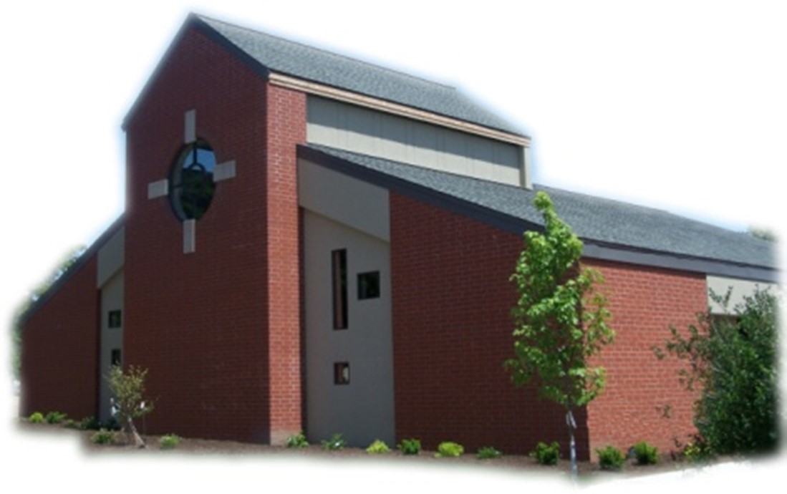

Sacramental Priest, Rev. Robert “Bud” Grant Email: grantrobert@sau.edu

Priest Moderator, Rev. Dale Mallory Email: malloryd@diodav.org

Parish Life Coordinator, Deacon Dan Freeman
Cell - 563-320-2462 Email: wiltonstmary@diodav.org

Office Manager - Rosemary Sullivan Director of Religious Education – Hilary Henke
Cell - 563-723-1050 / wiltonstmaryfin@diodav.org Cell - 563-260-5861 / wiltonstmarydre@diodav.org

Mass Time: Sunday – 8:30 a.m.
Religious Education Classes start at 9:30 am during the school year.

Website: https://www.stmarywilton.org Facebook Page - https://www.facebook.com/stmarysofwilton
Today’s Readings – 7-12-26. The setting of today’s Gospel may remind us of a warm midsummer day - maybe like today. Jesus comes outside and walks down to the sea. So many people gather along the shoreline that Jesus decides to go out in a boat and speak to the entire crowd from there. Imagine yourself sitting on a beach on a beautiful day with hundreds of others, listening to the Lord teaching in parables. Through the power of imagination, we have that opportunity today. Question of the Week - What will I do this week to cultivate God’s word? Which passages from scripture have I applied to my life recently or regularly?

St. Mary Parish Schedule:
- Sun Jul 12th Mass. Parish & Finance Councils meet after Mass.
- Tue Jul 14th Vocations Committee meeting at 5:30 pm.
- Wed Jul 15th St. Mary Day at Muscatine County Fair at West Liberty 11 am – 7 pm. Sign up!
- Sun Jul 19th Mass – 1 Baptism.
- Tue Jul 22nd OCIA Team meeting for Christian Initiation at 5:30 pm.
- Sun Jul 26th Mass. Homebound Communion Ministry training after Mass.
- Sun. Aug 2nd Mass.
- Wed Aug 5th Faith Formation at 5:30 pm.

50th Wedding Anniversary Mass and Reception with Bishop Walsh at St. Patrick Catholic Church in Iowa City on Sunday, October 18, 2026, at 2 p.m. Please send me your name and address if you were married in 1976 or had not attended a Diocesan 50th Anniversary previously.

Wilton Family & Fellowship Nights – The Wilton Public Library and the Wilton-Durant Ministerial Association are teaming up to bring everyone some family fun this summer! Friday, July 31st is Game Night from 6-8 pm. Saturday, August 29th is Music Night from 6-8 pm.

Aspire to be a Deacon. Bishop Walsh has approved the start of a 10th Class in our deacon formation program. An overview of the application process (including information about the required information sessions this fall) and brochures (in English and Spanish) are available at the website below. Please note that attendance at one of the information sessions is required for application. For more information, please see the Class X webpage: https://www.davenportdiocese.org/class-x. We are excited to be able to offer formation in both English and Spanish. Please contact Deacon Dan if you have any questions.

EPIC - Muscatine County Fair – a Catholic presence. Please sign up on the form in the Gathering Area if you are willing to volunteer a 4-hour time period to represent our St. Mary Parish at the Muscatine County Fair at 101 North Clay Street West Liberty, IA 52776. Fair dates are Wednesday, July 15 – Sunday, July 19, 2025. St. Mary parishioners will man the tent on Wednesday, July 15th from 11:00 am to 7:00 pm. Details will be sent to everyone who signs up.

Please pray for Cameron Costello and all the Seminarians of the Davenport Diocese. We also pray for the 11 men in Diaconate Formation to be Ordained July 2027.

The 2025-26 Annual Financial Report is attached to this Bulletin. Please contact a Parish Representative or me with any questions or concerns.

John Kuhl will take Phil Keese’s place on the Finance Council effective August 1st. Phil is retiring from long service on our Finance Council. Please thank him for his service and welcome John Kuhl.

Mass Ministry Schedule for August & September will be completed soon. Please email Denise Timmerman at Denisetimmerman13@gmail.com if you will NOT be able to serve. Thank you!

Holy Family Catholic Church of Davenport announces the St. Philomena Academy Youth Camp, August 7-9, 2026. All students 6th - 12th grade are invited. Theme is the Invincible Champion of Chasity. Daily Mass, Adoration, etc. Come and experience God's love and graces! Register deadline July 25th. To register or more information visit https://www.saintphilomenaacademy.com/.
Small Faith Groups – Anyone who would like to join others and start a Small Faith Group should contact Deacon Dan. This is a great way to grow your faith in the company of our St. Mary community. Participants/Groups may engage in Scripture study group, book study group, Prayer group (there are many types of prayers that can be studied and used such as Centering Prayer, Liturgy of the Hours, etc.), Grief group, Mother’s Support, and others. The Parish will publicize your group and provide resources. We are called to engage our faith and to grow.

The Mustard Seed, Inc. at http://www.catholicbookiowa.com/ is a non-profit, Roman Catholic organization in Iowa City, Iowa. Its goal is to make available the teachings of the Catholic Church through the sale of select Catholic books, gifts, artwork, videos, and audio products. The Mustard Seed also offers a Reference Library of Catholic Classics. The organization strives to instill and strengthen the Catholic Faith as guarded by the Holy Father and the Magisterium of the Church. All proceeds go toward the pursuit of this goal.

OCIA Team will meet Tuesday, July 22nd at 5:30 pm. OCIA stands for the Order of Christian Initiation of Adults. It’s a process through which non-baptized or baptized non-Catholic men and women enter the Catholic Church. It includes several stages marked by Study, Prayer, and Rites at Mass. Anyone interested in learning more about our Catholic Faith please contact Deacon Dan.
OCIA Team – we are looking for a few Catholics to build a small team to help guide those who want to join our Catholic faith and St. Mary. Please contact Deacon Dan for information.

Saint of the Day – St. John Gualbert, Abbot - a Florentine soldier who, after a change of heart marked by mercy toward his enemy, entered monastic life and later helped found the more austere monastic family at Vallombrosa.

Loss of Pregnancy or Infertility – you are not alone. Our Catholic faith offers hope, consolation, and support for those who have experienced infertility or loss of a pregnancy. Please feel free to contact Father Bud or me. Also a great resource is this website - https://springsinthedesert.org.

Mass Intention for Sunday, July 19, 2026 – Dale Lilienthal
Lay Mass Ministers for Sunday, July 19, 2026.
Announcer & 1st Reading – Nevin Williams 2nd Reading – Jessica Williams
EMHC – Jacqueline Grotzky & Henry Bentley Gift Bearers – Amanda Vasey & Dyllin Kitzmiller
Ushers – Joe Kaufman & Rick Janney Servers – Carter, Cooper, & Tucker Smyser

Mass Intentions for the deceased are $10.00 each. Please indicate who the Mass is for, who requested it, and how many Masses are requested. We will try to honor requested Mass dates.

To report child abuse, contact the Iowa Dept. of Human Services Child Abuse hotline: 800-362-2178. If clergy or church personnel are involved also notify Alicia Owens, Victim Assistance Coordinator, 563-349-5002; vac@diodav.org or 780 W. Central Park Ave., Davenport, IA 52804.

New Parishioners: Please complete the Registration form online at https://www.stmarywilton.org/ or request a form after Mass. The completed form may be placed in the Contribution Basket or given to Deacon Dan. See the contact information on the Bulletin to contact me with any questions.

Envelopes – If you are not receiving Parish Contribution Envelopes, please contact Deacon Dan.

Meal Train Ministry - Our meal train ministry helps parishioners who have recently had a baby, those who have recently lost a loved one, are going through an illness or rough time, or those who are temporarily homebound and need assistance with meals. If you'd like more information, would like to nominate a parishioner, or would like to be put on the list to make meals when able, please contact Sarah Costello at 563-210-3977 or email slcostello09@gmail.com.

Holy Communion - Parishioners that are homebound or hospitalized may request that Holy Communion be brought to them after Mass on Sunday, or other days as necessary. Please contact Deacon Dan at 563-320-2462 or wiltonstmary@diodav.org with your request.
Sacraments - to schedule participation in any of these please contact Deacon Dan:
- Confession – email Father Bud at grantrobert@sau.edu for times prior/after Mass.
- Baptism – A prep class required for family’s first child. Contact Deacon Dan 1 month prior.
- Marriage – contact Deacon Dan a minimum of 7 months prior to the proposed event.
- Anointing – Anyone having surgery or experiencing illness may ask for the Rite of Anointing of the Sick. Father Bud will anoint immediately after Mass. Contact Deacon Dan.
- Funeral Preparation – please contact Deacon Dan. A great booklet is available to help.

St. Mary Cemetery – for information or to purchase plots please contact Scott Wolf at 563-370-3734 or srwolf64@gmail.com, or Deacon Dan.

Wounded by Abortion? Project Rachel can help! New helpline 563-888-4376 or email at projectrachel@diodav.org. Calls answered personally Monday – Thursday 9 am – 3 pm or leave a message. 1) Understands the emotional pain that follows an abortion, 2) Provides free referrals for confidential and caring counseling and reconciliation by trained professionals, and 3) Can help get you on the road to spiritual recovery.

Loss of Pregnancy or Infertility – you are not alone. Our Catholic faith offers hope, consolation, and support for those who have experienced infertility or loss of a pregnancy. Please feel free to contact Father Bud or Deacon Dan. This website is a great resource - https://springsinthedesert.org.

Communion Rite videos - How to Receive the Body of Christ – (4.75 minutes – from Busted Halo.) www.stcroixcatholic.org/apps/video/watch.jsp?v=64276. How to receive the Blood of Christ (1 minute) https://www.youtube.com/shorts/xgCsaYzd0I4?feature=share.

The Coming Home Network was established to help non-Catholic Christians, clergy and laity to make the journey home to full communion with the Catholic Church. https://chnetwork.org/.

Fighting to break free from pornography? Get Help! https://integrityrestored.com/ or https://www.strive21.com/, or https://www.covenanteyes.com/. Call 563-334-4505 for a local group.

2026-27 Parish Leadership Team

Trustees: (2 year term – max 4 terms)
Denise Timmerman (24) 563-349-3880 denisetimmerman13@gmail.com
Henry Bentley (24) 563-340-3111 henrybentley1961@outlook.com
Parish Council: (2 year term – max 2 terms)
Damon Boorn (24) President/At Large 563-260-9816 damon.boorn@gmail.com
Jessica Williams (25) VP/At Large 563-320-3699 jesss_99@yahoo.com
Andrew Koopmann (26) At Large 563-920-2993 ajkoop88@gmail.com
Taci Lilienthal (25) 563-343-1144 taci.lilienthal@gmail.com
Jeremiah Costello (23) Faith Form. 563-370-2065 Jeremiahecostello@gmail.com
Scott Wolf Cemetery 563-370-3734 srwolf64@gmail.com
Jim Gavin Bldg. & Grounds 563-506-5112 gavinjames@netwtc.net
Dennis Sass Liturgy 319-430-2063 dwsass51@gmail.com
Finance Council: (4 year term – max 2 terms)
Andrea Shaffer (24) 563-299-5632 shafferauto06@gmail.com
Eric Thornton (25) 563-299-4624 eric6982@hotmail.com
John Kuhl (26) 563-320-7433 johnkuhl@kentww.com

