Saint Mary Catholic Church
701 East Third Street, Wilton, IA 52778

11th Sunday in Ordinary Time - June 14, 2026
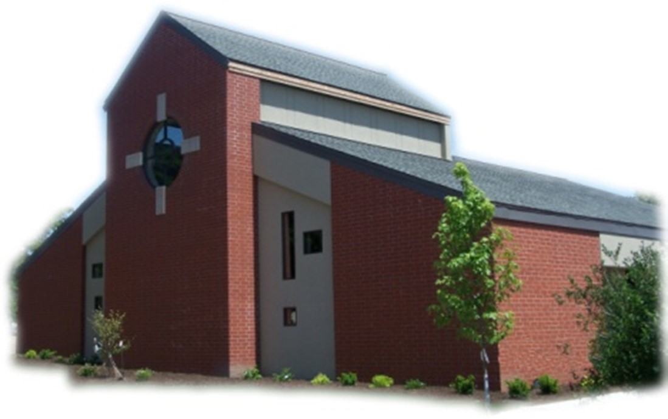

Sacramental Priest, Rev. Robert “Bud” Grant Email: grantrobert@sau.edu

Priest Moderator, Rev. Dale Mallory Email: malloryd@diodav.org

Parish Life Coordinator, Deacon Dan Freeman
Cell - 563-320-2462 Email: wiltonstmary@diodav.org

Office Manager - Rosemary Sullivan Director of Religious Education – Hilary Henke
Cell - 563-723-1050 / wiltonstmaryfin@diodav.org Cell - 563-260-5861 / wiltonstmarydre@diodav.org

Mass Time: Sunday – 8:30 a.m.
Religious Education Classes start at 9:30 am during the school year.

Website: https://www.stmarywilton.org Facebook Page - https://www.facebook.com/stmarysofwilton
Today’s Readings – 6-14-26. After celebrating the fifty-day season of Easter, culminating with Jesus’ ascension to heaven and the descent of the Holy Spirit upon the apostles, we are emboldened to become disciples ourselves, proclaiming Jesus’ message of the nearness of the kingdom of heaven through our words and actions. Let Jesus’ final words in today’s Gospel propel us on our mission: “Without cost you have received; without cost you are to give.” Without cost we have received the salvation Jesus won for us; without cost we are to share this gift. Question of the Week - Whom do I know, or know of, who is troubled or abandoned? What can I do to bring them serenity, make them feel valued, and restore hope to their lives?

St. Mary Parish Schedule:
- Sun Jun 14th Mass.
- Sun Jun 21st Mass. Father’s Day.
- Wed Jun 24th Advanced Altar Server Training from 5:30 – 7:30 pm.
- Sun Jun 28th Mass.
- Sun Jul 5th Mass
- Sun Jul 12th Mass. Parish & Finance Councils meet after Mass.
- Wed Jul 15th St. Mary Day at Muscatine County Fair at West Liberty 11 am – 7 pm. Sign up!

Wilton Family & Fellowship Nights – The Wilton Public Library and the Wilton-Durant Ministerial Association are teaming up to bring everyone some family fun this summer! Saturday, June 27th is Movie Night from 6:00-8:00 pm. Friday, July 31st is Game Night from 6:00-8:00 pm. Saturday, August 29th is Music Night from 6:00-8:00 pm.

Aspire to be a Deacon. Bishop Walsh has approved the start of a 10th Class in our deacon formation program. An overview of the application process (including information about the required information sessions this fall) and brochures (in English and Spanish) are available at the website below. Please note that attendance at one of the information sessions is required for application. For more information, please see the Class X webpage: https://www.davenportdiocese.org/class-x. We are excited to be able to offer formation in both English and Spanish. Please contact Deacon Dan if you have any questions.

EPIC - Muscatine County Fair – a Catholic presence. Please sign up on the form in the Gathering Area if you are willing to volunteer a 4-hour time period to represent our St. Mary Parish at the Muscatine County Fair at 101 North Clay Street West Liberty, IA 52776. Fair dates are Wednesday, July 15 – Sunday, July 19, 2025. St. Mary parishioners will man the tent on Wednesday, July 15th from 11:00 am to 7:00 pm. Details will be sent to everyone who signs up.

OCIA stands for the Order of Christian Initiation of Adults. It’s a process through which non-baptized or baptized non-Catholic men and women enter the Catholic Church. It includes several stages marked by Study, Prayer, and Rites at Mass. If you, or someone you know, is interested in learning more about our Catholic Faith please contact Deacon Dan. Classes will begin late Summer.
OCIA Team – we are looking for a few Catholics to build a small team to help guide those who want to join our Catholic faith and St. Mary. Please contact Deacon Dan for information.

Totus Tuus invitation from St. Mary Church of Tipton. What is Totus Tuus? Watch this short video to find out more! https://youtu.be/YaCgJu3XJm0?si=wxEI9resyYoOBBZ5. St. Mary of Tipton has invited us to their week of Totus Tuus that will be held from Sunday June 21st through Friday, June 26th at St. Mary Parish Hall, in Tipton. Totus Tuus is taught by a team of four college student missionaries who spend the summer teaching the faith to youth in our diocese. This year will emphasize the 10 Commandments, the Luminous Mysteries of the Rosary, and how to discern what God is calling us to. Totus Tuus is open for children in 1st through 12th grade. Grades 7-12th attend during the evening sessions from Sunday through Thursday from 6:30-9pm, and grades 1st - 6th grades attend Monday through Friday from 9am-3pm. All meals and snacks are provided! Cost per child is just $10, with costs not exceeding $20 per family if you have more than 2 children. You can either register online at https://form.jotform.com/261104521778051 or email me to request a PDF of the form at tiptonstmarydre@diodav.org. Registration fees can either be mailed or dropped off at our parish office at: 208 Meridian St., Tipton, IA, or you can bring your registration fee with you on the first day of Totus Tuus.

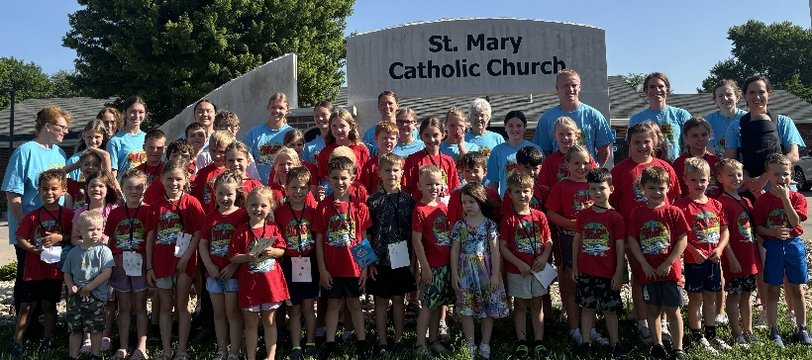
2026 St. Mary Vacation Bible School – Radical Ride on the Wings of Prayer is an EPIC success! We have 40 kids participating and 20 volunteers! We have much to be thankful for! Thank you to the parents for encouraging their kids to participate. Thank you to the kids who were focused and engaged - we are blessed with the best at St. Mary. Thank you to the rockstar volunteers that made this year's VBS a huge success: Terri Lilienthal, Kate Welch, Cindy Gavin, Kara Meyer, Gina Holladay, Sarah Costello, Amanda Vasey, Amelia Costello, Lucy Costello, Gabriel Costello, Alaina Lawler, Jean Semsch, Maddie Smyser, Emerson Kirk, Liz Walker, Kensington Boorn, Tessa Costello, Natalie Koopmann, Brielle Walker, and Dennis Sass. Suzy Bohnsack and Taci Lilienthal were instrumental in making St. Mary VBS a fruitful event. Thank you all! We can't wait for next year!

Please welcome our new Janitor, Natalie Avis. She will begin her duties July 1st. We thank Kim Barber for her many years of service to our Parish Family. Thank you Kim!

Holy Family Catholic Church of Davenport announces the St. Philomena Academy Youth Camp, August 7-9, 2026. All students 6th - 12th grade are invited. Theme is the Invincible Champion of Chasity. Daily Mass, Adoration, etc. Come and experience God's love and graces! Register deadline July 25th. To register or more information visit https://www.saintphilomenaacademy.com/.

Prayers are requested for Cameron Costello and all the Seminarians of the Davenport Diocese. We also pray for the 11 men in Diaconate Formation to be Ordained July 2027.

Mass Intention for Sunday, June 21, 2026 – Otto Geering
Lay Mass Ministers for Sunday, June 21, 2026. Deacon gone
Announcer & 1st Reading – Natalie Koopmann
2nd Reading & Prayers of Faithful – Jacqueline Grotzky
EMHC – Mary Grotzky, Linda Lund & Dennis Sass Gift Bearers – Gail & Bill McCrabb
Ushers – Joe Kaufman & Andy Koopmann Servers – Kinley, Kinsington, & Kendall Boorn

Mass Intentions for the deceased are $10.00 each. Please indicate who the Mass is for, who requested it, and how many Masses are requested. We will try to honor requested Mass dates.

To report child abuse, contact the Iowa Dept. of Human Services Child Abuse hotline: 800-362-2178. If clergy or church personnel are involved also notify Alicia Owens, Victim Assistance Coordinator, 563-349-5002; vac@diodav.org or 780 W. Central Park Ave., Davenport, IA 52804.

New Parishioners: Please complete the Registration form online at https://www.stmarywilton.org/ or request a form after Mass. The completed form may be placed in the Contribution Basket or given to Deacon Dan. See the contact information on the Bulletin to contact me with any questions.
Envelopes – If you are not receiving Parish Contribution Envelopes, please contact Deacon Dan.

Meal Train Ministry - Our meal train ministry helps parishioners who have recently had a baby, those who have recently lost a loved one, are going through an illness or rough time, or those who are temporarily homebound and need assistance with meals. If you'd like more information, would like to nominate a parishioner, or would like to be put on the list to make meals when able, please contact Sarah Costello at 563-210-3977 or email slcostello09@gmail.com.

Holy Communion - Parishioners that are homebound or hospitalized may request that Holy Communion be brought to them after Mass on Sunday, or other days as necessary. Please contact Deacon Dan at 563-320-2462 or wiltonstmary@diodav.org with your request.
St. Mary Cemetery – for information or to purchase plots please contact Scott Wolf at 563-370-3734 or srwolf64@gmail.com, or Deacon Dan.

Sacraments - to schedule participation in any of these please contact Deacon Dan:
- Confession – email Father Bud at grantrobert@sau.edu for times prior/after Mass.
- Baptism – A prep class required for family’s first child. Contact Deacon Dan 1 month prior.
- Marriage – contact Deacon Dan a minimum of 7 months prior to the proposed event.
- Anointing – Anyone having surgery or experiencing illness may ask for the Rite of Anointing of the Sick. Father Bud will anoint immediately after Mass. Contact Deacon Dan.
- Funeral Preparation – please contact Deacon Dan. A great booklet is available to help.

Wounded by Abortion? Project Rachel can help! New helpline 563-888-4376 or email at projectrachel@diodav.org. Calls answered personally Monday – Thursday 9 am – 3 pm or leave a message. 1) Understands the emotional pain that follows an abortion, 2) Provides free referrals for confidential and caring counseling and reconciliation by trained professionals, and 3) Can help get you on the road to spiritual recovery.

Loss of Pregnancy or Infertility – you are not alone. Our Catholic faith offers hope, consolation, and support for those who have experienced infertility or loss of a pregnancy. Please feel free to contact Father Bud or Deacon Dan. This website is a great resource - https://springsinthedesert.org.

Communion Rite videos - How to Receive the Body of Christ – (4.75 minutes – from Busted Halo.) www.stcroixcatholic.org/apps/video/watch.jsp?v=64276. How to receive the Blood of Christ (1 minute) https://www.youtube.com/shorts/xgCsaYzd0I4?feature=share.

The Coming Home Network was established to help non-Catholic Christians, clergy and laity to make the journey home to full communion with the Catholic Church. https://chnetwork.org/.

Fighting to break free from pornography? Get Help! https://integrityrestored.com/ or https://www.strive21.com/, or https://www.covenanteyes.com/. Call 563-334-4505 for a local group.

2025-26 Parish Leadership Team

Trustees: (2 year term)
Denise Timmerman 563-349-3880 denisetimmerman13@gmail.com
Henry Bentley 563-340-3111 henrybentley1961@outlook.com
Parish Council: (2 year term)
Damon Boorn (24) President/At Large 563-260-9816 damon.boorn@gmail.com
Jessica Williams (25) 563-320-3699 jess_99@yahoo.com
Kathy Keese (22) Secretary/At Large 563-260-4904 Kskeese5@gmail.com
Taci Lilienthal (25) 563-343-1144 taci.lilienthal@gmail.com
Jeremiah Costello (23) Faith Form. 563-370-2065 Jeremiahecostello@gmail.com
Scott Wolf Cemetery 563-370-3734 srwolf64@gmail.com
Jim Gavin Bldg. & Grounds 563-506-5112 gavinjames@netwtc.net
Dennis Sass Liturgy 319-430-2063 dwsass51@gmail.com
Finance Council: (4 year term)
Phil Keese (22) 563-260-4905 plkeese5@gmail.com
Andrea Shaffer (24) 563-299-5632 shafferauto06@gmail.com
Eric Thornton (25) 563-299-4624 eric6982@hotmail.com

