Saint Mary Catholic Church
701 East Third Street, Wilton, IA 52778

5th Sunday of Easter - May 3, 2024
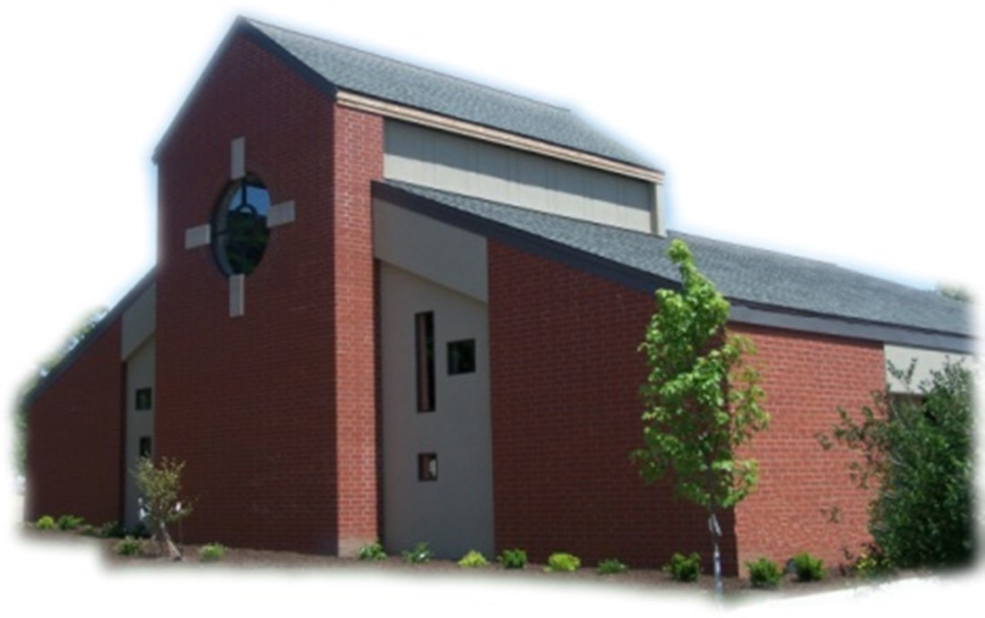

Sacramental Priest, Rev. Robert “Bud” Grant Email: grantrobert@sau.edu
Priest Moderator, Rev. Dale Mallory Email: malloryd@diodav.org

Parish Life Coordinator, Deacon Dan Freeman
Cell - 563-320-2462 Email: wiltonstmary@diodav.org

Office Manager - Rosemary Sullivan Director of Religious Education – Hilary Henke
Cell - 563-723-1050 / wiltonstmaryfin@diodav.org Cell - 563-260-5861 / wiltonstmarydre@diodav.org

Mass Time: Sunday – 8:30 a.m.
Religious Education Classes start at 9:30 am during the school year.

Website: https://www.stmarywilton.org Facebook Page - https://www.facebook.com/stmarysofwilton
Today’s Readings – 5-3-26. On the night before he died, Jesus assured his disciples that “in my Father’s house there are many dwelling places, I am going to prepare a place for you” (John 14:2). Jesus knew that their faith would be severely tested and their hope would be dashed in the coming days. Our faith and hope waver as well. May the words of our Lord in today’s Gospel reassure us through our doubts and despair about our future. God’s house has a place for each of us. Question of the Week - What can I do this week to know Jesus better, to serve those who are overlooked, and to prepare my spiritual home?

St. Mary Parish Schedule:
- Sun May 3rd Mass. May Crowning. Parish Council Nominations.
  - Leland Smith / St. Mary Scholarship application due to Deacon Dan.
- Wed May 6th Faith Formation meets at 5:30 pm.
- Sun May 10th Mass. Mother’s Day.
- Sun May 17th Mass – Ascension. Graduates’ recognition & Leland Smith Scholarship award.
  - Parish & Finance Councils meet. Parish Council Nominations.
- Sun May 24th Mass – Pentecost – Father Stack. Cemetery Blessing after Mass by Dcn Dan.
- Sun May 31st Mass – Holy Trinity. Father Stack.
- Wed Jun 3rd Faith Formation meets at 5:30 pm.
- Sun Jun 7th Mass – Holy Body & Blood of Christ.
  - Anniversary of St. Mary Church 6-10-07. Dedication of the new sign.
- Vacation Bible School; Mon. – Friday, June 8th – 12th, 2026 from 8:30 am to 11:30 am.
- Fri Jun 12th Mass at 10:am - Vacation Bible School. Everyone Welcome.

Vacation Bible School will be held from June 8th – 12th! All students ages 4-11 are welcome! Adult and student volunteers (12 years old and up) are welcome to join us. Please complete a Student or Volunteer registration form. Any questions please contact Taci (564-343-1144) or Suzy (563-357-0612). We are excited about this EPIC event!

Leland Smith / St. Mary Scholarship - All high school graduating seniors who are members of St. Mary are encouraged to apply for St. Mary-Leland R. Smith Scholarship. Contact Deacon Dan for an application. Please return the completed form to Deacon Dan by the Sunday, May 3rd due date.

Loss of Pregnancy or Infertility – you are not alone. Our Catholic faith offers hope, consolation, and support for those who have experienced infertility or loss of a pregnancy. Please feel free to contact Father Bud or Deacon Dan. This website is a great resource - https://springsinthedesert.org.

Saint of May 3, 2026 – Feast of Saints Philip and James, Apostles. Of these, Philip, born at Bethsaida like Peter and Andrew and having become a disciple of John the Baptist, was called by the Lord to follow him; James, son of Alphaeus, was considered the same as the brother of the Lord by the Latins, surnamed the Just, he first governed the Church of Jerusalem and, when controversy arose concerning circumcision, he agreed with Peter's opinion, so that the old yoke might not be imposed on the disciples from the Gentiles; he soon crowned his apostleship with martyrdom.

Parish Council Election – Sunday, May 17th, parishioners will be asked to nominate one person to serve a two year term on our St. Mary Parish Council. The person with the most nominations will be selected. Please thank Kathy Keese for her diligent service as a Parish Council Member and for the number of years she has served as Council Secretary. We truly thank her for her ministry.

New DRE. Elizabeth Walker has been hired as our new Director of Religious Education. Elizabeth, husband Greg, and their four children, have moved back to the Muscatine area and have joined St. Mary Parish. Elizabeth replaces Hilary Henke who resigned the position due to a heavy work load and family obligations. Hilary and Elizabeth will work together for a smooth leadership transition. We are very grateful for Hilary's outstanding leadership and collaboration and wish her well in her future endeavors. Hilary and her family will remain active members of our parish family.

St. Mary Mass for graduating seniors – Sunday, May 17th at 8:30 am. 2026 Graduates of College, Trade Schools & High Schools are asked to contact Deacon Dan by email with your future plans.

St. Mary Youth Group outing to Sacred Heart Cathedral last Sunday was a great success. Deacon Dan Huber gave a very informed tour of the nuances of the Cathedral. Bishop Walsh answered many questions and even posed several to us. He is very personable and engaging. We prayed the Evening Liturgy of the Hours and finished with pizza with the Bishop. Thank you Sarah Lawlor and Dennis Sass for arranging this Faith, Food, and Fun event.

Affordable Housing in Wilton - Muscatine Habitat for Humanity is building their 2026 home in Wilton! This home will be built on the lot located at 312 Locust St. The home is being built by Homes for Iowa and will be delivered 80% completed. The home will be delivered around August/September and estimated to be completed in November. Go to muscatinehabitat.org and “click” on the “Apply” link and complete the form.

Wounded by Abortion? Project Rachel can help! New helpline 563-888-4376 or email at projectrachel@diodav.org. Calls answered personally Monday – Thursday 9 am – 3 pm or leave a message. 1) Understands the emotional pain that follows an abortion, 2) Provides free referrals for confidential and caring counseling and reconciliation by trained professionals, and 3) Can help get you on the road to spiritual recovery.

Steubenville Youth Conferences are an outreach of Franciscan University of Steubenville, OH. Their mission is to build the Church by evangelizing, equipping, and empowering God’s children to become radical and joyful disciples. Go to https://partnershipforyouth.org/ for dates and details.

Mass Intention for Sunday, May 10, 2026 – Christopher Gross
Lay Mass Ministers for Sunday, May 10, 2026. Deacon Dan gone.
Announcer & 1st Reading – Madison Smyser 2nd Reading & Prayers of Faithful – Megan Smyser
EMHC – Amanda Rockow, Sara Tucker, & Dennis Sass Gift Bearers – Jean & Jay Semsch
Ushers – Gail & Bill McCrabb Servers – Brady Blake, Ruth Costello, & Scarlet Grotzky

Mass Intentions for the deceased are $10.00 each. Please indicate who the Mass is for, who requested it, and how many Masses are requested. We will try to honor requested Mass dates.

To report child abuse, contact the Iowa Dept. of Human Services Child Abuse hotline: 800-362-2178. If clergy involved or church personnel also notify Alicia Owens, Victim Assistance Coordinator, 563-349-5002; vac@diodav.org or 780 W. Central Park Ave., Davenport, IA 52804.

New Parishioners: Please complete the Registration form online at https://www.stmarywilton.org/ or to request a form after Mass. The completed form may be placed in the Contribution Basket or given to Deacon Dan. See the contact information on the Bulletin to contact me with any questions.
Envelopes – If you are not receiving Parish Contribution Envelopes, please contact Deacon Dan.

The Coming Home Network was established to help non-Catholic Christians, clergy and laity to make the journey home to full communion with the Catholic Church. https://chnetwork.org/.

Holy Communion - Parishioners that are homebound or hospitalized may request that Holy Communion be brought to them after Mass on Sunday, or other days as necessary. Please contact Deacon Dan at 563-320-2462 or wiltonstmary@diodav.org with your request.

Fighting to break free from pornography? Get Help! https://integrityrestored.com/ or https://www.strive21.com/, or https://www.covenanteyes.com/. Call 563-334-4505 for a local group.

St. Mary Cemetery – we have developed a Cemetery policy that is effective March 1, 2026. Cemetery Plot prices - $200 each. Please contact Deacon Dan for a copy of the policy.

Communion Rite videos - How to Receive the Body of Christ – (4.75 minutes – from Busted Halo.) www.stcroixcatholic.org/apps/video/watch.jsp?v=64276. How to receive the Blood of Christ (1 minute) https://www.youtube.com/shorts/xgCsaYzd0I4?feature=share.

Prayers are requested for Cameron Costello and all the Seminarians of the Davenport Diocese. We also pray for the 11 men in Diaconate Formation to be Ordained July 2027.

Vocations Prayer: Almighty Father, we beg you for an increase in religious vocations and holy marriages in our diocese. Help us to be generous in our response to Your call. Choose from our homes those who are needed for Your work and strengthen us with the courage to say “yes” and to follow You. Help us as a Diocese, as a parish, as families to encourage and foster vocations to priesthood, permanent diaconate, and consecrated life. Through Jesus Christ our Lord. Amen.

STEP Theology Online - Connecting the Catholic intellectual life to the life of the Church. April 27, classes will begin. The Diocese of Davenport has partnered with STEP at the University of Notre Dame - https://mcgrath.nd.edu/online-courses/step/ to offer online formation for the people of the diocese. Contact Trevor Pullinger at pullinger@davenportdiocese.org for more information. Individuals from the Diocese of Davenport receive a 50% discount.

Sacraments - to schedule participation in any of these please contact Deacon Dan:
- Baptism – A prep class required for family’s first child. Contact Deacon Dan 1 month prior.
- Confession – email Father Bud at grantrobert@sau.edu for times prior/after Mass.
- Marriage – contact Deacon Dan a minimum of 7 months prior to the proposed event.
- Anointing – Anyone having surgery or experiencing illness may ask for the Rite of Anointing of the Sick. Father Bud will anoint immediately after Mass. Contact Deacon Dan.
- Funeral Preparation – please contact Deacon Dan. A great booklet is available to help.

Meal Train Ministry - Our meal train ministry helps parishioners who have recently had a baby, those who have recently lost a loved one, are going through an illness or rough time, or those who are temporarily homebound and need assistance with meals. For more information, to be put on the list, or to nominate a parishioner for the list, or to be put on the list to make meals when able, please contact Sarah Costello at 563-210-3977 or email slcostello09@gmail.com.

2025-26 Parish Leadership Team

Trustees: (2 year term)
Denise Timmerman 563-349-3880 denisetimmerman13@gmail.com
Henry Bentley 563-340-3111 henrybentley1961@outlook.com
Parish Council: (2 year term)
Damon Boorn (24) President/At Large 563-260-9816 damon.boorn@gmail.com
Jessica Williams (25) 563-320-3699 jess_99@yahoo.com
Kathy Keese (22) Secretary/At Large 563-260-4904 Kskeese5@gmail.com
Taci Lilienthal (25) 563-343-1144 taci.lilienthal@gmail.com
Jeremiah Costello (23) Faith Form. 563-370-2065 Jeremiahecostello@gmail.com
Scott Wolf Cemetery 563-370-3734 srwolf64@gmail.com
Jim Gavin Bldg. & Grounds 563-506-5112 gavinjames@netwtc.net
Dennis Sass Liturgy 319-430-2063 dwsass51@gmail.com
Finance Council: (4 year term)
Phil Keese (22) 563-260-4905 plkeese5@gmail.com
Andrea Shaffer (24) 563-299-5632 shafferauto06@gmail.com
Eric Thornton (25) 563-299-4624 eric6982@hotmail.com

