Saint Mary Catholic Church
701 East Third Street, Wilton, IA 52778

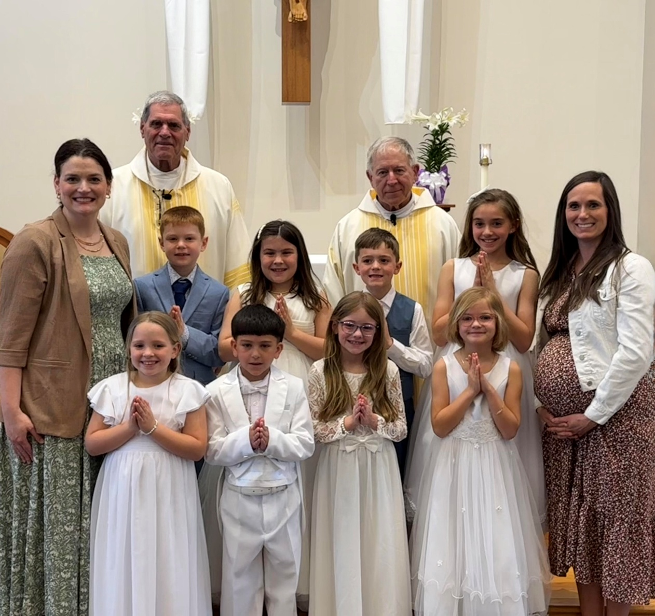
3rd Sunday of Easter - April 19, 2024
First Communion Class of 2026

Sacramental Priest, Rev. Robert “Bud” Grant Email: grantrobert@sau.edu
Priest Moderator, Rev. Dale Mallory Email: malloryd@diodav.org

Parish Life Coordinator, Deacon Dan Freeman
Cell - 563-320-2462 Email: wiltonstmary@diodav.org

Office Manager - Rosemary Sullivan Director of Religious Education – Hilary Henke
Cell - 563-723-1050 / wiltonstmaryfin@diodav.org Cell - 563-260-5861 / wiltonstmarydre@diodav.org

Mass Time: Sunday – 8:30 a.m.
Religious Education Classes start at 9:30 am during the school year.

Website: https://www.stmarywilton.org Facebook Page - https://www.facebook.com/stmarysofwilton
Today’s Readings – 4-19-26. Today, on the third Sunday of Easter, we hear the story of the two disciples who encounter the risen Lord as they walk the road to Emmaus. They listen to this stranger as he opens the scriptures to them, explaining that the Christ had to suffer and die before rising in glory. After inviting him into their home, they recognize him when he breaks bread with them at their table. Every Sunday we live out this experience. We listen to the risen Lord speak to us through God’s word. Then we receive him in the Eucharist. May we, like the disciples on the road to Emmaus, invite him into our midst. Question of the Week - What am I impassioned about? Can I see the Easter miracle, the continuing presence of the risen Lord, and the promise of the Resurrection bringing me as much joy?

St. Mary First Communion – This past Sunday was a great day for our eight St. Mary students as they received the Eucharist for the first time. Thank you to our Catechists Andrea Koopmann and Kara Meyer, who helped our youth understand this great opportunity for receiving our Lord and Savior!

Baptism at Mass today - St. Mary Family Celebration: Please welcome and pray for Arlo Lloyd and his parents Megan & Darren Keppy.

St. Mary Parish Schedule:
- Sun Apr 19th Mass.
- Sun Apr 26th Mass. Parish & Finance Councils meet after Mass.
  - Youth to Cathedral at 2:00 pm, meet Bishop at 3:00 pm. Pizza afterwards.
- Sun May 3rd Mass. May Crowning. Parish Council Nominations.
  - Leland Smith / St. Mary Scholarship application due to Deacon Dan.
- Wed May 6th Faith Formation meets at 5:30 pm.
- Sun May 10th Mass. Mother’s Day.
- Sun May 17th Mass – Ascension. Graduates’ recognition & Leland Smith Scholarship award.
  - Parish & Finance Councils meet. Parish Council Nominations.
- Sun May 24th Mass - Pentecost. Cemetery Blessing. (Monday-Memorial Day).

VBS registration forms are on a table in the Gathering Area! June 8th – 12th! All students ages 4-11 are welcome! Adult and student volunteers (12 years old and up) are welcome to join us. Student and volunteer registration forms are due Sunday, April 26th. Any questions please contact Taci (564-343-1144) or Suzy (563-357-0612). We are excited about this EPIC event!

Leland Smith / St. Mary Scholarship - All high school graduating seniors who are members of St. Mary are encouraged to apply for St. Mary-Leland R. Smith Scholarship. This Scholarship is separate from any school Leland Smith Scholarships. Contact Deacon Dan for an application. Return completed form to Deacon Dan by the Sunday, May 3rd due date.

Loss of Pregnancy or Infertility – you are not alone. Our Catholic faith offers hope, consolation, and support for those who have experienced infertility or loss of a pregnancy. Please feel free to contact Father Bud or Deacon Dan. This website is a great resource - https://springsinthedesert.org.

St. Mary Mass for graduating seniors – Sunday, May 17th at 8:30 am. 2026 Graduates of College, Trade Schools & High Schools are asked to contact Deacon Dan by email with your future plans.

Youth Group Outing – Arrive 2:00 pm Sacred Heart Cathedral (422 East 10th Street, Davenport, IA 52803) for a tour, prayer/group activity, meet the Bishop at 3:00 pm for questions, and a Pizza party in the Cathedral Parish Hall. All 7th – 12th Grade Students are invited. RSVP to Sarah Lawlor - sarahlawlor865@gmail.com or Dennis Sass - dwsass51@gmail.com by Wednesday, April 25th.

Day of Caring – Wilton Elementary School. Day of caring is a special day when Wilton elementary students give back to the community by helping others. Students will volunteer their time by visiting local homes or businesses to assist with tasks such as yard work and trash pickup on Friday, May 8th from 9 am to 11:30 am. Service must be requested by Friday, April 24th. Please contact Grace Finnegan – gracefinnegan@wiltoncsd.org.
Vocations Discernment Upcoming Events - Women’s Morning of Discernment (April 18 at St. Mary Parish, Iowa City), Duc In Altum Discernment Dinner for men, (April 13 at the Newman Center, Iowa City or April 27 at Sacred Heart Cathedral, Davenport) and Summer Summit Camp for boys ages 14-18 (June 20-21 in Nichols). Contact Fr. Andrew at rauenbuehlera@diodav.org.

Vocations Prayer: Almighty Father, we beg you for an increase in religious vocations and holy marriages in our diocese. Help us to be generous in our response to Your call. Choose from our homes those who are needed for Your work and strengthen us with the courage to say “yes” and to follow You. Help us as a Diocese, as a parish, as families to encourage and foster vocations to priesthood, permanent diaconate, and consecrated life. Through Jesus Christ our Lord. Amen.

STEP Theology Online - Connecting the Catholic intellectual life to the life of the Church. April 27, classes will begin. The Diocese of Davenport has partnered with STEP at the University of Notre Dame - https://mcgrath.nd.edu/online-courses/step/ to offer online formation for the people of the diocese. Contact Trevor Pullinger at pullinger@davenportdiocese.org for more information.
Classes offered - Foundations of Catholic Belief (Great Beginner Course), A Preface to the Study of Scripture, Faith & Science: The Catholic Approach, Liturgical Music: A Historical, Musical, and Pastoral Survey, Mary as Mother: A Symbol of Life and Hope for Christians, and many more.
Individuals from the Diocese of Davenport receive a 50% discount.

Youth Conference – Steubenville Youth Conferences are an outreach of Franciscan University of Steubenville. A series of 15 conferences across North America help teens encounter the love of Christ every summer. Our mission is to build the Church by evangelizing, equipping, and empowering God’s children to become radical and joyful disciples. This 3-day conference for Catholic teens features: National Speakers, Adoration, Mass, Confession, Small Group Time with 1700+ Catholic teens. Go to https://partnershipforyouth.org/ for dates and details.

Prayer Chain Request - please contact Colleen at 563-260-2212 or collienichols@yahoo.com

Mass Intention for Sunday, April 26, 2026 – Jerry Williams
Lay Mass Ministers for Sunday, April 26, 2026 – Father Ken Kuntz
Announcer & 1st Reading – Natalie Koopmann 2nd Reading – Jacqueline Grotzky
EMHC – Mary Grotzky & Linda Lund Gift Bearers – Gail & Bill McCrabb
Ushers – Joe Kaufman & Andy Koopmann Servers – Kinley, Kinsington, & Kendall Boorn

Mass Intentions for the deceased are $10.00 each. Please indicate who the Mass is for, who requested it, and how many Masses are requested. We will try to honor requested Mass dates.

To report child abuse, contact the Iowa Dept. of Human Services Child Abuse hotline: 800-362-2178. If clergy involved or church personnel also notify Alicia Owens, Victim Assistance Coordinator, 563-349-5002; vac@diodav.org or 780 W. Central Park Ave., Davenport, IA 52804.

New Parishioners: Please complete the Registration form online at https://www.stmarywilton.org/ or to request a form after Mass. The completed form may be placed in the Contribution Basket or given to Deacon Dan. See the contact information on the Bulletin to contact me with any questions.

Envelopes – If you are not receiving Parish Contribution Envelopes, please contact Deacon Dan.

The Coming Home Network was established to help non-Catholic Christians, clergy and laity to make the journey home to full communion with the Catholic Church. https://chnetwork.org/.

Holy Communion - Parishioners that are homebound or hospitalized may request that Holy Communion be brought to them after Mass on Sunday, or other days as necessary. Please contact Deacon Dan at 563-320-2462 or wiltonstmary@diodav.org with your request.
Fighting to break free from pornography? Get Help! https://integrityrestored.com/ or https://www.strive21.com/, or https://www.covenanteyes.com/. Call 563-334-4505 for a local group.

St. Mary Cemetery – we have developed a Cemetery policy that is effective March 1, 2026. Cemetery Plot prices - $200 each for now. Please contact Deacon Dan for a copy of the policy.

Communion Rite - How to Receive the Precious Body & Blood of Christ videos.
How to Receive the Body of Christ – (4.75 minutes – from Busted Halo.) www.stcroixcatholic.org/apps/video/watch.jsp?v=64276. How to receive the Blood of Christ (1 minute) https://www.youtube.com/shorts/xgCsaYzd0I4?feature=share.

Prayers are requested for Cameron Costello and all the Seminarians of the Davenport Diocese. We also pray for the 11 men in Diaconate Formation to be Ordained July 2027.

Sacraments - to schedule participation in any of these please contact Deacon Dan:
- Baptism – A prep class required for family’s first child. Contact Deacon Dan 1 month prior.
- Confession – email Father Bud at grantrobert@sau.edu for times prior/after Mass.
- Marriage – contact Deacon Dan a minimum of 7 months prior to the proposed event.
- Anointing – Anyone having surgery or experiencing illness may ask for the Rite of Anointing of the Sick. Father Bud will anoint immediately after Mass. Contact Deacon Dan.
- Funeral Preparation – please contact Deacon Dan. A great booklet is available to help.

New Meal Train Ministry - Our meal train ministry helps parishioners who have recently had a baby, those who have recently lost a loved one, are going through an illness or rough time, or those who are temporarily homebound and need assistance with meals. If you'd like more information, would like to nominate a parishioner, or would like to be put on the list to make meals when able, please contact Sarah Costello at 563-210-3977 or email slcostello09@gmail.com.

The Coming Home Network was established to help non-Catholic Christians, clergy and laity to make the journey home to full communion with the Catholic Church. https://chnetwork.org/.

2025-26 Parish Leadership Team

Trustees: (2 year term)
Denise Timmerman 563-349-3880 denisetimmerman13@gmail.com
Henry Bentley 563-340-3111 henrybentley1961@outlook.com

Parish Council: (2 year term)
Damon Boorn (24) President/At Large 563-260-9816 damon.boorn@gmail.com
Jessica Williams (25) 563-320-3699 jess_99@yahoo.com
Kathy Keese (22) Secretary/At Large 563-260-4904 Kskeese5@gmail.com
Taci Lilienthal (25) 563-343-1144 taci.lilienthal@gmail.com
Jeremiah Costello (23) Faith Form. 563-370-2065 Jeremiahecostello@gmail.com
Scott Wolf Cemetery 563-370-3734 srwolf64@gmail.com
Jim Gavin Bldg. & Grounds 563-506-5112 gavinjames@netwtc.net
Dennis Sass Liturgy 319-430-2063 dwsass51@gmail.com

Finance Council: (4 year term)
Phil Keese (22) 563-260-4905 plkeese5@gmail.com
Andrea Shaffer (24) 563-299-5632 shafferauto06@gmail.com
Eric Thornton (25) 563-299-4624 eric6982@hotmail.com

