Saint Mary Catholic Church
701 East Third Street, Wilton, IA 52778

5th Sunday of Lent – March 22, 2026

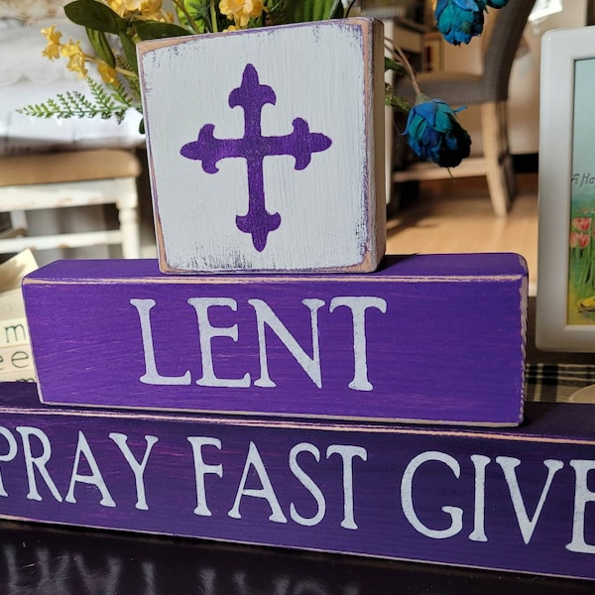

Sacramental Priest, Rev. Robert “Bud” Grant Email: grantrobert@sau.edu
Priest Moderator, Rev. Dale Mallory Email: malloryd@diodav.org

Parish Life Coordinator, Deacon Dan Freeman
Cell - 563-320-2462 Email: wiltonstmary@diodav.org

Office Manager - Rosemary Sullivan Director of Religious Education – Hilary Henke
Cell - 563-723-1050 / wiltonstmaryfin@diodav.org Cell - 563-260-5861 / wiltonstmarydre@diodav.org

Mass Time: Sunday – 8:30 a.m.
Religious Education Classes start at 9:30 am during the school year.

Website: https://www.stmarywilton.org Facebook Page - https://www.facebook.com/stmarysofwilton
Today’s Readings – 3-22-26. As we approach Holy Week and the final days of Lent, we hear the well-known story of Lazarus, the brother of Martha and Mary, whom Jesus raises from the dead. John’s account of this miracle is one of the most dramatic accounts in any of the Gospels, save Jesus’ own passion, death, and resurrection. We can only imagine the emotions coursing through Martha and Mary and their loved ones when Jesus stands at the tomb and dramatically cries: “Lazarus, come out!” On this final scrutiny Sunday, may we hear Jesus calling out to us as well, to come out of our tombs of sin and death and embrace new life in the resurrection. Question of the Week - What sins are keeping me entombed, isolated from God’s love and from others? What can I do to free myself from my tomb?

St. Mary Family – we celebrate the 3rd Scrutiny with our Elect, Jet Riley today. The Third Scrutiny focuses on the Elect's, and everyone’s, liberation from sin and death toward new life in Christ.

St. Mary Parish Schedule:
- Sun Mar 22nd Mass – 5th Sun. Lent. 3rd Scrutiny & Lord’s Prayer. No RE Classes.
- Tue Mar 24th WDMA Lent Service at 12:10 pm - St. Mary, Wilton is host.
- Wed Mar 25th Adoration 5:00 pm. Stations of the Cross 6:00 pm. Soup - Confirmation Class.
- Sun Mar 29th Mass – Palm Sunday. RE Classes.
- Mon Mar 30th Diocesan Chrism Mass at Sacred Heart Cathedral.
- Tue Mar 31st WDMA Lent Service at 12:10 pm – First Presbyterian, Wilton.
- Thu Apr 2nd Mass – Holy Thursday. 6:00 pm. Father Stephen Page.
- Fri Apr 3rd Mass – Good Friday. 6:00 pm.
- Sat Apr 4th Mass – Easter Vigil - 8:30 pm.
- Sun Apr 5th Mass – Easter. No RE Classes.

Christian Initiation Classes – Helping those Becoming Catholic or Joining the Catholic Church. Candidates, Sponsors & Friends invited. All sessions are in the Day Chapel. Everyone is invited.
- Tue Mar 24th 5:30 pm Deacon Dan Practice & the Triduum, Easter and Foot washing

12 Hours Confession & Adoration – March 27th from 7am – 8pm at Sts. Mary & Mathias, at 215 West 8th Street, Muscatine, IA 52761. We go to confession, not only to confess our sins, but to be reconciled with God. Through this sacrament, we are really, truly forgiven by God Himself.

Mass Ministry Schedule for April and May will be completed soon. Please email Denise Timmerman at Denisetimmerman13@gmail.com if you will NOT be able to serve. Thank you!

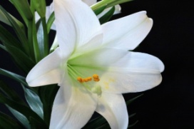
Easter Flowers - Donating a flower for use in the Sanctuary for Easter is a beautiful way to remember a loved one. The cost is $15. Please use the envelope in your Contribution packet. Money is to be returned by the end of Mass on Palm Sunday, March 29th. Donors will be listed in the Easter Sunday, April 5th bulletin. Forms are available in the Gathering Area.

Adoration Service – Exposition, Adoration, & Benediction of the Eucharist will be offered from 5 pm to 6 pm each Wednesday of Lent before Stations of the Cross. If you can’t make it at 5 pm, please join us whenever you can. The Stations of the Cross will be led by our Confirmation Students. Soup will be provided afterwards by one of our Parish committees or groups.

VBS registration forms are in the back of the gathering area! Radical Ride – on the Wings of Prayer will be June 8th – 12th! Buckle up as we prepare to soar around the world with Amazing Angels and Super Saints. We will help children understand the purpose of prayer and how to put prayer into action through the ups and downs of daily life. All students ages 4-11 are welcome! We are also looking for adult and student volunteers (12 years old and up) to join us. Student and volunteer registration forms are due April 26th. Any questions please contact Taci (564-343-1144) or Suzy (563-357-0612). We are excited about this EPIC event!

Help Wanted – We are looking for a Director of Religious Education (DRE) for St. Mary. Please contact Hilary or Deacon Dan to review the position and job description.

CRS Rice Bowl Collection: We invite you to use this resource to fulfill the Gospel’s command to love and serve our neighbors. Funds raised through the CRS Rice Bowl collection support development projects in 100 countries overseas, and 25% of the funds stay in our diocese to support local hunger and poverty efforts. Rice Bowls are due back Sat. April 4th or Sun. April 5th.

Leland Smith / St. Mary Scholarship - All high school graduating seniors who are members of St. Mary are encouraged to apply for the St. Mary-Leland Smith Scholarship. This Scholarship is separate from any school Leland Smith Scholarships. Deadline is Sunday, May 3rd. Contact Deacon Dan for an application. Return completed form to Deacon Dan by due date.

St. Mary is hosting the WDMA Lenten Service on Tuesday, March 24th at 12:10 pm. Please sign up in the Gathering Area to bring desserts, thank you! Contact Jean Semsch at 563-340-3327.

Chrism Mass – All are encouraged to attend Monday, March 30, 2026, at 10:30 am. This Mass manifests the communion of priests with their bishop in Christ's priesthood, underscores the unity of the diocese, and prepares the oils for use in the sacraments throughout the year.

Palm Sunday – Next Sunday we will begin our procession from the Parish Hall to commemorate Jesus' entrance into Jerusalem. As he rode into the city on a donkey, his followers spread palm branches at his feet and called him "Hosanna" or "savior." Palm branches were considered symbols of victory and triumph at the time. Days later, the people of Jerusalem would turn on Jesus and demand the Romans crucify him. Christian churches across the country hand out palm branches that have been blessed to the congregation. The branch is meant to serve as a reminder of Christ's victory over death. The palms have been blessed, so they are holy.
Old Palms disposal – bring to church and place in trash container in the Gathering Area. We will burn them with the Easter Fire on the Easter Vigil, Saturday, April 4th.

Mass Intention for Palm Sunday, March 29, 2026 – Betty Heirigs
Lay Mass Ministers for Palm Sunday, March 29, 2026.
Announcer & 1st Reading – Nevin Williams 2nd Reading – Nolan Williams
EMHC – Denise Timmerman & Linda Lund Gift Bearers – Mac Flack Family
Ushers – Gail & Bill McCrabb Servers – Natalie & Rosa Koopmann & Brady Blake

Mass Intentions for the deceased are $10.00 each. Please indicate who the Mass is for, who requested it, and how many Masses are requested. We will try to honor requested Mass dates.

To report child abuse, contact the Iowa Dept. of Human Services Child Abuse hotline: 800-362-2178. If clergy involved or church personnel also notify Alicia Owens, Victim Assistance Coordinator, 563-349-5002; vac@diodav.org or 780 W. Central Park Ave., Davenport, IA 52804.

New Parishioners: Please complete the Registration form online at https://www.stmarywilton.org/ or to request a form after Mass. The completed form may be placed in the Contribution Basket or given to Deacon Dan. See the contact information on the Bulletin to contact me with any questions.
Envelopes – If you are not receiving Parish Contribution Envelopes, please contact Deacon Dan.

Sacraments - to schedule participation in any of these please contact Deacon Dan:
- Confession – email Father Bud at grantrobert@sau.edu for times prior/after Mass.
- Baptism – A preparation class is required for your first child. Contact Deacon Dan.
- Marriage – contact Deacon Dan a minimum of 8 months prior to the proposed event.
- Anointing – Anyone having surgery or experiencing illness may ask for the Rite of Anointing of the Sick. Father Bud will anoint immediately after Mass. Contact Deacon Dan.
- Funeral Preparation for you or a loved one, please contact Deacon Dan.
Confession Schedule – during Lent Father Bud will be available before Mass and immediately after Mass. If possible, please email him at grantrobert@sau.edu so he can plan accordingly.

St. Mary Cemetery – we have developed a Cemetery policy that is effective March 1, 2026. Cemetery Plot prices - $200 each for now. Please contact Deacon Dan for a copy of the policy.

Prayers are requested for Cameron Costello and all the Seminarians of the Davenport Diocese. We also pray for the 11 men in Diaconate Formation to be Ordained July 2027.

Holy Communion - Parishioners that are homebound or hospitalized may request that Holy Communion be brought to them after Mass on Sunday, or other days as necessary. Please contact Deacon Dan at 563-320-2462 or wiltonstmary@diodav.org with your request.

Fighting to break free from pornography? Get Help! https://integrityrestored.com/ or https://www.strive21.com/, or https://www.covenanteyes.com/. Call 563-334-4505 for a local group.

Parish Directory App – With our new Pictorial Directory we were also given the ability to download our Parish Directory to our Cell Phones. Anyone who would like help to download this App to their cell phone should contact Deacon Dan for a special email and code or sign up on the sheet in the Gathering Area. Also, if you would like to have your picture in the Parish Directory App, please see Deacon Dan.

New Meal Train Ministry - Our meal train ministry helps parishioners who have recently had a baby, those who have recently lost a loved one, are going through an illness or rough time, or those who are temporarily homebound and need assistance with meals. If you'd like more information, would like to nominate a parishioner, or would like to be put on the list to make meals when able, please contact Sarah Costello at 563-210-3977 or email slcostello09@gmail.com.

The Coming Home Network was established to help non-Catholic Christians, clergy and laity to make the journey home to full communion with the Catholic Church. https://chnetwork.org/.

Vocations Prayer: Almighty Father, we beg you for an increase in religious vocations and holy marriages in our diocese. Help us to be generous in our response to Your call. Choose from our homes those who are needed for Your work and strengthen us with the courage to say “yes” and to follow You. Help us as a Diocese, as a parish, as families to encourage and foster vocations to priesthood, permanent diaconate, and consecrated life. Through Jesus Christ our Lord. Amen.

Parish Contacts:
Trustees: Denise Timmerman 563-349-3880 denisetimmerman13@gmail.com
Henry Bentley 563-340-3111 henrybentley1961@outlook.com
Parish Council President Damon Boorn 319-491-4833 damon.boorn@gmail.com
Finance Council Joe Kaufman 563-320-6436 kaufjmm@iowatelecom.net
Faith Formations Jeremiah Costello 563-370-2065 Jeremiahecostello@gmail.com
Liturgy Committee Dennis Sass 319-430-2063 dwsass51@gmail.com
Music Coordinator Bev Reuter 319-321-8524 bsreuter@netwtc.net
Funeral Dinner Coord Jean Semsch 563-340-3327 fourjsem@netins.net
Face Book Page: Sarah Costello 563-210-3977 slcostello09@gmail.com
Prayer Chain Colleen Nichols 563-260-2212 collienichols@yahoo.com
St. Mary Cemetery Scott Wolf 563-370-3734 srwolf64@gmail.com

