Saint Mary Catholic Church
701 East Third Street, Wilton, IA 52778

4th Sunday of Ordinary Time - February 1, 2026

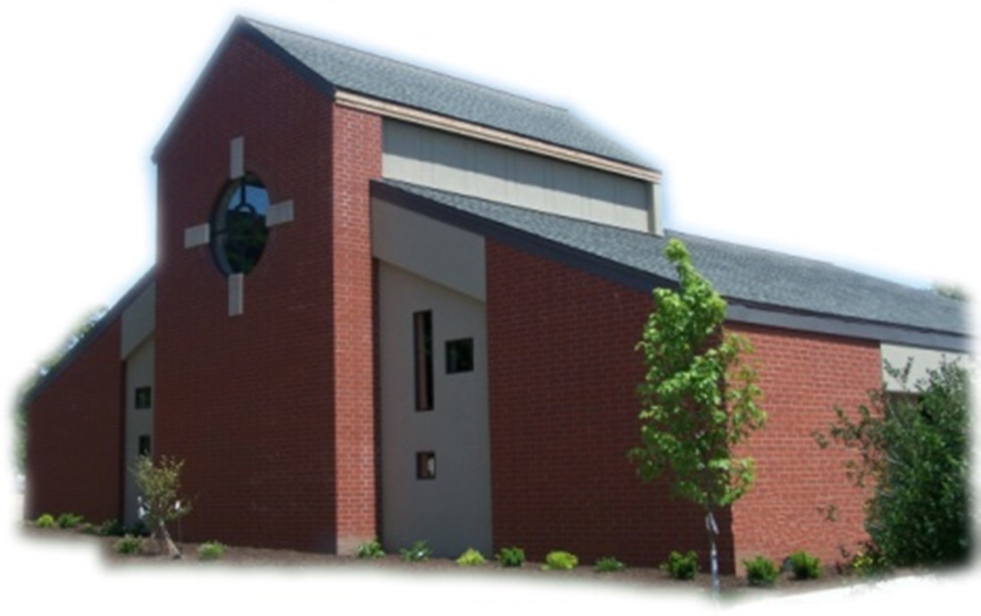
Sacramental Priest, Rev. Robert “Bud” Grant Email: grantrobert@sau.edu
Priest Moderator, Rev. Dale Mallory Email: malloryd@diodav.org

Parish Life Coordinator, Deacon Dan Freeman
Cell - 563-320-2462 Email: wiltonstmary@diodav.org

Office Manager - Rosemary Sullivan Director of Religious Education – Hilary Henke
Cell - 563-723-1050 / wiltonstmaryfin@diodav.org Cell - 563-260-5861 / wiltonstmarydre@diodav.org

Mass Time: Sunday – 8:30 a.m.
Religious Education Classes start at 9:30 am during the School year.

Website: https://www.stmarywilton.org Facebook Page - https://www.facebook.com/stmarysofwilton
Today’s Readings – 2-1-26. Matthew structures his Gospel around five lengthy sermons of Jesus and today we hear the beginning of the first of them, the well-known and oft-quoted Sermon on the Mount. It can be a challenge to hear it as the radical departure from conventional thinking that it was when Jesus first spoke these words from the mountaintop. May we ask God for the grace to realign our ideals and realize the kingdom of heaven. Question of the Week - How will I allow myself to be meek, merciful, and poor in spirit, choosing to rely more often on God’s grace?

The Quad City Young Adults (QCYA) organization provides a host of activities (Faith on Tap), events (Retreats), Adoration, Confession and Mass, and social time for Quad City area Young Adults. Young Adults diocesan website – https://davenportdiocese.org/qcya.

Please welcome our new family: Natalie and Nate Avis and their daughters Payton and Oakley.

St. Mary Parish Schedule:
- Sun Feb 1st Mass. Blessing Throats. RE Classes. First Communion Parent mtg.
  - First Reconciliation for Confirmation Students. Mass Ministries – Grade 3.
  - Youth to University of Iowa Newman Center & Iowa Heartlander Hockey Game.
- Wed Feb 4th Faith Formation meet at 5:30pm.
- Sun Feb 8th Mass with Rite of Acceptance - Catechumen and Candidate. RE Classes.
  - Parish & Finance Councils. Reconciliation – Grade 2.
- Sun Feb 15th Mass. No RE Class – Presidents’ Day.
- Wed Feb 18th Mass – Ash Wednesday - St. Mary at 7:00 pm.
- Sun Feb 22nd Mass - 1st Sun Lent with Rite of Sending. RE Classes. Mass Train – Grade 6.
  - Reconciliation – Grade 4. .Rite of Election at Cathedral for Catechumen & Candidate.
- Tue Feb 24th WDMA Lenten Service at 12:10 pm –
- Wed Feb 25th Adoration – 5:00pm. Stations of the Cross - 6:00pm. Soup by Faith Formation.

Christian Initiation Classes – Helping those Becoming Catholic or Joining the Catholic Church. Candidates, Sponsors & Friends invited. All sessions are in the Day Chapel. Everyone is invited.
- Sun Feb 1st 9:45 am Amanda Vasey & Jean Semsch - Virtues, Morality, & Conscience & Sexuality Ten Commandments & the Golden Rule, Praying Memories & Praying Scriptures.
- Sun Feb 22nd 9:45 am Amanda Vasey & Jean Semsch #48 Life after Death, #49 Life Issues, #29 Mary, & Mother of God and #23 The Rosary and #14 Lectio Divina - Philippians.
- Rite of Election at Sacred Heart Cathedral, Davenport at 2:00 pm.
- Tue Feb 24th 5:30 pm Father Bud #36 Eucharist, 38 Anointing, & 40 Reconciliation Creed presentation.

Catholic Messenger annual subscription drive begins this month. The cost of the Messenger this year is $30. Every household is to take the Messenger. Subscription envelopes are in your January packet of envelopes. Checks should be made payable to St. Mary and returned in the Offertory basket. Thank you! The Envelope is dated for January 25th.

Contribution Statements – Your 2025 Parish Contribution Statements are available for pick up in the Gathering Area after Mass. Contact Deacon Dan for any questions.

Mass Ministry Schedules for February and March are available in the Gathering Area.

Prayers are requested for Cameron Costello and all the Seminarians of the Davenport Diocese. We also pray for the 11 men in Diaconate Formation to be Ordained July 2027.

St. Mary 7th -12 Grade Youth to tour U of I Newman Center and attend an Iowa Heartlander Hockey game in Iowa City on Sunday afternoon, February 1st. Contact Dennis Sass for more information.

Blessing of Throats will be offered this Sunday at the end of Mass. There are few facts known about St. Blaise (Feb. 3rd) except that he was a fourth-century bishop in the city of Sebaste, Western Armenia, and died as a martyr. A physician, he was regarded as a righteous man and, at an early age, elected bishop by the citizens of Sebaste. Beyond those few facts, much of what we know of Blaise comes from legends. The miraculous cure of a boy suffering from a fish bone caught in his throat - and because Blaise had been a physician - created the belief that St. Blaise could cure most illnesses but especially those of the throat. As early as the 9th century in the Western Church, he was invoked for throat ailments, and by 15th century, the blessing of the throat ritual had begun.

Sacraments - to schedule participation in any of these please contact Deacon Dan:
- Reconciliation is available before & after Mass. Let Father Bud know of your need.
- Baptism – A preparation class is required for your first child. Contact Deacon Dan.
- Marriage – contact Deacon Dan a minimum of 8 months prior to the proposed event.
- Anointing – Anyone having surgery or experiencing illness may ask for the Rite of Anointing of the Sick. Father Bud will anoint immediately after Mass. Contact Deacon Dan.
- Funeral Preparation for you or a loved one, please contact Deacon Dan.

Special Collection Sunday, February 8th Envelope - the mission of the Newman Catholic Student Center at the University of Iowa is to prepare disciples for the Church and the world. Preparing disciples involves preparing faith-filled leaders who will impact their future families, parishes, workplaces, and our diocesan communities. Please prayerfully consider supporting the Newman Center through the special collection authorized by the Diocese of Davenport. For more information, please visit www.iowacatholic.org.

Trivia Night – Fundraiser for our Youth activities. St. Mary Parish Hall. Saturday, February 28th. Doors open at 5:30 pm / Games start at 6:30 pm. $10 per person. Win cash prizes, gift baskets, & 50/50 Raffles. Teams of 8, singles are welcome. Bring your own snacks and non-alcoholic beverages. All proceeds will go for our youth to attend the Iowa Catholic Youth Conference (ICYC) in Cedar Rapids March 21 & 22, 2026 and other youth activities. Donate option if you cannot attend. For Registration & Information contact Jean Semsch at 563-340-3327 or fourjsem@netins.net. EPIC – Every Parishioners Involvement Counts! Volunteers needed.

Mass Intention for Sunday, February 8, 2026 – Lois Timmerman & Ken Grunder
Lay Mass Ministers for Sunday, February 8, 2026.
Announcer & 1st Reading – Kinley Boorn 2nd Reading – Jean Semsch
EMHC – Darcy Wolf & Henry Bentley Gift Bearers – Colleen Nichols & Terry Martz
Ushers – Andy Koopmann & Rick Janneys
Servers – Natalie Koopmann, Scarlet Grotzky & Savannah Tucker

Mass Intentions for the deceased are $10.00 each. Please indicate who the Mass is for, who requested it, and how many Masses are requested. We will try to honor requested Mass dates.

To report child abuse, contact the Iowa Dept. of Human Services Child Abuse hotline: 800-362-2178. If clergy involved or church personnel also notify Alicia Owens, Victim Assistance Coordinator, 563-349-5002; vac@diodav.org or 780 W. Central Park Ave., Davenport, IA 52804.

New Parishioners: Please complete the Registration form online at https://www.stmarywilton.org/ or to request a form after Mass. The completed form may be placed in the Contribution Basket or given to Deacon Dan. See the contact information on the Bulletin to contact me with any questions.
Envelopes – If you are not receiving Parish Contribution Envelopes, please contact Deacon Dan.

Marguerite Ritzinger Scholarship - Applications for the Marguerite Ritzinger Scholarship of the Diocese of Davenport are being accepted through Feb. 27, 2026. Catholic individuals who plan to attend a college or university next fall may apply for a $1,000 scholarship. Nontraditional students may apply for the scholarship. Applications must include an essay, copy of a high school or college transcript and two reference letters. All items must be sent together with the application form, on the diocesan website at https://www.davenportdiocese.org See the Quick Links of the homepage.
Crisis Emergency Phone: 855-581-8111 or call 988 for those contemplating suicide.

Fighting to break free from pornography? Get Help! https://integrityrestored.com/ or https://www.strive21.com/, or https://www.covenanteyes.com/. Call 563-334-4505 for a local group.

Questions about our Faith – here’s your chance to ask any question pertaining to the Catholic Church and our Catholic Faith that you are curious about. Simply email your question to wiltonstmary@diodav.org and it will be answered in the Bulletin anonymously.

Our Lady of the Prairie Retreat, Wheatland
For details and to register via email, olpretreat@gmail.com or call 563-374-1092.
- Lectio Divina: (Online every Tuesday) is the foundation for Benedictine prayer. Make it a steady prayer in your life. Facilitator: Linda Clewell, SMM Oblate. Free will offering.

Parish Directory App – With our new Pictorial Directory we were also given the ability to download our Parish Directory to our Cell Phones. Anyone who would like help to download this App to their cell phone should contact Deacon Dan for a special email and code or sign up on the sheet in the Gathering Area. Also, if you would like to have your picture in the Parish Directory App, please see Deacon Dan.

Blessings & Prayers Offered. Blessings or Special Prayers for your family or any family event or gathering such as an engagement, birthday, etc., or for your home, pets, livestock, crops, new buildings or for any other reason are offered to celebrate God’s goodness or ask for His grace. Blessings and Prayers with our family and friends help all of us recognize that God is always among us and wants to be active in our lives. Please contact Deacon Dan for more information.

Prayer Chain Request - please contact Colleen at 563-260-2212 or collienichols@yahoo.com.

New Meal Train Ministry - Our meal train ministry helps parishioners who have recently had a baby, those who have recently lost a loved one, are going through an illness or rough time, or those who are temporarily homebound and need assistance with meals. If you'd like more information, would like to nominate a parishioner, or would like to be put on the list to make meals when able, please contact Sarah Costello at 563-210-3977 or email slcostello09@gmail.com.

The Coming Home Network was established to help non-Catholic Christians, clergy and laity to make the journey home to full communion with the Catholic Church. https://chnetwork.org/.

Vocations Prayer: Almighty Father, we beg you for an increase in religious vocations and holy marriages in our diocese. Help us to be generous in our response to Your call. Choose from our homes those who are needed for Your work and strengthen us with the courage to say “yes” and to follow You. Help us as a Diocese, as a parish, as families to encourage and foster vocations to priesthood, permanent diaconate, and consecrated life. Through Jesus Christ our Lord. Amen.

Parish Contacts:
Trustees: Denise Timmerman 563-349-3880 denisetimmerman13@gmail.com
Henry Bentley 563-340-3111 henrybentley1961@outlook.com
Parish Council President Damon Boorn 319-491-4833 damon.boorn@gmail.com
Finance Council Joe Kaufman 563-320-6436 kaufjmm@iowatelecom.net
Faith Formations Jeremiah Costello 563-370-2065 Jeremiahecostello@gmail.com
Liturgy Committee Dennis Sass 319-430-2063 dwsass51@gmail.com
Music Coordinator Bev Reuter 319-321-8524 bsreuter@netwtc.net
Funeral Dinner Coord Jean Semsch 563-340-3327 fourjsem@netins.net
Face Book Page: Sarah Costello 563-210-3977 slcostello09@gmail.com
Prayer Chain Colleen Nichols 563-260-2212 collienichols@yahoo.com
St. Mary Cemetery Scott Wolf 563-370-3734 srwolf64@gmail.com

