Saint Mary Catholic Church
701 East Third Street, Wilton, IA 52778

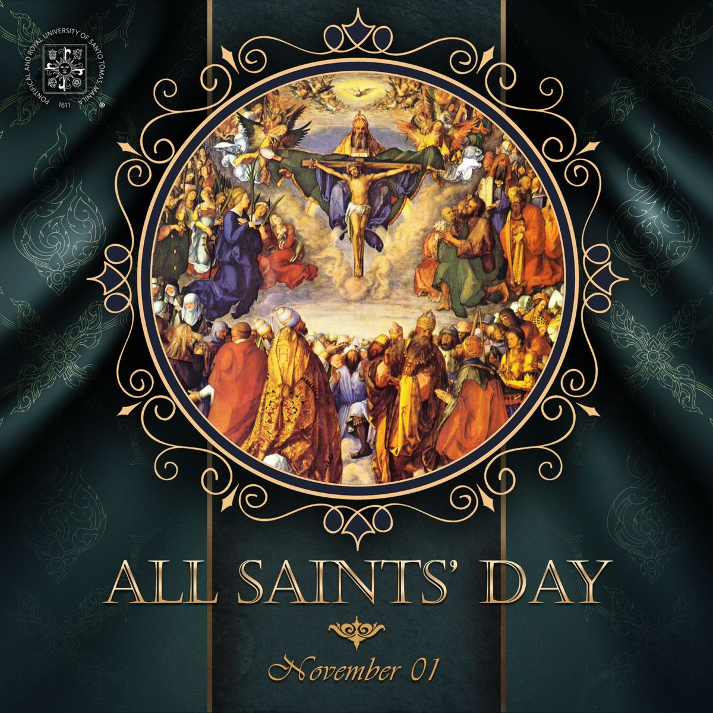
All Saints Day – 31st Sunday – November 1, 2026

Sacramental Priest, Rev. Robert “Bud” Grant Email: grantrobert@sau.edu

Priest Moderator, Rev. Dale Mallory Email: malloryd@diodav.org

Parish Life Coordinator, Deacon Dan Freeman
Cell - 563-320-2462 Email: wiltonstmary@diodav.org

Office Manager - Rosemary Sullivan Director of Religious Education – Elizabeth Walker
C- 563-723-1050 /wiltonstmaryfin@diodav.org C- 563-260-3675/wiltonstmarydre@diodav.org

Mass Time: Sunday – 8:30 a.m.
Religious Education Classes start at 9:30 am during the school year.

Website: https://www.stmarywilton.org Facebook Page - https://www.facebook.com/stmarysofwilton
Today’s Readings – 11-1-26. We set every Sunday aside to worship the Lord, but today we also remember the saints. These men and women served the Lord during their time on earth and continue to give witness to the Lord by the example of their lives. During this month at the end of autumn, when we give thanks for the abundance of the harvest for another year, we also give thanks to God, whose harvest of souls in heaven we recognize in all the saints. May we one day join them and reap the heavenly reward that our Lord has won for us. Question of the Week - How can I show the unconditional love of a saint in a way that I have been reluctant to in the past?

$1221 was raised for the WDMA Help Fund! Thank you for generously loving your neighbors.

St. Mary Parish Schedule:
- Sun Nov 1st Mass – All Saints. RE Classes. 1st Grade - Gift Bearers. Altar Server training.
- Sun Nov 4th Faith Formation Committee at 5:30 pm.
- Sun Nov 8th Mass. RE Classes. Mass Training Grade 5.
  - Recognition of Veterans. Parish & Finance Councils meet after Mass.
  - Youth Group Hayride & Bonfire, Sunday, November 8, 2026, 3-6 pm.
- Wed Nov 11th Liturgy Committee at 5:30 pm. (Advent Postcards)
- Sat Nov 14th Mass – Catholic Rural Life Farm Mass – 4pm – Terri & Jim Lilienthal.
- Sun Nov 15th Mass. RE Classes. Mass Ministry Grade 5. Mass Ministry Training.
- Sun Nov 22nd Mass - Christ the King Sunday. RE Classes. Advent decorations after Mass.
  - Mass Ministry Training.
- Sun Nov 29th Mass – 1st Sun. Advent. Thanksgiving week - NO RE Classes.

Christian Initiation Classes – Helping those Becoming Catholic or Joining the Catholic Church. Candidates, Sponsors, & Friends invited. All sessions are in the Parish Hall. Everyone is invited.
- Tue Nov 10th 5:30 pm Denise Austin & Dennis Sass Ch 12. Celebrating the Paschal Mystery - the Sacraments & Ch 13. Two Sacraments of Initiation: Baptism & Confirmation
- Sun Nov 29th 9:45 am Katy & Jim Jepsen Ch 16. Sacraments at the Service of Communion I: Holy Orders & Ch 17. Sacraments at the Service of Communion II: Matrimony.

Donuts & Coffee every Sunday!!! Serve Donuts & Coffee & clean up afterward. Signup sheets in the Gathering Area. Volunteers needed to pick up Donuts on Saturday – contact Jessica Williams.

Catholic Rural Life Mass of Thanksgiving will be held on Saturday, November 14, 2026, starting at 4:00 pm. Location is at the Seed barn of Terri and Jim Lilienthal, 2106 Yankee Avenue, Durant, IA 52747 – a big brown barn just north of I80 and on the right side of the road. Handicap Parking will be available. We will share a Potluck Supper after Mass, so bring your best dish! St. Mary will provide the table service. We will be in a partially heated building.

Are you registered to vote, go https://apps.sos.iowa.gov/elections/voterreg/regtovote/search.aspx. If not register here; https://mymvd.iowadot.gov/Account/Login?ReturnUrl=%2fVoterRegistration.

Thank you to everyone who helped with the Parish Fall Cleanup and the Breakfast Potluck.

Any family that did NOT receive their St. Mary Coin should contact Deacon Dan.

2027 NCYC - The National Catholic Youth Conference (NCYC) is a three-day gathering for high school youth and their adult chaperones, taking place November 18–21, 2027, at Lucas Oil Stadium and the Indiana Convention Center in Indianapolis. Sponsored by the National Federation for Catholic Youth Ministry, NCYC invites young people to encounter Christ, experience the wider Church, and be strengthened for lives of discipleship. NCYC is open to young people who will be in high school at the time of the conference. Check out the https://ncyc.us/about/ for more details on what to expect at the conference. Sign up in the Gathering Area by Wednesday, November 11th.
2026-27 ADA - 10/21/26. Goal $24,954. Pledged $12,686. Paid $5,921. Thank you for prayerfully considering your participation in this year’s Appeal. Every gift helps continue Christ’s mission.

Youth Hayride & Bonfire – Sunday, November 8, 2026, from 3 to 6 pm. At Jessica & Damon Boorn farm, 2561 122nd St., Moscow, IA 52760. 7-12 grades. Invite a friend. Faith, Food, & Fun!

2026 Christmas card for the Catholic Messenger - Youths in grades K-6 are invited to participate in our annual contest to create a 2026 Christmas card for The Catholic Messenger annual contest. Youths living in or attending school or religious education in the diocese are eligible. The artwork should focus on the religious nature of Christmas and entries submitted by the Nov. 19th postmark deadline. Please submit original artwork only, no black and white drawings. Complete drawings on white, 8 ½- by 11-inch paper using colored pencil, crayon, marker or paints. If you use the color yellow, it should be a deeper shade or surrounded by a dark color because yellow is hard to reproduce. Messenger staff members will judge the entries based on originality and the ability to convey what Christmas means to Catholics. On the back of the artwork, include the following information about the artist: first and last name, age, grade, home address, school (public, private or home school and location) and parish (name and city). Please do not fold entries. Any information omitted could be grounds for disqualification. The winning entries will be featured in the Christmas edition (Dec. 24) and on The Catholic Messenger Web site: www.catholicmessenger.net. Send to The Catholic Messenger, 780 W. Central Park Ave., Davenport, IA 52804.

Cameron Costello will be ordained a Deacon on Saturday, December 5, 2026. On that Sunday he will come to St. Mary to serve as Deacon in thanksgiving for your prayers. You may check out his gift registry for his future priesthood ordination at www.withjoy.com/cameroncostello/. Prayers are requested for Cameron and all the Seminarians of the Davenport Diocese. There are currently 16 men in Seminary for the Diocese of Davenport and another 13 seeking information about entering the Seminary. This is why we pray for vocations. We also pray for the 11 men in Diaconate Formation to be Ordained July 2027.

Iowa Concern - When Life Gets Tough. Call 800-447-1985 or visit the Iowa Concern website.

Prayer Chain – to submit a name please contact Colleen Nichols at 563-260-2212.

Mass Intention for Sunday, November 8, 2026 – Debra Krogman
Lay Mass Ministers for Sunday, November 8, 2026.
Announcer & 1st Reading – Jacqueline Grotzky 2nd Reading – Rosemary Sullivan
EMHC – Darcy Wolf & Steve Grotzky Gift Bearers – Damon Boorn Family
Ushers – Jean Semsch & Dennis Sass Servers – Tucker, Cooper & Carter Smyser
Homebound Communion Minister – Liz Walker & Family Hospitality – Hilary Henke

Mass Intentions for the deceased are $10.00 each. Please indicate who the Mass is for, who requested it, and how many Masses are requested. We will try to honor requested Mass dates.

To report child abuse, contact the Iowa Dept. of Human Services Child Abuse hotline: 800-362-2178. If clergy or church personnel are involved also notify Alicia Owens, Victim Assistance Coordinator, 563-349-5002; vac@diodav.org or 780 W. Central Park Ave., Davenport, IA 52804.

New Parishioners: Please complete the Registration form online at https://www.stmarywilton.org/ or request a form after Mass. The completed form may be placed in the Contribution Basket or given to Deacon Dan. See the contact information on the Bulletin to contact me with any questions.

Envelopes – If you are not receiving Parish Contribution Envelopes, please contact Deacon Dan.

Social Action - Our Davenport Diocese offers two email groups; 1) Social Action Advocacy addresses legislative advocacy on social issues of concern to the Catholic Church and encourages faithful advocacy. 2) Parish Social Action Email Group offers resources, ideas and opportunities for parishioners to live out their faith working for charity and justice. Subscribe for free at https://diodavsocialaction.substack.com. Publication archives.
Walking with Moms in Need is a nationwide, parish-based initiative to increase support for pregnant and parenting mothers in need. It works to ensure that any woman who finds herself unexpectedly pregnant, or parenting in difficult circumstances, can turn to her local Catholic Church and be connected with the resources she needs. Volunteers walk with moms throughout the motherhood journey, offering them authentic Christian friendship and ongoing support. If you need our support, please contact Deacon Dan. If you want to volunteer, please contact Deacon Dan.

Social Action - Our Davenport Diocese offers two email groups; 1) Social Action Advocacy addresses legislative advocacy on social issues of concern to the Catholic Church and encourages faithful advocacy. 2) Parish Social Action Email Group offers resources, ideas and opportunities for parishioners to live out their faith working for charity and justice. Subscribe for free at https://diodavsocialaction.substack.com. Publication archives.

Loss of Pregnancy or Infertility – you are not alone. Our Catholic faith offers hope, consolation, and support for those who have experienced infertility or loss of a pregnancy. Please feel free to contact Father Bud or me. Also a great resource is this website - https://springsinthedesert.org.

Project Rachel - is a confidential, post-abortion healing ministry of the Catholic Church offering hope and healing to women and men hurting from past abortions. Project Rachel staff understand the emotional pain that follows an abortion. Helpline: 563-888-4376, Email: projectrachel@diodav.org. Calls answered personally Monday, Tuesday, Wednesday & Thursday 9am-3pm. Voice messaging all other times.

NEW-Communion Rite videos - How to Receive the Body & Blood of Christ, (4.46 minutes, Busted Halo.) https://www.bing.com/videos/riverview/relatedvideo?q=How+to+recieve+the+Blood+of+Christ+as+a+Catholic&mid=B8201E5F095973893DA3B8201E5F095973893DA3&churl=https%3a%2f%2fwww.youtube.com%2fchannel%2fUCKYZOHnWG_5lVhke0NxsljA&FORM=VIRE. This video offer great information regarding properly receiving the Holy Eucharist.

Fighting to break free from pornography? Get Help! https://integrityrestored.com/ or https://www.strive21.com/, or https://www.covenanteyes.com/. Call 563-334-4505 for a local group.

2026-27 Parish Leadership Team
Trustees: (2 year term – max 4 terms)
Denise Timmerman (24) 563-349-3880 denisetimmerman13@gmail.com
Henry Bentley (24) 563-340-3111 henrybentley1961@outlook.com
Parish Council: (2 year term – max 2 terms)
Jessica Williams (25) Chair/At Large 563-320-3699 jesss_99@yahoo.com
Andrew Koopmann (26)Vice Chair/Secretary 563-920-2993 ajkoop88@gmail.com
Taci Lilienthal (25) At Large 563-343-1144 taci.lilienthal@gmail.com
Damon Boorn (24) At Large 563-260-9816 wilpowerps@netwtc.net
Jeremiah Costello (23) Faith Formation 563-370-2065 Jeremiahecostello@gmail.com
Scott Wolf Cemetery 563-370-3734 srwolf64@gmail.com
Jim Gavin Bldg. & Grounds 563-506-5112 gavinjames@netwtc.net
Dennis Sass Liturgy 319-430-2063 dwsass51@gmail.com
Finance Council: (4 year term – max 2 terms)
Andrea Shaffer (24) Chair 563-299-5632 shafferauto06@gmail.com
Eric Thornton (25) 563-299-4624 eric6982@hotmail.com
John Kuhl (26) 563-320-7433 johnkuhl@kentww.com

