Saint Mary Catholic Church
701 East Third Street, Wilton, IA 52778

30th Sunday Ordinary Time – October 25, 2026
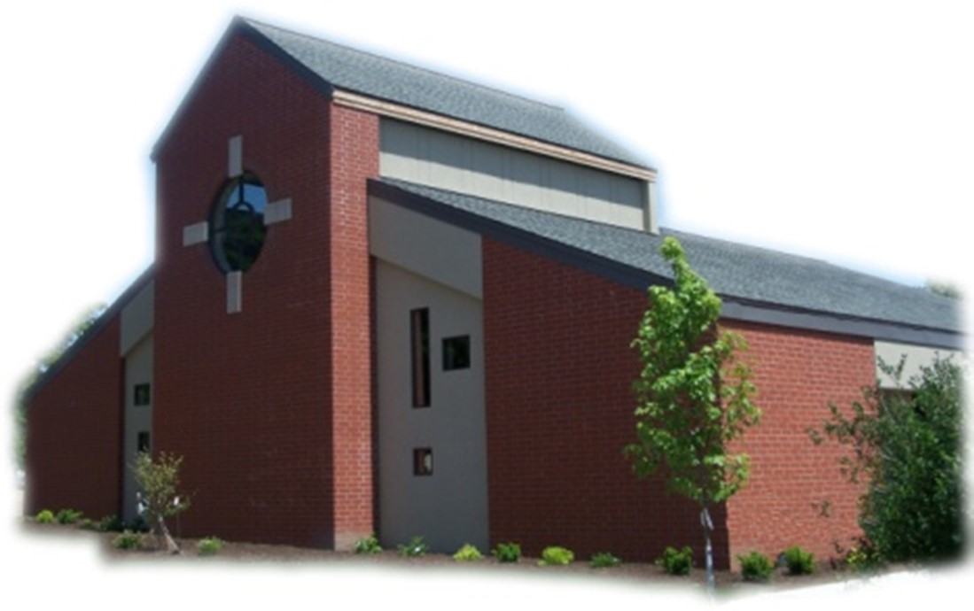

Sacramental Priest, Rev. Robert “Bud” Grant Email: grantrobert@sau.edu

Priest Moderator, Rev. Dale Mallory Email: malloryd@diodav.org

Parish Life Coordinator, Deacon Dan Freeman
Cell - 563-320-2462 Email: wiltonstmary@diodav.org

Office Manager - Rosemary Sullivan Director of Religious Education – Elizabeth Walker
C- 563-723-1050 /wiltonstmaryfin@diodav.org C- 563-260-3675/wiltonstmarydre@diodav.org

Mass Time: Sunday – 8:30 a.m.
Religious Education Classes start at 9:30 am during the school year.

Website: https://www.stmarywilton.org Facebook Page - https://www.facebook.com/stmarysofwilton
Today’s Readings – 10-25-26. Out of love, God created us and the entire world we live in. Out of love, God sent the Son who died for us to save us from our sins. Out of love, God sent the Holy Spirit to remain with us always. No wonder John wrote quite simply that God is love. Because we were created, redeemed, and made holy as acts of love, we are called to love in return. Specifically, Jesus teaches us today that the greatest commandment is to love God and love our neighbor. May our hearts expand with love as we join with our neighbor to worship God. Question of the Week - How can I give of myself this week and to whom?

St. Mary Parish Schedule:
- Sun Oct 25th Mass. NO RE Classes. Volunteer Mass Ministries Sign up.
  - Parish Potluck Breakfast and Parish Cleanup Day.
- Sun Nov 1st Mass – All Saints. RE Classes. 1st Grade - Gift Bearers. Altar Server training after RE Class.
- Sun Nov 4th Faith Formation Committee at 5:30 pm.
- Sun Nov 8th Mass. Dedication St. John Latern. RE Classes. Mass Training Grade 5. Recognition of Veterans. Parish & Finance Councils after Mass.
  - Youth Group Hayride & Bonfire, Sunday, November 8, 2026, 3-6 pm.
- Wed Nov 11th Liturgy Committee at 5:30 pm. (Advent Postcards)
- Sat Nov 14th Mass – Catholic Rural Life Farm Mass – 4pm – Terri & Jim Lilienthal.
- Sun Nov 15th Mass. RE Classes. Mass Ministry Grade 5. Mass Ministry Training.

Christian Initiation Classes – Helping those Becoming Catholic or Joining the Catholic Church. Candidates, Sponsors, & Friends invited. All sessions are in the Parish Hall. Everyone is invited.
- Tue Oct 27th 5:30 pm Amanda & Dyllin Kitzmiller Ch 1. The Existence of God & Ch 2. God: Our Loving Creator.
- Tue Nov 10th 5:30 pm Denise Austin & Dennis Sass Ch 12. Celebrating the Paschal Mystery - the Sacraments & Ch 13. Two Sacraments of Initiation: Baptism & Confirmation

Donuts & Coffee every Sunday!!! Serve Donuts & Coffee & clean up afterward. Signup sheets in the Gathering Area. Volunteers needed to pick up Donuts on Saturday – contact Jessica Williams.

Catholic Rural Life Mass of Thanksgiving will be held on Saturday, November 14, 2026, starting at 4:00 pm. Location is at the Seed barn of Terri and Jim Lilienthal, 2106 Yankee Avenue, Durant, IA 52747 – a big brown barn just north of I80 and on the right side of the road. Handicap Parking will be available. We will share a Potluck Supper after Mass, so bring your best dish! St. Mary will provide the table service. We will be in a partially heated building.

Walking with Moms in Need is a nationwide, parish-based initiative to increase support for pregnant and parenting mothers in need. It works to ensure that any woman who finds herself unexpectedly pregnant, or parenting in difficult circumstances, can turn to her local Catholic Church and be connected with the resources she needs. Volunteers walk with moms throughout the motherhood journey, offering them authentic Christian friendship and ongoing support. If you need our support, please contact Deacon Dan. If you want to volunteer, please contact Deacon Dan.

Parish Breakfast Potluck & Cleanup Day – Today after Mass we will have a Breakfast Potluck. The Parish will provide meat, drinks, and table service. A Parish Cleanup Day will be held after the Potluck so bring/wear your work clothes. We have purchased special St. Mary Coins to distribute to each family after Mass. They will be blessed during Mass.

Lay Mass Ministry Signup - Sundays. Signup sheets are in the Gathering Area for each of our Lay Mass Ministries – Lectors, Extra-Ordinary Eucharistic Ministers, Ushers, Altar Servers, Gift Bears, and new – Greeters, Hospitality, and Homebound Communion Ministers. Information sheets will be available to explain each Ministry. Please ask if you have any questions.

2026-27 ADA. Thank you for prayerfully considering your participation in this year’s Appeal. Every gift helps continue Christ’s mission. St. Mary ADA goal for 2026-27 is $24,954.
2027 NCYC - The National Catholic Youth Conference (NCYC) is a three-day gathering for high school youth and their adult chaperones, taking place November 18–21, 2027, at Lucas Oil Stadium and the Indiana Convention Center in Indianapolis. Sponsored by the National Federation for Catholic Youth Ministry, NCYC invites young people to encounter Christ, experience the wider Church, and be strengthened for lives of discipleship. NCYC is open to young people who will be in high school at the time of the conference. Check out the https://ncyc.us/about/ for more details on what to expect at the conference. Sign up in the Gathering Area. No commitment at this time.

Committees Signup Sundays - Sign up forms for each committee are in the Gathering Area. The Committees are; Buildings & Grounds, Cemetery, Faith Formation, Liturgy, Safety, and Welcoming & Belonging. Please ask if you have any questions about these committees.

Youth Hayride & Bonfire – Sunday, November 8, 2026, from 3 to 6 pm. At Jessica & Damon Boorn farm, 2561 122nd St., Moscow, IA 52760. 7-12 grades. Invite a friend. Faith, Food, & Fun!

2026 Christmas card for the Catholic Messenger - Youths in grades K-6 are invited to participate in our annual contest to create a 2026 Christmas card for The Catholic Messenger annual contest. Youths living in or attending school or religious education in the diocese are eligible. The artwork should focus on the religious nature of Christmas and entries submitted by the Nov. 19th postmark deadline. Please submit original artwork only, no black and white drawings. Complete drawings on white, 8 ½- by 11-inch paper using colored pencil, crayon, marker or paints. If you use the color yellow, it should be a deeper shade or surrounded by a dark color because yellow is hard to reproduce. Messenger staff members will judge the entries based on originality and the ability to convey what Christmas means to Catholics. On the back of the artwork, include the following information about the artist: first and last name, age, grade, home address, school (public, private or home school and location) and parish (name and city). Please do not fold entries. Any information omitted could be grounds for disqualification. The winning entries will be featured in the Christmas edition (Dec. 24) and on The Catholic Messenger Web site: www.catholicmessenger.net. Send to The Catholic Messenger, 780 W. Central Park Ave., Davenport, IA 52804.

Mass Intention for Sunday, November 1, 2026 – Jim Koopmann
Lay Mass Ministers for Sunday, November 1, 2026.
Announcer & 1st Reading – Madison Smyser 2nd Reading – Jessica Williams
EMHC – Amanda Rockow & Steve Grotzky Gift Bearers – 1st Graders
Ushers – Mac Flack Family Servers – Kensington & Kinley Boorn & Scarlet Grotzky
Homebound Communion Minister – Colleen Nichols
Hospitality – Megan & Jared Verhasselt

Mass Intentions for the deceased are $10.00 each. Please indicate who the Mass is for, who requested it, and how many Masses are requested. We will try to honor requested Mass dates.

To report child abuse, contact the Iowa Dept. of Human Services Child Abuse hotline: 800-362-2178. If clergy or church personnel are involved also notify Alicia Owens, Victim Assistance Coordinator, 563-349-5002; vac@diodav.org or 780 W. Central Park Ave., Davenport, IA 52804.

New Parishioners: Please complete the Registration form online at https://www.stmarywilton.org/ or request a form after Mass. The completed form may be placed in the Contribution Basket or given to Deacon Dan. See the contact information on the Bulletin to contact me with any questions.

Envelopes – If you are not receiving Parish Contribution Envelopes, please contact Deacon Dan.

Social Action - Our Davenport Diocese offers two email groups; 1) Social Action Advocacy addresses legislative advocacy on social issues of concern to the Catholic Church and encourages faithful advocacy. 2) Parish Social Action Email Group offers resources, ideas and opportunities for parishioners to live out their faith working for charity and justice. Subscribe for free at https://diodavsocialaction.substack.com. Publication archives.

Ordination Banns - As Cameron John Costello, a seminarian from this parish, prepares for possible diaconate ordination this winter, the People of God are asked about his worthiness. If you are aware of any reason why this man should not be ordained, you are asked to contact: Fr. James Flattery (Pastor of St. Isidore, the Farmer Catholic Parish & Director of Seminarians, Diocese of Davenport), 208 Meridian St, Tipton, IA 52772. Phone: 563-886-2506 or flatteryj@diodav.org. The names of those expressing concerns will not be shared with any of the candidates, though the nature of the concern may be shared with them as part of the discernment and evaluation process.

Prayers are requested for Cameron Costello and all the Seminarians of the Davenport Diocese. We also pray for the 11 men in Diaconate Formation to be Ordained July 2027.

Prayer Chain – to submit a name please contact Colleen Nichols at 563-260-2212.

Are you registered to vote, go to https://apps.sos.iowa.gov/elections/voterreg/regtovote/search.aspx. If not register here; https://mymvd.iowadot.gov/Account/Login?ReturnUrl=%2fVoterRegistration.

Loss of Pregnancy or Infertility – you are not alone. Our Catholic faith offers hope, consolation, and support for those who have experienced infertility or loss of a pregnancy. Please feel free to contact Father Bud or me. Also a great resource is this website - https://springsinthedesert.org.

Project Rachel - is a confidential, post-abortion healing ministry of the Catholic Church offering hope and healing to women and men hurting from past abortions. Project Rachel staff understand the emotional pain that follows an abortion. Helpline: 563-888-4376, Email: projectrachel@diodav.org. Calls answered personally Monday, Tuesday, Wednesday & Thursday 9am-3pm. Voice messaging all other times.

NEW-Communion Rite videos - How to Receive the Body & Blood of Christ, (4.46 minutes, Busted Halo.) https://www.bing.com/videos/riverview/relatedvideo?q=How+to+recieve+the+Blood+of+Christ+as+a+Catholic&mid=B8201E5F095973893DA3B8201E5F095973893DA3&churl=https%3a%2f%2fwww.youtube.com%2fchannel%2fUCKYZOHnWG_5lVhke0NxsljA&FORM=VIRE. This video offer great information regarding properly receiving the Holy Eucharist.

Fighting to break free from pornography? Get Help! https://integrityrestored.com/ or https://www.strive21.com/, or https://www.covenanteyes.com/. Call 563-334-4505 for a local group.

2026-27 Parish Leadership Team
Trustees: (2 year term – max 4 terms)
Denise Timmerman (24) 563-349-3880 denisetimmerman13@gmail.com
Henry Bentley (24) 563-340-3111 henrybentley1961@outlook.com
Parish Council: (2 year term – max 2 terms)
Jessica Williams (25) Chair/At Large 563-320-3699 jesss_99@yahoo.com
Andrew Koopmann (26)Vice Chair/Secretary 563-920-2993 ajkoop88@gmail.com
Taci Lilienthal (25) At Large 563-343-1144 taci.lilienthal@gmail.com
Damon Boorn (24) At Large 563-260-9816 wilpowerps@netwtc.net
Jeremiah Costello (23) Faith Formation 563-370-2065 Jeremiahecostello@gmail.com
Scott Wolf Cemetery 563-370-3734 srwolf64@gmail.com
Jim Gavin Bldg. & Grounds 563-506-5112 gavinjames@netwtc.net
Dennis Sass Liturgy 319-430-2063 dwsass51@gmail.com
Finance Council: (4 year term – max 2 terms)
Andrea Shaffer (24) Chair 563-299-5632 shafferauto06@gmail.com
Eric Thornton (25) 563-299-4624 eric6982@hotmail.com
John Kuhl (26) 563-320-7433 johnkuhl@kentww.com

