Saint Mary Catholic Church
701 East Third Street, Wilton, IA 52778

29th Sunday Ordinary Time – October 18, 2026
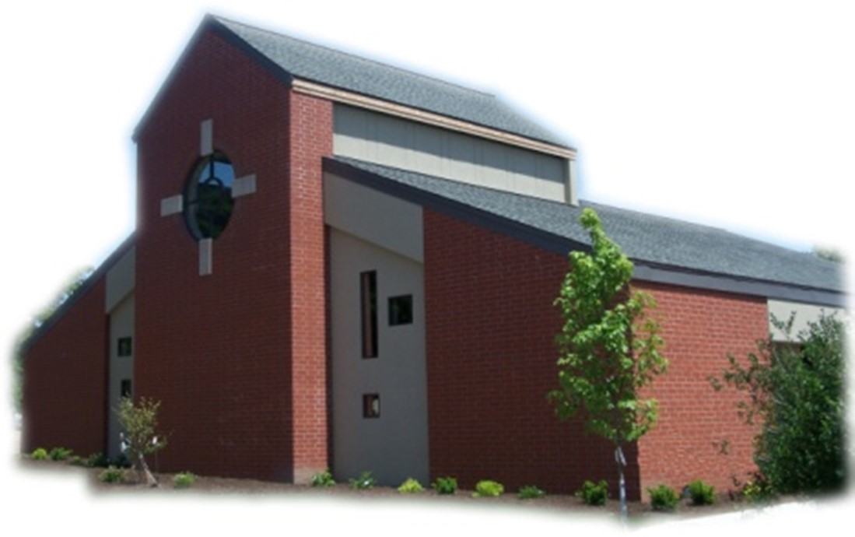

Sacramental Priest, Rev. Robert “Bud” Grant Email: grantrobert@sau.edu

Priest Moderator, Rev. Dale Mallory Email: malloryd@diodav.org

Parish Life Coordinator, Deacon Dan Freeman
Cell - 563-320-2462 Email: wiltonstmary@diodav.org

Office Manager - Rosemary Sullivan Director of Religious Education – Elizabeth Walker
C- 563-723-1050 /wiltonstmaryfin@diodav.org C- 563-260-3675/wiltonstmarydre@diodav.org

Mass Time: Sunday – 8:30 a.m.
Religious Education Classes start at 9:30 am during the school year.

Website: https://www.stmarywilton.org Facebook Page - https://www.facebook.com/stmarysofwilton
Today’s Readings – 10-18-26. We gather as a faith community each Sunday to worship God by celebrating Mass and receiving the Eucharist. In doing so, we are coming here, as Jesus says in today’s Gospel, “to repay to God what belongs to God.” Praise and thanks belong to God for creating us, redeeming us, and making us holy. We make this day and this gathering holy with our presence. We go forth to serve the Lord as his disciples, repaying God with our prayers, words, and actions. Question of the Week - This week ahead, how will I repay to God what belongs to God?

Ordination Banns - As Cameron John Costello, a seminarian from this parish, prepares for possible diaconate ordination this winter, the People of God are asked about his worthiness. If you are aware of any reason why this man should not be ordained, you are asked to contact: Fr. James Flattery (Pastor of St. Isidore, the Farmer Catholic Parish & Director of Seminarians, Diocese of Davenport), 208 Meridian St, Tipton, IA 52772. Phone: 563-886-2506 or flatteryj@diodav.org. The names of those expressing concerns will not be shared with any of the candidates, though the nature of the concern may be shared with them as part of the discernment and evaluation process.

St. Mary Parish Schedule:
- Sun Oct 18th Mass. RE Classes. Volunteer Mass Ministries Sign up. Mass Ministries Confirm. Students
- Sun Oct 25th Mass. NO RE Classes. Volunteer Mass Ministries Sign up.
  - Parish Potluck Breakfast and Parish Cleanup Day.
- Sun Nov 1st Mass – All Saints. RE Classes. 1st Grade - Gift Bearers. Altar Server training.
- Sun Nov 1st Mass – All Saints. RE Classes. 1st Grade - Gift Bearers. Altar Server training.
- Sun Nov 8th Mass. Dedication St. John Latern. RE Classes. Mass Training Grade 5. Recognition of Veterans. Parish & Finance Councils after Mass.
  - Youth Group Hayride & Bonfire, Sunday, November 8, 2026, 3-6 pm.
- Wed Nov 11th Liturgy Committee at 5:30 pm. (Advent Postcards)

Christian Initiation Classes – Helping those Becoming Catholic or Joining the Catholic Church. Candidates, Sponsors, & Friends invited. All sessions are in the Parish Hall. Everyone is invited.
- Sun Oct 18th 9:45 am Katy & Jim Jepsen Ch 11. Christian Destiny: The Last Things
- Tue Oct 27 5:30 pm Amanda & Dyllin Kitzmiller Ch 1. Existence of God, Ch 2. Loving Creator.

Donuts & Coffee every Sunday!!! Serve Donuts & Coffee and clean up after Mass. Parents of RE students sign up for the RE Sundays, Parishioners sign up for those Non-RE Sundays. Signup sheets in the Gathering Area. We also need volunteers to pick up the Donuts on the Saturday before – contact Jessica Williams.

Theology of the Body event. A multi-media event entitled Made for More will weave together live music, video clips and sacred art for an evening of beauty and reflection on the meaning of life, love and human destiny through the lens of St. John Paul II’s Theology of the Body writings. This event gives us an understanding of JPII’s (St. John Paul II) work to provide us with ways to have conversations with others, both young and old, regarding how to live our lives with dignity and as God intended. Thursday, November 12, 2026, at 7:00 pm. Our Lady of Victory Parish, Davenport.

2027 NCYC - The National Catholic Youth Conference (NCYC) is a three-day gathering for high school youth and their adult chaperones, taking place November 18–21, 2027, at Lucas Oil Stadium and the Indiana Convention Center in Indianapolis. Sponsored by the National Federation for Catholic Youth Ministry, NCYC invites young people to encounter Christ, experience the wider Church, and be strengthened for lives of discipleship. NCYC is open to young people who are in high school at the time of the conference. Check out the https://ncyc.us/about/ for more details on what to expect at the conference. Sign up in the Gathering Area. No commitment at this time.

Parish Breakfast Potluck & Cleanup Day – Sunday, October 25th after Mass we will have a Breakfast Potluck. The Parish will provide meat, drinks, and table service. A Parish Cleanup Day will be held after the Potluck so bring/wear your work clothes. We have purchased special St. Mary Commemorative Coins that will be blessed at Mass and distributed to each family after Mass in the Gathering Area. Please bring Wheelbarrows, shovels, rakes, scrub brushes & buckets & caulk guns.
Catholic Rural Life Mass of Thanksgiving will be held on Saturday, November 14, 2026, starting at 4:00 pm. Location is at the Seed barn of Terri and Jim Lilienthal, 2106 Yankee Avenue, Durant, IA 52747 – a big brown barn just north of I80 and on the right side of the road. Handicap Parking will be available. We will share a Potluck Supper after Mass, so bring your best dish! St. Mary will provide the table service. We will be in a partially heated building.

2026-27 ADA. Thank you for prayerfully considering your participation in this year’s Appeal. Every gift helps continue Christ’s mission. St. Mary ADA goal for 2026-27 is $24,954.

Lay Mass Ministry Signup - Sundays. There will be sign-up sheets in the Gathering Area for each of our Lay Mass Ministries – Lectors, Extra-Ordinary Eucharistic Ministers, Ushers, Altar Servers, Gift Bears, and new – Greeters, Hospitality, and Homebound Communion Ministers. Information sheets will be available to explain each Ministry. Please ask if you have any questions.

Committees Signup Sundays - Information about each committee is printed out and on the tables in the Gathering Area with the signup forms. Sign up forms for each committee are in the Gathering Area. The Committees are; Buildings & Grounds, Cemetery, Faith Formation, Liturgy, Safety, and Welcoming & Belonging. Please ask if you have any questions about these committees.

Youth Hayride & Bonfire – Sunday, November 8, 2026, from 3 to 6 pm. At Jessica & Damon Boorn farm, 2561 122nd St., Moscow, IA 52760. 7-12 grades. Invite a friend. Faith, Food, & Fun!

Walking with Moms in Need is a nationwide, parish-based initiative to increase support for pregnant and parenting mothers in need. It works to ensure that any woman who finds herself unexpectedly pregnant, or parenting in difficult circumstances, can turn to her local Catholic Church and be connected with the resources she needs. Volunteers walk with moms throughout the motherhood journey, offering them authentic Christian friendship and ongoing support. If you need our support, please contact Deacon Dan. If you want to volunteer, please contact Deacon Dan.

Mass Intention for Sunday, October 25, 2026 – Christopher Gross
Lay Mass Ministers for Sunday, October 25, 2026.
Announcer & 1st Reading – Kinley Boorn 2nd Reading – Renee Cooley
EMHC – Rick Janney & Henry Bentley Gift Bearers – Jamey Meyer Family
Ushers – Andy Koopmann & Fred Grunder Servers – Colin & Connor Thornton & Zane Grotzky
Homebound Communion Minister – Cyndi Hammes Hospitality –

Mass Intentions for the deceased are $10.00 each. Please indicate who the Mass is for, who requested it, and how many Masses are requested. We will try to honor requested Mass dates.

To report child abuse, contact the Iowa Dept. of Human Services Child Abuse hotline: 800-362-2178. If clergy or church personnel are involved also notify Alicia Owens, Victim Assistance Coordinator, 563-349-5002; vac@diodav.org or 780 W. Central Park Ave., Davenport, IA 52804.

New Parishioners: Please complete the Registration form online at https://www.stmarywilton.org/ or request a form after Mass. The completed form may be placed in the Contribution Basket or given to Deacon Dan. See the contact information on the Bulletin to contact me with any questions.
Envelopes – If you are not receiving Parish Contribution Envelopes, please contact Deacon Dan.

Social Action - Our Davenport Diocese offers two email groups; 1) Social Action Advocacy addresses legislative advocacy on social issues of concern to the Catholic Church and encourages faithful advocacy. 2) Parish Social Action Email Group offers resources, ideas and opportunities for parishioners to live out their faith working for charity and justice. Subscribe for free at https://diodavsocialaction.substack.com. Publication archives.

Prayer Chain – to submit a name please contact Colleen Nichols at 563-260-2212.
Sacraments - to schedule participation in any of these please contact Deacon Dan:
- Confession – email Father Bud at grantrobert@sau.edu for times prior/after Mass.
- Baptism – A prep class required for family’s first child. Contact Deacon Dan 1 month prior.
- Marriage – contact Deacon Dan a minimum of 7 months prior to the proposed event.
- Anointing – Anyone having surgery or experiencing illness may ask for the Rite of Anointing of the Sick. Father Bud will anoint immediately after Mass. Contact Deacon Dan.
- Funeral Preparation – please contact Deacon Dan. A great booklet is available to help.

Prayers are requested for Cameron Costello and all the Seminarians of the Davenport Diocese. We also pray for the 11 men in Diaconate Formation to be Ordained July 2027.

Are you registered to vote, go to https://apps.sos.iowa.gov/elections/voterreg/regtovote/search.aspx. If not register here; https://mymvd.iowadot.gov/Account/Login?ReturnUrl=%2fVoterRegistration.

Loss of Pregnancy or Infertility – you are not alone. Our Catholic faith offers hope, consolation, and support for those who have experienced infertility or loss of a pregnancy. Please feel free to contact Father Bud or me. Also a great resource is this website - https://springsinthedesert.org.

Project Rachel - is a confidential, post-abortion healing ministry of the Catholic Church offering hope and healing to women and men hurting from past abortions. Project Rachel staff understand the emotional pain that follows an abortion. Helpline: 563-888-4376, Email: projectrachel@diodav.org. Calls answered personally Monday, Tuesday, Wednesday & Thursday 9am-3pm. Voice messaging all other times.

Family Prayer for Vocations. Lord, help us to know more clearly the work you have called us to do in life. And grant us the graces we need to fulfill this call with courage, love, and a genuine dedication to your will. If it is your will to choose someone from our family to be a priest, sister, or brother, we thank you and we rejoice. Finally, we ask you to help us be a living example of your unselfish love. Amen.

NEW-Communion Rite videos - How to Receive the Body & Blood of Christ, (4.46 minutes, Busted Halo.) https://www.bing.com/videos/riverview/relatedvideo?q=How+to+recieve+the+Blood+of+Christ+as+a+Catholic&mid=B8201E5F095973893DA3B8201E5F095973893DA3&churl=https%3a%2f%2fwww.youtube.com%2fchannel%2fUCKYZOHnWG_5lVhke0NxsljA&FORM=VIRE. This video offer great information regarding properly receiving the Holy Eucharist.

Fighting to break free from pornography? Get Help! https://integrityrestored.com/ or https://www.strive21.com/, or https://www.covenanteyes.com/. Call 563-334-4505 for a local group.

2026-27 Parish Leadership Team
Trustees: (2 year term – max 4 terms)
Denise Timmerman (24) 563-349-3880 denisetimmerman13@gmail.com
Henry Bentley (24) 563-340-3111 henrybentley1961@outlook.com
Parish Council: (2 year term – max 2 terms)
Jessica Williams (25) Chair/At Large 563-320-3699 jesss_99@yahoo.com
Andrew Koopmann (26)Vice Chair/Secretary 563-920-2993 ajkoop88@gmail.com
Taci Lilienthal (25) At Large 563-343-1144 taci.lilienthal@gmail.com
Damon Boorn (24) At Large 563-260-9816 wilpowerps@netwtc.net
Jeremiah Costello (23) Faith Formation 563-370-2065 Jeremiahecostello@gmail.com
Scott Wolf Cemetery 563-370-3734 srwolf64@gmail.com
Jim Gavin Bldg. & Grounds 563-506-5112 gavinjames@netwtc.net
Dennis Sass Liturgy 319-430-2063 dwsass51@gmail.com
Finance Council: (4 year term – max 2 terms)
Andrea Shaffer (24) Chair 563-299-5632 shafferauto06@gmail.com
Eric Thornton (25) 563-299-4624 eric6982@hotmail.com
John Kuhl (26) 563-320-7433 johnkuhl@kentww.com

