Saint Mary Catholic Church
701 East Third Street, Wilton, IA 52778

28th Sunday Ordinary Time – October 11, 2026
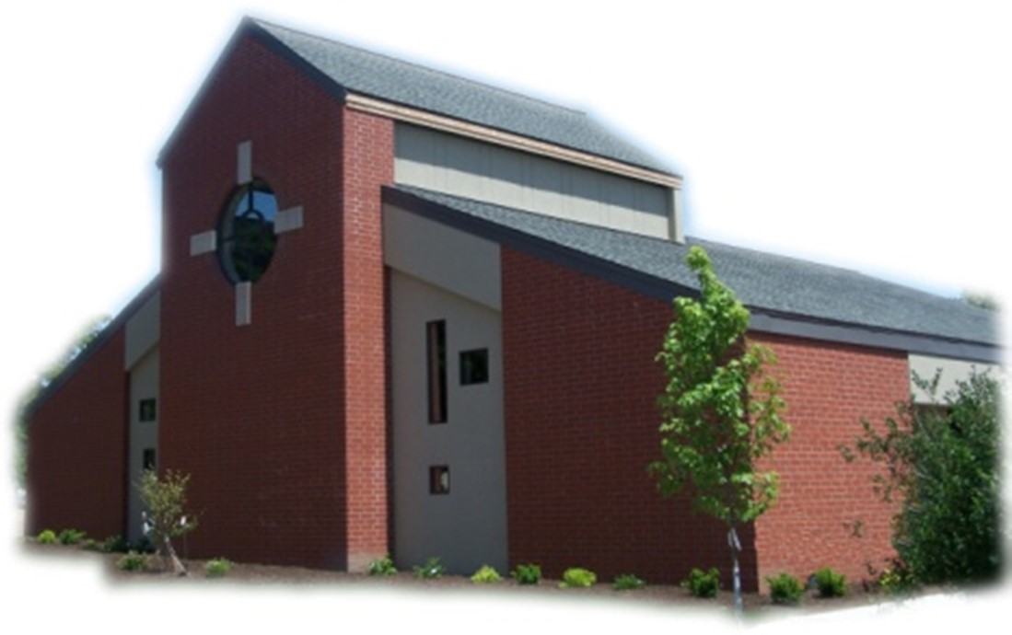

Sacramental Priest, Rev. Robert “Bud” Grant Email: grantrobert@sau.edu

Priest Moderator, Rev. Dale Mallory Email: malloryd@diodav.org

Parish Life Coordinator, Deacon Dan Freeman
Cell - 563-320-2462 Email: wiltonstmary@diodav.org

Office Manager - Rosemary Sullivan Director of Religious Education – Elizabeth Walker
C- 563-723-1050 /wiltonstmaryfin@diodav.org C- 563-260-3675/wiltonstmarydre@diodav.org

Mass Time: Sunday – 8:30 a.m.
Religious Education Classes start at 9:30 am during the school year.

Website: https://www.stmarywilton.org Facebook Page - https://www.facebook.com/stmarysofwilton
Today’s Readings – 10-11-26. In today’s Gospel, Jesus tells a parable of a king who invites anyone and everyone to a huge feast he is giving for the wedding of his son. Similarly, every Sunday we all are invited to a wonderful feast: the eucharistic feast, the wedding feast of the Lamb. We accept the Lord’s invitation to partake in his sacrificial meal, a foretaste of the heavenly banquet we hope to attend one day. Let us give thanks and praise to our God, who welcomes us to the feast. Question of the Week - What will I do this week to weave a wedding garment of repentance, mercy, and love for the Lord’s feast? What do I need to repent of? Who needs my mercy? How can I show love?

Ordination Banns - As Cameron John Costello, a seminarian from this parish, prepares for possible diaconate ordination this winter, the People of God are asked about his worthiness. If you are aware of any reason why this man should not be ordained, you are asked to contact: Fr. James Flattery (Pastor of St. Isidore, the Farmer Catholic Parish & Director of Seminarians, Diocese of Davenport), 208 Meridian St, Tipton, IA 52772. Phone: 563-886-2506 or flatteryj@diodav.org. The names of those expressing concerns will not be shared with any of the candidates, though the nature of the concern may be shared with them as part of the discernment and evaluation process.

New Families Welcome – Diane & Jeffrey Wilson of Wilton. Thank you for joining us!

St. Mary Parish Schedule:
- Sun Oct 11th Mass. RE Classes. Volunteer Mass Ministries Sign up. Mass Training Confirmation Students. Parish & Finance Councils meet after Mass.
- Wed Oct 14th Liturgy Committee meets at 5:30 pm.
- Sun Oct 18th Mass. RE Classes. Volunteer Mass Ministries Sign up. Mass Ministries Confirm. Students
- Sun Oct 25th Mass. NO RE Classes. Volunteer Mass Ministries Sign up.
  - Parish Potluck Breakfast and Parish Cleanup Day.
- Sun Nov 1st Mass – All Saints. RE Classes. 1st Grade - Gift Bearers.
  - Altar Server training after RE Classes.

Christian Initiation Classes – Helping those Becoming Catholic or Joining the Catholic Church. Candidates, Sponsors, & Friends invited. All sessions are in the Parish Hall. Everyone is invited.
- Sun Oct 18th 9:45 am Katy & Jim Jepsen Ch 11. Christian Destiny: The Last Things
- Tue Oct 27 5:30 pm Amanda & Dyllin Kitzmiller Ch 1. The Existence of God & Ch 2. God: Our Loving Creator.

Donuts & Coffee every Sunday!!! Serve Donuts & Coffee and clean up after Mass. Parents of RE students sign up for the RE Sundays, Parishioners sign up for those Non-RE Sundays. Signup sheets in the Gathering Area. We also need volunteers to pick up the Donuts on the Saturday before – contact Jessica Williams.

October is Respect Life Month - “Mary, Mother of Life” as this year's theme reflects Our Lady’s distinguished role as mother of all the living. The life of the Blessed Mother teaches us to respect each human life in every stage and circumstance. Go to https://www.respectlife.org/.

2026-27 ADA. Thank you for prayerfully considering your participation in this year’s Appeal. Every gift helps continue Christ’s mission. St. Mary ADA goal for 2026-27 is $24,954.

Parish Breakfast Potluck & Cleanup Day – Sunday, October 25th after Mass we will have a Breakfast Potluck. The Parish will provide the meat, drinks, and table service. A Parish Cleanup Day will be held after the Potluck so bring/wear your work clothes. Details to follow.

Catholic Rural Life Mass of Thanksgiving will be held on Saturday, November 14, 2026, starting at 4:00 pm. Location is at the Seed barn of Terri and Jim Lilienthal, 2106 Yankee Avenue, Durant, IA 52747 – a big brown barn just north of I80 and on the right side of the road. Handicap Parking will be available. We will share a Potluck Supper after Mass, so bring your best dish! St. Mary will provide the table service. We will be in a partially heated building.
Lay Mass Ministry Signup - Sundays. There will be sign-up sheets in the Gathering Area for each of our Lay Mass Ministries – Lectors, Extra-Ordinary Eucharistic Ministers, Ushers, Altar Servers, Gift Bears, and new – Greeters, Hospitality, and Homebound Communion Ministers. Information sheets will be available to explain each Ministry. Please ask if you have any questions.

Committees Signup Sundays - Information about each committee is printed out and on the tables in the Gathering Area with the signup forms. Sign up forms for each committee are in the Gathering Area. The Committees are; Buildings & Grounds, Cemetery, Faith Formation, Liturgy, Safety, and Welcoming & Belonging. Please ask if you have any questions about these committees.

Youth Hayride & Bonfire – Sunday, November 8, 2026, from 3 to 6 pm. At Jessica & Damon Boorn farm, 2561 122nd St., Moscow, IA 52760. 7-12 grades. Invite a friend. Faith, Food, & Fun!

Theology of the Body event. A multi-media event entitled Made for More will weave together live music, video clips and sacred art for an evening of beauty and reflection on the meaning of life, love and human destiny through the lens of St. John Paul II’s Theology of the Body writings. This event gives us an understanding of JPII’s (St. John Paul II) work to provide us with ways to have conversations with others, both young and old, regarding how to live our lives with dignity and as God intended. Thursday, November 12, 2026, at 7:00 pm. Our Lady of Victory Parish, Davenport.

Walking with Moms in Need is a nationwide, parish-based initiative to increase support for pregnant and parenting mothers in need. It works to ensure that any woman who finds herself unexpectedly pregnant, or parenting in difficult circumstances, can turn to her local Catholic Church and be connected with the resources she needs. Volunteers walk with moms throughout the motherhood journey, offering them authentic Christian friendship and ongoing support. If you need our support, please contact Deacon Dan. If you want to volunteer, please contact Deacon Dan.

Are you registered to vote, go to https://apps.sos.iowa.gov/elections/voterreg/regtovote/search.aspx. If not register here; https://mymvd.iowadot.gov/Account/Login?ReturnUrl=%2fVoterRegistration.

Mass Intention for Sunday, October 18, 2026 – John Hammes
Lay Mass Ministers for Sunday, October 18, 2026.
Announcer & 1st Reading – Confirm. Students 2nd Reading – Confirm. Students
EMHC – Denise Timmerman & Sara Tucker Gift Bearers – Confirm. Students
Ushers – Confirm. Students Servers – Amelia & Ruth Costello & Rose Koopmann
Homebound Communion Minister – Amanda Rockow Greeters - Confirm. Students
Hospitality – Amber Marolf

Mass Intentions for the deceased are $10.00 each. Please indicate who the Mass is for, who requested it, and how many Masses are requested. We will try to honor requested Mass dates.

To report child abuse, contact the Iowa Dept. of Human Services Child Abuse hotline: 800-362-2178. If clergy or church personnel are involved also notify Alicia Owens, Victim Assistance Coordinator, 563-349-5002; vac@diodav.org or 780 W. Central Park Ave., Davenport, IA 52804.

New Parishioners: Please complete the Registration form online at https://www.stmarywilton.org/ or request a form after Mass. The completed form may be placed in the Contribution Basket or given to Deacon Dan. See the contact information on the Bulletin to contact me with any questions.

Envelopes – If you are not receiving Parish Contribution Envelopes, please contact Deacon Dan.

Loss of Pregnancy or Infertility – you are not alone. Our Catholic faith offers hope, consolation, and support for those who have experienced infertility or loss of a pregnancy. Please feel free to contact Father Bud or me. Also a great resource is this website - https://springsinthedesert.org.
Sacraments - to schedule participation in any of these please contact Deacon Dan:
- Confession – email Father Bud at grantrobert@sau.edu for times prior/after Mass.
- Baptism – A prep class required for family’s first child. Contact Deacon Dan 1 month prior.
- Marriage – contact Deacon Dan a minimum of 7 months prior to the proposed event.
- Anointing – Anyone having surgery or experiencing illness may ask for the Rite of Anointing of the Sick. Father Bud will anoint immediately after Mass. Contact Deacon Dan.
- Funeral Preparation – please contact Deacon Dan. A great booklet is available to help.

Questions about our Faith – here’s your chance to ask any question pertaining to the Catholic Church and our Catholic Faith that you are curious about. Simply email your question to wiltonstmary@diodav.org and it will be answered in the Bulletin anonymously.

Prayers are requested for Cameron Costello and all the Seminarians of the Davenport Diocese. We also pray for the 11 men in Diaconate Formation to be Ordained July 2027.
Prayer Chain – to submit a name please contact Colleen Nichols at 563-260-2212.

Project Rachel - is a confidential, post-abortion healing ministry of the Catholic Church offering hope and healing to women and men hurting from past abortions. Project Rachel staff understand the emotional pain that follows an abortion. Helpline: 563-888-4376, Email: projectrachel@diodav.org. Calls answered personally Monday, Tuesday, Wednesday & Thursday 9am-3pm. Voice messaging all other times.

Family Prayer for Vocations. Lord, help us to know more clearly the work you have called us to do in life. And grant us the graces we need to fulfill this call with courage, love, and a genuine dedication to your will. If it is your will to choose someone from our family to be a priest, sister, or brother, we thank you and we rejoice. Finally, we ask you to help us be a living example of your unselfish love. Amen.

Fighting to break free from pornography? Get Help! https://integrityrestored.com/ or https://www.strive21.com/, or https://www.covenanteyes.com/. Call 563-334-4505 for a local group.

2026-27 Parish Leadership Team
Trustees: (2 year term – max 4 terms)
Denise Timmerman (24) 563-349-3880 denisetimmerman13@gmail.com
Henry Bentley (24) 563-340-3111 henrybentley1961@outlook.com
Parish Council: (2 year term – max 2 terms)
Jessica Williams (25) Chair/At Large 563-320-3699 jesss_99@yahoo.com
Andrew Koopmann (26)Vice Chair/Secretary 563-920-2993 ajkoop88@gmail.com
Taci Lilienthal (25) At Large 563-343-1144 taci.lilienthal@gmail.com
Damon Boorn (24) At Large 563-260-9816 damon.boorn@gmail.com
Jeremiah Costello (23) Faith Formation 563-370-2065 Jeremiahecostello@gmail.com
Scott Wolf Cemetery 563-370-3734 srwolf64@gmail.com
Jim Gavin Bldg. & Grounds 563-506-5112 gavinjames@netwtc.net
Dennis Sass Liturgy 319-430-2063 dwsass51@gmail.com
Finance Council: (4 year term – max 2 terms)
Andrea Shaffer (24) Chair 563-299-5632 shafferauto06@gmail.com
Eric Thornton (25) 563-299-4624 eric6982@hotmail.com
John Kuhl (26) 563-320-7433 johnkuhl@kentww.com

