Saint Mary Catholic Church
701 East Third Street, Wilton, IA 52778

3rd Sunday or Ordinary Time - January 25, 2026

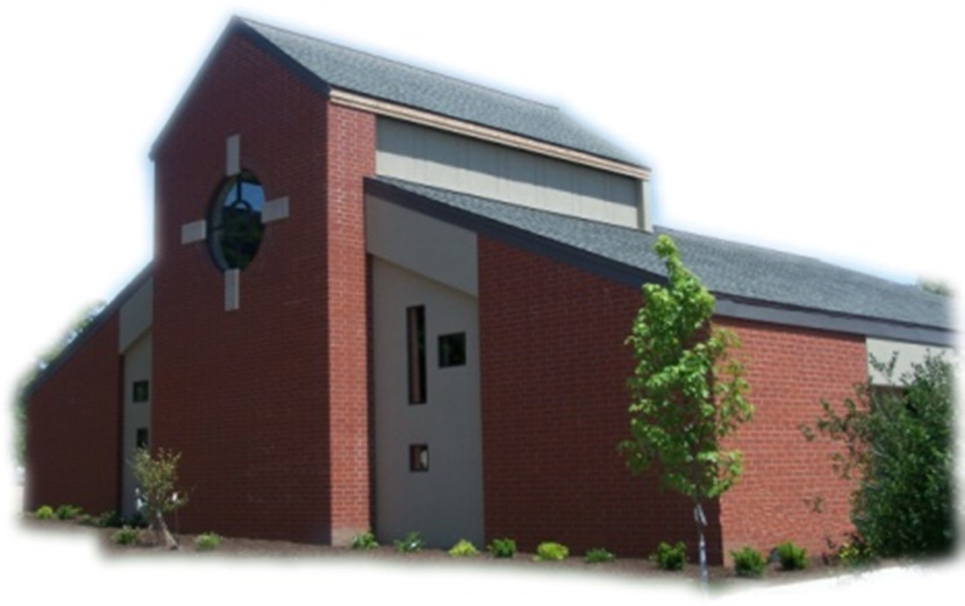
Sacramental Priest, Rev. Robert “Bud” Grant Email: grantrobert@sau.edu
Priest Moderator, Rev. Dale Mallory Email: malloryd@diodav.org

Parish Life Coordinator, Deacon Dan Freeman
Cell - 563-320-2462 Email: wiltonstmary@diodav.org

Office Manager - Rosemary Sullivan Director of Religious Education – Hilary Henke
Cell - 563-723-1050 / wiltonstmaryfin@diodav.org Cell - 563-260-5861 / wiltonstmarydre@diodav.org

Mass Time: Sunday – 8:30 a.m.
Religious Education Classes start at 9:30 am during the School year.

Website: https://www.stmarywilton.org Facebook Page - https://www.facebook.com/stmarysofwilton
Today’s Readings – 1-25-26. In today’s Gospel, we hear Jesus call his first disciples. “Come after me,” he calls out to the first two. “Follow me,” he says to two more. We are the ones Jesus calls out to now. Today is the Sunday of the Word of God, the day Pope Francis chose to dedicate to the proclamation, the study, and the celebration of the scriptures. The call of the first disciples also reminds us of Jesus’ own words. His words invite us to a deeper commitment, to one like Peter and Andrew and James and John made with him. May the word of God inspire us to enter our discipleship more deeply. Question of the Week - The first disciples left their old lives behind to follow Jesus. What is Jesus calling me to leave behind?

Please welcome our new families: Jennifer and Todd Jaeger, Nicole and Jakob Airgood and their son Carson, Emily (Prinz) & Nathan Peterson. Welcome to St. Mary!!

St. Mary Family Celebration – Nolan Williams earns Eagle Scout Award! Please congratulate Nolan and his parents Jessica & Austin Williams.

St. Mary Parish Schedule:
- Sun Jan 25th Mass. RE Classes. Mass Train - Grade 3. Confession – Grade 6
- Sun Feb 1st Mass. Blessing Throats. RE Classes. First Communion Parent mtg.
  - First Reconciliation for Confirmation Students. Mass Ministries – Grade 3.
  - Youth to University of Iowa Newman Center & Iowa Heartlander Hockey Game.
- Wed Feb 4th Faith Formation meet at 5:30pm.
- Sun Feb 8th Mass with Rite of Receiving Catechumen and Candidate. RE Classes.
  - Parish & Finance Councils. Reconciliation – Grade 2.
- Sun Feb 15th Mass- 6th Sun OT. No RE Class – Presidents’ Day.
- Wed Feb 18th Mass – Ash Wednesday - St. Mary at 7:00 pm.
- Sun Feb 22nd Mass - 1st Sun Lent with Rite of Sending. RE Classes. Mass Train – Grade 6.
  - Reconciliation – Grade 4. Rite of Election – Sacred Heart Cathedral at 2:00 pm.
- Tue Feb 24th WDMA Lenten Service at 12:10 pm –
- Wed Feb 25th Adoration – 5:00 pm. Stations of the Cross - 6:00 pm. Soup by Faith Formation.

Christian Initiation Classes – Helping those Becoming Catholic or Joining the Catholic Church. Candidates, Sponsors & Friends invited. All sessions are in the Day Chapel. Everyone is invited.
- Sun Feb 1st 9:45 am Amanda Vasey & Jean Semsch Virtues, Morality, & Conscience & Sexuality Ten Commandments & the Golden Rule, Praying Memories & Praying Scriptures

Catholic Messenger annual subscription drive begins this month. The cost of the Messenger this year is $30. Every household is to take the Messenger. Subscription envelopes are in your January packet of envelopes. Checks should be made payable to St. Mary and returned in the Offertory basket. Thank you! The Envelope is dated for January 25th.

Prayers are requested for Cameron Costello and all the Seminarians of the Davenport Diocese. We also pray for the 11 men in Diaconate Formation to be Ordained July 2027.

Saint - the principal feast on Sunday, January 25th marks the Conversion of Saint Paul the Apostle. This commemorates St. Paul's dramatic encounter with the risen Christ on the road to Damascus, where he was called from persecuting the Church to becoming the Apostle to the Gentiles. As described in the Roman Martyrology, "while traveling to Damascus, still breathing threats and slaughter against the disciples of the Lord, [he] was revealed to by Jesus himself on the road in his glory, and He chose him to be filled with the Holy Spirit to proclaim the Gospel of salvation among the Gentiles, suffering many things for the name of Christ." This feast highlights God's power to transform lives and is a fixed liturgical celebration in the General Roman Calendar.

Contribution Statements – We will strive to have 2025 Statements available for pick up in the Gathering Area after Mass by Sunday, January 25, 2026. Questions – please contact Deacon Dan.

Mass Ministry Schedules for February and March are available in the Gathering Area.
Sacraments - to schedule participation in any of these please contact Deacon Dan:
- Reconciliation is available before & after Mass. Let Father Bud know of your need.
- Baptism – A preparation class is required for your first child. Contact Deacon Dan.
- Marriage – contact Deacon Dan a minimum of 8 months prior to the proposed event.
- Anointing – Anyone having surgery or experiencing illness may ask for the Rite of Anointing of the Sick. Father Bud will anoint immediately after Mass. Contact Deacon Dan at least the day before Mass if possible.
- Funeral Preparation for you or a loved one, please contact Deacon Dan.

Special Collection Sunday, February 8th Envelope - the mission of the Newman Catholic Student Center at the University of Iowa is to prepare disciples for the Church and the world. Preparing disciples involves preparing faith-filled leaders who will impact their future families, parishes, workplaces, and our diocesan communities. Please prayerfully consider supporting the Newman Center through the special collection authorized by the Diocese of Davenport. For more information, please visit www.iowacatholic.org.

St. Mary 7th -12 Grade Youth to tour U of I Newman Center and attend an Iowa Heartlander Hockey game, Sunday afternoon on February 1st. Contact Dennis Sass for more information.

EPIC – Every Parishioners Involvement Counts! Volunteers needed:
Trivia Night – Fundraiser for our Youth activities. St. Mary Parish Hall. Saturday, February 28th. Doors open at 5:30 pm and Games start at 6:30 pm. $10 per person. Win cash prizes, gift baskets, & 50/50 Raffles. Teams of 8, singles are welcome. Bring your own snacks and non-alcoholic beverages. All proceeds will go for our youth to attend the Iowa Catholic Youth Conference (ICYC) in Cedar Rapids March 21 & 22, 2026 and other youth activities. If you are unable to attend, please consider a donation. For Registration & Information contact Jean Semsch at 563-340-3327 or fourjsem@netins.net.

Mass Intention for Sunday, February 1, 2026 – Ed Hammes
Lay Mass Ministers for Sunday, February 1, 2026.
Announcer & 1st Reading – 3rd Graders 2nd Reading – 3rd Graders
EMHC – Steph Lilientahl & Linda Lund Gift Bearers – 3rd Graders
Ushers – Gail & Bill McCrabb & 3rd Graders
Servers – Natalie & Rosa Koopmann & Brady Blake

Mass Intentions for the deceased are $10.00 each. Please indicate who the Mass is for, who requested it, and how many Masses are requested. We will try to honor requested Mass dates.

To report child abuse, contact the Iowa Dept. of Human Services Child Abuse hotline: 800-362-2178. If clergy involved or church personnel also notify Alicia Owens, Victim Assistance Coordinator, 563-349-5002; vac@diodav.org or 780 W. Central Park Ave., Davenport, IA 52804.

New Parishioners: Please complete the Registration form online at https://www.stmarywilton.org/ or to request a form after Mass. The completed form may be placed in the Contribution Basket or given to Deacon Dan. See the contact information on the Bulletin to contact me with any questions.

Envelopes – If you are not receiving Parish Contribution Envelopes, please contact Deacon Dan.

Marguerite Ritzinger Scholarship - Applications for the Marguerite Ritzinger Scholarship of the Diocese of Davenport are being accepted through Feb. 27, 2026. Catholic individuals who plan to attend a college or university next fall may apply for a $1,000 scholarship. Nontraditional students may apply for the scholarship. Applications must include an essay, copy of a high school or college transcript and two reference letters. All items must be sent together with the application form, on the diocesan website at https://www.davenportdiocese.org See the Quick Links of the homepage.

Crisis Emergency Phone: 855-581-8111 or call 988 for those contemplating suicide.
Fighting to break free from pornography? Get Help! https://integrityrestored.com/ or https://www.strive21.com/, or https://www.covenanteyes.com/. Call 563-334-4505 for a local group.

Questions about our Faith – here’s your chance to ask any question pertaining to the Catholic Church and our Catholic Faith that you are curious about. Simply email your question to wiltonstmary@diodav.org and it will be answered in the Bulletin anonymously.

Our Lady of the Prairie Retreat, Wheatland
For details and to register via email, olpretreat@gmail.com or call 563-374-1092.
- Lectio Divina: (Online every Tuesday) is the foundation for Benedictine prayer. Make it a steady prayer in your life. Facilitator: Linda Clewell, SMM Oblate. Free will offering.
- Centering Prayer: (Online every Wednesday) An ancient form of praying based on the words of Jesus. Facilitator: Carol Mizeur. Free will offering.

Parish Directory App – With our new Pictorial Directory we were also given the ability to download our Parish Directory to our Cell Phones. Anyone who would like help to download this App to their cell phone should contact Deacon Dan for a special email and code or sign up on the sheet in the Gathering Area. Also, if you would like to have your picture in the Parish Directory App, please see Deacon Dan.

Blessings & Prayers Offered. Blessings or Special Prayers for your family or any family event or gathering such as an engagement, birthday, etc., or for your home, pets, livestock, crops, new buildings or for any other reason are offered to celebrate God’s goodness or ask for His grace. Blessings and Prayers with our family and friends help all of us recognize that God is always among us and wants to be active in our lives. Please contact Deacon Dan for more information.

Prayer Chain Request - please contact Colleen at 563-260-2212 or collienichols@yahoo.com.

New Meal Train Ministry - Our meal train ministry helps parishioners who have recently had a baby, those who have recently lost a loved one, are going through an illness or rough time, or those who are temporarily homebound and need assistance with meals. If you'd like more information, would like to nominate a parishioner, or would like to be put on the list to make meals when able, please contact Sarah Costello at 563-210-3977 or email slcostello09@gmail.com.

The Coming Home Network was established to help non-Catholic Christians, clergy and laity to make the journey home to full communion with the Catholic Church. https://chnetwork.org/.

Vocations Prayer: Almighty Father, we beg you for an increase in religious vocations and holy marriages in our diocese. Help us to be generous in our response to Your call. Choose from our homes those who are needed for Your work and strengthen us with the courage to say “yes” and to follow You. Help us as a Diocese, as a parish, as families to encourage and foster vocations to priesthood, permanent diaconate, and consecrated life. Through Jesus Christ our Lord. Amen.

Parish Contacts:
Trustees: Denise Timmerman 563-349-3880 denisetimmerman13@gmail.com
Henry Bentley 563-340-3111 henrybentley1961@outlook.com
Parish Council President Damon Boorn 319-491-4833 damon.boorn@gmail.com
Finance Council Joe Kaufman 563-320-6436 kaufjmm@iowatelecom.net
Faith Formations Jeremiah Costello 563-370-2065 Jeremiahecostello@gmail.com
Liturgy Committee Dennis Sass 319-430-2063 dwsass51@gmail.com
Music Coordinator Bev Reuter 319-321-8524 bsreuter@netwtc.net
Funeral Dinner Coord Jean Semsch 563-340-3327 fourjsem@netins.net
Face Book Page: Sarah Costello 563-210-3977 slcostello09@gmail.com
Prayer Chain Colleen Nichols 563-260-2212 collienichols@yahoo.com
St. Mary Cemetery Scott Wolf 563-370-3734 srwolf64@gmail.com

