Saint Mary Catholic Church
701 East Third Street, Wilton, IA 52778

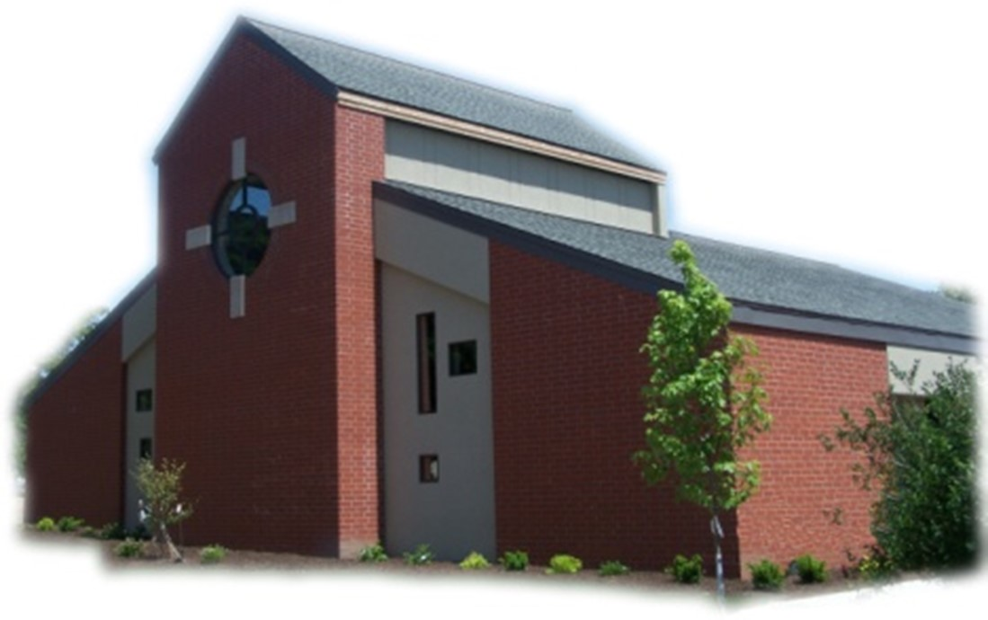
23rd Sunday of Ordinary Time - September 7, 2025

Sacramental Priest, Rev. Robert “Bud” Grant Email: grantrobert@sau.edu
Priest Moderator, Rev. Thom Hennen Email: hennent@diodav.org

Parish Life Coordinator, Deacon Dan Freeman
Cell - 563-320-2462 Email: wiltonstmary@diodav.org

Office Manager - Rosemary Sullivan Director of Religious Education – Hilary Henke
Cell - 563-723-1050 / wiltonstmaryfin@diodav.org Cell - 563-260-5861 / wiltonstmarydre@diodav.org

Mass Time: Sunday – 8:30 a.m.
Religious Education Classes start at 9:30 am during the School year.

Website: https://www.stmarywilton.org Facebook Page - https://www.facebook.com/stmarysofwilton
Today’s Readings – 9-7-25. Over the last two thousand years Jesus has been given many titles, from Bread of Life to Our Savior. One of his first titles, going back to when he first stood and proclaimed God’s word in the synagogue, is Rabbi, or Teacher. How appropriate to focus on that title on this first Sunday of September, a time of year when millions of young people are returning to school. Today we hear Jesus teach the crowds what it means to be a disciple. May he teach us as well as we gather together in his name. Question of the Week - How do I feel challenged by Jesus’ demands of discipleship?

St. Mary Family – We pray for the repose of the souls of Jeanne and David Happ and that their family be comforted – Nicholas & Kristal Happ and children of Durant and Andrew & Anna Happ and children of Polk City, Iowa.

St. Mary Parish Schedule:
- Sun Sep 7th Mass. RE Registration after Mass. Teacher Inservice 9:30-11 am.
- Sun Sep 14th Mass – Exaltation of Holy Cross. RE Registration. Parish/Finance Councils.
- Sun Sep 21st Mass – Catechetical Sunday. RE Classes start. Bless Students & Teachers.
    - Parent meeting for all Religious Ed. Pre-K – Grade 6, 9:30 am in the Parish Hall.
    - Parent meeting for Conformation Class to be held in the Annex Building, 1st floor.
- Sun Sep 28th Mass. RE Classes. Priesthood Sunday. 2025-26 ADA Kick off.
- Wed Oct 1st Faith Formation at 5:30 pm.
- Sat Oct 4th BINGO for Youth & NCYC. Doors open at 5:00 pm. Games start at 5:30 pm.

Registration for Religious Education - Sundays, Sept. 7th and Sept. 14th after Masses. You may also download a form from our website. Those who have previously registered only have to indicate if they will allow pictures of their children to be published on St. Mary’s Facebook or Website. Teachers’ children pay NO fees for Religious Education regardless of numbers.

Saint for September 7th – Saint Clodoald - Priest. In the village of Saint-Cloud in the region of Paris in Gaul, Saint Clodoald, priest, who, born of royal lineage, after his father and brothers were killed, was raised by his grandmother Saint Clotilde. He renounced an earthly kingdom, became a cleric, and is known as Saint Cloud.

Coordinator of Youth Ministry (CYM) job opening. Time commitment is approximately 10 hours per month for 10 months (August – May). Contact Deacon Dan for details.

Pilgrims of Hope – The Bishops of Iowa have released a Pastoral Reflection on Immigration. This reflection seeks to remind our Catholic community of the authentic teaching of the Church on immigration and of the long-standing Catholic Social Teaching on Immigration. The full document may be accessed at https://iowacatholicconference.org/. Following are additional key points:
Part III - The Immigration Reality in the United States: A Moral and Human Concern
- The bishops do not believe it is consistent with the claims of justice to employ enforcement tactics that treat all immigrants, especially hardworking, longstanding, and peaceful members of our communities, in the same manner as violent criminals.
- The U.S. bishops have voiced particular concern about the open-ended deployment of military assets to enforce civil immigration laws, the prevention of access to asylum, and proposals to reinterpret birthright citizenship.
- The Church recognizes the right of nations to regulate immigration, but this right must always be exercised in accord with the precepts of justice, respect for the rule of law, and prudential restraint.
- The bishops engage with government to advocate for a system that is both effective and humane, protecting immigrants, refugees, and the poor as part of the Church’s broader mission to uphold the dignity of all life.
Part IV - The Church’s Call to Action: Living the Faith
- Every Catholic Christian has a moral responsibility to ensure that the personal dignity of migrants is upheld.
- Catholics can embrace their mission as disciples of Jesus by learning about Church teaching on immigration, participating in advocacy efforts, and supporting ministries that serve migrants and refugees.
- Catholic institutions must be places of welcome and accompaniment for migrants and refugees.
- more to follow next week.
JPII Retreat for 8th–10th Graders - All students in grades 8 - 10 are invited to take part in the Pope John Paul II Retreat at Sacred Heart Cathedral in Davenport on Nov. 8–9, 2025. This overnight retreat gives young people the chance to grow in their faith through inspiring talks, prayer, small group discussion, and time for fun and fellowship. The weekend is designed to help teens take ownership of their faith and to learn more about the life and witness of Pope John Paul II. Registration is open https://davenportdiocese.org/jpii-retreat. Cost is $50 and includes meals and lodging. Contact Deacon Ryan Burchett at 563-271-0608 or retreats@diodav.org for information.

Bingo – Saturday, October 4th doors open at 5:00 pm, Games begin at 5:30 pm. The proceeds will go to our Youth Group activities and NCYC. We would love to have everyone come out to play and support our youth programs. If you are not a Bingo player or otherwise unable to be there perhaps you can still help out. We are looking for “basket” donations to be raffled off and also game “sponsors”. Please contact Amanda Rockow or Dennis Sass for details or to volunteer to help.

A Women’s Discernment Evening is scheduled for Thursday September 18 at 5:30 pm at St. Mary in Iowa City. Join sisters from the Dominican Sisters of St. Cecilia for dinner and a Holy Hour. The public is invited to the Holy Hour as we pray for vocations and all those discerning.

Sign up to help with Coffee & Donuts during Religious Ed. Sundays after Mass. There is a sign-up board in the Gathering Area for preparation and cleanup. Please sign up early and often.

SURVEY - Consultation of the Laity: The USCCB wants to learn how the people of God are living out their baptism and how parish leadership can better support that. The survey is open until the end of September. Please fill out this survey at - https://www.surveymonkey.com/r/6PMVLP3.

2024-25 ADA – we hope that those who haven’t completed their pledge payments for this past year’s ADA can finish their pledges very soon as we will start the new ADA pledge soon. 2024-25 ADA Goal - $19,450. Total Pledged - $31,162. Total Paid as of 8-20-25 is $25,602. Thank you!

50th Wedding Anniversary Mass and Reception with Bishop Walsh at St. Patrick Catholic Church in Iowa City on Sunday, October 19, 2025, at 2 p.m. Please send me your name and address if you were married in 1975 or have not attended a Diocesan 50th Anniversary previously.

Celebrate World Day for Grandparents and Elderly: September 6th – 7th. The theme for the 2025 celebration selected by the pope is “Blessed are those who have not lost hope.” The celebration of World Day for Grandparents and the Elderly was moved to the first weekend after Labor Day to coincide with National Grandparents (and the Elderly) Day in the United States.

Great Resources – Catholic Moms at https://www.catholicmom.com/. Another great resource is https://www.catholic.org/.

Fighting to break free from pornography? Get Help! https://integrityrestored.com/ or https://www.strive21.com/, or https://www.covenanteyes.com/. Call 563-334-4505 for a local group.

STEP Theology Online - Connecting the Catholic intellectual life to the life of the Church: June 16 classes begin. The Diocese of Davenport has partnered with STEP at the University of Notre Dame to offer online formation for the people of the diocese. Learn more about certificate offerings through STEP which has 20 years’ experience of offering “satellite” intellectual formation. Individuals receive a 50% discount off $99. Questions, https://www.davenportdiocese.org/ff-step or contact Trevor Pullinger at pullinger@davenportdiocese.org.

Questions about our Faith – here’s your chance to ask any question pertaining to the Catholic Church and our Catholic Faith that you are curious about. Simply email your question to wiltonstmary@diodav.org and it will be answered in the Bulletin anonymously.
Crisis Emergency Phone: 855-581-8111 for those contemplating suicide in Eastern Iowa. A crisis is any stress or pressure that has become far too great for you to cope with alone. Trained counselors are available to meet in person anywhere. Mobile outreach is also offered.

Meal Train Ministry - Our meal train ministry helps parishioners who have recently had a baby, those who have recently lost a loved one, are going through an illness or rough time, or those who are temporarily homebound and need assistance with meals. If you'd like more information, would like to nominate a parishioner, or would like to be put on the list to make meals when able, please contact Sarah Costello at 563-210-3977 or email slcostello09@gmail.com.

Mass Intention for Sunday, September 14, 2025 – Martha Timmerman
Lay Mass Ministers for Sunday, September 14, 2025.
Announcer & 1st Reading – Josh Smyser 2nd Reading – Amanda Vasey
EMHC –Darcy Worl & Amanda Rockow Gift Bearers – Austin Williams Family
Ushers – Dennis Sass & Joe Kaufman
Servers – Kinley Boorn, Ruby Timmerman, & Owen DeLong

Mass Intentions for the deceased are $5.00 each. Please indicate who the Mass is to be said for and how many Masses are requested. We will try to honor requested Mass dates.

Protecting God’s Children - To report child abuse contact the Iowa Dept. of Human Services Child Abuse hotline: 800-362-2178 and if clergy involved or church personnel also notify Alicia Owens, Victim Assistance Coordinator, 563-349-5002; vac@diodav.org or PO Box 232, Bettendorf, IA.

New Parishioners: Please complete the Registration form online at https://www.stmarywilton.org/ or to request a form after Mass. The completed form may be placed in the Contribution Basket or given to Deacon Dan. See the contact information on the Bulletin to contact me with any questions.
Envelopes – If you are not receiving Parish Contribution Envelopes, please contact Deacon Dan.

The Coming Home Network was established to help non-Catholic Christians, clergy and laity, discover the truth and beauty of Catholicism and to make the journey home to full communion with the Catholic Church. https://chnetwork.org/.

Sacraments - to schedule participation in any of these please contact Deacon Dan:
- Baptism – A prep class required for family’s first child. Contact Deacon Dan 1 month prior.
- Confession – email Father Bud at grantrobert@sau.edu for times prior/after Mass.
- Marriage – contact Deacon Dan a minimum of 7 months prior to the proposed ceremony.
- Anointing – Anyone having surgery or experiencing illness may ask for the Rite of Anointing of the Sick. Father Bud will anoint immediately after Mass. Contact Deacon Dan.
- Funeral Preparation – please contact Deacon Dan. A great booklet is available to help.

