Saint Mary Catholic Church
701 East Third Street, Wilton, IA 52778

25th Sunday of Ordinary Time
September 21, 2025

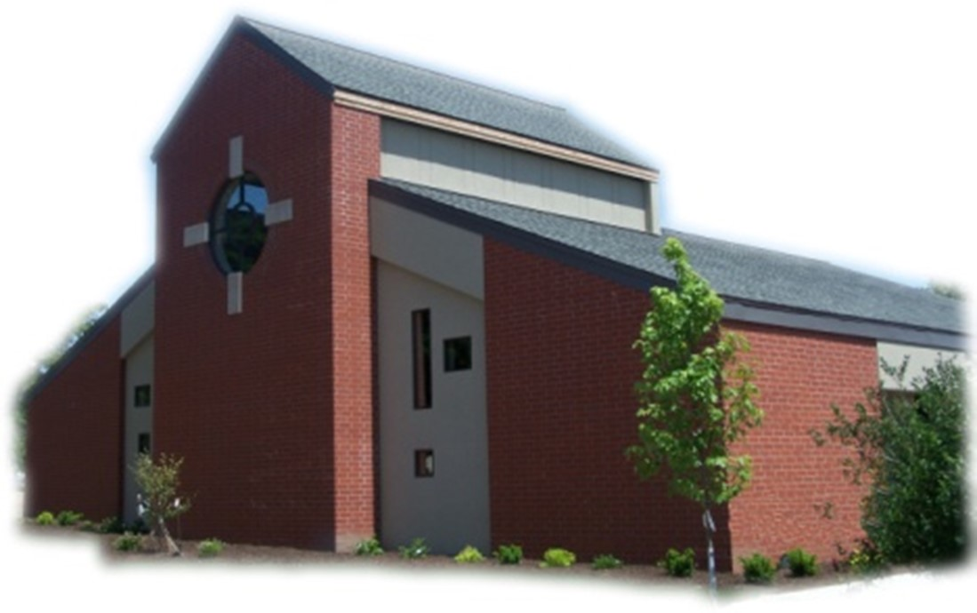

Sacramental Priest, Rev. Robert “Bud” Grant Email: grantrobert@sau.edu
Priest Moderator, Rev. Thom Hennen Email: hennent@diodav.org

Parish Life Coordinator, Deacon Dan Freeman
Cell - 563-320-2462 Email: wiltonstmary@diodav.org

Office Manager - Rosemary Sullivan Director of Religious Education – Hilary Henke
Cell - 563-723-1050 / wiltonstmaryfin@diodav.org Cell - 563-260-5861 / wiltonstmarydre@diodav.org

Mass Time: Sunday – 8:30 a.m.
Religious Education Classes start at 9:30 am during the School year.

Website: https://www.stmarywilton.org Facebook Page - https://www.facebook.com/stmarysofwilton
Today’s Readings – 9-21-25. “You cannot serve both God and mammon,” we hear Jesus tell his disciples in today’s Gospel. He challenges us to decide where our priorities lie. Which do we spend more time and energy building up: our faith or our wealth? It is difficult to ignore the need for money, if only to have enough to get by, let alone pursuing more so that we can live a comfortable life. But we believe our treasure can be found in the kingdom of God, in which money is irrelevant. May today’s liturgy remind us of that truth. Question of the Week - How do I value true wealth over material wealth? How can I do so more fully?

Religious Education classes will start on Sunday, September 21st after Masses.
Coffee & Donuts during Religious Ed. Sundays after Mass. There is a sign-up board in the Gathering Area for preparation, serving, and cleanup. Please sign up early and often.

St. Mary Parish Schedule:
- Sun Sep 21st Mass – Catechetical Sunday. RE Classes start. Bless Students & Teachers.
    - Parent meeting for all Religious Ed. Pre-K – Grade 6, 9:30 am in the Parish Hall.
    - Parent meeting for Conformation Class to be held in the Annex Building, 1st floor.
- Sun Sep 28th Mass. Priesthood Sunday. RE Classes. 2025-26 ADA Kick off.
- Sat Oct 4th BINGO for Youth & NCYC. Doors open at 5:00 pm. Games start at 5:30 pm.
- Sun Oct. 5th Mass. RE Classes
- Tue Oct 7th Faith Formation at 5:30 pm.
- Sun Oct 12th Mass. RE Classes. Volunteer Ministries Sign up.
    - Parish & Finance Councils meet after Mass. Mass Training – Confirmation Students.
- Sun Oct 19th Mass. RE Classes. Volunteer Ministries Sign up.
    - Mass Ministries – by Confirmation Students.

Christian Initiation Classes – Helping those Becoming Catholic or Joining the Catholic Church. Candidates, Sponsors, & Friends invited. All sessions are in the Parish Hall. Everyone is invited.
- Sun Sep 28th 9:45 am Deacon Dan #56 & #57 The Mass Part I & II.
- Tue Sep 30th 5:30 pm Father Bud #28 Jesus & #27 Trinity.
- Sun Oct 5th 9:45 am Deacon Dan #31 Introduction to Bible & #32 The Old Testament
- Sun Oct 19th 9:45 am Katy & Jim #33 New Testament $ #30 Communion of Saints.
- Sun Nov 2nd 9:45 am Denise & Dennis #34 Intro. Sacraments, Baptism / Confirmation

SURVEY - Consultation of the Laity: The USCCB wants to learn how the people of God are living out their baptism and how parish leadership can better support that. The survey is open until the end of September. Please fill out this survey at - https://www.surveymonkey.com/r/6PMVLP3.

Women’s Faith Group - Join us for a Ladies Faith Sharing group to begin the week of Oct 6th. Please contact Jodie Dirksen 641-430-5044 for more information. Materials will be provided.

Coordinator of Youth Ministry (CYM) job opening. Time commitment is approximately 10 hours per month for 10 months (August – May). Contact Deacon Dan for details.

2025-26 Annual Diocesan Appeal - Next weekend marks the start of the Annual Diocesan Appeal (ADA). Our Goal is set at $21,727 for the 2025-26 year. We ask that you prayerfully consider your support. If we exceed this amount as a parish, 100% of the additional funds will be returned to us, allowing us to further our mission and ministries, and continue making a lasting impact on our parishioners and the wider community. Generosity in stewardship is rooted in the belief that everything we are and all that we have is a gift from God. Last year our parish exceeded our goal. ADA Envelopes and pencils will be placed in the pews so that you can complete your pledge form. Thank you for your generosity! www.davenportdiocese.org/annual-diocesan-appeal.

Reminder - Lay Mass Ministers – Please contact Denise Timmerman at 563-349-3880 or denisetimmerman13@gmail.com or if you are NOT available for Oct. or Nov. Mass Ministries.
Bingo – Saturday, October 4th doors open at 5:00 pm, Games begin at 5:30 pm. The proceeds will go to our Youth Group activities and NCYC. We would love to have everyone come out to play and support our youth programs. If you are not a Bingo player or otherwise unable to be there perhaps you can still help out. We are looking for “basket” donations to be raffled off and also game “sponsors”. Please contact Amanda Rockow or Dennis Sass for details or to volunteer to help.

Fighting to break free from pornography? Get Help! https://integrityrestored.com/ or https://www.strive21.com/, or https://www.covenanteyes.com/. Call 563-334-4505 for a local group.

Questions about our Faith – here’s your chance to ask any question pertaining to the Catholic Church and our Catholic Faith that you are curious about. Simply email your question to wiltonstmary@diodav.org and it will be answered in the Bulletin anonymously.

Saint for September 21st – Saint Matthew, Apostle and Evangelist, who is also known as Levi, was called by Jesus to follow him. He left his work as a tax collector and , chosen as one of the Apostles, wrote he Gospel where he especially proclaimed that Jesus Christ, the son of David, the son of Abraham, fulfilled the Old Testament.

JPII Retreat for 8th–10th Graders - All students in grades 8 - 10 are invited to take part in the Pope John Paul II Retreat at Sacred Heart Cathedral in Davenport on Nov. 8–9, 2025. This overnight retreat gives young people the chance to grow in their faith through inspiring talks, prayer, small group discussion, and time for fun and fellowship. The weekend is designed to help teens take ownership of their faith and to learn more about the life and witness of Pope John Paul II. Registration is open https://davenportdiocese.org/jpii-retreat. Cost is $50 and includes meals and lodging. Contact Deacon Ryan Burchett at 563-271-0608 or retreats@diodav.org for information.

Prayers are requested for Cameron Costello and all the Seminarians of the Davenport Diocese. We also pray for the 11 men in Diaconate Formation to be Ordained July 2027.

Protecting God’s Children - To report child abuse contact the Iowa Dept. of Human Services Child Abuse hotline: 800-362-2178 and if clergy involved or church personnel also notify Alicia Owens, Victim Assistance Coordinator, 563-349-5002; vac@diodav.org or PO Box 232, Bettendorf, IA.

New Parishioners: Please complete the Registration form online at https://www.stmarywilton.org/ or to request a form after Mass. The completed form may be placed in the Contribution Basket or given to Deacon Dan. See the contact information on the Bulletin to contact me with any questions.
Envelopes – If you are not receiving Parish Contribution Envelopes, please contact Deacon Dan.

The Coming Home Network was established to help non-Catholic Christians, clergy and laity to make the journey home to full communion with the Catholic Church. https://chnetwork.org/.

Crisis Emergency Phone: 855-581-8111 for those contemplating suicide. Trained counselors are available to meet in person. Mobile outreach is also offered.

Our Lady of the Prairie – Retreat at 2664 145th Avenue, Wheatland, Iowa 52777. Details and register at www.theprairieretreat.org, or email – olpretreat@gmail.com, or call 563-374-1092.
- Wed., October 15th at 6:00-8:00 p.m. ONLINE ONLY: Come Forth: How the story of Lazarus can offer you new life by Rev. James Martin, SJ. “Martin dives deep into the Gospel story to reveal how Jesus's greatest miracle can help each of us experience the new life that God promises. Come Forth is a spiritual masterpiece.” — Richard Rohr, OFM, author of The Universal Christ. Cost is $20

Mass Intentions for the deceased are $5.00 each. Please indicate who the Mass is to be said for and how many Masses are requested. We will try to honor requested Mass dates.

Mass Intention for Sunday, September 28, 2025 – Virginette Finck
Lay Mass Ministers for Sunday, September 28, 2025.
Announcer & 1st Reading – Jacqueline Grotzky 2nd Reading – Kaci Owens
EMHC –Denise Timmerman & Judy Freeman Gift Bearers – Damon Boorn Family
Ushers – Jean Semsch & Tom Kelley Servers – Carter, Cooper & Tucker Smyser

Sacraments - to schedule participation in any of these please contact Deacon Dan:
- Baptism – A prep class required for family’s first child. Contact Deacon Dan 1 month prior.
- Confession – email Father Bud at grantrobert@sau.edu for times prior/after Mass.
- Marriage – contact Deacon Dan a minimum of 7 months prior to the proposed ceremony.
- Anointing – Anyone having surgery or experiencing illness may ask for the Rite of Anointing of the Sick. Father Bud will anoint immediately after Mass. Contact Deacon Dan.
- Funeral Preparation – please contact Deacon Dan. A great booklet is available to help.

Meal Train Ministry - Our meal train ministry helps parishioners who have recently had a baby, those who have recently lost a loved one, are going through an illness or rough time, or those who are temporarily homebound and need assistance with meals. If you'd like more information, would like to nominate a parishioner, or would like to be put on the list to make meals when able, please contact Sarah Costello at 563-210-3977 or email slcostello09@gmail.com.

STEP Theology Online - Connecting the Catholic intellectual life to the life of the Church: June 16 classes begin. The Diocese of Davenport has partnered with STEP at the University of Notre Dame to offer online formation for the people of the diocese. Learn more about certificate offerings through STEP which has 20 years’ experience of offering “satellite” intellectual formation. Individuals receive a 50% discount off $99. Questions, https://www.davenportdiocese.org/ff-step or contact Trevor Pullinger at pullinger@davenportdiocese.org.

St. Mary Pastoral Leadership 2025-26

Trustees: (Appointed w/ approval of Bishop. 2 year terms with max of 4 terms)
Denise Timmerman (’24, can do 3 more 2 yr. terms) 563-349-3880 denisetimmerman13@gmail.com
Henry Bentley (’24, can do 2 more 2 yr. terms) 563-340-3111 henrybentley1961@outlook.com

Parish Council: (At Large 2 yr. term, max 2 terms) (Comm. Chairs until replaced). Officers Elections in June.
- Damon Boorn (24) President/At Large 563-260-9816 damon.boorn@gmail.com
- Jessica Williams (25) Vice President/At Large 563-320-3699 jesss_99@yahoo.com
- Kathy Keese (22) Secretary/At Large 563-260-4904 Kskeese5@gmail.com
- Taci Lilienthal (25) 563-343-1144 taci.lilienthal@gmail.com
- Jeremiah Costello (23) Faith Form. 563-370-2065 Jeremiahecostello@gmail.com
- Scott Wolf Cemetery 563-370-3734 srwolf64@gmail.com
- Jim Gavin Bldg. & Grounds 563-506-5112 gavinjames@netwtc.net
- Dennis Sass Liturgy 319-430-2063 dwsass51@gmail.com

Finance Council: (Appointed, 4 year term w/ 2 term limit)
Phil Keese (22) President 563-260-4905 plkeese5@gmail.com
Andrea Shaffer (24) 563-299-5632 shafferauto06@gmail.com
Eric Thornton (25) 563-299-4624 eric6982@hotmail.com

